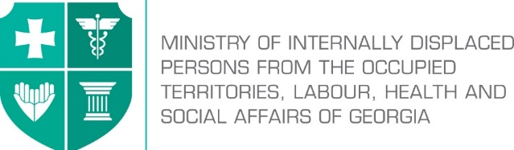

Labour Conditions Inspection Department
Create Together Safe Working Environment!

Annex №2

General Guidance Related to Infection (COVID-19) Caused by Novel Coronavirus (SARS-CoV-2) for Construction Sector

შენიშვნა:

Note: In accordance with Order N281/N of the Minster of Internally Displaced Persons from the Occupied Territories, Labour, Health and Social Affairs of Georgia on “the rule for Examination for Short-term Employment Disability and Issuance of Doctors Note”, the Ministry of Internally Displaced Persons from the Occupied Territories, Labour, Health and Social Affairs of Georgia will issue an equivalent document to the doctors excuse note (Medical Certificate) to persons quarantined in order to prevent the spread of coronavirus. The document will serve as the basis to receive monthly payment and therefore, the working days spend in quarantine or in self-isolation will be legitimate and fully paid to the employees. In order to get the certificate, an interested person has to apply to the Ministry of Internally Displaced Persons from the Occupied Territories, Labour, Health and Social Affairs of Georgia at - info@moh.gov.ge.

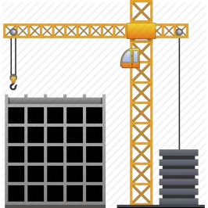
The job of builders involves constantly changing work places and work activity existing in open-air conditions. For this reason, in terms of virus spread, construction falls within the medium risk sector because its specificity covers natural ventilation. Nevertheless, it is important to consider the following preventive measures at construction work.

The staff must not appear in the workplace if they:
- Left the affected country over the past 14 days;
- Were in close contact with infected person/persons for the past 14 days (they must be self-isolated/quarantined as per the rule);
- Have symptoms of respiratory infection (coughing, temperature, sneezing, difficulty in breathing, general weakness etc.);
- Are among the ones who have high risk of getting infected with COVID-19 or serious complications: over 70 years of age, people suffering from chronicle diseases (cardio-vascular diseases, diabetes, bronchial asthma and other respiratory diseases.

Employer’s responsibilities

- Whether or not the incidence of infection is detected, employer should develop an emergency action plan to support reduction of working days missed due to illness, and in case of detection – prevention of spread;
- Provide employees with information about safe working procedures and about prevention of virus spread (guide with the recommendations defined by LEPL L. Sakvarelidze National Center for Disease Control and Public Health of the Ministry of Internally Displaced Persons from the Occupied Territories, Labour, Health and Social Affairs of Georgia);
- Inside the working space post announcements about COVID-19 and about the preventive measures that have been identified by LEPL L. Sakvarelidze National Center for Disease Control and Public Health;
- In relation to the employees who can perform job remotely (administrative personnel) ensure as much as possible use of such working mode;
- At the entrances of break room/dining room, place disinfecting rugs with relevant mandatory sign marking;
- Provide hand-washing facility with soap and other disinfectants. If hand-washing facility is not feasible, at least 70% alcohol-based hand cleansing liquid should be used;
- Visibly place the hand sanitizers and post the rules of their proper use;
- Make sure that employees have access to hand sanitizers and are aware of their use with proper rules;
- Provide all employees and contractors, personnel responsible for cleaning with information about relevant preventive measures to avoid spread of coronavirus in the working environment;
- Train the employees in proper use and further storage/removal of personal protective equipment and disinfectants;
- Depending on their work specificity, provide the employees with necessary personal protective equipment (protective clothing, protective shoes, helmet, gloves, respirator) and establish control on their use;
- Periodically, several times a day ensure natural ventilation of closed spaces/facilities;
- At certain periodicities disinfect frequently used working equipment and working places;
- Maintain ergonomics at construction site. Ensure timely cleaning of working space and timely disposal of construction waste.
- For employees and visitors ensure closed containers for used disposable tissues and other used hygienic waste in the working space.

Employees’ responsibilities
Ensuring proper hand hygiene regularly and thoroughly is the best way to be protected from most of the viruses. Therefore, it is necessary to take the following measures in the workplace:

- Follow hygiene rules in your workplace;
- Carry out the working process in accordance with emergency situations action plan defined by employer/occupational safety manager;
- When greeting do not shake hands and avoid contact with others (touching etc.);
- Avoid gatherings, it is recommended not more than 10 people in one working platform by keeping a safe distance (at least 2 m);
- While performing your work, fully use personal protective equipment provided by the employers;
- Treat with disinfectants the working places and tools used in the course of the work;
- Before and after taking meals, before and after using the restrooms thoroughly wash your hands with soap and water. After washing dry your hands well;
- If you can not wash and dry your hands, use alcohol-based hand sanitizers;
- Keep safe distance (at least 2 m);
- While coughing or sneezing, cover the face with a clean tissue or elbow and place used dispensable tissue in the waste bin;

- Avoid touching your eyes, nose and mouth with your hands.

