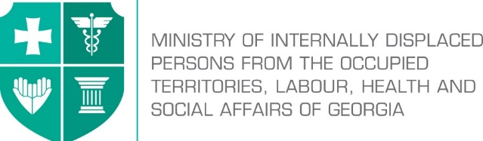

Labour Conditions Inspection Department
Create Together Safe Working Environment!

Annex №4

General Guidance Related to Infection (COVID-19) Caused by Novel Coronavirus (SARS-CoV-2) for Hotel Personnel and Visitors

Note: In accordance with Order N281/N of the Minster of Internally Displaced Persons from the Occupied Territories, Labour, Health and Social Affairs of Georgia on “the rule for Examination for Short-term Employment Disability and Issuance of Doctors Note”, the Ministry of Internally Displaced Persons from the Occupied Territories, Labour, Health and Social Affairs of Georgia will issue an equivalent document to the doctors excuse note (Medical Certificate) to persons quarantined in order to prevent the spread of coronavirus. The document will serve as the basis to receive monthly payment and therefore, the working days spend in quarantine or in self-isolation will be legitimate and fully paid to the employees. In order to get the certificate, an interested person has to apply to the Ministry of Internally Displaced Persons from the Occupied Territories, Labour, Health and Social Affairs of Georgia at - info@moh.gov.ge.

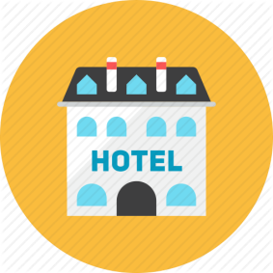
The staff must not appear in the workplace if they:
- Left the affected country over the past 14 days;
- Were in close contact with infected person/persons for the past 14 days (they must be self-isolated/quarantined as per the rule);
- Have symptoms of respiratory infection (coughing, temperature, sneezing, difficulty in breathing, general weakness etc.);
- Are among the ones who have high risk of getting infected with COVID-19 or serious complications: over 70 years of age, people suffering from chronicle diseases (cardio-vascular diseases, diabetes, bronchial asthma and other respiratory diseases

Employer’s responsibilities

- Whether or not the incidence of infection is detected, should develop an emergency action plan to support reduction of working days missed due to illness, and in case of detection – prevention of spread;
- Provide the personnel with information on safe working procedures. Where feasible, work must be performed remotely, employer shall ensure the use of such method;
- Upon their arrival provide the visitors with information on preventive measures against spread of COVID-19;
- Ensure supply of posters developed by World Health Organization and their placement at visible places at the hotel;
- If any of the hotel visitors develops these symptoms, should ensure his/her isolation and immediate notification of competent authorities;
- Post hand hygiene rules at visible places;
- Make sure that the staff and visitors have access to hand disinfectants;
- Place used disinfectants in a closed container and ensure their timely disposal by relevant person/service;
- Temporarily install at reception desk additional transparent protective barrier to avoid as much as possible the risk of airborne transmission of infection;
- Provide all employees and contractors, personnel responsible for indoor and outdoor cleaning with information about relevant preventive procedures to avoid spread of coronavirus in the working space.

Employees’ responsibilities
Ensuring proper hand hygiene regularly and thoroughly is the best way to be protected from most viruses. Therefore, it is necessary to take the following measures in the workplace:
- Follow hygiene rules in your workplace.
- Treat work surfaces and tools with disinfectants;
- Before and after taking meals, before and after using the restrooms thoroughly wash your hands with soap and water and dry them well;
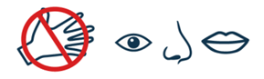
- Avoid contact with others (touching, hugging etc.);
- Keep safe distance (at least 2 m);
- While coughing or sneezing, cover the face with a clean tissue or elbow and place used dispensable tissue in the waste bin;
- Use alcohol-based hand sanitizers if you cannot wash or dry your hands;
- Avoid contact with visitors who don’t feel well and if so should ask for relevant medical aid;
- Avoid touching your eyes, nose and mouth with your hands.

Collective and Personal Protective Equipment to be used
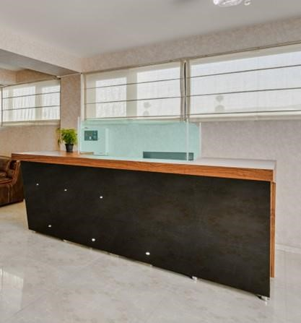
Since the hotel visitors have initial contact with security workers and receptionists, it is recommended to equip each of them with surgical mask and gloves, as well as additionally install at the reception desk temporary transparent barrier to avoid as much as possible the risk of airborne transmission of infection.

Personnel responsible for cleaning should avoid close contact with visitors. They should wear gloves during cleaning and before putting on and putting of the gloves use alcohol-based hand sanitizers. As an additional safety measure, the personnel responsible for cleaning may wear special mask during room cleaning. Before entering the room, cleaning staff should ask the visitor how s/he feels and ask him/her to wear a mask.

The visitors being in self-isolation
If visitors need to be self-isolate, it is important for the personnel to take relevant safety measures.

The risk for the personnel will be low if they wash hands thoroughly and guide with relevant recommendations. The personnel should avoid close contact with these visitors.

When hotel personnel will have to have contact with self-isolated person (e.g delivery of food), it is important to keep proper distance and use special protective equipment. However, it is strictly recommended for the self-isolated visitors to receive meal at the room door.

