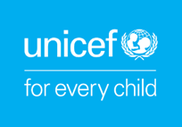
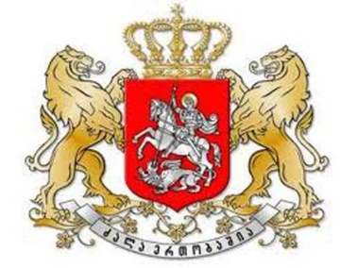

Annual Review Meeting Agenda
19 December 2019

Venue: Biltmore Tbilisi Hotel, 29 Shota Rustaveli Ave, meeting room #8.

Overall objectives of the meeting:
- Review the progress achieved in the implementation of 2019 Work Plans,
- Review the priorities for draft 2020 Work Plans.

10:00 - 10:15 Welcome Coffee

10:15 - 10:45 Opening Remarks:

Ghassan Khalil, UNICEF Representative in Georgia
Sopio Kiladze, Chairperson of the Committee on Human Rights and Civil Integration of the Parliament of Georgia
Irina Abuladze, First Deputy Minister of Education, Science, Culture and Sport of Georgia
Londa Toloraia, State Inspector

10:45 - 12:15 Review the progress achieved in 2019 and review the priorities for 2020 Work Plans:

Presentations on expected results, achievements, challenges and lessons learned, and programme priorities for 2020:

- Mother and Child Health – UNICEF
Comments from partners
- Early Childhood & Inclusive Education – UNICEF
Comments from partners
- Child Care – UNICEF
Comments from partners
- Social Protection – UNICEF
Comments from partners
- Justice and Child Rights Monitoring – UNICEF
Comments from partners
- Communication/C4D – UNICEF

12:15 - 13:00 Discussion, overall assessment, recommendations and way forward

13:00 - 13:15 Closing remarks:

Ghassan Khalil, UNICEF Representative in Georgia
Government Representative, TBD

