Annex 7 – Cooperation with Employers
Comments on Flow Chart (18.06.2020)
Employer Service Flow Chart
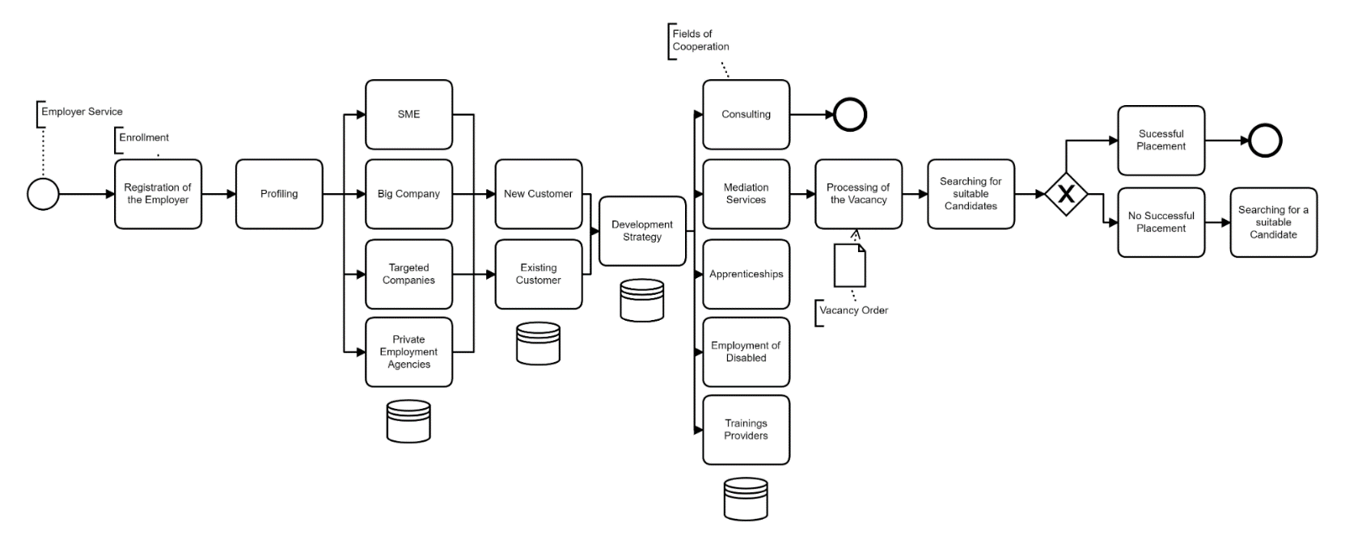
The above chart which we received for comments displays relevant aspects of working with employers, but it is focusing mainly on the situation of a new employer entering the register with the intention of filling a vacancy. This presupposes an already well functioning system of mediation. As this is not yet the case in Georgia, we would suggest looking at the following two aspects separately:
- Establishing cooperation with employers
- Filling of vacancies
1. Establishing cooperation with employers
The acquisition of clients on the demand side requires an active attitude of contacting employers, based on a strategic approach which companies are relevant. Currently employers don’t seem to be too eager registering with the SESA. Therefore, this task is of utmost importance for identifying more vacancies and increasing the number of placements. (This is also relevant with respect to Indicator 2.2 of the Skills for Jobs Programme.)
In view of the high relevance of this task contacting employers should be duty of the Heads of the Regional Offices. This would demonstrate the importance attached to this task. Initiating good working relationships with companies requires approaching their leadership and, therefore, should not be delegated to a subordinate staff member.
We would propose the following steps:
1. Get an overview of all companies registered in the region.
2. Make a selection based on profiling the companies regarding the following features:
- Big companies
- SMEs
- Key companies
Obviously, all big employers are relevant, because they employ a large share of the work force. However, the number of big companies will vary from region to region.
SMEs are relevant, because they form the majority of companies and usually provide also the majority of workplaces in a region. But due to their number a selection has to made which ones to approach.
Key companies are those of particular relevance either for the region or for a sector of national relevance, based on macroeconomic or other policy decisions. The decision on key companies should therefore be in line with the Labour Market Strategy and the Action Plan of the Ministry and has to be updated on a regular basis.
3. After the selection of the targeted companies has been made, they need to be contacted to establish a working relationship. As already mentioned in our previous memo on working with local employers this includes regular visits and exchange of information, including phone calls to receive feedback on the activities of the ROs.
Other activities like organising job fairs, holding events with employers, conducting info tours etc. should be intensified and, where necessary, improved. Finally, establishing such a relationship is not a one-off task.
One important purpose in this context is to receive information not only on current vacancies and their specific requirements but also on the employers’ future expectations and planning regarding employment, investment, and technological innovations. Moreover, this exchange of information should also serve the purpose of identifying those companies who are committed to be serious partners in supporting the integration of young people into the labour market and in the implementation of and ALMP measures for unemployed persons from Groups 3 and 4.
Last, but not least, the planned improvement of the WorkNet must ensure that it becomes easy for employers to register vacancies.
2. Filling of vacancies
Mediation of job-seekers requires good knowledge of the company’s specific skills need as well as of the job-seeker’s profile. It should be the duty of the heads of the ROs who are in regular contact with the employers keeping the Employment Specialists informed and updated with all relevant information on the targeted companies.
Placement of job-seekers should be carried out by the Employment Specialists. They have to be aware of both sides of the labour market in their region to be capable of selecting suitable applicants for the announced vacancies. After a working relationship has been established with a company, they can go on with contacting their HR managers. Based on the profiling they should also be in position to decide which unemployed job-seekers are easy to be placed and who needs additional support, either by the Career Counsellor (Group 3) or additionally by the Supportive Employment Consultant (Group 4).
As for private job agencies, they are not contacted as clients, but cooperation with them should be established, to achieve synergies in the interest of jobseekers.
3. Suggestion
This is quite a rough outline which needs to be concretised. We propose to discuss the division of tasks in the Agency in more detail regarding its suitability and based on the result, develop 2 flowcharts mapping the aspects outlined above and, finally, update the manual on working with employers accordingly.

