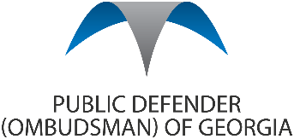 |  | 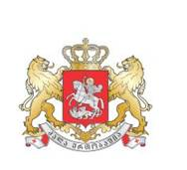 |  |  | 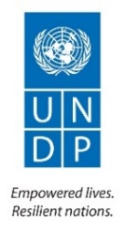
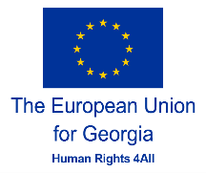 | 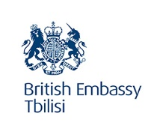 |  | 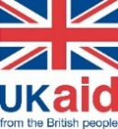 |  | 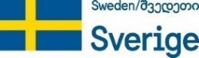

Conference
See, Hear, Take a Step
Hotel Radisson Blu Iveria Tbilisi
Tuesday, 3 December 2019
Concept Note

Background
The Conference is dedicated to the International Day of Persons with Disabilities and marks the five-year anniversary of Georgia’s ratification of the United Nations Convention on the Rights of Persons with Disabilities (UNCRPD). United Nations Development Programme (UNDP) together with partners - Government of Georgia and Public Defender’s Office, UK Government, Government of Sweden, Danish Government and the European Union Delegation to Georgia wishes to commemorate this special date.

Objectives
The annual observance of the International Day of Persons with disabilities was proclaimed in 1992, by the United Nations General Assembly resolution 47/3. The observance of the Day aims to promote an understanding of disability issues and mobilize support for the dignity, rights and well-being of persons with disabilities. It also seeks to increase awareness of gains to be derived from the integration of persons with disabilities in every aspect of political, social, economic and cultural life. The theme of the International Day of Persons with disabilities for this year is “Promoting the participation of persons with disabilities and their leadership: taking the action on the 2030 Development Agenda.”
Despite the government’s efforts and some positive reforms, persons with disabilities still are one of the most invisible group of the society. Long-standing challenges continue to persist with regards to the proper realization of the rights of persons with disabilities to education, health, rehabilitation, access to labour and employment, participation in political and social life, etc.
3rd of December is an international day of persons with disabilities. UNDP plans to organize full day conference to discuss the achievements as well as institutional, legislative, practical and living challenges related to the persons with disabilities. The observance of the Day will aim to promote the rights and well-being of persons with disabilities and increase awareness on the participation of persons with disabilities in political, social, economic and cultural life.

Involved actors
Major partners and stakeholders will be involved in the discussions during the Conference. Administration of Government of Georgia, Ministry of Justice, Ministry of Internally Displaced Persons from the Occupied Territories, Labour, Health and Social Affairs of Georgia, Ministry of Economy and Sustainable Development, Ministry of Education and Science, Parliament of Georgia, Public Defender’s Office, Public Service Hall, Tbilisi City Hall, representatives of Local Self-Governments, Civil Society Organizations working on the rights of persons with disabilities along with the International Organizations and Private Sector.

Thematic sessions
The Conference will consist of three thematic panels and a keynote speech:
- Panel 1: State Policy on Persons with Disabilities
This panel will aim at discussing the Vision of the State on the coordination mechanism under UNCPRD Article 33.1 and the action plan on rights of persons with disabilities under National Human Rights Strategy, along with the legislation on the rights of persons with disabilities. Even though, Georgia ratified the UNCRPD in 2014, the country does not yet have functional coordination mechanism to ensure facilitation of the actions related to the implementation of the Convention, inter alia on the protection of rights of persons with disabilities in different sectors and at different levels.
The panel will also touch upon the ratification status of Optional Protocol to UNCRPD. The Protocol was signed in 2009, however it is not ratified yet. It represents important leverage for the individuals for reparation of their violated rights in a sense that with ratification state party recognizes the competence of the Committee on the Rights of Persons with Disabilities to receive and consider claims from individuals on the violation of the rights enshrined in the UNCRPD.
- Panel 2: Artificial Intelligence and Robotics for People with Disabilities
Keynote Speaker: Irakli Beridze, Head of Centre for Artificial Intelligence and Robotics United Nations, UNICRI
The keynote speaker in the panel will present major developments in the international arena on Artificial Intelligence and Robotics and its relation to the needs of persons with disabilities. While, in the second part of the panel developments in Georgia in relation to AI and robotics will be discussed. Start-ups in the field the products of which can be used to support the needs of persons with disabilities will be described.

- Panel 3: Accessibility: Public services and physical environment
The panel will discuss building adaptation standards. The Ministry of Economy and Sustainable Development, with the support of UNDP is working on elaboration of the standards on accessible and usable buildings and facilities based on ICC A117.1.2017. The activity was recommended by the Public Defender with its Special Report on accessibility of physical environment for persons with disabilities. The panel will also inform on the activities implemented in Tbilisi and Kutaisi municipalities, as well as the efforts undertaken for making Parliament more accessible.

Communication Campaign
Communication Campaign will consist of three phases:
Pre-campaign with videos: Promo videos aimed at raising awareness on the issues persons with disabilities face will be filmed and distributed in central and regional TV channels.
Conference day: Promo video will be presented during the Conference. Start-ups will showcase assistive devices for people with disabilities in parallel of the sessions throughout the event. An illustrated and simplified United Nations Convention on the Rights of Persons with Disabilities will be created and presented in creative form of installations.
CSR campaign after the Conference: Georgian companies will be involved in CSR campaign, especially the ones with service- and client-oriented architecture (Banks, Pharmacies, Insurance companies, etc.). They will finance training for their stuff on how to communicate properly with the persons with disabilities. Businesses will promote their participation with their own channels.

