In-depth analysis of Targeted Social Assistance and child poverty and simulations of the poverty-reducing effects of social transfers

Introduction
Since 2009 UNICEF’s Georgia country office has been conducting a biennial Welfare Monitoring Survey (WMS). This nationally-representative panel survey is designed to assess multiple dimensions of wellbeing of Georgian children and their families and as such, has actively been used by UNICEF and partner organisations to inform child policy making process in Georgia. The overall evidence generated by WMS suggests that while considerable progress has been made in reducing child poverty, significant challenges remain. A major concern is the volatility of Georgian households’ welfare – 70 per cent of households participating in WMS have been found to consume less than the subsistence minimum at least once in the past eight years. Consumption poverty rates also conceal various forms of material deprivation experienced by large proportions of Georgian children that may have irreversible damaging effects on their development. Moreover, the progress appears to be significantly decelerating in recent years and low-income households increasingly rely on debts to finance their consumption. These worrying trends raise the need for considering different ways through which the existing social protection programmes can be made more effective in terms of protecting Georgian children from poverty.
The purpose of the present paper is to facilitate this discussion by presenting the latest evidence obtained from WMS 2017. In addition, Geostat’s Integrated Household Survey (SHINDA) is also used to utilise more detailed data on working age population’s labour market characteristics. The paper is organized as follows. The first section examines the reasons why people apply or refrain from applying for social assistance. This is followed by a comparison of general socio-economic and labour market profiles of the recipients of Targeted Social Assistance (TSA) and the rest of the population. The third section analyses the factors correlated with households’ movement out of poverty. The fourth section presents the results of various simulations involving increases of different social transfers. Each section concludes with a summary of main findings.

Section 1. Demand for social assistance
TSA programme is Georgia’s primary tool for channelling resources to poor households. After old-age pensions it is the largest social protection programme in terms of both spending and coverage. It uses proxy means-testing procedure to identify households eligible for cash transfers and some in-kind benefits, including health insurance. Cash transfers are provided to households with a welfare score below 65,000. The amount of cash benefit is graded in line with the households’ welfare score – the maximum amount is 60 GEL a month per person while the minimum is 30 GEL a month per person. In addition, households with a welfare score between 65,000 and 100,000 receive 10 GEL a month for each child.
According to Social Services Agency (SSA) which administers the TSA programme, by October 2018, there were 316,039 households containing 942,855 individuals registered in the database of socially vulnerable families to request social assistance. Of these, 121,345 households with 418,351 persons received cash assistance. Figure 1.1 shows the distribution of TSA applicant households based on their welfare score.

Figure 1.1 Number of households registered in the Database of Socially Vulnerable Households by welfare score brackets

Source: http://ssa.gov.ge/index.php?lang_id=&sec_id=1297

However, TSA is not the only type of social assistance in Georgia – people also apply to other organisations, such as local authorities, the Ministry of Internally Displaced Persons from the Occupied Territories, Accommodation and Refugees, national and international charities, public defender’s office, private enterprises and so on. According to WMS, in the 12 months preceding its fifth round (2017), 15.4% of Georgian households applied for some form of social assistance, either from TSA programme, or from other organisations. Of these, 8.6% of households applied only for TSA; 6.0% for other social assistance only and 0.6% for both TSA and some other form of assistance.
There are multiple reasons for why households apply for social assistance, but in the case of both TSA and the assistance provided from other organisations the most frequently reported requests are cash assistance and health insurance/medical assistance (Table 1.1). However, cash assistance is more frequently sought in the case when people apply for TSA only, while assistance in obtaining health services is more prevalent when people apply either for other assistance or for TSA and other assistance simultaneously.
Table 1.1 Reasons for applying for social assistance
Type of assistance requested | Applied for TSA only | Applied for other assistance | Applied for both types of assistance
Cash assistance | 91% | 56% | 95%
Assistance in obtaining health services | 17% | 42% | 67%
Food assistance | 5% | 2% | 8%
Financing education | 1% | 0% | 0%
Benefits for transport and other payments | 6% | 0% | 9%
Repair of dwelling | 1% | 7% | 11%
Own dwelling | 1% | 2% | 0%
Others received assistance and I also wanted | 3% | 0% | 0%
Service for children with disabilities | 1% | 0% | 0%
Other | 1% | 2% | 0%
Difficult to answer | 1% | 0% | 2%
Refusal | 0% | 0% | 0%
Source: WMS 2017. Note: respondents were allowed to select several options, thus figures add up to more than 100%.

There is a marked difference in the success of submitted applications between TSA and other assistance. Only one in six people who applied for TSA was fully satisfied with the outcome and another one in 12 considered their request to be partially satisfied (Table 1.2). This contrasts with assistance requests to other public and private entities of which nearly three-fifths were fully or partially satisfied. One reason for this difference is that unlike TSA, which follows a uniform procedure, organisations that assistance seekers applied to have more discretion at the bureaucracy level and thus can be more flexible when considering the requests. Furthermore, most of the requests outside TSA are one-off and thus easier to satisfy. However, the large difference in application success rates necessitates the need for more in-depth understanding of the cause.

Table 1.2 Application success rate for TSA and other assistance
 | TSA | Other assistance
Fully satisfied | 16.7% | 28.5%
Partially satisfied | 7.8% | 29.9%
Not satisfied at all | 65.1% | 33.5%
Other | 8.3% | 4.7%
Refusal | 0 | 0.7%
Difficult to answer | 2% | 2.6%
Source: WMS 2017
Table 1.3 compares the socio-demographic profiles of people who are dissatisfied with the TSA application outcomes with those who are either fully or partially satisfied. The dissatisfied households are more likely to live in cities, mountainous areas or Qvemo Qartli region, contain pensioners, be ethnic Azeris, have less children, have a higher share of people with bad health and a higher share of members with formal jobs. It should also be noted that over 8 per cent of dissatisfied households have been given a welfare score less than 65,001 and therefore should be receiving cash assistance, so it seems that these households are dissatisfied with the level of support they get rather than with not being included in the scheme at all.

Table 1.3 Socio-demographic characteristics, households dissatisfied with the TSA application outcome vs households fully or partially satisfied with TSA application outcome
Socio-demographic characteristics | Satisfied with TSA application | Standard error | Not satisfied with TSA application | Standard error
Rural | 66,3% | 5,2% | 56,9% | 2,7%
Mountain | 4,6% | 2,3% | 12,7% | 1,8%
Tbilisi | 14,2% | 3,9% | 17,4% | 2,1%
Achara | 5,4% | 2,5% | 5,5% | 1,3%
Guria | 3,3% | 2,0% | 3,9% | 1,1%
ImereTi, Racha | 12,4% | 3,6% | 14,1% | 1,9%
Kakheti | 17,4% | 4,2% | 7,2% | 1,4%
Mtskheta-Mtianeti | 2,6% | 1,8% | 2,1% | 0,8%
Qvemo Qartli | 2,1% | 1,6% | 14,8% | 2,0%
Samtskhe-Javakheti | 0,9% | 1,0% | 6,9% | 1,4%
Samegrelo | 12,3% | 3,6% | 13,5% | 1,9%
Shida Qartli | 29,4% | 5,0% | 14,7% | 1,9%
IDP Household | 15,5% | 4,0% | 5,5% | 1,3%
Number of children | 1,46 | 0,13 | 0,74 | 0,05
Pensioner household | 36,2% | 5,3% | 58,3% | 2,7%
Household with disabled member | 5,5% | 2,5% | 6,4% | 1,4%
Armenian household | 10,0% | 3,3% | 8,3% | 1,5%
Azeri household | 1,0% | 1,1% | 9,7% | 1,6%
TSA 0-30,000 | 25,6% | 4,8% | 3,1% | 1,0%
TSA 30,001-57,000 | 36,8% | 5,3% | 2,8% | 0,9%
TSA 57,001-60,000 | 9,4% | 3,2% | 1,3% | 0,6%
TSA 60,001-65,000 | 10,7% | 3,4% | 0,9% | 0,5%
TSA 65,001-100,000 | 0,0% | 0,0% | 13,7% | 1,9%
TSA 100,000+ | 0,8% | 1,0% | 20,1% | 2,2%
TSA unknown score | 12,5% | 3,7% | 44,4% | 2,7%
TSA not registered | 4,2% | 2,2% | 13,6% | 1,9%
Share of household with a formal job | 6,5% | 1,5% | 13,4% | 1,2%
Share of household with bad health | 16,8% | 3,0% | 29,6% | 1,8%
Number of observations | 83 |  | 330
Source: WMS 2017

It should also be noted that 33 per cent of households below the general poverty (consumption per equivalent adult < 165 GEL) line did not apply for TSA. Table 1.4 displays the reasons why poor households refrain from applying for social assistance. The most common reason appears to be the lack of hope that the request will be satisfied or previous rejection (70%). 12 per cent say that they have problems with submitting the application, either because they do not have the documents in order, or do not know who to apply to or have language barriers. Another 12 per cent stated other reasons or struggled to provide answer. Importantly, only 8 per cent considered that they did not need assistance or that it is demeaning.

Table 1.4 Reasons for not applying for TSA
Reason | %
I have asked earlier and there is no more need in asking/ I do not hope that I will be given assistance | 69,1
I thought that my family does not need social assistance/ Asking for assistance is above my family’s dignity | 7,6
I do not know whom to ask/ I cannot myself and have nobody who could help me to apply/ I did not have the documents in order/ Language barrier | 11,5
Other/refusal/difficult to answer | 11,8
Source: WMS 2017

Table 1.5 compares the socio-demographic profile of people who do not apply for TSA despite being in poverty with those people who are poor and receive TSA. Poor people not applying for TSA are more likely to live in rural areas, Kakheti, Qvemo Qartli and Samtskhe-Javakheti regions, be internally displaced, contain pensioners, be ethnic Armenian or Azeri and have a household member in wage employment.

Table 1.5. Socio-demographic characteristics, poor households (<165 GEL) not applying for TSA vs. poor households receiving TSA
Socio-demographic characteristics | Poor and receiving TSA | Standard error | Poor and not applying for TSA | Standard error
Rural | 48,5% | 3,3% | 57,8% | 2,1%
Mountain | 14,1% | 2,3% | 12,6% | 1,4%
Tbilisi | 33,5% | 3,1% | 21,1% | 1,7%
Achara | 11,5% | 2,1% | 9,8% | 1,3%
Guria | 4,6% | 1,4% | 3,2% | 0,7%
ImereTi, Racha | 23,3% | 2,8% | 12,1% | 1,4%
Kakheti | 5,9% | 1,5% | 11,6% | 1,4%
Mtskheta-Mtianeti | 1,9% | 0,9% | 2,5% | 0,7%
Qvemo Qartli | 4,3% | 1,3% | 15,2% | 1,5%
Samtskhe-Javakheti | 1,1% | 0,7% | 9,9% | 1,3%
Samegrelo | 7,7% | 1,8% | 8,0% | 1,2%
Shida Qartli | 6,3% | 1,6% | 6,4% | 1,0%
IDP Household | 7,8% | 1,8% | 11,5% | 1,4%
Number of children | 1,69 | 0,09 | 1,19 | 0,05
Pensioner household | 47,3% | 3,3% | 55,9% | 2,1%
Household with disabled member | 7,5% | 1,7% | 4,8% | 0,9%
Armenian household | 4,3% | 1,3% | 9,2% | 1,2%
Azeri household | 1,0% | 0,7% | 13,1% | 1,4%
Share of household with a formal job | 4,9% | 0,7% | 15,2% | 0,9%
Share of household with bad health | 15,4% | 1,7% | 18,1% | 1,2%
Number of observations | 232 |  | 551
Source: WMS 2017

The analysis also shows that both the demand and the supply of social assistance drop as household incomes rise. In the lowest income decile, over 76 per cent of people receive some form of social assistance (whether TSA or other, including disability pensions) and another 5 per cent have applied for assistance but did not receive it (Figure 1.2). In the second decile 52 per cent have applied for assistance and 39 per cent receive some kind of support. In contrast, in the richest decile 13 per cent receive some social assistance and another 4 per cent have applied for but did not get it.
Figure 1.2 Probability of receiving or requesting social assistance by pre-social transfer income (PAE) deciles
Source: WMS 2017

Summary
The analysis shows that the primary reason why people apply for social assistance is cash and health care services. While TSA is the main social assistance programme, assistance seekers also frequently apply to other public and non-governmental organisations. Reported success rate for recent TSA applications appears to be particularly low when compared to other forms of social assistance. This is likely to be one of the main reasons why many poor people from applying for TSA: almost 70 per cent of poor households that did not apply for any assistance quoted lack of hope and previous rejection as the reasons why they refrained from seeking social assistance. The fact that a third of poor households do not apply for TSA places considerable limits on how much poverty reduction can be achieved by targeting resources through this programme.

Section 2. How do TSA recipients differ from the rest of the population?
This section provides the profile of TSA recipients by showing the composition of the this group based on general socio-economic and labour market characteristics and comparing it to the rest of the population. As figure 2.1 shows, the majority of TSA beneficiaries – 56 per cent - lives in rural areas while among those who do not benefit from the programme 50 per cent live outside cities.

Figure 2.1 Place of residence, TSA recipients vs. the rest

Source: WMS 2017

People with low education qualifications are over-represented among the TSA beneficiaries. Almost three quarters of working-age beneficiaries have not continued education beyond the secondary school (Figure 2.2). Only one in ten beneficiaries has a university degree and 16% possess upper secondary education. In contrast, among non-TSA beneficiaries about half have either upper secondary or higher education.

Figure 2.2 Education status, TSA recipients vs. the rest

Source: WMS 2017

The majority of the TSA recipients are working age persons – 58 per cent, while among non-beneficiaries this share is 52 per cent (Figure 2.3). However, of all age cohorts, children are the most over-represented among the beneficiaries – they constitute 30 per cent of all beneficiaries while their share in population not covered by the programme is 18 per cent. This reflects the recent changes in TSA formula which ascribe more weight to the needs of families with children, but also the fact that children continue to face higher risk of being poor than the working age adults or retired people.

Figure 2.3 Age cohorts, TSA recipients vs. the rest

Source: WMS 2017

The fact that TSA at present is skewed in favour of families with children can also be seen from figure 2.4. Almost 70 per cent of households that do not receive TSA have no children, while more than half of TSA beneficiary households have at least one child. TSA recipient households are also more likely to have two, three or four children than the other households.

Figure 2.4. Number of children in household, TSA recipients vs. the rest

Source: WMS (2017)

Households that receive TSA are also more likely to have additional vulnerabilities than the rest of the households. Nearly 7 per cent of TSA recipient households has at least one disabled member, while among non-recipient households this proportion is only 2 per cent (Figure 2.5). Similarly, over 11 per cent of households that receive TSA are internally displaced, while among non-recipient households the corresponding ratio is 7 per cent (Figure 2.6).

Figure 2.5 Disability status, TSA recipients vs. the rest

Source: WMS 2017
Figure 2.6 IDP status, TSA recipients vs. the rest

Source: WMS 2017

Working age members’ employment status is a major determinant of household’s welfare. The following figures compare key labour market characteristics of population above the age of 15 for TSA recipients and the rest.
Figure 2.7 shows that less than 10 per cent of TSA recipients are in paid employment compared to 27 per cent among the rest of the population. TSA recipients are also more likely to be self-employed (39% vs. 34%), retired (15% vs. 12%), unemployed (10% vs. 8%) and disabled (5.6% vs 1.1%). It should be emphasized that the share of unemployed is only about two percentage points higher among TSA beneficiaries. This provides a strong evidence against the alleged work disincentives generated by TSA. Instead the problem appears to be the low educational qualifications and lack of wage employment for TSA recipients, as well as a higher risk of vulnerabilities such as old age and disability.

Figure 2.7 Employment status of population above the age of 15, TSA recipients vs. the rest

Source: SHINDA 2016

The differences between the two groups become more pronounced in the case of distribution of the employed across economic activities. 81% of TSA recipients are employed in agriculture, while for non-TSA recipients this share is 46% (Table 2.1). Apart from agriculture there is no other economic activity in which at least four per cent of TSA recipients would be employed. In contrast, small, but substantial proportions of non-TSA recipients are employed in wholesale and retail trade, education, transport and communication and public administration.
Table 2.1 Employment distribution by economic activities, TSA recipients vs. the rest
Economic activity | no TSA | TSA recipient
Agriculture, hunting and forestry; Fishing | 45,9% | 80,6%
Mining | 0,9% | 0,8%
Manufacturing | 5% | 2,6%
Production and distribution of electricity, gas and water | 1,1% | 0,3%
Construction | 4,4% | 2,3%
Wholesale and retail trade; repair of motor vehicles and personal and household items | 10% | 3,7%
Hotels and restaurants | 1,5% | 1%
Transport and communication | 5,2% | 1,4%
Financial intermediation | 2% | 0,6%
Real estate, renting and business activities | 2,2% | 0,6%
Public administration | 6,3% | 1,7%
Education | 8,5% | 1,7%
Health and social work | 3,3% | 1%
Other community, social and personal service activities | 3,1% | 1,3%
Private households employing domestic staff and undifferentiated production activities | 0,7% | 0,5%
Source: SHINDA 2016
Zooming in on the distribution of wage employment across public and private enterprises, TSA recipients who are in salaried jobs are less likely to work for a state-owned organisation than people who do not receive TSA – 24 per cent vs 36 per cent (Figure 2.8).

Figure 2.8 Wage employment by sector, TSA recipients vs. the rest

Source: SHINDA 2016

Agriculture remains the primary source of self-employment in Georgia. As figure 2.9 shows, 96 per cent of TSA beneficiaries who are self-employed work in their own or family member’s farms. The share of family farmers is also very high among non-TSA recipient self-employed people, but in this group 18 per cent either own a non-agricultural enterprise without hired employees, or own a farm which employees non-family members for wage.
Figure 2.9 Distribution of self-employed across, TSA recipients vs. the rest

Source: SHINDA 2016

Because farming is a major source of self-employment, the size of the land plots used for farming matters. As Figure 2.10 shows, the majority of Georgian households living in rural areas have no or less than one hectare of land plots they can use for farming. However, TSA recipients more disadvantaged in this regard as well: only 15 per cent of them live in households that have one to five hectares of land, while for non-TSA recipients this proportion is 30 per cent.

Figure 2.10 Size of land plots in rural areas, TSA recipients vs. the rest

Source: SHINDA 2016

There are also some, but not large differences in the duration of unemployment between TSA recipients and the rest (Figure 2.11). For example, 27 per cent of unemployed TSA recipients have never worked while for non-TSA recipients this proportion is 20 per cent. Yet, the most important finding of this figure is that long-term unemployment is major challenge for the whole country. More than half of unemployed in both groups have either never had a job or have been unemployed for over three years.

Figure 2.11 Duration of unemployment, TSA recipients vs. the rest

Source: SHINDA 2016

Summary
The analysis shows that as intended, TSA disproportionately benefits people from vulnerable groups: rural population, people with low educational qualification, children, disabled people and IDPs. Furthermore, the labour market profile helps to identify the key vulnerability of TSA recipient households: the lack of wage employment opportunities and dominance of small-scale farming as the primary source of livelihood. In addition, it appears that receiving TSA does not provide adverse incentives for the majority of working-age recipients as unemployment rates and duration of unemployment do not differ much between the beneficiaries and the rest.

Section 3. Determinants of poverty dynamics
One of the key characteristics of poverty in Georgia is its dynamic nature: as Table 3.1 shows, 70 per cent of households in the true panel sample (that is households that have been interviewed in each of the five rounds) have been found to be below the poverty line at least once in the these five surveys. As expected, urban households have lower probability of temporary poverty (65%) than rural ones (75%), but in both locations, over two-thirds of households have experienced poverty at least once in eight years.
Table 3.1 Temporary and chronic poverty, 2009-2017
 | (1) | (2) | (3)
Number of times in poverty | National 2017 | Urban 2017 | Rural 2017
0 | 0.299 | 0.354 | 0.241
 | (0.0169) | (0.0314) | (0.0122)
1 | 0.275 | 0.285 | 0.264
 | (0.0180) | (0.0330) | (0.0131)
2 | 0.175 | 0.137 | 0.215
 | (0.0131) | (0.0227) | (0.0120)
3 | 0.136 | 0.113 | 0.160
 | (0.0133) | (0.0240) | (0.0110)
4 | 0.0727 | 0.0561 | 0.0900
 | (0.00723) | (0.0113) | (0.00859)
5 | 0.0424 | 0.0547 | 0.0296
 | (0.00999) | (0.0188) | (0.00539)
Observations | 2,395 | 604 | 1,791
Source: WMS 2009, 2011, 2013, 2015, 2017

Also important to note that the urban households appear to have a higher incidence of chronic poverty, defined as being below the general poverty line in each of the five surveys (5.4%), than rural households (3%), but the difference is not statistically significant. The overall incidence of chronic poverty is relatively small – 4.2%, but the vulnerability of the vast majority of Georgian households is alarming. It raises the urgent need of understanding what are the factors that are associated with household’s movement in and out of poverty. This section tries to answer the question by developing multiple statistical models which are applied to panel data, consisting of all five waves of WMS. The main factors included in the models are the following:
- Change in household size, e.g. due to birth, death or marriage of a household member
- Change in household members’ health and disability status
- Change in household members’ employment status – losing or finding a job; change in the share of adults that are employed. We also differentiate between wage employment and non-wage employment as previous research has shown that the latter is closely correlated with the risk of poverty
- Change in the ownership of agricultural land
- Change in retirement status

We start by fitting a set of models that show the correlation between these factors and poverty dynamics. The second set of models consider the drivers of changes in employment situation while the third set of models analyses the effects of the listed factors on household income.

Household characteristics’ effects on poverty
Models 1-7 are logit regressions with fixed household and year effects (Table 3.2). Coefficients should be interpreted as a change in the risk of poverty experienced by the household.
Starting with the demographic predictors, depending on a model, an increase in the family size increases the risk of poverty from 3.5 to 5.6 percentage points. However, the effect of an additional member varies depending on the age group. An extra pensioner in the household reduces the risk of poverty by 3.2 to 4.5 percentage points, clearly due to having a stable source of income that is slightly, but still above the poverty line. Somewhat surprisingly, having an extra child is associated with a 1.6 to 2.9 percentage points decrease in the risk of poverty. However, in this case it seems more reasonable to expect that the causal link is from welfare status to the presence of the extra child, rather than the other way – families decide to have more children when their financial situation is more secure. In the models we also control for household head’s age and gender. The latter has no statistically significant effect, but higher age is associated with very small (though statistically significant) increase in the risk of poverty.
As expected, having at least one disabled member increases households’ risk of poverty, by more than 4 percentage points. Having at least one member with bad health also increases the probability of poverty, ranging from 1.5 to 1.8 percentage points. The effects of disability and bad health can be felt in three ways: a) an employed member is no longer able to work or works less hours; b) the carer looking after the sick/disabled person has to quit job or work less hours; c) household is forced to sell the means of production in order to fund the treatment or medicines. Also important to note that the inclusion of the disability status variable in model 6 does not reduce the effect of the health status variable, suggesting that the two variables measure separate dimensions.
Table 3.2. Covariates of changes in poverty status
 | (1) | (2) | (3) | (4) | (5) | (6) | (7)
 | Poverty (general) | Poverty (general) | Poverty (general) | Poverty (general) | Poverty (general) | Poverty (general) | Poverty (general)
VARIABLES
Age of hh head | 0.00172*** | 0.00173*** | 0.00170*** | 0.00154*** | 0.00152*** | 0.00170*** | 0.00173***
Sex of hh head | 0.0132 | 0.0126 | 0.0154 | 0.0163 | 0.0155 | 0.0149 | 0.0138
# of people with bad health | 0.0180*** | 0.0166*** | 0.0161** | 0.0146** | 0.0133** | 0.0151** | 0.0147**
# of jobs lost | 0.0177
# of pensioners | -0.0320*** | -0.0353*** | -0.0416*** | -0.0382*** | -0.0358*** | -0.0421*** | -0.0455***
# of children | -0.0166* | -0.0211** | -0.0248** | -0.0225** | -0.0227** | -0.0241** | -0.0290**
Land ownership | -0.0450** | -0.0415** | -0.0455** |  |  | -0.0457** | -0.0485**
hh size | 0.0324*** | 0.0399*** | 0.0493*** | 0.0455*** | 0.0422*** | 0.0490*** | 0.0565***
year_2011 | 0.123*** | 0.124*** | 0.121*** | 0.105*** | 0.0975*** | 0.121*** | 0.125***
year_2013 | 0.0260** | 0.0365** | 0.0284** | 0.0258** | 0.0218* | 0.0277* | 0.0275*
year_2015 | -0.0585*** | -0.0568*** | -0.0680*** | -0.0639*** | -0.0601*** | -0.0694*** | -0.0718***
# of employed |  | -0.0186***
# of wage employed |  |  | -0.0872*** | -0.0780*** | -0.0733*** | -0.0871*** | -0.0870***
# of non-wage employed |  |  | -0.00762 | -0.00410 | -0.00521 | -0.00713 | -0.00765
Size of land |  |  |  | -0.0654***
Acquire land |  |  |  |  | -0.0449***
Sell land |  |  |  |  | -0.00312
Hh with a disabled member |  |  |  |  |  | 0.0420** | 0.0455**
Education level 2 |  |  |  |  |  |  | 0.0103
Education level 3 |  |  |  |  |  |  | -0.0161
Education level 4 |  |  |  |  |  |  | -0.0830**
Observations | 6,847 | 6,847 | 6,847 | 6,848 | 6,619 | 6,847 | 6,847
Number of hhid | 1,893 | 1,893 | 1,893 | 1,893 | 1,844 | 1,893 | 1,893
Standard errors in parentheses
*** p<0.01, ** p<0.05, * p<0.1

Given that a large share of the Georgian labour force is engaged in farming, the models also include variables of land ownership. As can be seen from table 3.2, the households who own agricultural land have a 4 to 4.8 percentage points lower risk of poverty compared to those who do not. The size of the land plot also matters: the ownership of an extra hectare is correlated with a 6.5 percentage point reduction in the risk of poverty. Purchasing more land is associated with a 4.4 percentage point decrease in the risk of poverty, while selling land has no effect. We should stress that the causal link between land ownership and poverty status is difficult to assert. Households may have a lower risk of poverty because they derive income from cultivating the land, but they may also have (more) land plots because their financial means allow them to buy and use it.
Since employment is the primary source of income, it should have the largest effects on household’s probability of poverty. Yet, model 1 shows that the loss of a job had no statistically effect on the risk of poverty and model 2 shows that an extra employed person reduces the risk only by 1.8 percentage points. One reason for this may be that people who lose jobs, quickly find new ones, or they have other household members with income sufficient to keep the household above the poverty line. Likewise, households where at least one employed earns high wage may also be more likely to have other members employed. But in Georgia, the type of employment also matters a lot as there is a dual labour market of formal jobs with relatively high wages and self-employment, which mainly implies low-productivity farming. Indeed, models 3 to 7 show that an extra member in paid employment reduces the risk of poverty by 7.3 to 8.7 percentage points, while an extra self-employed person has no statistically significant effect.
Lastly, model 7 also considers the effects of education status on the risk of poverty. It appears that having a tertiary education has a substantial effect, reducing the probability of poverty by 8.3 percentage points.

Household characteristics’ effects on employment status
Given the importance of the employment type, in a second set of models (8-11) we try to understand how these are affected by ‘shocks’ – worsening of health status and loss of a job. For this purpose we use panel fixed effect models where the number of household members in wage and non-wage employment are the dependent variables (Table 3.3). The models also control for household size, the number of pensioners and children.
As model 8 shows, worsening of health status has similar effects on both types of employment - it reduces the number of wage and non-wage employed people in household by 0.03 to 0.04. Disability, however, has a much stronger effect on non-wage employment: when a household member becomes disabled, the number of wage-employed people in the household decreases by 0.04, but the number of non-wage employed decreases by 0.26. Interestingly, when a household member starts receiving the old-age pension, the number of both wage and non-wage employed people decreases by less than 0.09, implying that most people continue working after retirement. In the case of having an extra child, the effects are more pronounced: with one more child the number of wage jobs is reduced by 0.09, but the number of non-wage jobs decreases by 0.22. A possible explanation of this is that people value formal jobs more and are less likely to quit them because of having another child.
Model 10 shows that when a person loses a wage job (in the 12 months preceding the survey), the number of wage jobs is reduced by 0.3. This implies that most people who lose job, find a new one within a year, but it is also possible that the loss of salaried job prompts another household member to look for and find one. Losing a non-wage job has no statistically significant effect on the number of non-wage jobs (model 11), very likely due to the fact that non-wage employment typically involves working in a family farm which can only be lost under extreme circumstances (such as being forced to sell the land to fund some urgent expenditure).
Table 3.3 Covariates of changes in employment status
 |  | (8) | (9) |  | (10) | (11)
VARIABLES |  | # of wage jobs | # of non-wage jobs |  | # of wage jobs | # of non-wage jobs
# of wage jobs lost |  |  |  |  | -0.306***
# of non-wage jobs lost |  |  |  |  |  | 0.0856
# of people with bad health |  | -0.0389*** | -0.0326** |  | -0.0391*** | -0.0328**
hh with a disabled member |  | -0.0479* | -0.259*** |  | -0.0467* | -0.258***
# of pensioners |  | -0.0864*** | -0.0599** |  | -0.0860*** | -0.0596**
# of children |  | -0.0908*** | -0.216*** |  | -0.0903*** | -0.216***
hh size |  | 0.176*** | 0.242*** |  | 0.176*** | 0.242***
Age of hh head |  | -0.00302*** | 0.000922 |  | -0.00303*** | 0.000913
year_2011 |  | -0.163*** | 0.209*** |  | -0.164*** | 0.209***
year_2013 |  | -0.0254 | 0.605*** |  | -0.0257* | 0.605***
year_2015 |  | -0.0152 | 0.148*** |  | -0.0149 | 0.148***
# of jobs lost |  | -0.289*** | -0.0136
Constant |  | 0.410*** | -0.129* |  | 0.411*** | -0.128*
Observations |  | 16,288 | 16,288 |  | 16,288 | 16,288
R-squared |  | 0.099 | 0.115 |  | 0.099 | 0.115
# of households |  | 6,730 | 6,730 |  | 6,730 | 6,730
Robust standard errors in parentheses
*** p<0.01, ** p<0.05, * p<0.1

Household characteristics’ effects on household income
Finally, we estimate two models explaining the variation in household income per adult equivalent (in logarithm) (Table 3.4). These models should yield similar results to the poverty models in terms of the signs of the effects, but having a continuous variable (income) instead of a binary variable (poverty status) allows us to have a more nuanced picture.

Table 3.4 Covariates of changes in monthly income (PAE)
 | (12) | (13)
VARIABLES | ln of total monthly income (PAE) | ln of total monthly income (PAE)
# of people with bad health | -0.0253** | -0.00381
# of wage jobs lost | -0.247***
# of non-wage jobs lost | 0.0313
# of pensioners | 0.309*** | 0.364***
# of children | 0.0518** | 0.0984***
land size | 0.111*** | 0.110***
hh size | -0.0922*** | -0.184***
year_2011 | -0.729*** | -0.644***
year_2013 | -0.120*** | -0.112***
year_2015 | -0.184*** | -0.170***
# of wage jobs |  | 0.488***
# of non-wage jobs |  | 0.0198*
Constant | 5.312*** | 5.189***
Observations | 16,288 | 16,288
R-squared | 0.177 | 0.257
# of observations | 6,730 | 6,730
Robust standard errors in parentheses
*** p<0.01, ** p<0.05, * p<0.1
The models show that two major factors that have the largest positive effect on household incomes are the increase in the number of people in wage employment and starting receiving the old-age pensions. Having an extra child and an extra hectare of land plot are also correlated with higher income, though, as argued before, in the case of children it is more likely that families have a higher probability of having more children when their incomes are higher and hence the causal link is from the income status to the number of children. Similarly, in the case of land plot size, it can both affect and be affected by household income. As for the factors that reduce household income, the most important one is the loss of a salaried job and the increase in household size, which reduces the household’s average consumption. The effects of worsened health are not large and the loss of a non-wage job has no effect.

Summary
The regression analysis allows us to derive the following conclusions regarding the effects of household characteristics on their welfare:
- Wage employment and self-employment have very different effects on household welfare. While an extra member in formal employment increases household income by 49 per cent and reduces the risk of poverty by almost 9 percentage points, an additional member in non-wage employment increases the income negligibly and does not reduce the risk of poverty.
- The education status of household members is another important predictor of household welfare. Households that have at least one member with tertiary education have 8 percentage points lower risk of poverty than others.
- Old-age pensions are an important safeguard against poverty. When a household member starts receiving it, household income increases by over 30 per cent and the risk of poverty reduces by 3-4 percentage points.
- Acquiring more land and increase in land plot size are also associated with higher income and lower risk of poverty, but the effects are lower compared to wage employment and receiving pensions.
- As expected, disability and bad health increase the risk of poverty, by 4 and 1.8 percentage points respectively. However, the effects of bad health on incomes are small.
- Becoming disabled and having an extra child considerably reduce the number of non-wage employed people in the household, but the effects of these changes are much weaker in the case of wage employment.
- The loss of a salaried job reduces the number of household members in wage employment by 0.3, suggesting that most redundant workers find new jobs relatively quickly and/or other household members start working to compensate for the lost job.

Section 4. Modelling poverty reducing effects of increased spending on various social transfers

Social transfers are an important tool for combating poverty - as UNICEF studies consistently show, each cash benefit reduces child poverty in Georgia. However, because each transfer is targeted in a unique way – e.g. some based on age or disability status, others based on welfare index derived through proxy means-testing, the effect of extra GEL spent will vary considerably depending on which transfer the government chooses to increase. This section presents and discusses the results of simulations of increases in three existing or hypothetical types of transfer:
- Child benefit
- Targeted Social Assistance (TSA)
- Old-age pensions
For each of these transfers several scenarios were modelled with different levels of benefits and variations in these levels based on TSA categories and household income. For each scenario we have calculated the following parameters at various levels of benefits: child poverty rates and gaps, total poverty headcount and gaps, required extra spending, share of total benefits going to children, per cent of poor children not reached, average benefit per poor child, average benefit per non-poor child, number of averted poverty cases, average cost of averting poverty case, net cost of averting a poverty case. For child benefit scenarios we also calculated the effects on extreme child and total poverty rates and gaps. Here we discuss only five parameters – effects on child and total poverty rates and gaps and the extra costs. Data on other parameters can be seen in the Annex in excel format.
Before discussing the results several caveats should be stressed. First, in simulations we use the standard accounting method which implies adding the monetary values of proposed new or increased benefits directly to households’ consumption. Our expectation is that poor households will use any extra income to increase consumption. However, they may also use it to pay off loans or make savings, thus their consumption, which is the primary measure of welfare in our analysis, may not increase, at least in the short run. Second, the static modelling method disregards the potential effects of a policy on individual behaviour. This may be particularly important in relation to TSA programme - considerably increased TSA benefits may generate “benefit traps”, whereby a member starting a low-paid job may worsen household’s welfare if it loses entitlement to the social assistance. Third, our modelling is retrospective, as it is based on 2017 WMS data, therefore if the government was to introduce any of these measures in 2019 or later, the effects would most likely differ, though it is difficult to anticipate in which direction. Nonetheless, our estimates enable comparing the possible effects of increases of different types of benefit, thus allowing us to identify the most effective option for the government to consider. Moreover, unless there are major changes in the market distribution of incomes since 2017, the actual effects will not be very different from our estimates.

Child benefit
Scenario 1. Universal child benefit
Most European countries provide universal child benefits to partially compensate families for the extra costs that bringing up a child entails and stimulate demographic growth, as well as provide a significant safeguard against the risk of child poverty. Scenario 1 considers providing universal child benefit for all children under the age of 16. As Figures 4.1a and 4.1b show, this universal transfer would have a significant effect on poverty rates and gaps. If the benefit level was set at 50 GEL per month, child poverty would decrease from 27.4 to 18.8 per cent and the gap from 33 to 25.2 per cent. At the same time, the total poverty headcount would decrease from 21.7 to 17.7 per cent and total poverty gap from 32.2 to 28.8 per cent. However, the extra costs would also be substantial. 50 GEL a month benefit would require 468 million GEL, which amounts to 1.2 per cent of GDP (38,042 billion GEL).

Figure 4.1a Poverty rates with universal child benefit (up to 120 GEL per month per child)
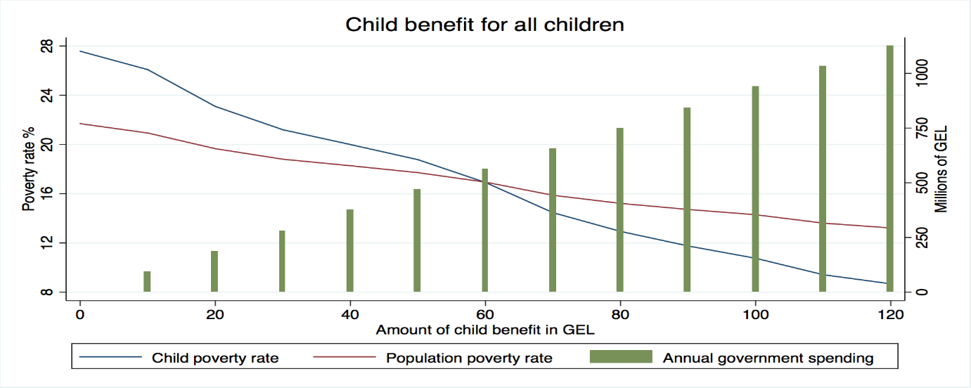

Figure 4.1b Poverty gaps with universal child benefit (up to 120 GEL per month per child)
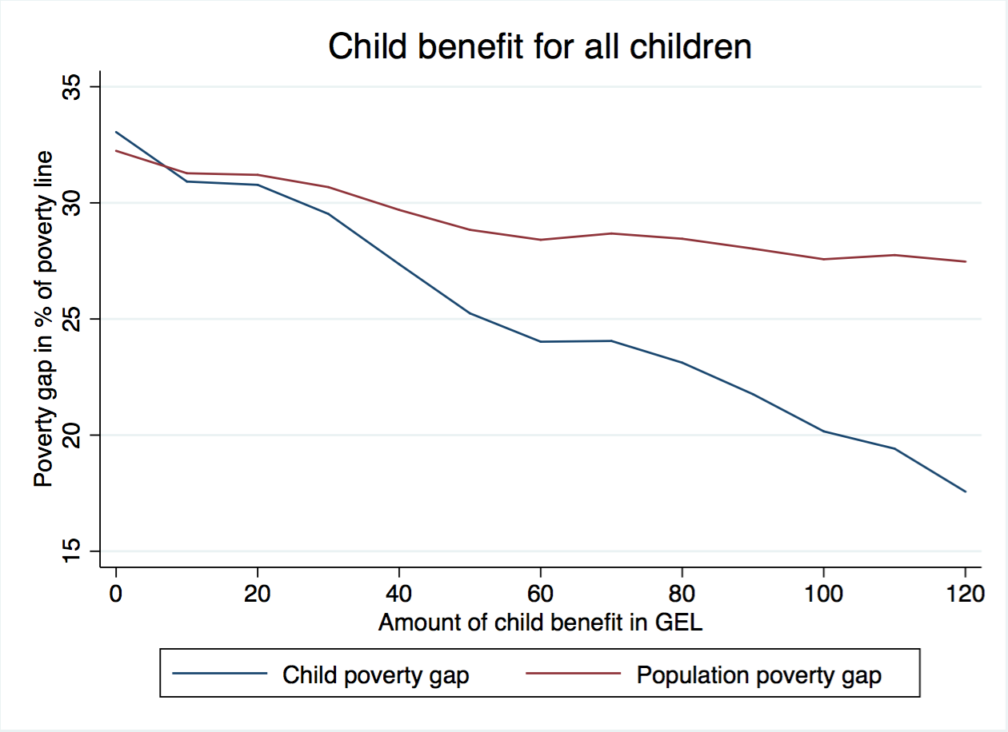

Scenario 2. Universal child benefit with claw back
Some countries, for example the UK, try to reduce the costs of universal child benefits by withdrawing it gradually from households once their incomes surpass certain thresholds. This is usually referred to as a ‘clawback’. Doing the same seems appropriate in Georgia – scenario 2 implies reducing the hypothetical universal child benefit at a rate of 2/3 for every extra GEL once households’ monthly income exceeds 500 GEL a month until it is completely withdrawn. In this scenario, the effect on child poverty would be almost the same as in the previous one. For example, if the benefit level was set at 50 GEL, child poverty would decrease from 27.4 to 19.7 per cent (compared to 18.8 per cent in scenario 1), but it would also cost 331 million GEL a year, that is 138 million GEL less than in the Scenario 1 (Figure 4.2a). Child poverty gap would also decrease at nearly the same rate as in Scenario 1 – to 25.4 per cent (Figure 4.2b). It should, however, be noted that clawing back the transfer from some households will not be possible if their income is from informal sources (i.e. those that are not subject to income tax).

Figure 4.2a Poverty rates with universal child benefit (up to 120 GEL per month per child) with a claw back (2/3 withdrawn for every GEL once household income exceeds 500 GEL a month)

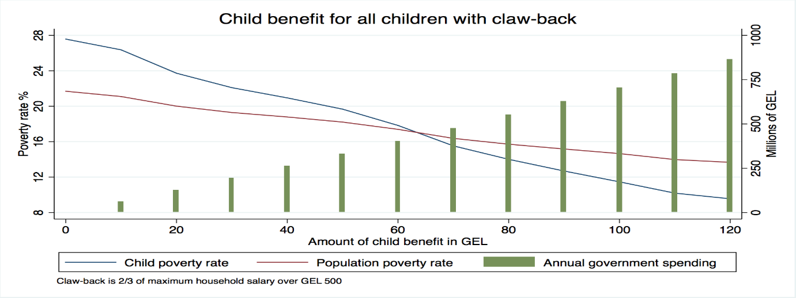

Figure 4.2b Poverty gaps with universal child benefit (up to 120 GEL per month per child) with a claw back (2/3 withdrawn for every GEL once household income exceeds 500 GEL a month)

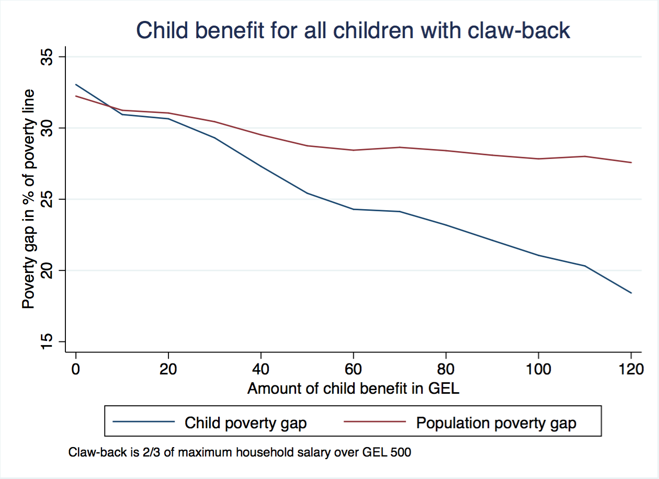

Scenarios 3 and 4. Child benefits only for TSA children
Another option is to limit child benefit only to TSA households, as it is at present, but increase the amount of transfer. Scenario 3 implies increasing child benefits for households with a score below 65,001 and Scenario 4 for households with a score below 100,001. This significantly reduces the costs. In scenario 3 the cost of increasing the current benefit by 40 GEL a month per child (to make it 50 GEL a month) is 54 million GEL and in scenario 4 it is 73 million GEL (Figures 4.3a and 4.4a). However, these savings come at the expense of reduced effects on poverty. For example, 40 GEL extra benefit in Scenario 3 reduces child poverty only to 25.9 per cent and in Scenario 4 to 25.3 per cent. Similarly, at this level of benefit poverty gaps decrease to 29 and 28.9 per cent respectively (Figures 4.3a and 4.3b). The main reason for these limitations is that 57 per cent of poor children are either not registered in the TSA database, or their welfare score exceeds 100,000.
Figure 4.3a Poverty rates with child benefits (up to 120 GEL per month per child) for children in households with a TSA score less than 65,001

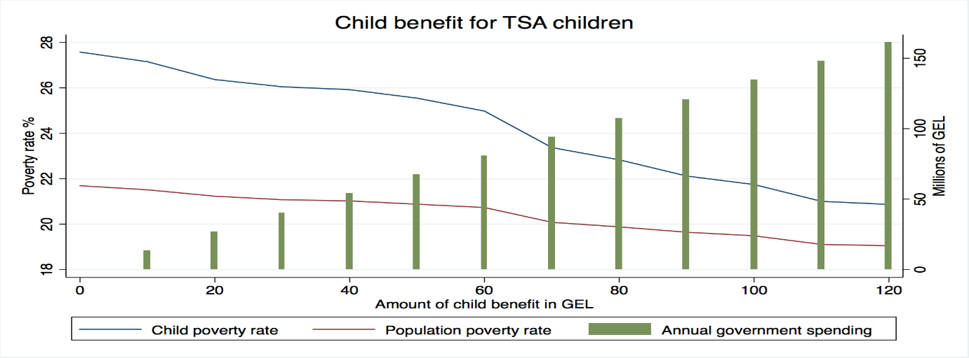
Figure 4.3b Poverty gaps with child benefits (up to 120 GEL per month per child) for children in households with a TSA score less than 65,001
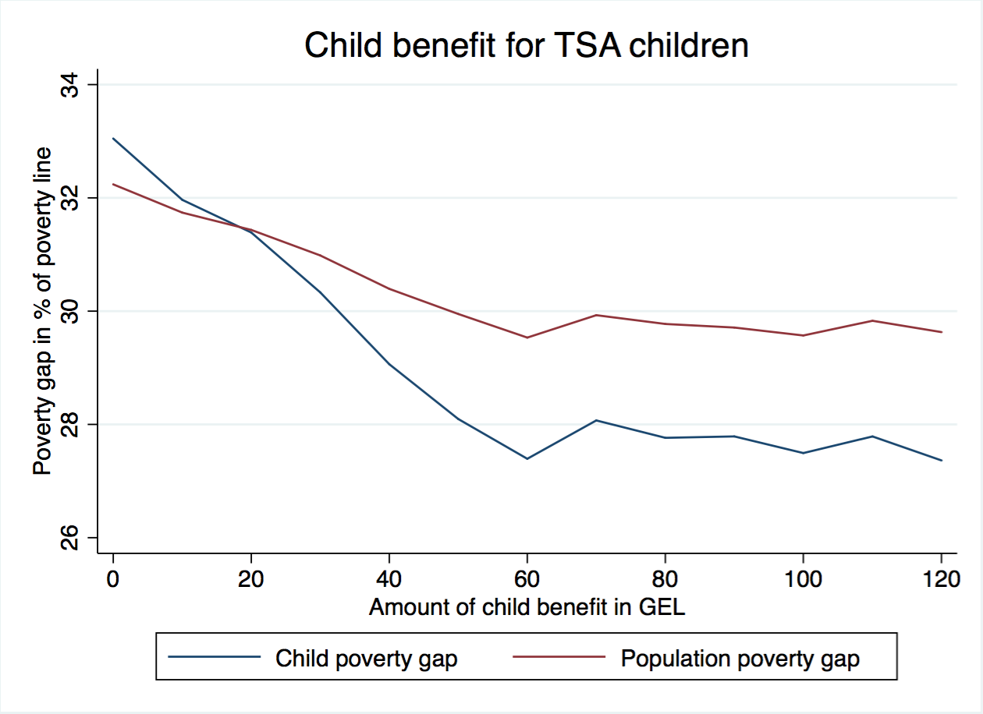
Figure 4.4a Poverty rates with child benefits (up to 120 GEL per month per child) for children in households with a TSA score less than 100,001
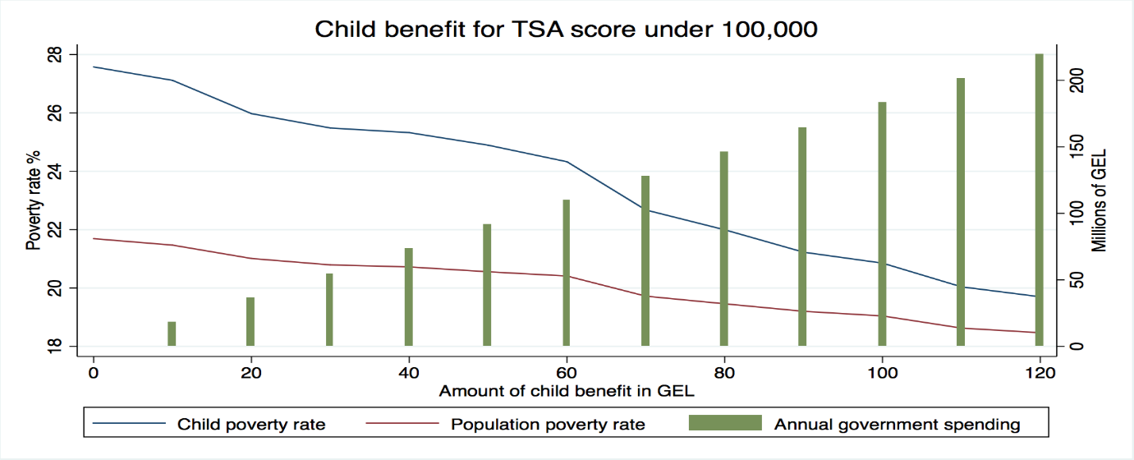

Figure 4.4b Poverty gaps with child benefits (up to 120 GEL per month per child) for children in households with a TSA score less than 100,001
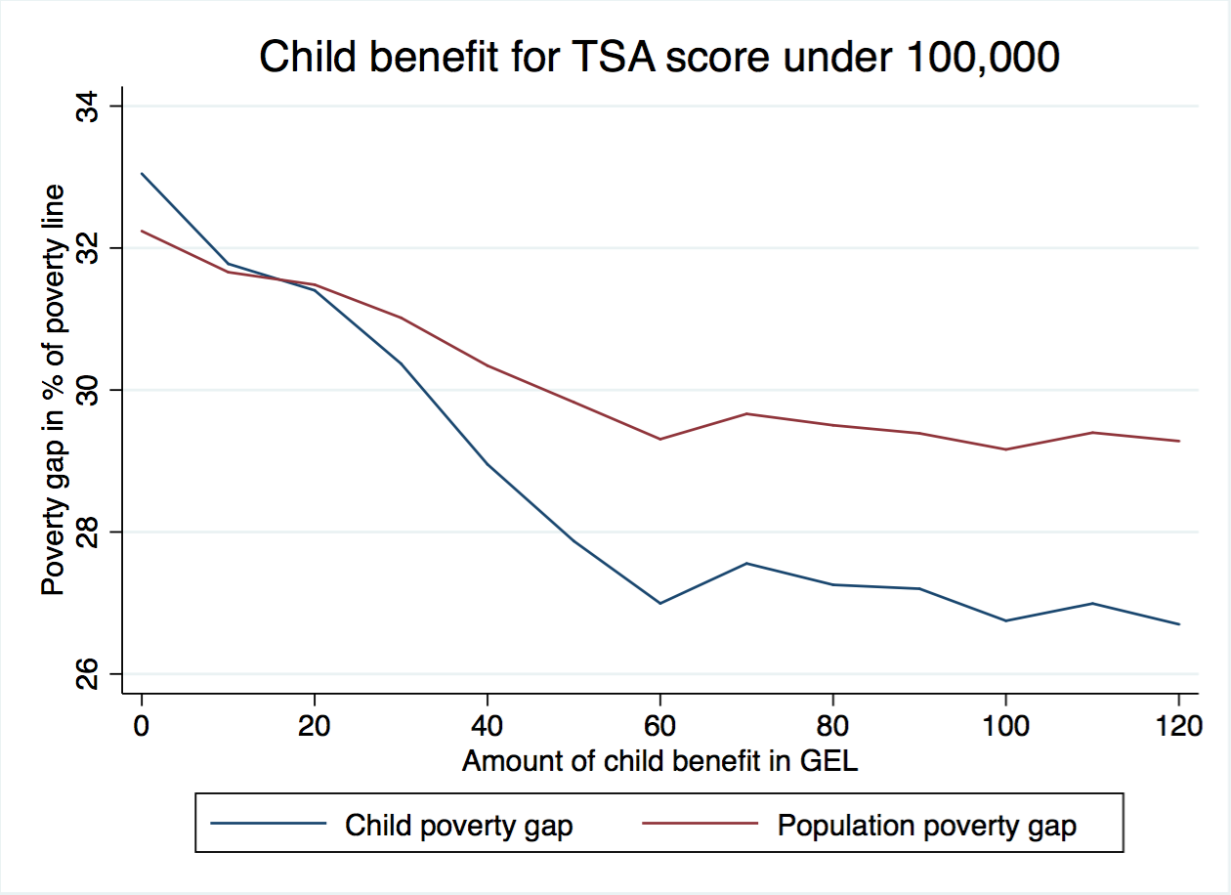

Scenario 5. Child benefit graded in line with TSA score and clawback
The best way of maintaining a certain level of universality and making it progressive is to grade the proposed child benefit in line with TSA score and claw it back from better-off households (Scenario 5). As Figures 4.5a and 4.5b show, under this scenario, child poverty could be reduced to 19.9 per cent and child poverty gap to 26.5 per cent at the extra cost of 200 million GEL, while reaching 91 per cent of all poor children.

Figure 4.5 Poverty rates with child benefits graded based on TSA score and clawback (2/3 withdrawn if the household income exceeds 500 GEL a month)
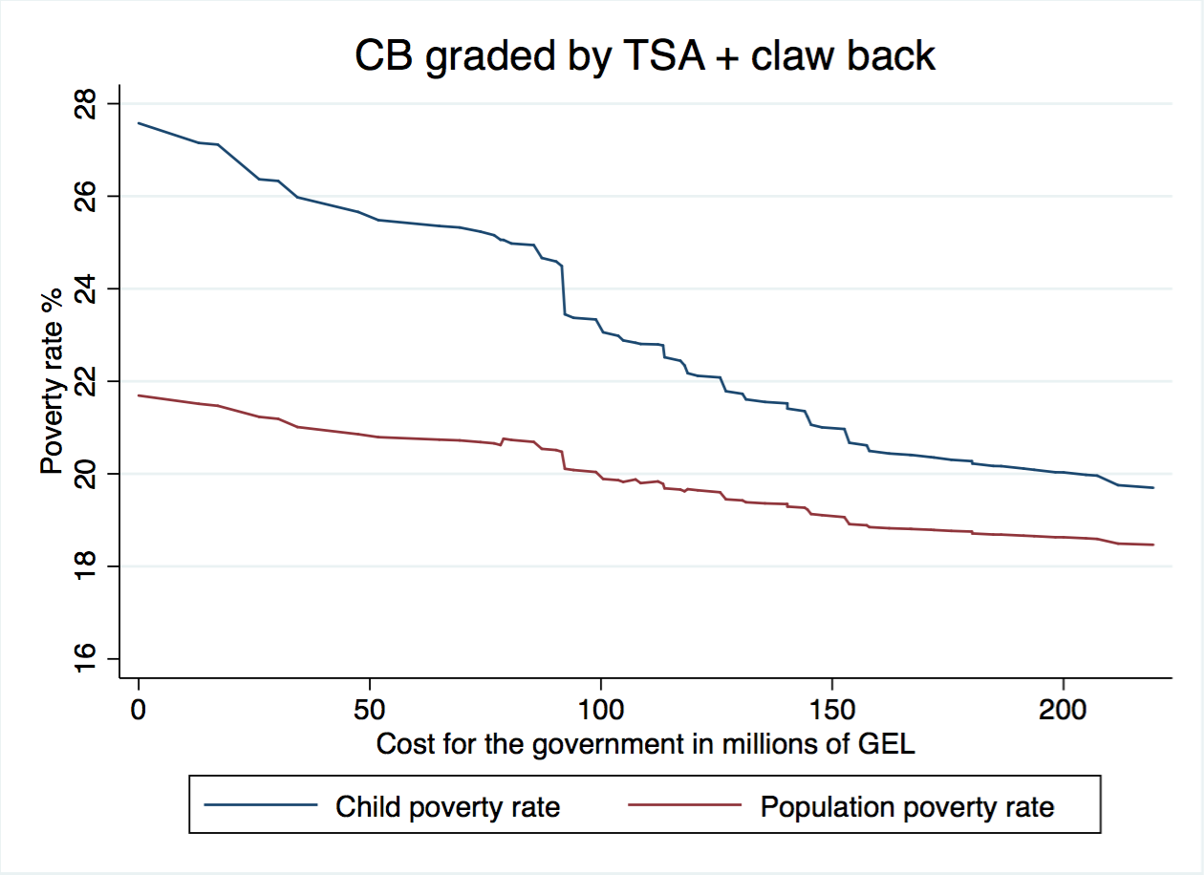

Figure 5b. Poverty gaps with child benefits graded based on TSA score and clawback (2/3 withdrawn if the household income exceeds 500 GEL a month)
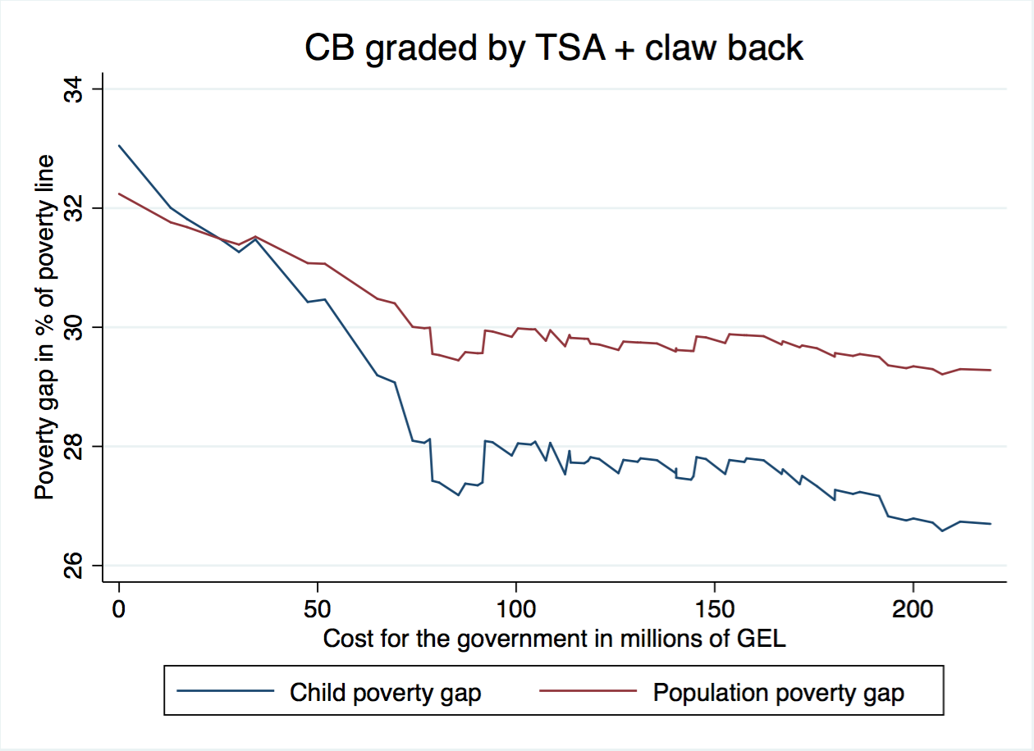

Comparison of child benefit scenarios
Figure 4.6 provides a comparison of the five child benefit scenarios. The most cost-effective of all options is to provide child transfers to families with a TSA score below 65,001. This is not surprising as children in this group have a higher risk of poverty than other children. However, this option has clear limits. Even if the amount of transfer was increased by 120 GEL per month per child (which may eventually generate some adverse work incentives), it would only reduce child poverty to 20.9 per cent as 63 per cent of poor children do not belong to this category. On the other hand, as noted above, if the government was to allocate 200 million GEL through Scenario 5 it would be able to reach almost all poor children and bring child poverty below the 20 per cent threshold.
Figure 4.6 Comparison of different scenarios for child benefit
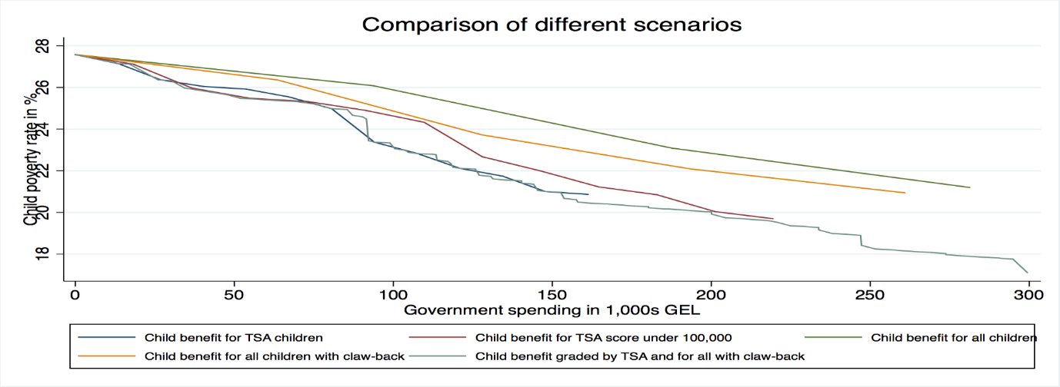

TSA

Scenario 6. Extend the coverage of TSA programme
An immediate way of extending the outreach of the TSA programme is to provide transfers to households with a welfare score between 65,001 and 100,000 (in addition to 10 GEL a month per child they are receiving at present). They may be entitled to 20 GEL a month per person, or 30 GEL similar to the households with a welfare score between 60,001 and 65,001 (Scenario 6). In either case, the effect would be rather small – even with 30 GEL a month the child poverty would only decrease to 26.7 per cent (Figure 4.7a) and poverty gap to 32.7 per cent (Figure 4.7b). Similarly, at this level of benefit the total poverty headcount would decrease to only 20.9 per cent and total poverty gap to 31.8 per cent. The total cost of 30 GEL a month benefit for households with a score between 65,001 and 100,000 would be 61 million GEL a year.

Figure 4.7a Poverty rates with TSA coverage increased to cover households with a welfare score between 65,0001 and 100,000

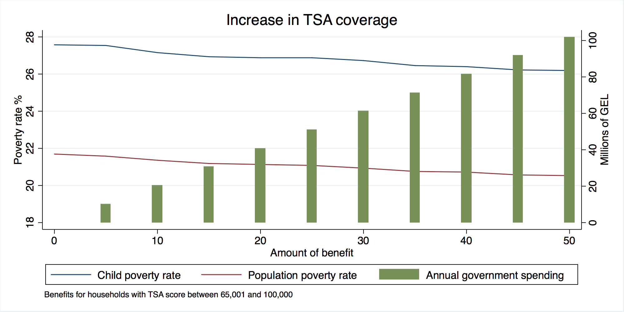

Figure 4.7b Poverty gaps with TSA coverage increased to cover households with a welfare score between 65,0001 and 100,000
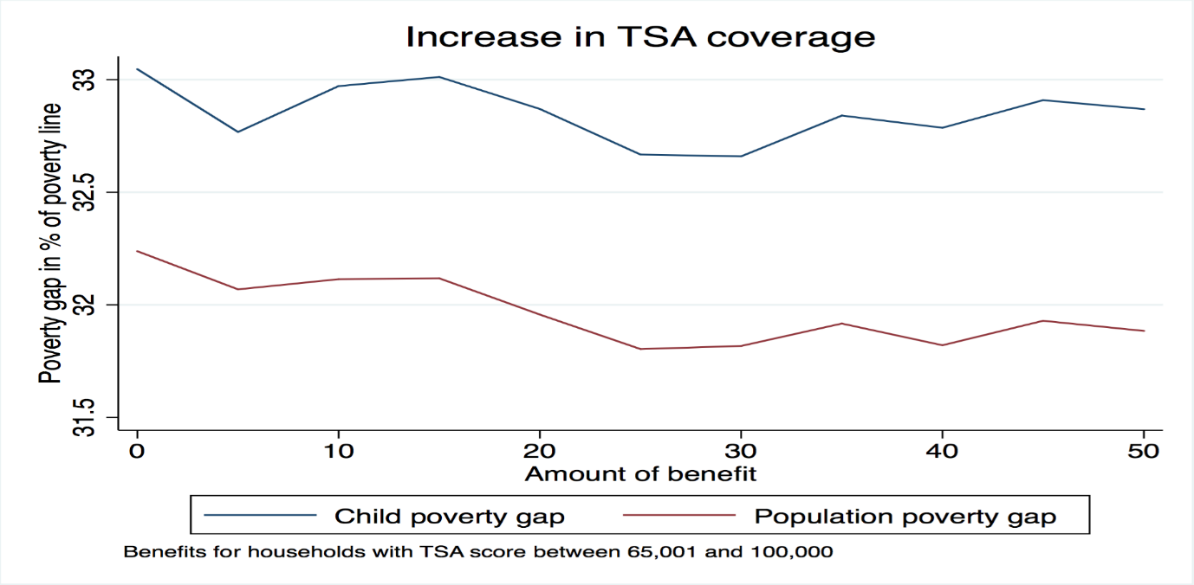

Scenario 7. Increase the level of benefits for current beneficiaries
Instead of extending the programme, the government may decide to focus on current beneficiaries (with a welfare score below 65,001) and increase their benefits (Scenario 6). An increase of 30 GEL a month per household member (for all present recipients irrespective of the welfare score) would reduce child poverty to 24.5 per cent and total poverty headcount to 19.7 per cent at the cost of 144 million GEL a year. In this case child poverty gap would reduce to 27.3 and total poverty gap to 28.5 per cent.

Figure 4.8a Poverty rates with increased TSA benefit for present beneficiaries (up to 50 GEL a person per month)
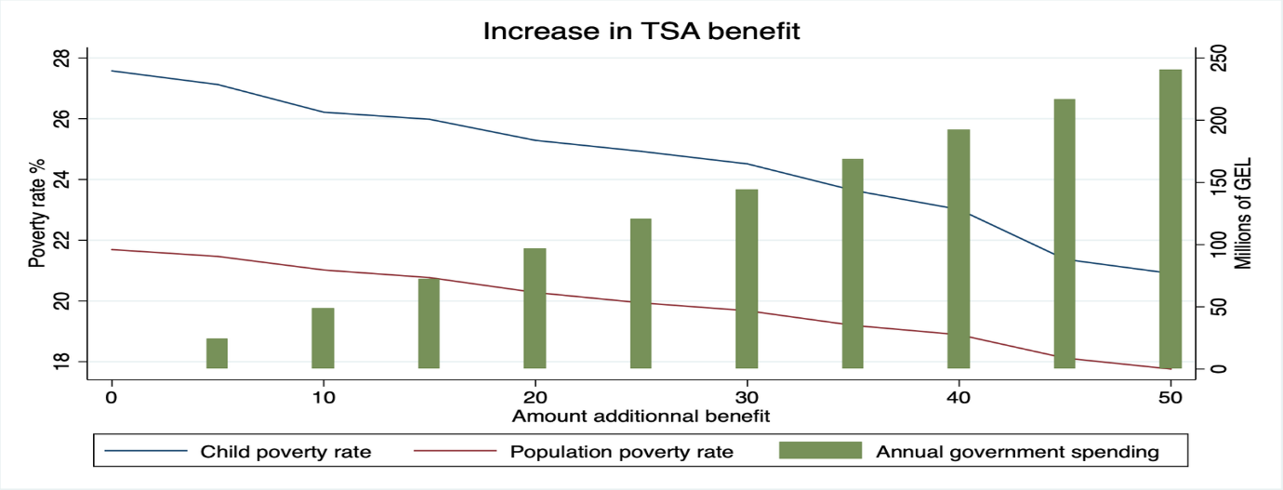
Figure 4.8b Poverty gaps with increased TSA benefit for present beneficiaries (up to 50 GEL a person per month)
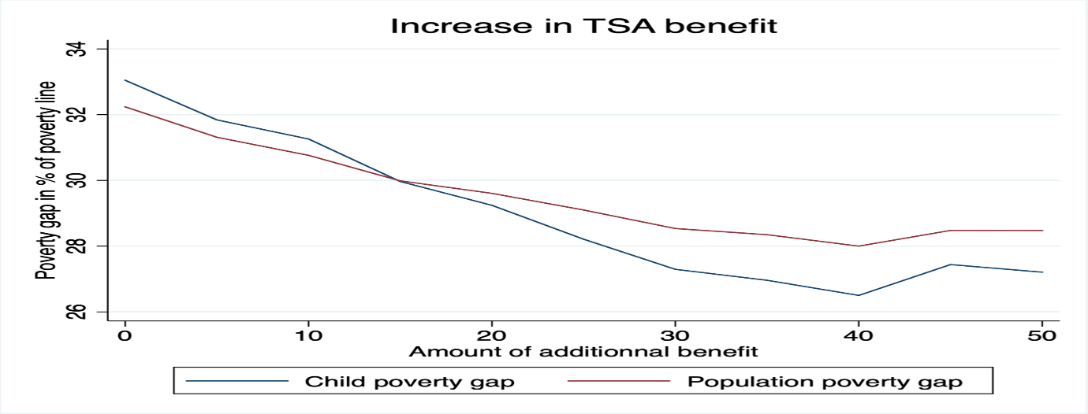

Scenario 8. Increase the coverage and benefit levels of TSA
Finally, the government may both extend the TSA coverage and increase the level of transfers (Scenario 8). In this case, if every person with a score below 100,000 was given extra 30 GEL, child poverty could be reduced to 23.7 per cent and child poverty gap to 26.6 per cent (Figures 4.9a and 4.9b). Total poverty would also decrease to 18.9 per cent and total poverty gap to 27.9 per cent at the extra cost of 205 million GEL a year.

Figure 4.9a Poverty rates with increased TSA benefit and increased coverage
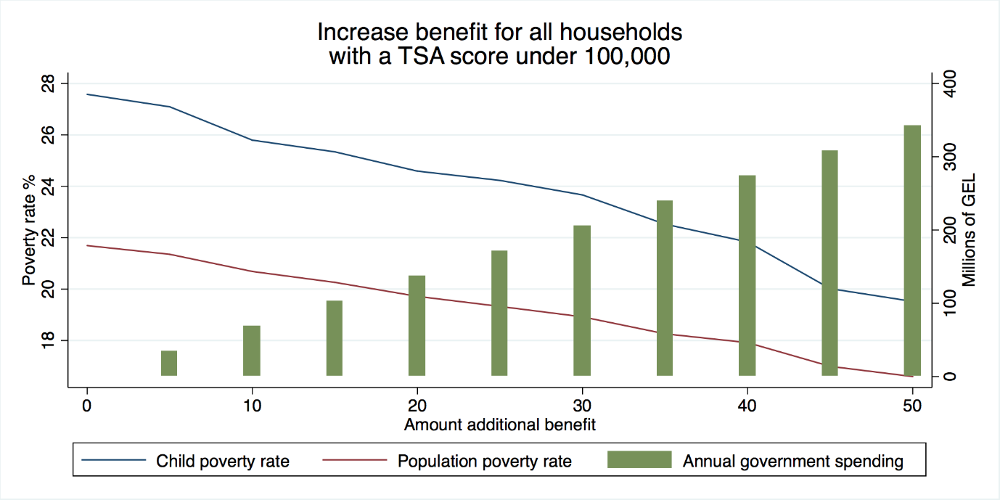

Figure 9b. Poverty gaps with increased TSA benefit and increased coverage

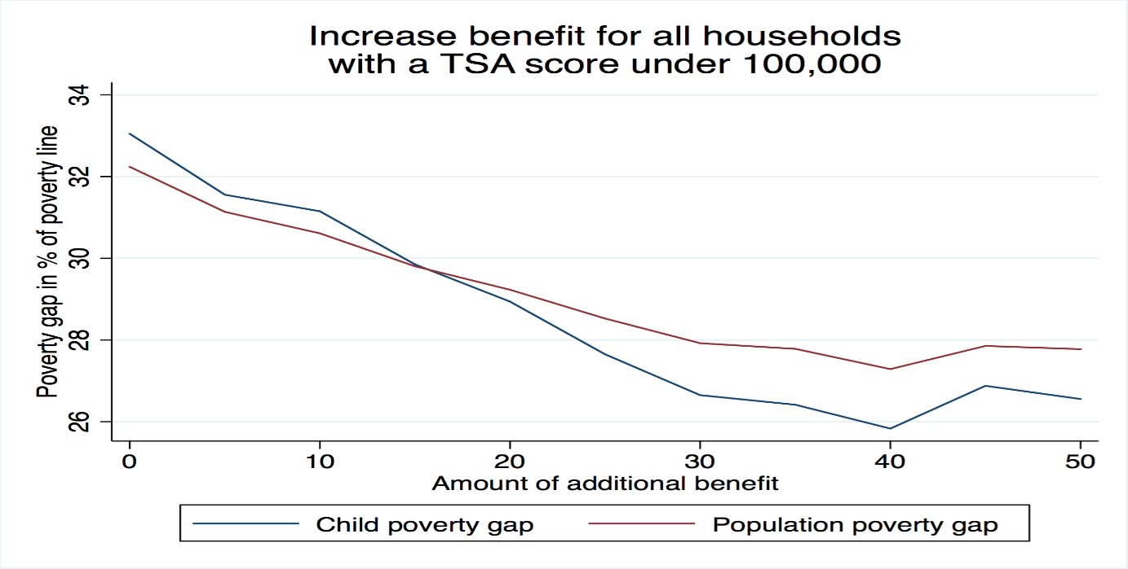

Old-age pension

Scenario 9. Increase old-age pensions
Old-age pension is the most important social transfer in Georgia. In order to maintain its purchasing power, the government indexes old-age pension from time to time, though not every year. Moreover, as in the case of TSA, indexation of pensions is not based on specific rules, such as increase in line with the growth of average incomes, inflation or subsistence minimum, but rather involves a lump sum increase. We simulate the effects of increases in the range of 5 to 60 GEL for all old-age pensioners, including those who live in high mountainous areas and therefore receive 216 GEL a month instead of 180 GEL a month (Scenario 9).
As figure 4.10a shows, an increase in old-age pension would reduce both child poverty and total poverty headcount due to high incidence of three-generation households. However, the effects would not be particularly strong – at the maximum rate of 60 GEL per month, child poverty would decrease from 27.6 to 24.6 per cent and total poverty headcount from 21.7 to 18 per cent. The reduction in poverty gap would also be small, bring child poverty gap from 33 to 31.5 per cent and total poverty gap from 32.2 to 30.3 per cent (Figure 4.10b). At the same time, with a 60 GEL a month increase the annual extra costs would be 533 million GEL a year.
Figure 4.10a Poverty rates with increase in old-age pensions (5 to 60 GEL a month)

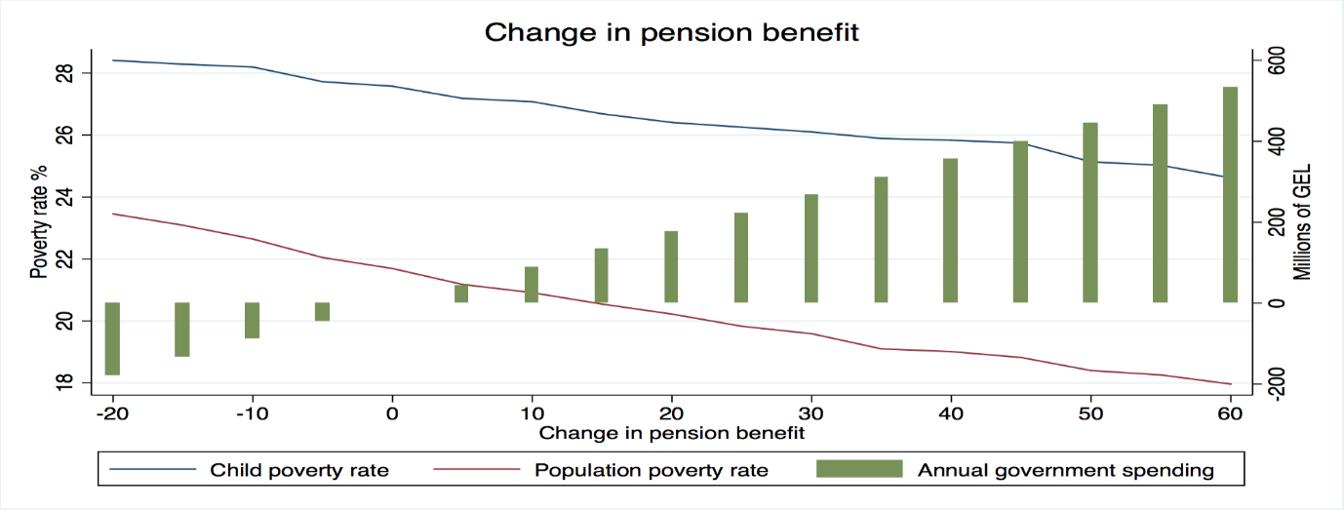

Figure 10b. Poverty gaps with increase in old-age pensions (5 to 60 GEL a month)
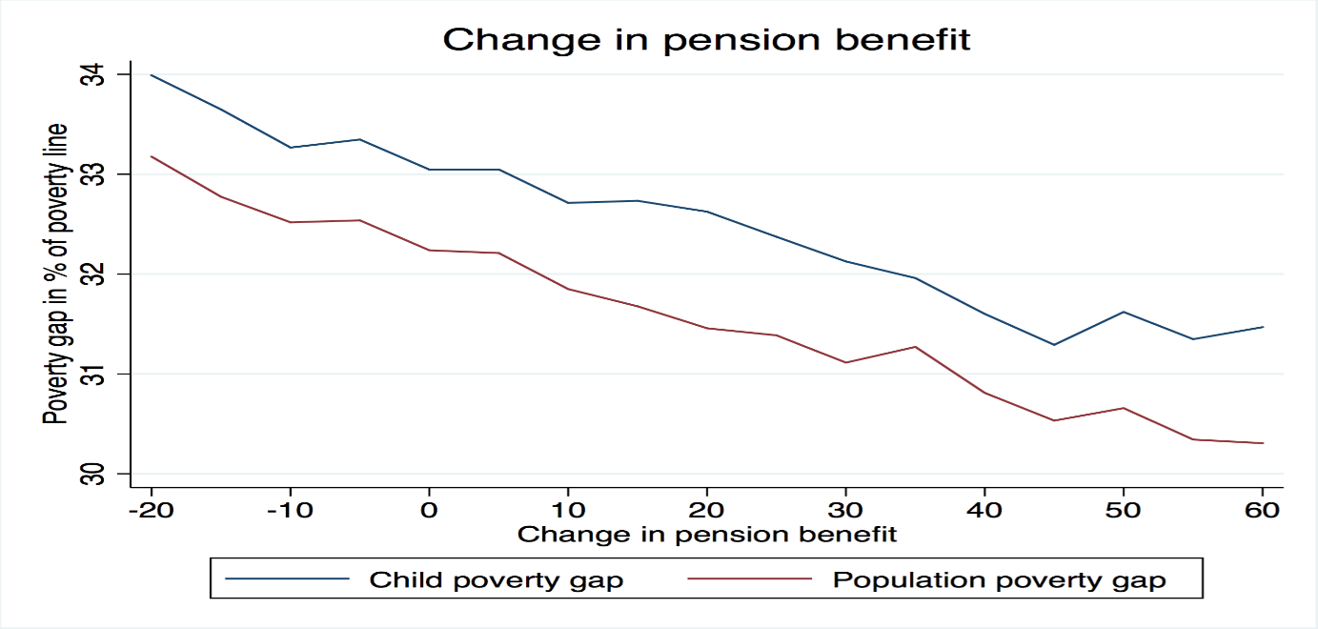

Summary
The results of the simulations show that an increase in any social transfer will help to reduce child (and total) poverty rates and gaps, but the effects will differ considerably depending on the type of transfer the government choses to increase. The main limitation of old-age pension is the high costs and low cost-effectiveness which is unavoidable when benefits are provided on a categorical basis. By design, TSA is the most cost-effective method as the leakage to non-poor children is minimised, but it has significant limits as more than half of poor children and their families are either not registered in the TSA database, or have a welfare score above 100,000. Therefore, increasing the TSA benefits for all individuals, or for child recipients, will have no effect for those who are not covered by the system at present. Against this background, child benefit appears the best option for reducing child poverty. To be sure, the costs of universal child benefits are also high, but can be substantially reduced by clawing transfers back from non-poor households and grading benefits based on TSA score.

Note that here the share of unemployed is calculated from total population aged above 15 years, while economically inactive population is disregarded when calculating the official unemployment rate.
This graph is generated based on SHINDA data, thus the incidence of disability differs slightly from that derived from WMS.

