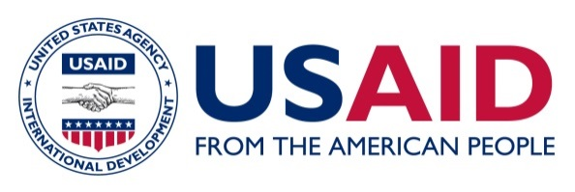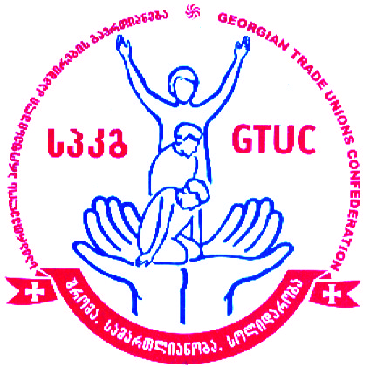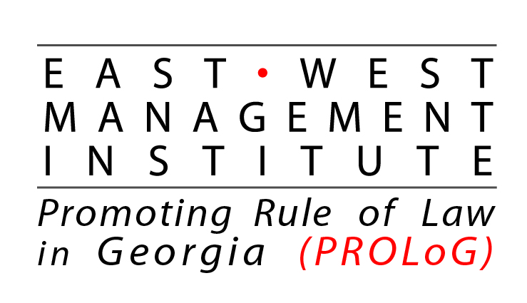

This event will be conducted under the project “Access to Justice to Ensure Labor Rights of Women”. This event is made possible by the generous support of the American people through the United States Agency for International Development (USAID) and EWMI/PROLoG
Georgian Trade Union Confederations
Presentation of recommendations on the challenges of the implementation of new amendments in Public Service Law with the special focus on women’s labor rights
March 29, 2019
Agenda
Venue: Holiday Inn. , Tbilisi
10:30 – 11:00 Coffee/Registration
11:00 – 11:35 Opening Remarks:
Irakli Petriashvili - Georgian Trade Union Confederation (GTUC)
Dimitri Tskitishvili – Member of the Georgian parliament
Salome Ichkiti - Access to Justice Director, EWMI/PROLoG
11:35 – 11:50 – Trade unions recommendations on improvement of Public Service law in the context of Labor rights of women.
Raisa Liparteliani, Deputy Chairperson, GTUC
11:50 – 12:10 - State obligations under the EU Association Agreements on equal treatment in labor relations and the steps taken by the government on these matter. Lika Klimashvili – Ministry of the Internally Displaced People from the Occupied Territories, Labour, Health and Social Affairs of Georgia, head of the unit of the labour relations and social partnership under the Labor and Employment Policy Department.
12:10 – 12:30 - Gender discrimination in public service and recommendations of the Public Defender’s Office. Ketevan Shubashvili, Head of the Equality Department, Public Defender’s Office. (TBC)
12:30 -12:50 – legal consequences of the termination of labor contract in Public Service.– Lasha Bekishvili. GYLA
12:50 – 13:10 - Constitutional court litigation on the challenges regarding the implementation of the Public Service Law. Teo Zakarashvili – TI- Georgia
13: 10 – 14:00 - Discussion
13:00 - Lunch

