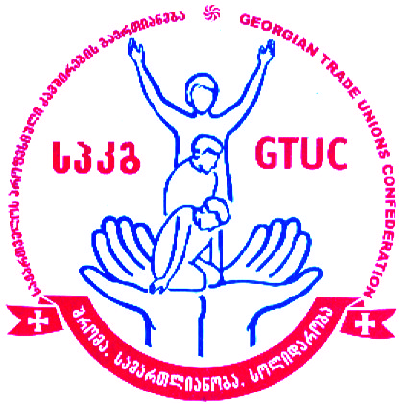

Georgian Trade Unions Confederation (GTUC)
Presentation of Recommendations on the Challenges of the Implementation of New Amendments in
Public Service Law with the special focus on women’s labor rights
March 29, 2019
Agenda
Venue: Holiday Inn. , Tbilisi
1, 26 May Square. Tbilisi
10:30 – 11:00 Coffee/Registration
11:00 – 11:35 Opening Remarks:
Irakli Petriashvili - Georgian Trade Union Confederation (GTUC)
Dimitri Tskitishvili – Member of the Parliament of Georgia
USAID/PROLoG (TBC)

11:35 – 11:50 Trade unions recommendations on improvement of Public Service law in the context of Labor rights of women. Raisa Liparteliani, Deputy Chairperson, GTUC

11:50 – 12:10 State obligations under the EU Association Agreements on equal treatment in labor relations and the steps taken by the government on these matters, Lika Klimashvili – Ministry of the Internally Displaced People from the Occupied Territories, Labour, Health and Social Affairs of Georgia, head of the unit of the labour relations and social partnership under the Labor and Employment Policy Department.

12:10 – 12:30 Public Defender’s Office, (TBC)

12:30 -12:50 Legal consequences of the termination of labor contract in Public Service. – Lasha Bekishvili. GYLA

12:50 – 13:10 Constitutional court practice on the challenges regarding the implementation of the Public Service Law. Teo Zakarashvili – TI Georgia

13: 10 – 14:00 Discussion
14:00 Lunch
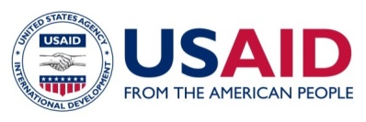
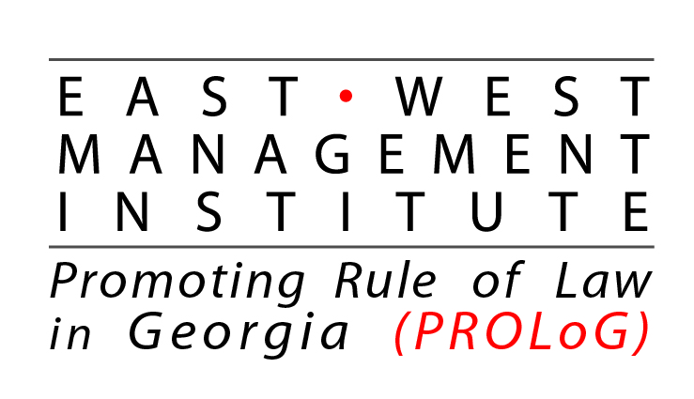

This event was made possible by the support of the American People through the United States Agency for International Development
(USAID), under East-West Management Institute (EWMI) program “Promoting Rule of Law Georgia” (PROLoG). GTUC is
responsible for the content of the meeting and do not necessarily reflect the views of the East West Management Institute, USAID or the
United States Government.

