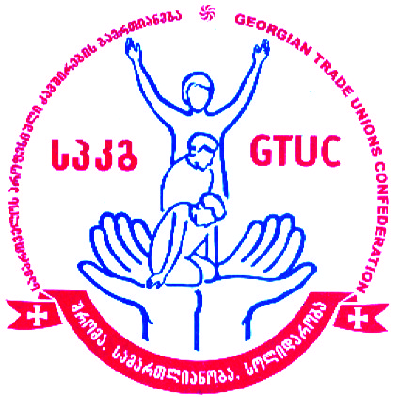

Georgian Trade Unions Confederation (GTUC)
Presentation of Recommendations on the Challenges of the Implementation of Amendments in
Public Service Law with the special focus on women’s labor rights
March 29, 2019
Agenda
Venue: Holiday Inn. , Tbilisi
1, 26 May Square. Tbilisi
10:30 – 11:00 Coffee/Registration

11:00 – 11:35 Opening Remarks:

Irakli Petriashvili – President, Georgian Trade Union Confederation (GTUC)
Dimitri Tskitishvili – Member of the Gender Equality Council of the Parliament of Georgia
Tamila Barkalaia – Deputy Minister of the Internally Displaced Persons from the Occupied Territories, Labor, Health and Social Affairs of Georgia
Elguja Meladze – President, Georgian Employers Association
Brian LeDuc - Deputy Chief of Party, USAID-PROLoG
11:35 – 11:50 Trade unions recommendations on improvement of Public Service law in the context of Labor rights of women - Raisa Liparteliani, GTUC Vice President

11:50 – 12:10 State obligations under the EU Association Agreements on equal treatment in labor relations and the steps taken by the government on these matters - Lika Klimiashvili, Head of the unit of the labor relations and social partnership under the Labor and Employment Policy Department, Ministry of the Internally Displaced People from the Occupied Territories, Labor, Health and Social Affairs of Georgia

12:10 – 12:30 Practice of the Public Defender’s Office regarding discrimination in Public Service - Giorgi Kapanadze, Senior Specialist, Equality Department of the Public Defender’s Office

12:30 -12:50 Legal consequences of the termination of labor contract in Public Service – Lasha Bekishvili, GYLA

12:50 – 13:10 Constitutional court practice on the challenges regarding the implementation of the Public Service Law - Teo Zakarashvili, TI Georgia

13: 10 – 14:00 Discussion
14:00 Lunch
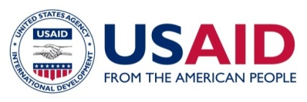
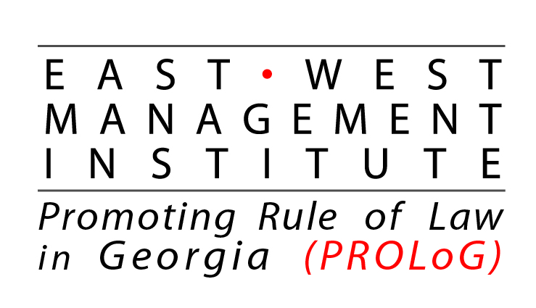

This event was made possible by the support of the American People through the United States Agency for International Development
(USAID), under East-West Management Institute (EWMI) program “Promoting Rule of Law Georgia” (PROLoG). GTUC is
responsible for the content of the meeting and do not necessarily reflect the views of the East West Management Institute, USAID or the
United States Government.

