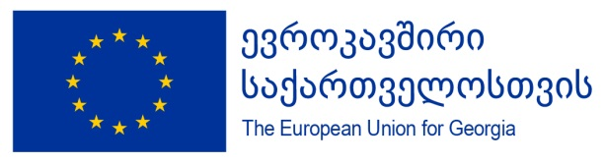

Twinning Project “Improving the standards of employment conditions/relations as well as health and safety at work in Georgia“
Twinning number: GE 17 ENI OT 02 19

Objective of the project

Support higher standards in employment relationship and working conditions in Georgia through improving legal framework and enforcing implementation

Mandatory result 1 | Mandatory result 2
Approximation of primary and secondary legislation related to Labour Law, Gender Equality, and Occupational Safety and Health in accordance with the Union acquis | Capacity building, inter- institutional cooperation and awareness raising of relevant state authorities and private sector for full implementation of amended legislation in labour law, gender equality and OSH
Activities | Activities
- Legal framework on labour law, including aspects of labour inspection system, amended in compliance with the Union acquis | - Assessment of the administrative structures and institutional capacities of the beneficiary and relevant stakeholders and improvement of their inter-institutional operations
- Legal framework on non-discrimination and gender equality, including aspects of labour inspection system, amended in compliance with the Union acquis | - Training need analysis and strengthening the institutional capacity of the beneficiary and relevant stakeholders and improvement of their inter-institutional operations
- Legal framework on occupational safety and health, including aspects of labour inspection system, amended in compliance with the Union acquis | - Delivery of comprehensive training programmes to improve the institutional capacities of the beneficiary and relevant stakeholders
Twinning partners:  Ministry of Internally Displaced Persons from Occupied Territories, Labour, Health and Social Affairs of Georgia | - Development of the relevant guidelines, labour inspection manuals, checklists and other tools to improve the institutional operations and procedures focused on precise implementation of newly adopted legislation
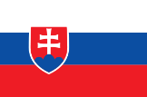  Ministry of Labour, Social Affairs and Family of the Slovak Republic  Regional Development Agency Senec-  Pezinok | - Preparing and implementing public information campaign aiming to raise awareness among the project among key stakeholders, public, private sector and civil society
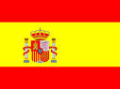  Ministry of Labour, Migrations And Social  Security (MITRAMISS). Labour and Social  Security Inspectorate of Spain State  Agency | - Conducting study visits to Member states, focused for transfer of good practices on organisation and management of labour inspection
  Ministry of Social Affairs of the Republic of  Estonia | - Supporting inter-institutional cooperation in the process of approximation and implementation of the relevant EU acquis

