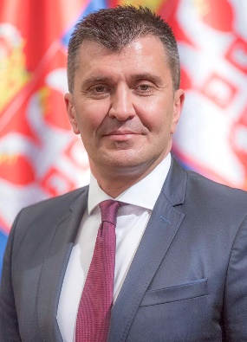

Zoran Djordjevic

Minister of Labour, Employment, Veteran and Social Affairs

Born on 11 February 1970 in Belgrade. He completed the Sixth Belgrade High School (mathematical and technical associate) and graduated from the Faculty of Business Studies in Belgrade – Megatrend University.

He completed his postgraduate studies at the Faculty of Business Studies at Megatrend University and acquired his Master’s Degree in Banking and Finance within a joint programme of the Faculty of International Economics in Belgrade – Megatrend University and the Faculty of Social and Political Sciences – "Panteion" (Athens, Greece).

Also, he completed School of National Defence – Advanced Security and Defence Studies at the University of Defence.

Currently, he is in his third year of doctoral studies in Economics, Business Economics at the Faculty of Economics and Engineering Management.

He was elected Minister of Labor, Employment, Veteran and Social Affairs in June 2017.

From March 2016 to June 2017 he held the position of Minister of Defence, while from August 2012 to March 2016 he served as State Secretary in the Ministry of Defence.

He worked as Senior Finance Specialist at the Financial Department of ComTrade IT Solutions and Services d.o.o., Belgrade, from June to August 2012.

From July 2011 to June 2012, he served as Finance Manager in the Financial Department of ComTrade IT Solutions and Services d.o.o., Belgrade.

He held the position of Executive Director at "Financial stability", Financial and Strategic Planning Agency, Belgrade, from April 2010 to July 2011.

From November 2008 to April 2010 he served as Executive Director for South East Europe at TELECRAFT (Kabel-X-Austria), Belgrade.

He worked as Executive Director of SIMM Computers, Belgrade, from January 2005 to November 2008.

Moreover, he held the position of Financial Director at TRINITY, Belgrade, from March 2001 to January 2005.

His qualification for the position he is currently holding in the government are reflected in his commitment to work, continuous personal development and education, as well as his performance in the workplace and in the working bodies under his management.

Within the above working bodies, particularly important are his positions of the President of the Gender Equality Council (UN Resolution 1325) of the Government of the Republic of Serbia he held from August 2012 to 2017 and of the National Armaments Director he held from August 2012 to December 2015.

He received “Mihajlo Petrovic - Alas” award in the field of Mathematics.

As for hobbies, he likes sports, especially rowing and reading psychology books.

He is a member of Mensa Serbia.

