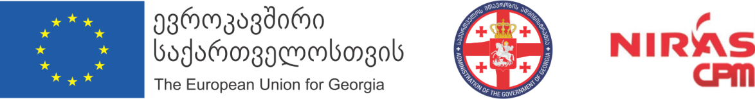

EU Supporting the Inter-Agency Commission on Gender Equality, Violence Against Women and Domestic Violence of Georgia
(2017-2019)

International Seminar on data collection and Research on Violence Against Women and Domestic Violence

11-12 April, 2019
Tbilisi (Georgia)
Hotel “Sheraton Metechi Palace”, #20 Telavi Str.

Agenda
11 April 2019
11.00 -11.30 am Opening remarks
Ms. Sopo Japaridze - Head of the Inter-Agency Commission on Gender Equality, Violence Against Women and Domestic Violence of Georgia
Ms. Patricia Rosa Garcia - Team Leader EU Project Supporting GE Commission of Georgia.
Mr Gogita Todradze – National Statistics Office of Georgia. Executive Director
11.30-12.00 Session 1
Data collection on VAW and DV: what the Istanbul Convention is about. EU Project Expert
12.00-13.00 Session 2
The current system for collecting and analyzing data regarding VAW and DV in Georgia
    - General Prosecutor Office. Salome Shengelia, Head of Human Rights Unit.
    - Ministry of Internal Affairs. Maka Peradze, Deputy Director of Department of Human Rights Protection and Quality Monitoring
    - Supreme Court of Georgia. Lia Mchedlishvili. Head of legal support statistic office Supreme Court of Georgia.

13.00-13.30 Q&A
13.30-14.30 Lunch
14.30-15.00 Session 3
Georgia Survey on Violence Against Women. Lia Charekishvilli - Head of Social Infrastructure Division, Department of Social Statistics. GEOSTAT
15.00-16.00 Session 4
Data collection on VAW and DV: good European Practices
Model of Sweden. Paul Fuehrer
Model of Denmark. Karin Helweg-Larsen
16.00-17.00 Discussion and wrap up Day 1. Moderator: Lia Charekishvilli - Head of Social Infrastructure Division, Department of Social Statistics. GEOSTAT

12 April 2019
10.30-10.45 Opening Session
Conclusions from Day 1 - Lia Charekishvilli, Head of Social Infrastructure Division, Department of Social Statistics. GEOSTAT
10.45-11.45 Session 1
System of collection, generalization and dissemination on data against VAW and DV: assessment of compliance with the Istanbul Convention
  - Case of Denmark. Karin Helweg-Larsen. Medical doctor, senior researcher at Department of Public Health, University Copenhagen, Denmark
  - Case of Sweden. Paul Fuehrer
  - Case of Georgia; Public Defender Office. Anna Iluridze. Head of Gender Equality Department
    - Coffee Break

12.00-13.30 Session 2
Group discussions on ways to improve the Georgian data collection system on VAW/DV in the light of the Istanbul Convention/Plenary

Group 1: Collection, analysis and dissemination/publication of data on general and specific support services provided to victims of VAW/DV: coordination problems.
Moderator: Public Defender Office Georgia
Group 2: Collection, analysis and dissemination/publication of data on cases of VAW/DV by law-enforcement and judiciary bodies of Georgia
Moderator: GEOSTAT
13.30 Final conclusions: moving forward. Lia Charekishvilli, Head of Social Infrastructure Division, Department of Social Statistics. GEOSTAT
14.00 Closing of Seminar. Ms. Sopo Japaridze, Head of the Inter-Agency Commission on Gender Equality, Violence Against Women and Domestic Violence of Georgia
14.15 Lunch

