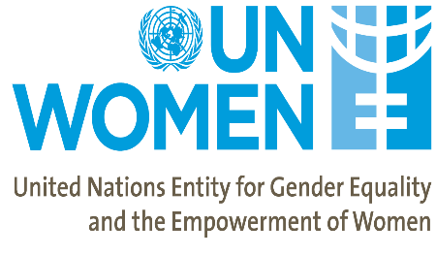

Nurturing future human capital through equality
between girls and boys
04:45pm - 06:00pm
ECOSOC Chamber, UNHQ
New York, 11 March 2019

The Permanent Missions of Georgia and Sweden to the United Nations, in partnership with the United Nations Entity for Gender Equality and the Empowerment of Women (UN Women) are organizing a side-event to present how fairy tales are powerful tool in promoting Sustainable Development Goal 5 on Gender Equality and a country’s future human capital. The side-event will be held on the side-lines of the 63rd session of the Commission on the Status of Women (CSW).

Fairy tales can have an enormous influence over the formation of a child’s value system and shape future social norms. Fairy tales serve as an important introduction to the outside world, teaching children how to distinguish kindness from malice, recognize justice from injustice, generate empathy and encourage bravery.

The fairy tale collection, which will be presented, was initiated by UN Women Georgia and was published in 2018 as part of the UN Joint Programme for Gender Equality in Georgia, funded by the Government of Sweden.

Authored by twelve Georgian writers, the collection of 21 fairy tales “Once There Was a Girl” features female protagonists throughout, something that up until now, was in short supply among children’s literature, including fiction and school textbooks in Georgia. The book deftly helps to address gender inequality, which is one of the biggest hurdles the country is facing. The book is aimed at children aged 7-15 years, nurturing equality of women and men, girls and boys from an early age.

Draft Programme

04:45PM – 04:50PM Moderator
- H.E. Mr. Kaha Imnadze, Ambassador Extraordinary and Plenipotentiary, Permanent Representative of Georgia to the United Nations

04:50PM – 05:10PM Opening Remarks
- H.E. Ms. María Fernanda Espinosa Garcés, President of the 73rd session of the UN General Assembly (TBC)
- Ms. Khatuna Totladze, Deputy Minister of Foreign Affairs of Georgia (TBC)
- Representative from Sweden (TBD)
- Representative from UN Women (TBD)

05:10PM – 05:25PM Speakers
- Ms. Erika Kvapilova, UN Women Representative in Georgia
- Ms. Nestan Nene Kvinikadze, author of the fairy tale “Blancmange Bridge” (TBC)

05:25PM – 05:40PM Reading extracts from fairy tales

05:40-06:00 Q&A and Closing Remarks

