
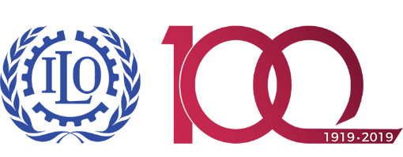
Certification course on mediation
of labour disputes
7 to 11 April 2019

Time | Sunday 7, April | Monday 8, April | Tuesday 9, April | Wednesday 10, April | Thursday 11, April
10:00–11:30 | Opening (9:30)  - Mr Kinan Bahnassi, CTA, ILO (10 min.)  - Ms Tamar Barkalaia, Deputy Minister, MoIDPLHSA TBC (10 min.)  - Ms Soledad Schenone, ITC ILO (10 min)  Objectives of the course- introductions and expectations -outline of the course & training methodology.  Group picture | Review reflection and open  outcomes in negotiation - different approaches to negotiation - the negotiators' dilemma - how to maximize joint value and achieve optimum outcomes - the significance of alternatives to a negotiated agreement | Review reflection and open  Distinguishing positions from needs - characteristics and typical language of positional and needs-based statements - working with interests and needs - reframing | Opening  Mediation process (continued)  Role-plays on mediation - assessed | Opening  Mediation process (continued)  Role-plays on mediation - assessed
11:30 – 12:00 | Coffee break
12:00 – 13:30 | Review of pre-work | Reality testing - how to open up a zone of possible agreement - generating options and brainstorming - managing reactive devaluation & the mandating dynamic. | Extracting needs - Finding mutual gains outcomes -The use of questions  Role-play on mediation – with coaching | Role-plays on mediation - assessed | Role-plays on mediation - assessed
13:30 – 14:30 | Lunch
14:30 – 15:45 | Process management skills  What typical mediation looks like - steps in mediation - suggested mediation process - demonstration of a mediation & identifying typical mistakes made in | Role-play mediation – with coaching | Responding to challenges  Responding effectively to the emotions of the parties and managing your own emotions - helping people save face - managing difficult behaviours and difficult people –  Role-play on mediation with coaching | Role-plays on mediation - assessed | Role-plays on mediation - assessed
15:45 – 16:15 | Coffee break
16:15 – 17:30 | Problem management skills  The relationship between negotiation and mediation - identifying typical mistakes made in negotiation - an experience of negotiation | building rapport and empathy -  effective listening -  paraphrasing  Reflections and close | The conciliator/mediator in society  Ethical considerations for mediators  Reflection and close | Role-plays on mediation - assessed | Final assessment and closure  Test  Writing a personal development plan

