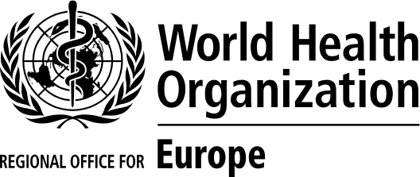
Short review of the country offices
in the WHO European Region
23 January 2020
ORIGINAL: ENGLISH

COUNTRY:_____________________________

- What functions of a WHO country office are most relevant to your country?

- What works well in the WHO country office in your country and what aspects of the current set up of the country office need to be safeguarded?

- What could be improved?

- What are the advantages / disadvantages of having an international WHO Representative (WR) versus a national Head of WHO Country Office (HWO)?

- What do you expect from the WHO Regional Office for Europe from its country presence and the work of the Regional Office at the country level?

