BFP Emergency Procurement of Medical Supplies
Global Offer Summary
Hillrom

This offer summary is effective from June 01, 2020.
Background
Hillrom is a global medical technology leader whose 10,000 employees have a single purpose: enhancing outcomes for patients and their caregivers by Advancing Connected Care™. Around the world, our innovations touch over 7 million patients each day. They help enable earlier diagnosis and treatment, optimize surgical efficiency and accelerate patient recovery while simplifying clinical communication and shifting care closer to home. We make these outcomes possible through connected smart beds, patient lifts, patient assessment and monitoring technologies, caregiver collaboration tools, respiratory care devices, advanced operating room equipment and more, delivering actionable, real-time insights at the point of care. Learn more at www.Hillrom.com.
Contents
This Offer Summary provides information on Hillrom’s products offered globally and describes the process to complete and return, to the World Bank, the Registration of Interest (ROI). The following Annexes are attached:
Annex 1 – Hillrom’s Product Specifications
Annex 2 – Other Offer terms
Annex 3 – WHO & ECRI baseline technical specifications
Annex 4 – ECRI assessment of Hillrom’s Life2000 ventilator
The following document is attached to the Offer Summary:
Registration of Interest form

IMPORTANT INFORMATION
- Price is available until the end of the year 2020
- You are encouraged to complete the Registration of Interest (ROI) to the World Bank as soon as possible to secure lead times – First In – First Supplied.
- Submitting a ROI does not bind the Borrower contractually to purchase the goods.

Offer Validity:
This pricing in this offer will expire at the end of 2020. You are encouraged to complete the ROI as soon as possible to be assured of stock. Completion of the ROI does not bind you to entering into a contract.
Please complete and return this form to the World Bank to register your interest with Hillrom so they can advise you of lead times and shipping details so you can make an informed decision whether to proceed with a contract or not.
Hillrom will promptly advise the precise lead time (fitting into their production schedule), and then the Borrower will have 5 days to sign a contract to procure the products.
Offered Products:
The products offered by Hillrom globally are listed below. The prices for the products (excluding freight) are global with no price variation per region or country.
- Laryngoscope
- Halogen Otoscope
- High Flow Delivery System (Ventilators)

Hillrom also offer Electrocardiographs and ICU Beds to specified countries.
Scope
This is a global offer available to all countries, on a first ordered first fulfilled basis.
WHO/ECRI Technical Performance Specifications
Ventilators
Hillrom has proposed its Life2000 High Flow Delivery System for use with patients that require non-invasive (e.g., nasal cannula or face mask) ventilation support, therefore making a facility’s critical care ventilator fleet more available to treat COVID-19 patients requiring intensive care. ECRI reviewed the Life2000 system and believes that it meets the needs of patients with mild respiratory distress and may be considered as a noninvasive ventilation option. Reportedly, the delivered tidal volume by the Life2000 is approximately three times what is set by the user. If an untrained user sets the tidal volume without this knowledge, there is potential for serious patient harm. To minimize this potential, ECRI highly recommends only providing noninvasive ventilation using the Life2000. A more detailed review conducted by ECRI of these performance variances is provided in Annex 4.
Other products
All other products offered meet or exceed World Health Organization (WHO) and ECRI developed baseline technical performance specifications that are provided in Annex 3. The tables in Annex 1 outline Hillrom’s models, key features and pricing.

Annex 1 | Hillrom Product Specifications
The following provisions apply to all products offered by Hillrom.
Price | - Prices quoted in the following tables are EXW
Shipping options/s | - Incoterms 2020 CIP  - Incoterms 2020 CPT (with the option for Hillrom to cover insurance)
Shipping costs | - On return of the ROI, Hillrom will obtain actual shipping costs per product based on quantity and destination as per the applicable Incoterm.  - Actual shipping costs will be in addition to the quoted prices below and will be detailed in the contract.
Advance Payment | - 40%
Payment trigger | - Paid within twenty (20) days of signing of the Contract and upon submission of claim (invoice) and a bank demand guarantee
Final payment | - 60%
Payment trigger | - On shipment and delivery of the goods, within fifteen (15) days of delivery of the shipping documents, as specified
Hillrom Subcontract Arrangement | - Hillrom Inc will supply and invoice for the following products:  - Ventilator  - ICU Beds  - Welch Allyn, an affiliate of Hillrom, is referred under this agreement as a subcontractor, will supply and invoice for the following products  - Laryngoscope  - Otoscope  - ECG  - Orders of products from both Hillrom and its subcontractor:  - Will generate two invoices (one from each company, however supplied together), each payable to separate bank accounts  - Are covered by the same Advanced Payment Guarantee

Table 1 – Laryngoscope Summary
Welch Allyn Fiber Optic Macintosh Set (P/N 69696)
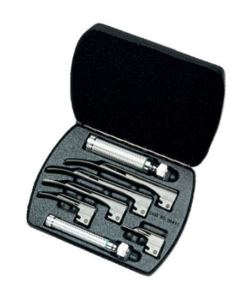
Intended Use | Adult, Pediatric
Blade Style | MacIntosh
Blade Sizes | 1, 2, 3, 4
Handle and Battery Type | "C" cell battery handle, "AA" cell battery handle
Heavy-wall plastic or metal case | ✔
Handle Light | 2.5 V Halogen
Warranty(months) | 12
ISO 7376:2009 Compliance | ✔
Shipping (Varies by Country) | By Air
Advanced Payment | 40%
Lead time | Available from August (first ordered first Supplied)
Price (EXW / USD) | 365.70
Table 2 – Otoscope Summary
Welch Allyn Halogen Otoscope (P/N 22820)
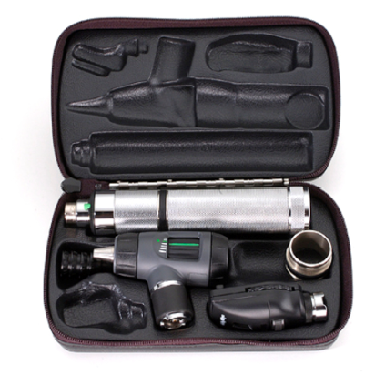
Intended Use | Adult, Pediatric
Throat Illuminator | ✔
Light Bulb | 2.5 V Halogen
Battery Type | 2 x AA
Accessories & consumables: | Halogen Replacement Bulb  Consumable - Disposable Specula, adult, 4.25 mm (6 month supplied with Otoscope covering 4,500 pediatric patients)"  Disposable Specula, pediatric, 2.75 mm (850/bag)
Warranty (months) | 12
Shipping (Varies by Country) | By Air
Advanced Payment | 40%
Lead time | Available Now (first ordered first supplied)
Price (EXW / USD) | Otoscope 365.70  Halogen Replacement Bulb 26.50  Disposable Specula (Adult or Pediatric) 15.00
Table 3 – High Flow Delivery System (Ventilator) Summary
Life2000 High Flow Delivery System
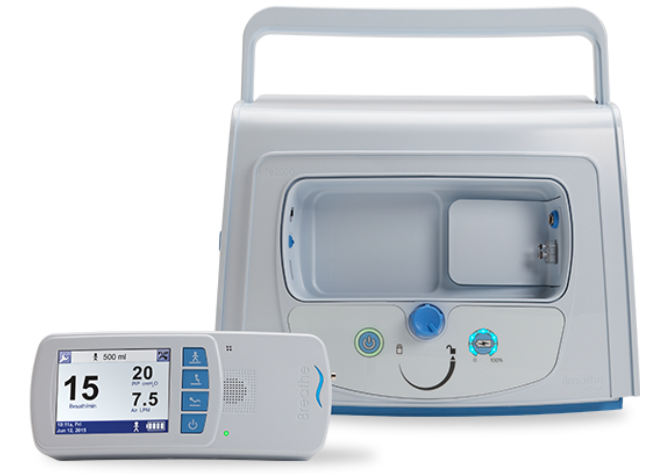
Primary Available Modes | Volume Control, Volume Assist/Control, Volume Assist
Indicated Patients | Adults
Tidal Volume (mL) | 0-2000
Max Inspiratory Flow (L/min) | Up to 120
CPAP/PEEP (cm H2O) | 20
Max Pressure Support (cm H2O) | 1 to 40
Inlet Gas Pressure Range (psi) | 41 to 87
Integrated Air Compressor | Option (included)
Battery Runtime (minutes) | 300-360
Alarm Capabilities | Numerous adjustable alarm settings appropriate for this system’s capabilities
Consumables and Accessories | - Universal Circuit Connector (Consumable) 1 years supplied per device  Replacement requirement: assume each patient is on device for 5-7 days, this means about 4-5 patients / ventilator / month, which = 4-5 adapters / device / month required)  - Life2000 Compressor (Accessory) Can serve as an optional alternate external pressure source for the Life2000 Ventilator in environments where access to compressed oxygen or cylinders is limited.  - CombO2™ Air & Oxygen Hose, 50 ft (consumable to the compressor)  (Consumable) 1 years supplied per device  Replacement requirement: assume each patient is on device for 5-7 days, this means about 4-5 patients / ventilator / month, which = 4-5 adapters / device / month required).
Warranty (months) | 12
Shipping (Varies by Country) | By Air
Advanced Payment | 40%
Lead time | Available from August (first ordered first Supplied)
Price (EXW / USD) | Life2000 7,150.00  Universal Circuit Connector (UCC) 96.00  Life2000 Compressor 2,500.00  CombO2™ Air & Oxygen Hose, 50 ft 300.00

Annex 2 | Other Offer Terms
Pricing: Quoted prices are in US Dollars (USD) and are recorded in your country specific ROI and:
- include warranty (as specified in the summary above),
- installation and training videos (no onsite training)
- are Ex Works.
- CIP or CPT prices to be established once destination and unit volume established.

Delivery Time: Deliveries will be phased, subject to the date of the order. Final dispatch dates will be provided upon receipt of the attached Buyer Registration of Interest Form.

Training: User training, where provided is included in the price, and is offered either in country, by video or video link, or web based using a train-the-trainer approach. In-country training may be an option for some countries and specific products, which Hillrom will confirm upon receiving the registration of interest.

Service: Service and Support for Laryngoscopes, and ELI 150c Electrocardiographs are to be provided by our service center in the Netherlands:

Welch Allyn Service & Repair Center
Maidstone 28 5026 SK Tilburg
The Netherlands
Phone: +31 (0) 20 206 1360

Service and Support for the Life2000 Ventilation System are to be provided by our service center in the United States.

Hillrom Advanced Respiratory
1020 West County Road F
St. Paul, MN 55126
Phone: +1 (800) 426-4224

Service and support for beds: For countries where Hill-Rom has an existing distributer, service during the warranty period will be provided through the local distributer.

Manuals: Printed user and service manuals will be provided with each piece of equipment. Manuals are available in English.

Regulatory Hillrom has reviewed current regulatory clearance against country requirements
Clearance: by product. In countries where we do not have regulatory clearance or approval, but there is a regulatory requirement, Hillrom will require a letter from the regulatory authority in the country stating that the product is approved for import. Hillrom will provide a letter to be accepted.

Borrower and Bank / Hillrom Next Steps:
The Borrower identifies the following on the attached Buyer Registration of Interest (ROI) Form:
  - Quantity of each device required.
  - Single delivery destination.
  - Your country’s accepted contract signing protocols (e.g. e-signature, scanned signature, etc.). Please note that a signature is not required. This request is for the protocol required by your country for signing a contract with the supplier.
- The Buyer Registration of Interest Form must be returned to the Bank as soon as possible to secure the products you require (products are provided on a first ordered, first supplied basis).
- The Borrower reviews the standard World Bank Facilitated Procurement contract, noting that this contract is not negotiable.
- Once the Borrower ROI is returned to the Bank, Hillrom will confirm specific dispatch times, delivery destination, CPT price and training and service details for the Borrower country.
- The Borrower confirms to the Bank if they wish to proceed with an order (a deadline for this decision will be advised when the details in point 4 above are provided), the Bank Country Procurement Specialist will finalize the contract for the Borrower with agreed lead times etc. If the Borrower chooses not to proceed, they need to advise the Bank immediately so available production capacity can be released to another Borrower.
- The Borrower country makes the final purchase decision and must sign the Supplier contract within 5 days from receiving the final contract from the Task Team Leader (TTL).

Annex 3 | WHO & ECRI Baseline Technical Specifications
Laryngoscopes

The World Bank seeks to procure laryngoscopes to expose and view the larynx and surrounding areas during orotracheal and nasotracheal intubation. In your proposal, do not include any advanced features or add-ons beyond the capabilities outlined below. Also indicate what types of batteries can be used to power the laryngoscope handle and if you can provide these batteries.
Technical Specifications
Laryngoscope set – pediatric and adult
- Model shall be compliant with ISO 7376:2009 Anesthetic and respiratory equipment-Laryngoscopes for tracheal intubation, or equivalent
- Handle shall be a large, cylindrical, hollow with a slightly ribbed surface and a threaded head compatible with different blade types and sizes
- Handle shall be approximately 28 mm in diameter and battery powered
- Each blade shall have fiber optics or a single bulb; bulb is at least 2.7 V halogen light and is removable for cleaning
- Example of acceptable blade (Macintosh and/or Miller) configurations include:
  - No. 1, length 100 mm, for child
  - No. 2, length 90-110 mm, for child
  - No. 3, length 110-135 mm, for small adult
  - No. 4, length 135-155 mm, for adult
- Blades and handle shall been stored in a heavy-wall plastic or metal case
- Interior of the case shall be designed so that blades and handle do not move while in transit
Laryngoscope set – neonate
- Model shall be compliant with ISO 7376:2009 Anesthetic and respiratory equipment-Laryngoscopes for tracheal intubation, or equivalent
- Handle shall be a large, cylindrical, hollow with a slightly ribbed surface and a threaded head compatible with different blade types and sizes
- Handle shall be approximately 19 mm in diameter and battery powered
- Each blade shall have fiber optics or a single bulb; bulb is at least 2.7 V halogen light and is removable for cleaning
- Example of acceptable blade (Macintosh) configurations include:
  - No. 0, length 55 mm, for newborn
  - No. 1, length 70 mm, for infant
  - No. 2, length 90 mm, for child
- Blades and handle shall been stored in a heavy-wall plastic or metal case
- Interior of the case shall be designed so that blades and handle do not move while in transit
Training and Manuals
- User Training: Supplier shall provide in-person or on-line training adequate to meet the needs of all operators. Training shall be available in English, Spanish and French, and shall be available to users within two (2) weeks of equipment delivery.
- User Manuals: Supplier shall provide at least one (1) user manual for each device purchased. Manuals shall provide guidance on the operation of all features of the purchased device, be provided in at a printed format, and be available in English, Spanish and French.
- Service Manuals: Supplier shall provide at least one (1) maintenance manual for each device purchased. Manuals shall provide at least, equipment schematics, parts summaries, preventive maintenance requirements, and troubleshooting guidance, be accessible in printed formats, and be available in English, Spanish and French.

Otoscopes

The World Bank seeks to procure otoscopes for use during routine pediatric and adult physical examinations. In your proposal, do not include any advanced features or add-ons beyond the capabilities outlined below. Also indicate what types of batteries can be used to power the otoscope handle and if you can provide these batteries.
Technical Specifications
- Handle shall be no shorter than 6 cm with grip assistance (e.g., rubber sleeve or anti-slip surface) and battery powered.
- Batteries may be alkaline, rechargeable, or both. If batteries are rechargeable, a charger shall be included in the proposal.
- The handle shall have a removable bulb is at least 2.5 V halogen light or equivalent
- Light intensity may be variable with a rotating switch or equivalent
- Appropriate disposable ear speculum sizes include:
  - 4 to 5 mm for adults
  - 2.5 to 3.75 mm for infants and children
- Otoscope may have throat illuminator, retinoscope, and ophthalmoscope head additions. If proposed:
  - Retinoscope shall have a focusing sleeve/switch
  - Ophthalmoscope shall have aperture and lens selection dials, multiplier lever, diopter display window, and filter switch (open or red-free filter).
Training and Manuals
- User Training: Supplier shall provide in-person or on-line training adequate to meet the needs of all operators. Training shall be available in English, Spanish and French, and shall be available to users within two (2) weeks of equipment delivery.
- User Manuals: Supplier shall provide at least one (1) user manual for each device purchased. Manuals shall provide guidance on the operation of all features of the purchased device, be provided in at a printed format, and be available in English, Spanish and French.
- Service Manuals: Supplier shall provide at least one (1) maintenance manual for each device purchased. Manuals shall provide at least, equipment schematics, parts summaries, preventive maintenance requirements, and troubleshooting guidance, be accessible in printed formats, and be available in English, Spanish and French.

Ventilators

The World Bank seeks to procure critical care ventilators that meet the following technical specifications. In your proposal, do not include any advanced features or add-ons beyond the capabilities outlined below. Also indicate which accessories/supplies (e.g., breathing circuits) you can supply for one year of continuous use. If additional supplies are needed for continuous operation that you do not provide, clearly indicate this and provide appropriate distributor information, if available.
Technical Specifications
- Compliant with ISO 80601-2-80 and ISO 80601-2-79
- Model must match the voltage and frequency of the purchasing country’s local power grid (e.g., 110-120 VAC at 60 Hz or 220-240 VAC at 50 Hz)
- Tidal volume up to 1000 mL
- Pressure (inspiratory) up to 80 cm H₂0
- Volume (inspiratory) up to 120 L/min
- Respiratory rate (RR): up to 60 breathes per minutes (BPM)
- Synchronized intermittent mandatory ventilation (SIMV): RR up to 40 BPM
- CPAP/PEEP up to 20 cm H₂0
- Pressure support up to 45 cm H₂0
- FiO2 between 21% and 100%
- Inspiratory and expiratory times up to at least 2 sec and 8 sec respectively
- I:E ratio from 1:1 to 1:3
- Air and externally supplied oxygen mixture ratios full controllable
- Inlet gas supply (O2) pressure range 35 psi to 65 psi
- Includes integrated medical air compressor with inlet filter
Modes of Ventilation
- Volume controlled with optional PEEP
- Pressure controlled with optional PEEP
- Pressure support
- SIMV with volume support
- SMMV with volume support
Required Alarm Conditions
If alarms can be silenced, this feature is temporary and clearly displayed on the ventilator’s screen when annunciated
- FiO2, minute volume, pressure, PEEP, apnea, occlusion, high RR, circuit disconnection
Power failure, gas disconnection, low battery, vent inoperative, self-diagnostics

Training and Manuals
- User Training: Supplier shall provide in-person or on-line training adequate to meet the needs of all operators. Training shall be available in English, Spanish and French, and shall be available to users within two (2) weeks of equipment delivery.
- User Manuals: Supplier shall provide at least one (1) user manual for each device purchased. Manuals shall provide guidance on the operation of all features of the purchased device, be provided in at a printed format, and be available in English, Spanish and French.
- Service Manuals: Supplier shall provide at least one (1) maintenance manual for each device purchased. Manuals shall provide at least, equipment schematics, parts summaries, preventive maintenance requirements, and troubleshooting guidance, be accessible in printed formats, and be available in English, Spanish and French.

Annex 4 | ECRI Review of Hillrom Ventilator Offer
Review of Hillrom Alternative Ventilator Offer

The demand for ventilators world-wide exceeds the available supply. In response to the scarcity of traditional intensive care ventilators, Hillrom has proposed a solution that, although it does not meet the WHO standards for an intensive care ventilator, it may be useful for patients that require non-invasive (e.g., nasal cannula or face mask) ventilation support, therefore making a facility’s intensive care ventilator fleet more available to treat COVID-19 patients requiring intensive care.
The Hillrom Life2000 Ventilator is a small, pneumatically driven, volume-controlled ventilator that does not have an internal blower. Accordingly, it relies on pressurized gas from a medical gas wall system or compressed air cylinder to provide ventilation. Alternatively, an air compressor can be purchased as an optional feature. The ventilator can provide up to 10 cm PEEP and 40 cm PIP and it does have user adjustable alarms of different priority levels.
Compared to the WHO criteria for an intensive care ventilator, the Life2000 does not meet the following criteria:
- lack of required modes, such as pressure control, pressure support, and synchronized intermittent mandatory ventilation (SIMV) w/ pressure support
- Pressure (inspiratory) up to 80 cm H20
- Volume (inspiratory) up to 120 L/min
- Pressure support up to 45 cm H20
- FiO2 of between 21% and 100% - this device uses a “bleed in” technique, therefore an exact oxygen percentage cannot be set adjusting ventilator settings. Additionally, the oxygen concentration of delivered air will vary depending on settings and the patient’s demands.
This device was originally designed to assist patients with COPD (Chronic Obstructive Pulmonary Disease) or a variety of neuromuscular diseases affecting lung function that requires a low level of ventilatory support. The patient circuit for the Hillrom Life2000 utilizes a proprietary breathing circuit whereas most other ventilators use a non-proprietary breathing circuit. Additionally, it was disclosed that the delivered tidal volume is approximately three times what is set by the user. If an untrained user sets the tidal volume without this knowledge, there is potential for serious patient harm. To minimize this potential, ECRI highly recommends only providing noninvasive ventilation using the Life2000.
In an ideal situation, a full featured critical care ventilator is the preferred device for treating patients with COVID-19 respiratory symptoms. Based on its technical and clinical review, ECRI believes that the Hillrom Life2000 Ventilator will meet the needs of patients with mild respiratory distress and should be used only as a noninvasive ventilation option.

