COVID-19 BANK FACILITIATED PROCUREMENT
Linet - Patient Beds

Linet (www.linet.cz) is the biggest production facility for hospital beds in Europe and one of the biggest globally. The company's portfolio includes solutions designed for intensive care, products for regular inpatient care and special beds for nursing homes or hospitals for the long-term sick. The vast majority of production is intended for export to more than a hundred countries around the world.

The products listed below are a global offer.

Offer Expiration Date:
This pricing in this offer will expire on December 31st 2020. You are encouraged to complete the ROI confirming products and quantities needed as soon as possible to be assured of stock. Completion of the ROI does not bind you to entering into a contract.

Once an ROI is received Linet will advise the precise lead time (fitting into their production schedule), then the Borrower has 7 days to decide whether to sign a contract to procure. If after this date the Borrower has not signed the contract, Linet will cancel the reservation in their production schedule.

Offered Products:
- Intensive Care Patient Beds (4 options)
- Med-Surg Patient Beds (1 option)
- Transport Stretcher (1 option)

Patient beds are highly configurable with multiple options. Linet offered recommended patient bed configurations that were compared against and meet or exceed World Health Organization and ECRI (www.ecri.org) developed baseline technical performance specifications that are provided in Appendix A. The tables below outline offered bed configurations, models, key features, and other contract terms for each proposed device.

Linet also offered a transport stretcher in addition to the requested patient beds for consideration by Borrower Countries.

Table 1: Offered Intensive Care Patient Beds Summary
Device Models | Eleganza 2 | Eleganza 4 | Eleganza 5 | Multicare
Device Models | 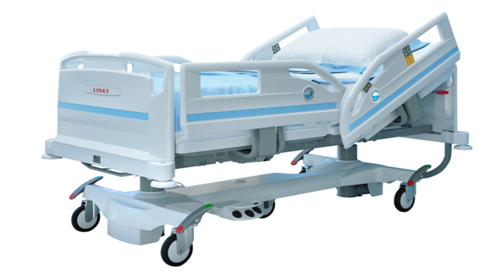 | 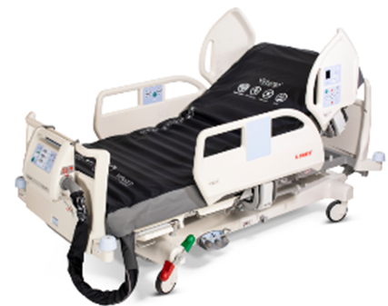 | 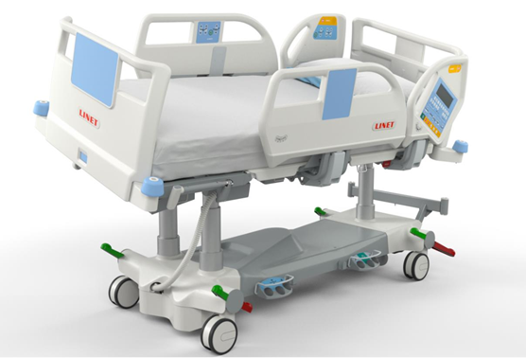 | 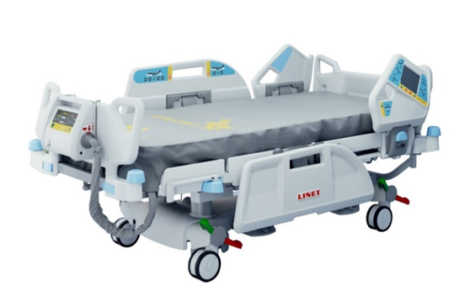
Max weight capacity including mattress | 250 kg (550 lbs.) | 250 kg (550 lbs.) | 250 kg (550 lbs.) | 250 kg (550 lbs.)
Siderails | split plastic, collapsible | Split plastic, collapsible | Split plastic, collapsible | Split plastic, collapsible
Adjustable height  min and max) | 39.5 to 77.5 cm | 41 to 79 cm | 43.5 to 81.5 cm | 44 to 82 cm
Removable Mattress  (dimensions, material, removable cover,  fluid ingress prevention) | 200 cm x 90 cm x  14 cm, polyurethane,  waterproof removable sewn cover, moisture vapor permeable | 208 cm x 90 cm x  14 cm,  polyurethane and GELTEX,  waterproof removable sewn cover, moisture vapor permeable | 208 cm x 90 cm x  14 cm,  polyurethane and GELTEX,  waterproof removable sewn cover, moisture vapor permeable | 208 cm x 88 cm x 14 cm  polyurethane and GELTEX  waterproof removable sewn cover, moisture vapor permeable
Bed Exit Alarms | No | No | Yes | Yes
Integrated Scale | No | Yes | Yes | Yes
Backup battery, Function | Yes, 1 full cycle* | Yes, 1 full cycle* | Yes, 1 full cycle* | Yes, 1 full cycle*
Powered patient positions  List | Fowler, semi-Fowler, Trend, Reverse Trend, Chair | Fowler, semi-Fowler, Trend, Reverse Trend, Chair | Fowler, semi-Fowler, Trend, Reverse Trend, Chair | Fowler, semi-Fowler, Trend, Reverse Trend, Chair
Nurse controls | Pendant  Lock-out | Rail-embedded  Lock-out | Rail-embedded; foot controls (lateral tilt)  Lock-out | Rail-embedded; pendant; foot controls (lateral tilt and height adjustment)  Lock-out
IV poles mounts | Not included, optional | 1 pole, 4 hooks | 1 pole, 4 hooks | 1 pole, 4 hooks
Angle indicators | No, optional | Yes | Yes | Yes
Offered configuration inclusions | PRIMACARE 10 mattress, X-ray modification, Full-length split side rails | CLINICARE 30 mattress, Weighing scales, X-ray modification, handset with LED flashlight, IV pole with 4 hooks | CLINICARE 30 mattress, X-ray modification, IV pole with 4 hooks | CLINICARE 30 mattress, Scales/bed exist alarm (Kit 1), Controls (Kit 2), Automatic lateral therapy (Kit 3), X-ray (Kit 4), IV pole with 4 hooks
Price  (as configured) | USD 2,447 | USD 4,731 | USD 8,139 | USD 11,663
Advance Payment | 40% | 40% | 40% | 40%
Shipping | By Air or Sea | By Air or Sea | By Air or Sea | By Air or Sea
Lead Times | From 45 days (dependent on order quantity) | From 4 weeks (dependent on order quantity) | From 4 weeks Available From 1 August 2020 (dependent on order quantity) | From 4 weeks  (dependent on order quantity)
Warranty | 24 months | 24 months | 24 months | 24 months
* 1 full cycle returns patient to a supine position.

Table 2 – Offered Med-Surg Patient Beds Summary
Device Model | Eleganza 1
Device Model | 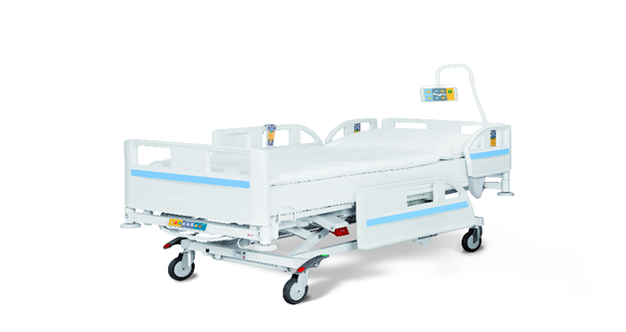
Max weight capacity including mattress | 250 kg (550 lbs.)
Siderails | single, collapsible
Adjustable height  min and max | 37 to 73.5 cm
Removable Mattress  (dimensions, material, removable cover,  fluid ingress prevention) | 200 cm x 86 cm x 14 cm  Polyurethane, waterproof removable sewn cover,  moisture vapor permeable
Backup battery | Not included, optional
Powered patient positions | Trend, Reverse Trend,  unpowered - Fowler, semi-Fowler
Nurse controls | Rail-embedded; pendant  Lock-out
IV poles mounts | Not included, optional
Angle indicators | Not included, optional
Offered configuration inclusions | EFFECTACARE 20 mattress, Side rail extension
Price  (as configured) | USD 1,673
Advance Payment | 40%
Shipping | By Air or Sea
Lead Times | From 4 weeks  (dependent on order quantity)
Warranty | Bed: 24 months;  Mattress: 12 months

Table 3: Transport Stretcher Summary

Device Model | Sprint 100
Device Model | 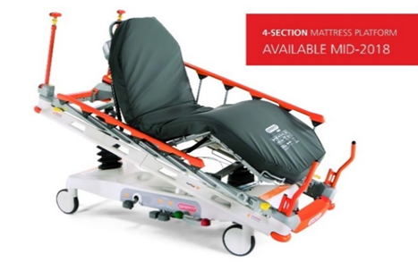
Castor brake system | central
Max weight capacity including mattress | 320 kg (705 lbs.)
Siderails | single, collapsible
Adjustable height  min and max | 2 section platform: 56.5 to 89 cm  4 section platform: 55.5 to 88 cm
Removable Mattress  (dimensions, material, removable cover,  fluid ingress prevention) | 193 cm x 66 cm x 8 cm  polyurethane,  cut corners cover (removable) with  waterproof top portion, moisture vapor permeable top portion
Backup battery | Not applicable
Powered patient positions | Trend, Reverse Trend (not powered)  Backrest: 0 - 90 degrees  With 4-section platform Thigh rest: 0 - 40 degrees  Calf rest: 0 - 17 degrees
Nurse controls | Foot controls (height)
IV poles mounts | Not included, optional
Angle indicators | No
Offered configuration inclusions | Standard PU mattress, Simple handles at head end/foot end
Price  (as configured) | USD 2,523
Advance Payment | 40%
Shipping | By Air or Sea
Lead Times | From 4 weeks  (dependent on order quantity)
Warranty | 24 months

Other Terms:

Pricing: FCA Prices in US dollars includes onsite training and warranty as outlined and exclude shipping/airfreight cost which varies by destination. CIP prices to be established once destination, freight method and unit volume established.

Unpacking and installation by Linet or its local distributor/partners will be included in final CIP pricing and would cost a maximum of 10% of the contract value.

Inspection Pre-shipment inspection: Linet will provide the Borrower with either a copy of the recognized regulatory approval (ie US FDA, CE Mark or equivalent) or other documentary evidence of the approval, prior to shipment.
Delivery inspection: The Borrower shall notify Linet in writing, within five working days of delivery at the agreed destination, of any short delivery or defects reasonably discoverable on careful examination of the packaging in which the goods are delivered. Linet will take such steps as may be necessary to rectify the situation as soon as reasonably practicable.
Linet’s Distributor/partner will also undertake an inspection of the equipment in hospital room once installed and this is included in the price.

Delivery Time: Delivery times will be phased, subject to the date of the order. Final dispatch dates will be provided upon receipt of a completed Buyer Registration of Interest Form.

Delivery: Linet is able to provide single delivery CIP. CIP prices to be established once destination, freight method and unit volume established. Under CIP the Borrower Country would be responsible for costs relating to:
- Terminal Charges Destination
- Customs Clearance Import
- Transport to Destination On Carriage (Linet can provide assistance to arrange this from their distributors/partners if required)
- Unloading at the Borrower’s Premises
Training: Training material with service and user manual for all offered countries, online product webinars, onsite training by distributors.

Service For countries where Linet has a local partner service during the warranty period will be provide through the local partner. Basic extended Post-warranty service 3% of contract value per year (spare parts and labour work included) to be contracted locally by the Borrower country and is provided either by Linet or a Local partner. More comprehensive service and preventative maintenance contracts can be provided if required.
Manuals: Printed user and service manuals will be provided with each piece of equipment. Electronic copies available
Borrower and Linet Next Steps:

- Borrower country identifies the following on the attached Buyer Registration of Interest Form:
  - Quantity of each device required.
  - Single delivery destination.
  - Your country’s accepted contract signing protocols (e.g. e-signature, scanned signature, etc.). Please note that a signature is not required. This request is for the protocol required by your country for signing a contract with a supplier.
- The Buyer Registration of Interest Form must be returned to the Bank as soon as possible to secure the products you require (products are provided on a first ordered, first fulfilled basis).

- Borrower reviews the standard World Bank Facilitated Procurement contract noting that the contract is not negotiable.
- Linet confirms the specific lead times, delivery destination, CIP price training and service details.
- Borrower confirms to the Bank if they wish to proceed (a deadline for this decision will be advised when the details on point 4 above are provided), the Bank Country Procurement Specialist will draft the contract for the Borrower with agreed lead times etc. If the Borrower chooses not to proceed, they need to advise the Bank immediately so available production capacity can be released to another Borrower.
- The Borrower country makes the final purchase decision and must sign the Supplier contract within 7 days from receiving the final contract from the Task Team Leader (TTL).

Appendix A – Baseline Technical Specifications

Patient Beds

Intensive care patient beds
- Model shall be specifically designed for the critical care setting
- Model shall be compliant with the following international industry standards:
  - Shall meet or exceed the latest revision of IEC 60601-1-2 Medical Electrical Equipment - Part 1-2: General Requirements for Safety - collateral Standard: Electromagnetic Compatibility - Requirements and Tests; and
  - Shall meet or exceed the latest revision IEC 60601-2-52 Medical electrical equipment – Part 2-52: Particular requirements for the basic safety and essential performance of medical beds
- Model shall match the voltage and frequency of the purchasing country’s local power grid (e.g., 110-120 VAC at 60 Hz or 220-240 VAC at 50/60 Hz)
- Model shall accommodate a mattress with minimum dimensions of – 75 cm x 200 cm (30 in x 80 in)
- Model shall have a weight capacity of at least 180 kg (400 pounds) without compromising bed functionality
- Model shall have four castors with brakes
- Model shall have a removable mattress with a removable, water-proof cover capable of withstanding common disinfectant solutions used in the healthcare setting
- Model shall have removable or collapsible lateral (side) rails on both sides of the bed that run at least ¾ the length of the bed frame
- Model shall have removable headboards and footboards
- Model shall have an adjustable height with lowest height from floor of 40 cm (16 inches) and highest height from floor of 80 cm (31 inches)
- All patient positions described below shall be power-adjusted (i.e., caregiver does not need to manually adjust bed frame) with automatic stops at range of motion limits:
  - Model shall accommodate a supine patient position
  - Model shall accommodate Fowler and semi-Fowler patient positioning (head and knees elevated and slightly elevated, respectively)
  - Model shall accommodate Trendelenburg and reverse Trendelenburg (body straight/feet elevated and body straight/feet lowered, respectively)
  - Model shall accommodate a chair position
- Model shall have rail-embedded and/or pendant-based nurse controls that includes, at least, all available bed/patient positioning and bed height raising/lowering with icons that clearly indicate button controls along with a lock-out feature (e.g., patient cannot control bed positioning)
- Model shall have at least one mountable IV pole at the head and foot of the bed
- Model shall have a battery backup that switches to the internal battery power if the main line power is interrupted that provide either 2 hours of function or support at least 10 bed operations, whichever comes first
Med-surg patient bed

- Model shall be compliant with the following international industry standards:
  - Shall meet or exceed the latest revision of IEC 60601-1-2 Medical Electrical Equipment - Part 1-2: General Requirements for Safety - collateral Standard: Electromagnetic Compatibility - Requirements and Tests; and
  - Shall meet or exceed the latest revision IEC 60601-2-52 Medical electrical equipment – Part 2-52: Particular requirements for the basic safety and essential performance of medical beds
- Model shall accommodate a mattress with minimum dimensions of – 75 cm x 200 cm (30 in x 80 in)
- Model shall have a weight capacity of at least 180 kg (400 pounds) without compromising bed functionality
- Model shall have four castors with brakes
- Model shall have a removable mattress with a removable, water-proof cover capable of withstanding common disinfectant solutions used in the healthcare setting
- Model shall have removable or collapsible lateral (side) rails on both sides of the bed that run at least ¾ the length of the bed frame
- Model shall have removable headboards and footboards
- Model shall have an adjustable height with lowest height from floor of 40 cm (16 inches) and highest height from floor of 80 cm (31 inches)
Training and Manuals
- User Training: Supplier shall provide in-person or on-line training adequate to meet the needs of all operators. Training shall be available in English, Spanish and French, and shall be available to users within two (2) weeks of equipment delivery.
- User Manuals: Supplier shall provide at least one (1) user manual for each device purchased. Manuals shall provide guidance on the operation of all features of the purchased device, be provided in at a printed format, and be available in English, Spanish and French.
- Service Manuals: Supplier shall provide at least one (1) maintenance manual for each device purchased. Manuals shall provide at least, equipment schematics, parts summaries, preventive maintenance requirements, and troubleshooting guidance, be accessible in printed formats, and be available in English, Spanish and French.

