BFP Emergency Procurement of Medical Supplies
Offer Summary
Medtronic
Background
Medtronic is one of the largest medical device companies in the world with operations in 150 countries, and products to treat 70 health conditions that include cardiac devices, cranial and spine robotics, insulin pumps, surgical tools, patient monitoring systems, and more. Medtronic’s BFP Offer relates only to devices to treat COVID-19. Medtronic has its operational headquarters in Minneapolis, Minnesota, USA and legal headquarters in Dublin, Eire. For more information please go to: www.medtronic.com
Contents
This Offer Summary provides information on Medtronic’s Offer and describes the process to complete and return, to the World Bank, the Registration of Interest (ROI). The following Annexes are attached:
Annex 1 – Medtronic’s Product Specifications
Annex 2 – Other Offer terms
Annex 3 – WHO & ECRI baseline technical specifications
Annex 4 – ECRI assessment of Medtronic’s PB560 ventilator
The following document is attached to the Offer Summary:
Registration of Interest form

IMPORTANT INFORMATION
- The DEADLINE for returning the Registration of Interest (ROI) to the World Bank is:
June 15, 2020
- If the ROI is not returned by this deadline Medtronic will hold the prices but cannot guarantee the lead times (all as described in this Offer Summary).
- Submitting a ROI does not bind the Borrower contractually to purchase the goods.

Offer validity
Medtronic offers the products at the prices listed below until May 31, 2021.
The current lead times cannot be guaranteed for ROIs submitted after the deadline stated in this Offer Summary.
The lead times in this Offer Summary are indicative as they may vary slightly, country to country. Actual delivery dates will be confirmed once an ROI has been returned and an individual contract prepared.
Scope
This offer is open to the following Borrower countries. These are countries that previously indicated a demand for the types of products manufactured by Medtronic. Medtronic is not prevented from increasing the scope beyond these countries in a subsequent offer.
  Bangladesh*
  Afghanistan*
  Bolivia*
  Cabo Verde
  Cambodia*
  Djibouti
  Ecuador*
  Gambia
  Ghana
  Guinea-Bissau
  Haiti
  Iraq (Kurdistan)*
  Kenya*
  Kyrgyz Republic
  Laos*
  Madagascar
  Maldives
  Mauritania
  Mongolia
  Nepal*
  Pakistan*
  Sao Tome
  Senegal
  Sri Lanka*
  St. Lucia
  Tajikistan
  Uzbekistan*
*countries where Medtronic offers local support
Products offered by Medtronic
The products offered are listed below. The prices for the products (excluding freight) are global with no price variation per region or country. Medtronic has provided current lead times for each product.
- Ventilators (2 options)
- Pulse oximeters (2 options)
- Laryngoscopes (video)
- Oxygen masks (2 options)
- Nasal cannula (2 options)
- Venturi masks (2 options)
WHO/ECRI Technical Performance Specifications
Ventilators
Medtronic has proposed its PB980 intensive care ventilator that exceeds the World Health Organization (WHO) and ECRI (www.ecri.org) developed baseline technical performance specifications.
In addition, Medtronic has offered its PB560 ventilator that meets most, but not all these baseline specifications. ECRI reviewed and found that the PB560 is very similar to an intensive care ventilator and can operate under the following modes:
- volume control
- pressure control
- SIMV
- SMMV
- PSV.
ECRI believes that, if the flow rate and air/O2 mixture can be accurately adjusted, the PB560 ventilator will meet the needs of patients with severe respiratory distress and it can be used to treat COVID-19 patients that require mechanical ventilation. A more detailed review conducted by ECRI of these performance variances is provided in Annex 4.
Other products
All other products offered meet or exceed World Health Organization (WHO) and ECRI developed baseline technical performance specifications that are provided in Annex 3. The tables in Annex 1 outline Medtronic’s models, their key features, pricing, contract terms, and WHO standards for oxygen masks, nasal cannula and venturi masks.
Next Steps
The next steps in this emergency procurement process are as follows. Where possible all steps will be accelerated to ensure that the procurement is achieved quickly and the urgently needed supplies delivered as quickly as possible in-country.
Timings indicate situations where there are no issues arising. Timings may vary on a case-by-case basis:
Step | Indicative timeline*
Borrower completes & returns ROI to the Bank | June 15, 2020**
Bank informs Medtronic of ROI details | 1 day | 5 DAYS
Medtronic confirms freight costs & delivery dates | 2 days | 5 DAYS
Bank prepares contract (including freight and dates) | 1 day | 5 DAYS
Medtronic reviews and completed the contact | 2 day | 5 DAYS
Bank sends contract to TTL to present to Borrower | 1 day | 7 DAYS
Borrower / TTL finalize local details in the contract*** | 1 day | 7 DAYS
Deadline for Borrower to sign the contract | 5 days | 7 DAYS
* Days are business days
** Close of business EST
*** Local details include e.g. full name of purchasing agency, name of signatory etc.
Registration of Interest
- The ROI must be returned to the World Bank on or before the deadline. Due to the volatile and fast-moving market conditions Medtronic cannot guarantee the quoted prices and lead times beyond this date.
- Complete the ROI by providing the information requested in the form, namely:
- name of Borrower’s purchasing agency and contact details
- name of single delivery destination (usually the capital city’s airport)
- indicate each product required (in the “Borrower requirements” table) by inserting the quantity needed (in the last column of the table).
- indicate the contract signing options that are workable for the Borrower i.e. meet the Borrower’s accepted contract signing protocols for a commercial contract with a supplier (e.g. e-signature, scanned signature, etc.). By clarifying what options will work this assists in making signing arrangements with Medtronic in advance, thereby accelerating the process and helping get urgently needed medical equipment quickly.
Please note, the ROI does not need to be signed.
Freight prices and delivery date/s
- On submitting the ROI, the Bank will start preparing the contract and send the details (products, quantities and delivery destination) to Medtronic. Based on these Medtronic will obtain prices for freight and confirm actual delivery dates (based on the lead times quoted in the offer). Medtronic will then schedule into their production plan the requirement to fulfil the order. Depending on the quantities required Medtronic will confirm if the products will be delivered in one or more batches.
- Medtronic will include the freight costs and delivery dates in the contract. This final contract will be reviewed by the Bank and then sent to the in-country TTL and APS.
- The APS will add country specific information to the contract e.g. the names and details of the contract signatories and finalize the contract for signing.
- The Task Team Leader will deliver the contract to the Borrower.
Contract award decision and signing
- On receiving the contract, the Borrower reviews the contract and decides to either sign or reject the offer. The contract cannot be renegotiated. The decision to purchase, or not, lies solely with the Borrower.
- The only exception to non-negotiation relates to Incoterms. Where the goods are being delivered from outside the Borrower’s country and there is a genuine reason that CIP is unworkable, then another suitable Incoterm will be agreed by the Bank and Medtronic.
- If the Borrower chooses not to proceed, the Borrower should advise the World Bank immediately, so that Medtronic’s available production capacity can be released to another buyer.
- If the Borrower chooses to proceed, the contract must be signed within the deadline stated in the contract cover sheet. This is usually within five business days of receiving the contract from the Bank. Usually the Borrower will sign the contract first, then the supplier, but there are instances where it is the other way around.
- If, after the deadline for signing has expired, the Borrower has not signed the contract, Medtronic will cancel the reservation in the production schedule and re-assign the goods to another buyer. The contract can still proceed but the delivery days will need to be reconfirmed and may need to be amended in the contract.

Annex 1 | Medtronic Product Specifications
The following provisions apply to all products offered by Medtronic.
Price | - Prices quoted in the following tables are EXW
Shipping options/s | - CIP – if the product is supplier from abroad  - EXW – if product is supplied within the Borrower’s country
Shipping costs | - On return of the ROI, Medtronic will obtain actual shipping costs per product based on quantity and destination as per the applicable Incoterm.  - Actual shipping costs will be in addition to the quoted prices below and will be detailed in the contract.
Advance Payment | - 40%
Payment trigger | - Paid within twenty days of signing of the Contract and upon submission of claim (invoice) and a bank demand guarantee
Final payment | - 60%
Payment trigger | - On shipment and delivery of the goods, within fifteen days of delivery of the shipping documents, as specified

Table 1 | Offered Ventilators Summary
Device Models | PB980 Intensive Care Ventilator | PB560 Portable Ventilator
Device Models | 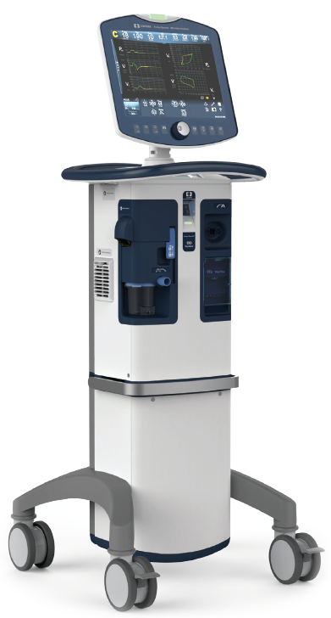 | 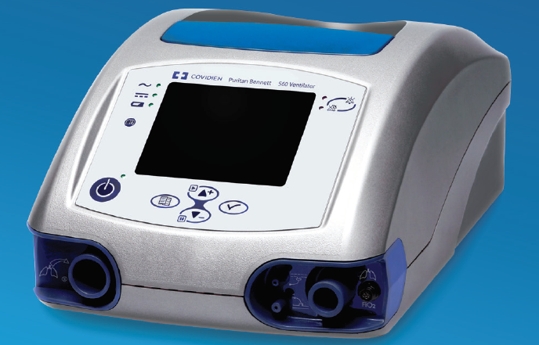
Intended Use | Adult, pediatric, neonates | Adult, pediatric
Modes | A/C VC, A/C PC, SIMV, SPONT, BiLevel, CPAP, VC, PC, VC+, PS, VS, TC, PAV+, NIV | CPAP, PSV/ST, P A/C, V A/C, V SIMV, P SIMV
Tidal Volume | 25 to 2500 mL | 50 to 2000 mL
Peak Inspiratory Flow | 150 L/min | < 130 L/min
CPAP/PEEP Support | 0 to 45 cm H₂O | 0.5 to 20 cm H₂O
Max Pressure Support | 70 cm H₂O | 5.0 to 56 cm H₂O
Alarms | Full capabilities | Full capabilities
Battery | Rechargeable, 60 minutes | Rechargeable, 11 hours
Accessories & Options | DAR Double limb circuit, box of 10 (SKU# 301/6378): USD 42  980 PAED/ADT Expiratory filter, box of 12 (SKU# 10043551): USD 200  Inspiratory Bacteria filter, box of 12 (SKU# 351U5856): US 36 | Dual Disposable Circuits, box of 10 (SKU#5094000): USD 333  DAR Filters, box of 25 (SKU#354/5876): USD 50  Exhalation block, box of 10 (SKU#10046803): US 160
Lead Time | 7 months | 12 weeks
Price | USD 35,000 | USD 8,000
Note on price | Price quoted EXW | Price quoted EXW
Warranty | 2 years | 2 years
Table 2 | Offered Pulse Oximeter and Sensor Summary
Device Models | Nellcor PM10N Portable | Nellcor PM100N Bedside
Device Models | 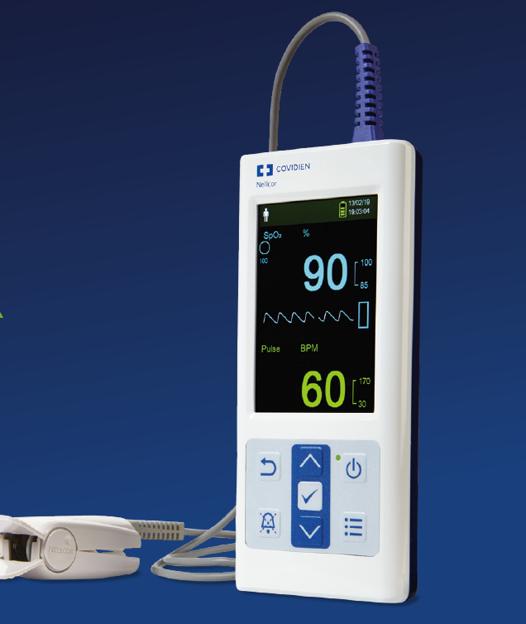 | 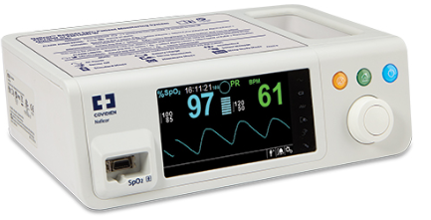
Intended Use | Spot checking and continuous monitoring | Continuous monitoring
Parameters | Oxygen saturation (SpO2), perfusion index (Pi), pulse rate (PR) | Oxygen saturation (SpO2), perfusion index (Pi), pulse rate (PR)
Alarms | Audio and visual, SpO2 and PR | Audio and visual, SpO2 and PR
Battery | Four (4) Li-AA/  20 hours per battery replacement | Rechargeable Li-ion/  5 hours per charge
Accessories & Options | Reusable Sensor Adult: USD 75  Reusable Sensor Pediatric: USD 75  Carry Case: USD 30 | Reusable Sensor Adult: USD 100  Reusable Sensor Pediatric: USD 100
Lead Time | 14 - 18 weeks | 14 - 18 weeks
Price | USD 400 | USD 1,100
Note | Price quoted EXW | Price quoted EXW
Warranty | 2 years | 2 years

Table 3 | Offered Video Laryngoscopes Summary
Device Models | Laryngoscope - MCGRATH MAC
Device Models | 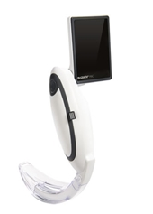
SKU# | 300-000-000
Intended Use | Adult, Pediatric
Video | Yes
Blade Style | MacIntosh
Blade Sizes | 2, 3, 4, X3
Handle Light | High Intensity LED
Handle/Battery | Proprietary 3.6V Lithium battery pack (250 min)
Accessories & Options | Single use Macintosh blade, Size 2, box of 50 (SKU# 350-017-000): USD 384  Single use Macintosh blade, Size 3, box of 50 (SKU# 350-005-000): USD 397  Single use Macintosh blade, Size 4, box of 50 (SKU# 350-013-000): USD 385  Single use Macintosh blade, X-blade, box of 10 (SKU# X3-003-000): USD 1050  McGrath MAC spare Battery (SKU#340-000-000): USD 33
Lead Time | 8 weeks
Price | USD 1,500
Note on price | Price quoted EXW
Warranty | 36 months

Table 4 | Offered Oxygen Masks
Device Models | High Concentration Oxygen Mask - Adult  Single Use | High Concentration Oxygen Mask – Pediatric  Single Use
Device Models | 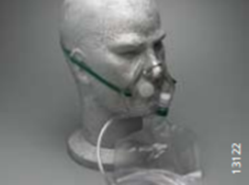
WHO Description | Adult high concentration non-rebreathing mask with 213cm crush resistant oxygen supply tube and safety valve, elastic strap style | Pediatric high concentration non-rebreathing mask with 213cm crush resistant oxygen supply tube and safety valve, elastic strap style
WHO Standard | WHO-UNICEF Technical Specifications and Guidance for Oxygen Therapy Devices - 2019 | WHO-UNICEF Technical Specifications and Guidance for Oxygen Therapy Devices - 2019
Product Code | #13122 | #13125
Intended Use | Adult | Pediatric
Product Review | Mask is intended to deliver high concentrations of oxygen to adult patients. Oxygen percentages of up to 100% can be delivered, depending on the fit of the mask. This product fully meets the specified standards. | Mask is intended to deliver high concentrations of oxygen to pediatric patients. Oxygen percentages of up to 100% can be delivered, depending on the fit of the mask. This product fully meets the specified standards.
Lead Time | 4 weeks | 4 weeks
Price | USD 70 (Box of 50) | USD 100 (Box of 50)
Note on price | Price quoted EXW | Price quoted EXW

Table 5 | Offered Nasal Cannulas
Device Models | Nasal Cannula – Adult  Single Use | Nasal Cannula – Pediatric  Single Use
Device Models |  | 
WHO Description | Adult nasal cannula for flows up to 6 LPM with 213cm crush resistant oxygen supply tube. | Pediatric nasal cannula for flows up to 6 LPM with 213cm crush resistant oxygen supply tube.
WHO Standard | WHO-UNICEF Technical Specifications and Guidance for Oxygen Therapy Devices - 2019 | WHO-UNICEF Technical Specifications and Guidance for Oxygen Therapy Devices - 2019
Product Code | # 13300 | # 13324
Intended Use | Adult | Pediatric
Product Review | Device is intended for adult use and flows up to 6 LPM, which in turn will deliver an approximate oxygen concentration of 44%. This product fully meets the specified standards. | Device is intended for pediatric use and flows up to 6 LPM, which in turn will deliver an approximate oxygen concentration of 44%. This product fully meets the specified standards.
Lead Time | 4 weeks | 4 weeks
Prices | USD 25 (Box of 50) | USD 60 (Box of 50)
Note on price | Price quoted EXW | Price quoted EXW

Table 6 | Offered Venturi Masks
Device Models | Venturi Mask Pack – Adult  Single Use | Venturi Mask Pack – Pediatric  Single Use
Device Models | 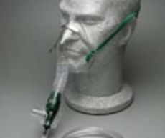 | 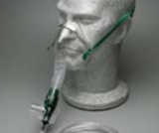
WHO Description | Adult Venturi system with variable valve for 7 oxygen concentrations (from 24% to 50%), 213 cm crush resistant Oxygen supply tube, humidity cup, reservoir corrugated 10cm tube and mask. | Pediatric Venturi system with variable valve for 7 oxygen concentrations (from 24% to 50%), 213 cm crush resistant Oxygen supply tube, humidity cup, reservoir corrugated 10cm tube and mask.
WHO Standard | WHO-UNICEF Technical Specifications and Guidance for Oxygen Therapy Devices - 2019 | WHO-UNICEF Technical Specifications and Guidance for Oxygen Therapy Devices - 2019
Product Code | #224/5009 | #214/5021
Intended Use | Adult | Pediatric
Product Review | This device is intended to deliver precise concentrations of oxygen to an adult patient, regardless of the amount of oxygen inputted to the device. Humidity may be added via the included collar. This product fully meets the specified standards. | This device is intended to deliver precise concentrations of oxygen to a pediatric patient, regardless of the amount of oxygen inputted to the device. Humidity may be added via the included collar. This product fully meets the specified standards.
Lead Time | 6 weeks | 6 weeks
Prices | USD 185 (Box of 50) | USD 86 (Box of 25)
Note on price | Price quoted EXW | Price quoted EXW

Annex 2 | Other Offer Terms

Prices Quoted prices are in US dollars. Quoted prices do not include the costs of freight. These costs will be obtained from Medtronic once the Registration of Interest has been returned to the Bank.
Prices include the following items where stipulated in the Product Specifications (Annex 1), where applicable:
- product warranty
- installation
- training.

Payment There is a 40% Advance Payment and 60% payment on delivery following the initial delivery inspection. Payments are to be made by Bank Direct Payment.

Incoterms The appropriate Incoterm will depend upon whether the goods are being supplied from within the Borrower’s country or from abroad. Medtronic has representatives in 12 of the countries to which this offer applies. So the Incoterms will be either:
- Standard Incoterm is CIP, or
- In situations where Medtronic has a place of business in-country the applicable incoterm will be EXW
Where there is a genuine reason why CIP cannot be used there is an option to use FCA (e.g. Medtronic delivers to an airport in a neighbouring country and the Borrower arranges for delivery from there to the destination).

Inspection Pre-shipment inspection: Where the goods have a recognized regulatory approval, Medtronic will provide the Borrower with either a copy of the approval or other documentary evidence of the approval, prior to shipment. Where the products do not have recognized regulatory approval, a factory-based inspection and testing will be carried out before shipment, to be arranged by the Borrower and facilitated by the Bank.
Delivery inspection: The Borrower shall notify Medtronic in writing, within five working days of delivery at the agreed destination, of any short delivery or defects reasonably discoverable on careful examination of the packaging in which the goods are delivered. Medtronic will take such steps as may be necessary to rectify the situation as soon as reasonably practicable.

Service Support and maintenance are most often part of the warranty on the device and then separately formed into a service agreement once the warranty ends, with terms agreed upon contractually or provided on a time and material basis.

Manuals Printed user and service manuals will be provided with each piece of equipment. In addition, all product manuals can be obtained at:
https://www.medtronic.com/covidien/en-us/support/product-manuals.html
Training Clinical training is part of the Medtronic responsibility and will be provided.
Medtronic has online training resources on its website, all of which are easy to identify in the manuals and other documents that accompany the ventilators.
Depending on specific needs, Medtronic education team can arrange tailored videoconferences with users. Medtronic recommends that these only be arranged, after the online training has been completed.
Ventilator Training Alliance (VTA) – the VTA is a consortium co-founded by several ventilator manufacturers (which include Medtronic). The VTA provides free, easy-to-use digital access to ventilator manuals and training materials. Any interested individual or organization can access the VTA at:
https://vta.allego.com/home.do

Support There are several options are available based on the country need and ability to support. For countries where Medtronic has a local distributor Medtronic could extend their authorization to support ventilators and have them import the goods. For countries where Medtronic does not have an in-country presence the best option could be to train the local hospital biomed on how to maintain the device. Medtronic also has ship-in service options available for these countries by sending the device back to Medtronic.

Contract The way in which the contract will be signed will depend upon options that are signing suitable for the Borrower and the Supplier. Options are listed in the Registration of Interest and include e.g. electronic signature. It is essential that the Borrower completes the Contract Signing Options section in the Registration of Interest so that arrangements are known in advance and can be planned for to assist in accelerated signing.
Annex 3 | WHO & ECRI Baseline Technical Specifications
Ventilators
The World Bank seeks to procure critical care ventilators that meet the following technical specifications. In your proposal, do not include any advanced features or add-ons beyond the capabilities outlined below. Also indicate which accessories/supplies (e.g., breathing circuits) you can supply for one year of continuous use. If additional supplies are needed for continuous operation that you do not provide, clearly indicate this and provide appropriate distributor information, if available.
Technical Specifications
- Compliant with ISO 80601-2-80 and ISO 80601-2-79
- Model must match the voltage and frequency of the purchasing country’s local power grid (e.g., 110-120 VAC at 60 Hz or 220-240 VAC at 50 Hz)
- Tidal volume up to 1000 mL
- Pressure (inspiratory) up to 80 cm H₂0
- Volume (inspiratory) up to 120 L/min
- Respiratory rate (RR): up to 60 breathes per minutes (BPM)
- Synchronized intermittent mandatory ventilation (SIMV): RR up to 40 BPM
- CPAP/PEEP up to 20 cm H₂0
- Pressure support up to 45 cm H₂0
- FiO2 between 21% and 100%
- Inspiratory and expiratory times up to at least 2 sec and 8 sec respectively
- I:E ratio from 1:1 to 1:3
- Air and externally supplied oxygen mixture ratios full controllable
- Inlet gas supply (O2) pressure range 35 psi to 65 psi
- Includes integrated medical air compressor with inlet filter
Modes of Ventilation
- Volume controlled
- Pressure controlled
- Pressure support
- SIMV with pressure support
- Assist/control mode
- CPAP/PEEP
Required Alarm Conditions
If alarms can be silenced, this feature is temporary and clearly displayed on the ventilator’s screen when annunciated
- FiO2, minute volume, pressure, PEEP, apnea, occlusion, high RR, circuit disconnection
Power failure, gas disconnection, low battery, vent inoperative, self-diagnostics
Training and Manuals
- User Training: Supplier shall provide in-person or on-line training adequate to meet the needs of all operators. Training shall be available in English, Spanish and French, and shall be available to users within two (2) weeks of equipment delivery.
- User Manuals: Supplier shall provide at least one (1) user manual for each device purchased. Manuals shall provide guidance on the operation of all features of the purchased device, be provided in at a printed format, and be available in English, Spanish and French.
- Service Manuals: Supplier shall provide at least one (1) maintenance manual for each device purchased. Manuals shall provide at least, equipment schematics, parts summaries, preventive maintenance requirements, and troubleshooting guidance, be accessible in printed formats, and be available in English, Spanish and French.
Pulse Oximeters
The World Bank seeks to procure pulse oximeters that meet the following technical specifications. In your proposal, do not include any advanced features or add-ons beyond the capabilities required below. Also indicate which accessories/supplies (e.g., cables, batteries) you can supply to ensure one year of continuous operation.
Technical Specifications
- Monitors hemoglobin oxygen saturation and calculates the pulse rate of a patient
- Sensor type fingertip, forehead, or ear available in adult and pediatric sizes
  - Reusable and disposable probe options preferred
- Device may be portable or tabletop
- Battery powered or line powered
  - Rechargeable batteries highly preferred
- If battery powered, batteries and battery chargers are included
- SpO2 detection includes the range of 70-100%
- SpO2 resolution: 1% or less
- Pulse rate detection to include the range 30-240 BPM
- Pulse rate resolution: 1 BPM or less
- SpO2 accuracy during no motion: +/- 2%
- SpO2 accuracy during motion: +/- 3%
- SpO2 accuracy during low perfusion: +/- 2%
- Pulse rate accuracy, No motion: =/- 3 BPM
- Pulse rate accuracy, Motion: +/- 5 BPM
- Pulse rate accuracy, low perfusion: +/- 3 BPM
- Complies with ISO 80601-2-61:2011 or equivalent
- Model must match the voltage and frequency of the purchasing country’s local power grid (e.g., 110-120 VAC at 60 Hz or 220-240 VAC at 50 Hz)

Training and Manuals
- User Training: Supplier shall provide in-person or on-line training adequate to meet the needs of all operators. Training shall be available in English, Spanish and French, and shall be available to users within two (2) weeks of equipment delivery.
- User Manuals: Supplier shall provide at least one (1) user manual for each device purchased. Manuals shall provide guidance on the operation of all features of the purchased device, be provided in at a printed format, and be available in English, Spanish and French.
- Service Manuals: Supplier shall provide at least one (1) maintenance manual for each device purchased. Manuals shall provide at least, equipment schematics, parts summaries, preventive maintenance requirements, and troubleshooting guidance, be accessible in printed formats, and be available in English, Spanish and French.
Laryngoscopes
The World Bank seeks to procure laryngoscopes to expose and view the larynx and surrounding areas during orotracheal and nasotracheal intubation. In your proposal, do not include any advanced features or add-ons beyond the capabilities outlined below. Also indicate what types of batteries can be used to power the laryngoscope handle and if you can provide these batteries.
Technical Specifications
Laryngoscope set – pediatric and adult
- Model shall be compliant with ISO 7376:2009 Anesthetic and respiratory equipment-Laryngoscopes for tracheal intubation, or equivalent
- Handle shall be a large, cylindrical, hollow with a slightly ribbed surface and a threaded head compatible with different blade types and sizes
- Handle shall be approximately 28 mm in diameter and battery powered
- Each blade shall have fiber optics or a single bulb; bulb is at least 2.7 V halogen light and is removable for cleaning
- Example of acceptable blade (Macintosh and/or Miller) configurations include:
  - No. 1, length 100 mm, for child
  - No. 2, length 90-110 mm, for child
  - No. 3, length 110-135 mm, for small adult
  - No. 4, length 135-155 mm, for adult
- Blades and handle shall been stored in a heavy-wall plastic or metal case
- Interior of the case shall be designed so that blades and handle do not move while in transit
Laryngoscope set – neonate
- Model shall be compliant with ISO 7376:2009 Anesthetic and respiratory equipment-Laryngoscopes for tracheal intubation, or equivalent
- Handle shall be a large, cylindrical, hollow with a slightly ribbed surface and a threaded head compatible with different blade types and sizes
- Handle shall be approximately 19 mm in diameter and battery powered
- Each blade shall have fiber optics or a single bulb; bulb is at least 2.7 V halogen light and is removable for cleaning
- Example of acceptable blade (Macintosh) configurations include:
  - No. 0, length 55 mm, for newborn
  - No. 1, length 70 mm, for infant
  - No. 2, length 90 mm, for child
- Blades and handle shall been stored in a heavy-wall plastic or metal case
- Interior of the case shall be designed so that blades and handle do not move while in transit
Training and Manuals
- User Training: Supplier shall provide in-person or on-line training adequate to meet the needs of all operators. Training shall be available in English, Spanish and French, and shall be available to users within two (2) weeks of equipment delivery.
- User Manuals: Supplier shall provide at least one (1) user manual for each device purchased. Manuals shall provide guidance on the operation of all features of the purchased device, be provided in at a printed format, and be available in English, Spanish and French.
- Service Manuals: Supplier shall provide at least one (1) maintenance manual for each device purchased. Manuals shall provide at least, equipment schematics, parts summaries, preventive maintenance requirements, and troubleshooting guidance, be accessible in printed formats, and be available in English, Spanish and French.

Annex 4 | ECRI Review of Medtronic PB560 Ventilator Offer
The demand for ventilators world-wide exceeds the available supply. In response to the scarcity of traditional intensive care ventilators, Medtronic proposes a modified home care ventilator that provides many ventilation options and feature to treat COVID-19 patients with acute respiratory distress syndrome (ARDS).
The PB560 ventilator is very similar to an intensive care ventilator and it can operate under the following modes: volume control, pressure control, SIMV, SMMV, and PSV. Using the WHO criteria for an intensive care ventilator it lacks the following features:
- Inspiratory pressure up to 80 cm H₂O (PB560 achieves 56 cm H₂O)
- Inlet gas supply (O2) pressure range 35 psi to 65 psi (PB560 accepts up to 7 psi)
- Air and externally supplied oxygen mixtures ratios fully controllable
The key consideration on whether the PB560 is a viable option for the purchaser is that, unlike most ventilators designed for hospital use, it does not accept high pressure oxygen and it lacks an internal air/oxygen blender. Therefore, the air/oxygen supply must be analyzed using an oxygen analyzer to ensure the desired oxygen concentration is being delivered.
Based on its technical and clinical review, ECRI believes that, if the flow rate and air/O2 mixture can be accurately adjusted, the PB560 ventilator will meet the needs of patients with severe respiratory distress and it can be used to treat COVID-19 patients that require mechanical ventilation.

