Ministry of Internally Displaced Persons from Occupied Territories, Labor, Health and Social Affairs of Georgia
Annex N15
Department for Labor Conditions Inspection
Let's Create a Safe Working Environment Together!
General recommendations related to new coronavirus (SARS-CoV-2) infection (COVID-19) for tour operators and guides
Recommendations for a travel company, organizer of all types of tours, guides and drivers:
- The number of people in a tourist vehicle shall be determined in accordance with Annex N1;
- Thermal screening of the guide, driver and tourists should be performed before going on tour. The data shall be recorded for consequent monitoring. Thermal screening should be performed daily;
- A tourist group (including the guide and the driver) must be provided with personal protective equipment. In a closed space, the mask is a necessity, and gloves, face guard and protective visor/goggles should be used as needed;
- The vehicle must be provided with at least 70% alcohol-based hand cleaning fluid;
- Frequently touching surfaces (including keyboards, buttons, door handles, on/off buttons, telephones and other frequently touched surfaces and objects) in offices and vehicles should be treated several times a day (at 2-hour intervals) with a disinfectant solution of appropriate concentration;
- To remove disposable towels or other hygiene items vehicles must have closed containers;
- A transparent protective barrier shall be provided at the driver’s cab to ensure a distance between the driver and passengers;
- Disinfection/sanitary treatment of internal and external handles of vehicles must be provided after each transfer of tourists;
- When cleaning vehicles, special attention should be paid to the treatment of headrests and armrests of the seats;
- Passenger compartment shall be aired with open windows regularly;
- During the tour, the driver must have an individual thermometer provided by the organizer. The thermal screening must be performed daily and data must be recorded for consequent monitoring;
- The organizer and self-employed guide of all types of tours shall comply with the requirements set forth in these recommendations.
Guide obligations:
- The guide should wear a mask when meeting directly with tourists;
- During the tour, the guide must keep his distance from the guests;
- During the tour, the guide must have an individual thermometer to monitor the temperature. Thermal screening should be performed daily, before the start of the tour;
- It is mandatory to wear a mask in a closed space;
- If a member of the group is found to have symptoms characteristic of the Covid 19 virus: cough, dry throat, fever, joint pain, etc., the guide is required to act according to the relevant protocol.
Note: If the guide/tour organizer uses audio equipment, disposable headphones should be used.
Exception: A teenager under the age of 12 may be placed in a vehicle at a shorter distance than the prescribed one.
Annex N1
List of vehicles according to categories and allowed number of passengers
Category of vehicle |  | Models | Number  of seats | Allowed number of passengers | %
M1 | Minivan | Mercedes Vito/Viano, Hyundai H1, Honda Elysion, Mazda MPV, etc. | 6 | 4 | N/A
M1 | Minivan 4x4 | Mitsubishi Delica 4x4, etc. | 6 | 4 | N/A
M2 | Microbus | Mercedes Sprinter C, Mercedes Sprinter XL,  Mercedes Sprinter XX, Ford Transit, etc. | 12 | 7 | N/A
M2 | Microbus |  | 15 | 9 | N/A
M2 | Microbus |  | 18 | 11 | N/A
M3 | Medium size bus 8-10 meters | Setra 309 HD, Setra 411 HD, Mercedes Tourino, Isuzu, Temsa Prestige, Temsa Opalin, etc. | 26 | 13 | 50%
M3 | Medium size bus 8-10 meters |  | 28 | 14 | 50%
M3 | Medium size bus 8-10 meters |  | 30 | 15 | 50%
M3 | Medium size bus 8-10 meters |  | 32 | 16 | 50%
M3 | Medium size bus 8-10 meters |  | 34 | 17 | 50%
M3 | Medium size bus 8-10 meters |  | 36 | 18 | 50%
M3 | Big size bus 11-14 meters | Setra 312 HD, Setra 315 HD/HDH, Setra 411 HD, Setra 415HD, Setra 416 HD, Setra 416 HD,  Mercedes Travego, Mercedes Travego 16, Mercedes Travego 17, Irizar pb 8, Mercedes Intouro, Neoplan Tourliner 116, Neoplan Cityliner 1217, Neoplan Cityliner 12218, Vanhool XS 4, MAN Lion Coach, Irizar pb 6m Irizar pb 8, Scania, etc. | 40 | 20 | 50%
M3 | Big size bus 11-14 meters |  | 42 | 21 | 50%
M3 | Big size bus 11-14 meters |  | 44 | 22 | 50%
M3 | Big size bus 11-14 meters |  | 46 | 23 | 50%
M3 | Big size bus 11-14 meters |  | 48 | 24 | 50%
M3 | Big size bus 11-14 meters |  | 50 | 25 | 50%
M3 | Big size bus 11-14 meters |  | 52 | 26 | 50%
M3 | Big size bus 11-14 meters |  | 54 | 27 | 50%
M3 | Big size bus 11-14 meters |  | 58 | 28 | 50%
M3 | Double-deck bus | Open Top City Bus, Guleryoz-Cobra, etc.  Setra-431, Neoplan Skyliner, etc. | 72 | 36 | 50%
M3 | Double-deck bus |  | 78 | 39 | 50%

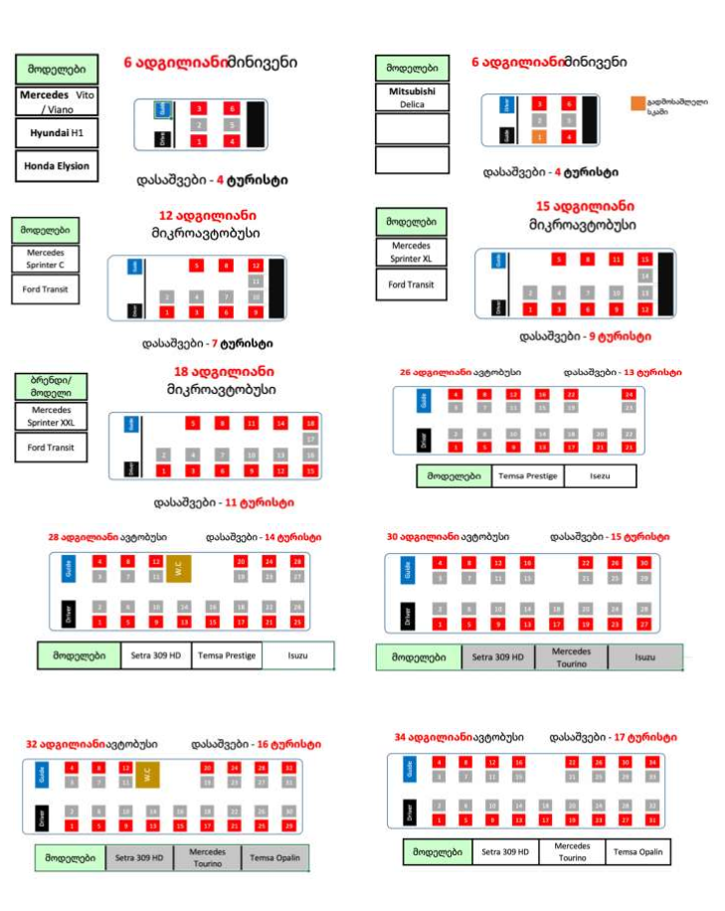
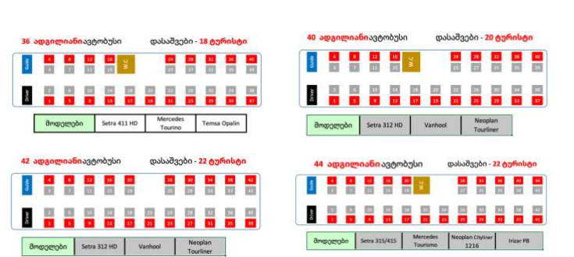
Note: If another vehicle that is not specified in this Annex is used for tourist purposes, the requirements for the vehicle category specified in this Annex shall apply.

For additional information please call us:

