Project ECHO and Coronavirus

As the coronavirus COVID-19 continues to spread around the world, Project ECHO, a global U.S.-based telementoring platform, is playing an important role in how public health officials, scientists, and health care workers here and abroad share best practices and information for addressing COVID-19 and coordinate their responses:

Coordinated by ECHO Institute at HSC UNM
- (Upcoming) March 27, MetaECHO Community call to discuss with partners nationally and globally how they are planning to respond and how the ECHO Institute can be of assistance.
- (Upcoming) Ongoing, inclusion of didactics on COVID-19 response as topics in existing teleECHO community sessions (including HCV, Rheumatology, Antimicrobial Stewardship, and Endocrinology)
- (Upcoming) March 26, ECHO will support the second weekly Indian Health Service national COVID19 weekly ECHO session.
- (Upcoming) March 24, ECHO will support an HHS/ASPR hosted COVID-19 CLINICAL ROUNDS: LIFESAVING TREATMENT AND OPERATIONS. This national COVID19 clinical learning initiative will engage the membership of many of the leading medical professional societies in the United States both as subject matter experts and participants.
- (Upcoming) March 23, Special One Health Covid-19 Response ECHO Session for SEAOHUN Members, including SEAOHUN Secretariat Jonna Mazet, and experts from the CDC. This program will be conducted as part of the One Health Consortium.
- (Upcoming) March 23, Special One Health Covid-19 Response ECHO for AFROHUN members, including AFROHUN Secretariat Jonna Mazet and leading experts from CDC, WHO, and ICAN.
- (Upcoming) Series of CHW ECHOs planned in conjunction with the UNM Office of Community Health Workers, focused on CHWs and frontline staff (English and Spanish sessions available)
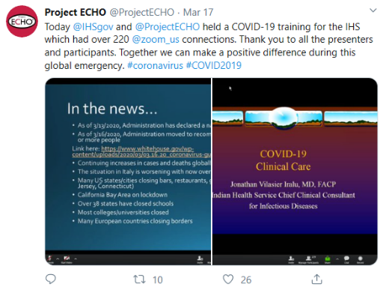
- On March 19, New Mexico Departments of Health and Health and Human Services will host jointly with the ECHO Institute a statewide training focused on COVID-19 response for the New Mexico ECHO community of healthcare workers. Key didactics from this session will be repeated next week with University of New Mexico available to answer questions and discuss cases.
- On March 16, the ECHO Institute was invited to support an Indian Health Service hosted a COVID-19 ECHO all hands-on deck session for IHS healthcare workers.
- On March 12, the U.S. Centers for Disease Control and Prevention (CDC) COVID-19 International Task Force conducted a 90-minute COVID-19 ECHO education session for the Department of Defense’s global HIV network of providers and their counterparts from other countries. An estimated 200 participants from over 30 countries participated representing medical staff who support the public health response capabilities in the countries where they work.
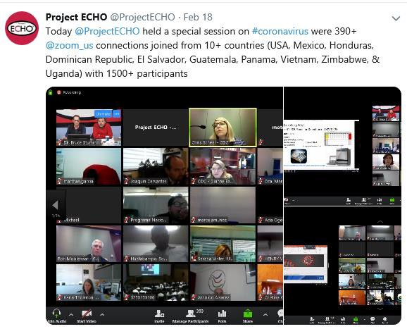
- The CDC COVID-19 International Task Force is also exploring developing an ECHO program to support the global network of laboratories that will receive the CDC-produced COVID-19 diagnostic kits.
- On Feb. 18, Project ECHO co-hosted a special virtual learning session with the CDC on COVID-19 that connected almost 400 sites in 20 countries in the Americas, Africa and Asia. Experts in epidemiology, laboratory diagnosis, infection control and prevention, and clinical management led the session, in which 1,000 to 2,000 health providers and key stakeholders participated.

Coordinated by U.S. ECHO Partners (Examples not complete, growing daily):

- Beginning March 23rd, University of Missouri, Telehealth, launching an on-going COVID-19.
- Beginning March 20th, Penn State University, College of Medicine, launching an on-going COVID-19 ECHO.
- Beginning March 19th, Oregon ECHO in conjunction with OHSU, launching an 8 session COVID-19 ECHO.
- Ongoing, University of Chicago, integrating didactics on COVID-19 into existing ECHO programs.
- Beginning March 26, University of West Virginia, integrating COVID-19 focus into existing programs.
- Beginning March 30, AAP, planning to launch a COVID-19 ECHO.
- Beginning March 20th, Oklahoma State University, launching 3-times per week COVID-19 ECHO for their community (hospital association, long term care facilities, military, national guard).
- Ongoing, CHC Inc. national COVID-19 ECHO for healthcare centers.

Coordinated by International Partners

Africa:
- Ongoing, Infection Control Africa Network (ICAN) is providing training on COVID-19 to its existing ICAN ECHO network.
- Ongoing, Côte D’Ivoire’s HIV focused ECHO is using their network to support COVID-19 training.
- March 20, The Namibian Ministry of Health and Social Services HIV ECHO held a special presentation on COVID-19, joined by healthcare workers at over 40 sites around the country.
- As of March 18, the Zambia Ministry of Health is incorporating COVID-19 education into their regular HIV ECHO Sessions. The first session provided an overview of the epidemiology, screening and testing, management, containment, and preparedness for their 60+ spokes

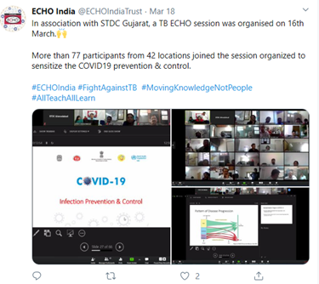
Asia: 11 partners
- Ongoing, Punjab, India. Existing HCV ECHO network using existing community to train providers around COVID 19.
- Ongoing, regular trainings by Piramal Swasthya Management & Research Institute on COVID-19 preparedness (7 sessions conducted, 2 planned)
- Ongoing, the National Institute for Tuberculosis and Respitory Diseases (NITRD) and state TB ECHO programs in Gujarat and Tamil Nadu have each conducted one session on COVID-19, more sessions planned.
- March 19th, Epidemic preparedness session hosted by GMER (ECHO Hub).
- March 19, Queensland University (Australia), collaborative of Australian ECHO programs to discuss how collectively they can respond to COVID-19 and support the government’s efforts.
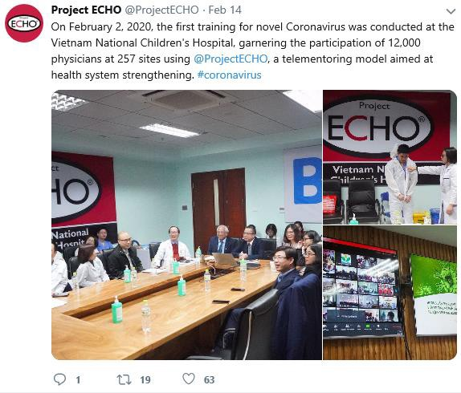
- March 16, ECHO India in conjunction with SDCT Gujarat used ECHO network on TB to train healthcare workers on COVID-19.
- On Feb 2nd, the National Children’s Hospital in Hanoi, an ECHO partner, conducted a special COVID-19 education and training session that connected more than 12,000 health care workers in 250-plus hospitals in northern Vietnam as part of COVID-19 preparedness efforts.
Europe
- March 12, more than 200 staff and leaders from hospices around the UK, part of Hospice UK’s ECHO network, joined a community call to discuss how they will respond to COVID-19.

More About Project ECHO:
TeleECHO sessions bring together teams of multi-disciplinary specialist experts who share best practices with health care workers on the front lines of containing and treating infectious disease. In turn, specialists learn about new and emerging best practices from those very same workers in the field. Project ECHO has also organized programs to prepare for and respond to outbreaks of H1N1, Rocky Mountain spotted fever, and Hanta virus in the United States; Zika in Puerto Rico and the Pacific Island territories; and Ebola in Africa.

Project ECHO is a global, telementoring organization that expands access to treatment for complex and chronic health conditions in rural and underserved communities. Based at the University of New Mexico Health Sciences Center, Project ECHO has more than 380 partners in 48 states and more than 35 countries.

For more information, please contact Elizabeth Clewett at eclewett@salud.unm.edu or 505-272-6859.

