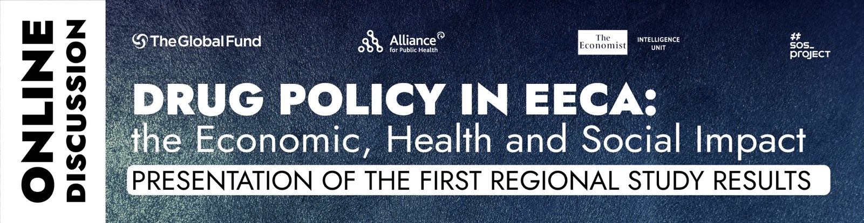
AGENDA
March 10, 2021 / Time: from 10 AM to 1 PM (EET, UTC +2) or from 9 AM to 12 PM (CET, UTC +1)
JOIN to DISCUSSION: https://youtu.be/g2h53bXlVFw
The webinar is dedicated to the presentation of the report "Drug Control Policies in EECA: The Economic, Health and Social Impact", which was prepared based on the results of a study conducted by the Economist Intelligence Unit with the support of the Alliance for Public Health in 2020. The study was conducted in 4 countries of the region: the Russian Federation, Belarus, Kazakhstan and Kyrgyzstan. The report contains data on the economic and social impact of the current drug policy, as well as the impact on public health.

The uniqueness of the report is that it provides data on the economic impact of the current drug policy, showing how much money countries are spending while continuing the existing approach and practices. It also provides predictive data on drug policy changes in countries. This is the first study of its kind in the EECA region.

The purpose of the webinar: presentation of data from a report on the economic and social consequences of existing drug policies in EECA countries and forecasting the impact of possible changes in policies.
In addition to the presentation of the report data, we look forward to discussing possible changes in EECA countries and planning possible advocacy priorities for 4 countries of the region.

time | sessions
10:00—10:20 | Welcoming words, aims and objectives of the webinar  -- Andriy Klepikov, Executive Director of the Alliance for Public Health  -- Aleksander Kwasniewski, ex-President of Poland, Global Commission on drug policy  --Peter Sands, Executive Director of the Global Fund  Olena Kucheruk--moderator
10:20—10:50 | Presentation of the report “Drug Control Policies in EECA: The Economic, Health and Social Impact”  -- Chrissy Bishop, Editor, the Economist Intelligence Unit  Questions, discussion
10:50—11:30 | Discussion on the report  --Professor Michel Kazatchkine, Global Commission on drug policy  --Zhannat Kosmukhamedova, Head, Regional Programme Office for EECA region, UNODC  --Vladimir Pozner, journalist, Russian Federation
11:30—12:30 | Current state in 4 countries: discussions for EECA countries  Russian Federation  -- Peter Meylakhs, Ph.D., Senior Research Fellow Higher School of Economics, St. Petersburg  -- Anna Sarang, expert on drug policy, Andrey Rylkov Foundation  -- Arseniy Levinson, lawyer, human rights activist  Kazakhstan  -- Oksana Ibragimova, Kazakhstan Union of People Living with HIV  Kyrgyzstan  -- Timur Isakov, State Committee on drug enforcement control, Government of Kyrgyzstan, colonel of Police  -- Erkinbek Iriskulbekov, Economical faculty of the International University of Kyrgyzstan, lawyer, human rights activist, expert on drug policy  Belarus  -- Alexey Aleksandrov, chief doctor Minsk clinical narcology, Belarus  -- Anatoliy Pospelov, “Positive action”, Belarus
12:30—12:40 | Summarizing and closing

