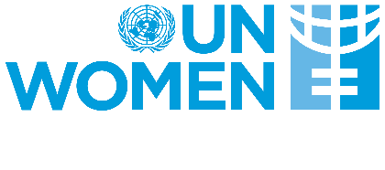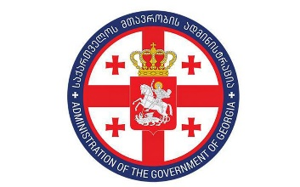

National-level Review of the Implementation of the Beijing Declaration and Platform for Action Beijing +25

Presentation of the Draft Report

Time: April 30,2019
Venue: Holliday Inn, Tbilisi, Georgia

AGENDA

14:30 – 15:00 | Registration
15:00 – 15:10 | Introduction and welcoming remarks  - Gocha Lortkipanidze - Deputy Minister of Justice / Co-chair of the Inter-Agency Commission on Gender Equality, Violence against Women and Domestic Violence Issues  - Tamar Sabedashvili - Deputy Country Representative of UN Women in Georgia
15:10-15:30 | National-level Review of the Implementation of the Beijing Declaration and Platform for Action Beijing +25 - Presentation of the Report  - Irina Lortkipanidze – Expert of Inter-Agency Commission and UN Women
15:30 – 16:30 | Discussion
16:30 | Wrap up & Closing remarks

