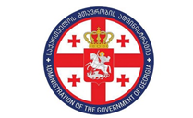 | 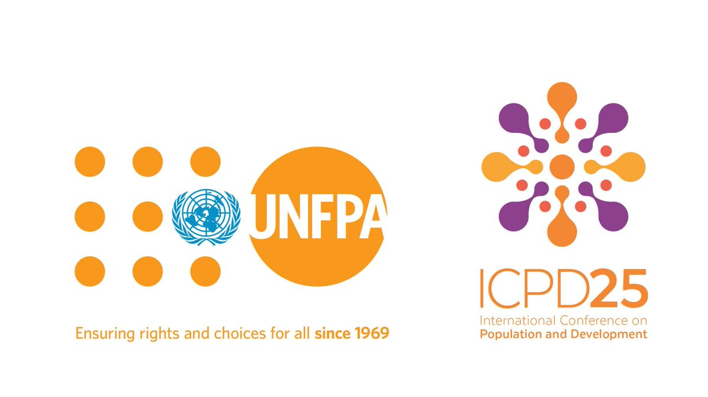 | 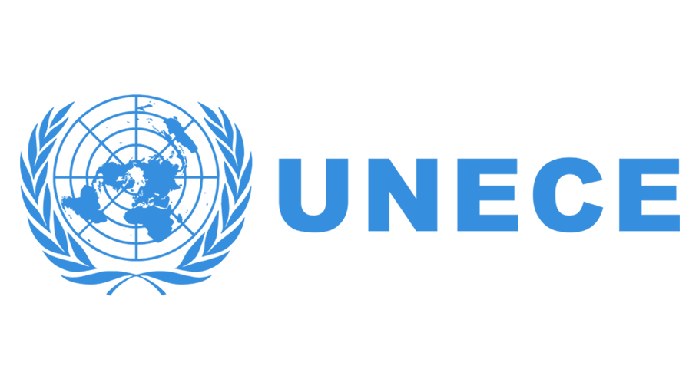

Regional Conference

Population Dynamics and Evidence-based Population Policies in the Eastern Europe and Central Asia Region
14 June, 2019
Sheraton Grand Tbilisi Metechi Palace, Georgia
20, Telavi Street, Tbilisi, Georgia

Concept Note

Background
The year 2019 marks a double anniversary to commemorate 25 years of the International Conference on Population and Development (ICPD) agenda and to celebrate UNFPA’s 50th anniversary. In 2019 UNFPA Country Office in Georgia also celebrates 20 years’ anniversary of its support to the country’s development.
UNFPA Country Office in Georgia in close collaboration with the UNFPA Regional Office for Eastern Europe and Central Asia has initiated the regional conference to mark these important anniversaries by reinvigorating the regional dialogue on population dynamics and evidence-based population policies in the countries of the region.
This regional dialogue and its recommendations are perceived as an important milestone in the Regional Roadmap to the Nairobi Summit on ICPD25: accelerating the promise. This global summit, to be held in November 2019, will offer an inclusive platform bringing together governments, UN agencies, civil society, private sector organizations, women’s groups and youth networks to discuss and agree on actions to accelerate the implementation of the ICPD Programme of Action, which is critical to achieving the UN’s Sustainable Development Goals (SDGs) by 2030.
The Regional Conference will host the What’s Changed conversation – as part of a series of thought leadership conversations on ICPD, organized by UNPFA globally, leading to the Nairobi Summit in November, 2019. This conversation aims at generating unique knowledge base drawing on the insights of leading ICPD experts and people at the community level delivering the ICPD agenda, as well as creating a new understanding of how ICPD commitments must be fully realized and also adapted to current realities. The conversation will be shaped around key thematic areas of the ICPD Programme of Action and gains made in the realization of sexual and reproductive rights.
Population Dynamics in the Region
A rising number of countries in the region face rapid population ageing and negative population growth, driven by longer lifespans, below replacement fertility and, in some countries, the out-migration of young people. It is well established, that population issues and dynamics have critical implications for sustainable development. Population dynamics are strongly inter-linked with development issues such as poverty reduction, gender equality, the aspirations of young people, and sexual and reproductive health.
Increased burden of Non-Communicable Diseases (NCDs) is another important area having an impact on population dynamics globally, including in Eastern Europe and Central Asia region. This is a phenomenon that almost universally accompanies advances in longevity and “modernization”. NCDs tend to result in chronic illnesses (diabetes, cardiovascular diseases, cancer) that are often incurable and require lifelong and expensive treatment, as well as result in lost of productive labor. The basis for these health issues is laid in early and middle ages, and their prevention is by far the most cost-effective remedy by applying “healthy ageing” approach.
Understanding population dynamics is essential as societies around the world strive to achieve the ambitious and holistic Sustainable Development Goals (SDGs). Taking a human-rights based approach – seeing the individual, their needs, rights and potential – beyond the mere numbers of population trends is a fundamental part of this process.
The ICPD+25 regional review, undertaken in 2018, highlighted major population and development trends affecting the region, among those:
- continued low fertility in large parts of the region, with fertility rates below replacement levels in the majority of countries; populations are projected to decline in 20 countries by 2030, and in 10 of them by 15% or more by 2050;
- increasing life expectancy and population ageing: by 2023, the region’s population aged 65+ will outnumber children (0-14 years) for the first time;
- low levels of participation in education and training among older workers (5% of women and 4% of men aged 55 to 74), revealing barriers to lifelong learning and unrealized potential;
- high rates of youth not in education, employment or training (NEET);
- transformations in family formation, with trends towards cohabitation, single-parent families and reconstituted families, among others;
- minority groups, including ethnic minorities and persons with disabilities, continue to face persistent exclusion, material deprivation and inferior educational and health outcomes compounding over the life course.
Faced with these prospects, many governments started implementing policies aiming to support families and address ageing issues. However, the demographic and development policies that governments put in place in response to the population challenges are not always based on evidence, and in some cases infringe upon the rights of individuals to have the numbers of children they desire - a fundamental principle which guides UNFPA’s approach in these matters.
Population Dynamics and Policies in Georgia
In the coming decades, Georgia, as many other countries of the region, will experience continuing population decline and population ageing. According to the United Nations Population Division (UNPD), the share of the Georgian population aged 65 years and above is projected to grow from 14% in 2015 to over 19% in 2030. The major demographic mechanisms of changes in population structure and population ageing in Georgia during the recent decades have been low fertility and emigration. At the same time, however, this mechanism provides a foundation for the ‘first demographic dividend’. While Georgia has relatively high old age dependency ratio, low fertility contributes to a total dependency ratio that will remain at a fairly low level for several years to come. While Georgia’s ‘window of demographic opportunity’ is expected to close within the next decade, it still presents opportunities for introducing appropriate policy measures to mitigate the negative effects of demographic ageing and population decline in the future. More so, the right policy mix could result in a “second demographic dividend” for Georgia, whereby savings and assets of the older generation constitute a basis for productive investments.
The Government of Georgia has recognized population dynamics issues as a priority for the country's development and has addressed it in two major policy documents elaborated with UNFPA technical support and adopted by the Parliament: The Demographic Security Concept of Georgia (2016) and The Concept of State Policy on the Issue of Aging in Georgia (2016).
UNFPA’s Support in the Area of Population Dynamics
UNFPA’s work in the countries of the region aims to further strengthen the capacity for quality data collection, analysis and utilization in policy making and programming around population issues, ageing, gender equality and reproductive health, including data in humanitarian settings. UNFPA also supports the introduction of evidence-based policies and services to promote healthy and active ageing. To strengthen the capacity for analysis of population dynamics and inter-linkages and to support policy analysis, UNFPA collaborates with academia and regional institutions active in the population and development field.
To further strengthen evidence-based population policy formulation, UNFPA, in collaboration with leading experts from the Vienna Institute of Demography (Austrian Academy of Sciences) / Wittgenstein Centre for Population and Global Human Capital will issue an analytical report that aims to summarize the available evidence on the effects of family policies on fertility rates through combining literature review with empirical illustrations for selected countries and policy interventions and showing the complexity of the policy-fertility links.

The objective of the Conference
The objective of the conference is to support enhanced understanding of the current population dynamics and trends in the region, including ageing, and of the status of policies and initiatives addressing these dynamics in the countries of the region. It is expected that through exchange of scientific evidence and good practices the evidence-based and people-centred policy making on population and development issues will be strengthened in the countries of the region.
The one-day conference will be co-organized by the UNFPA Country Office in Georgia, the UNFPA Regional Office for Eastern Europe and Central Asia and the United Nations Economic Commission for Europe (UNECE) in partnership with the Administration of the Government of Georgia.

Participants
Participants of the conference will be representatives of relevant government entities, academia, civil society organizations, international organizations from the countries of Eastern Europe and Central Asia Region; representatives of UNFPA Regional and Country Offices; invited international experts.

Agenda
08:30 - 09:00 | Registration of participants
09:00 – 09:30 | Opening of the Conference  Mr. Kakha Kakhishvili, Head of the Administration of the Government of Georgia (TBC);  Ms. Tamar Gabunia, Deputy Minister of Internally Displaced Persons from Occupied Territories, Labour, Health and Social Affairs of Georgia;  Ms. Sabine Machl, UN Resident Coordinator in Georgia;  Mr. Karl Kulessa , UNFPA Representative in Turkey, Country Director for Azerbaijan and Georgia.
09:30 – 10:30 | WHAT'S CHANGED?  Thought Leadership Conversations on ICPD:  What has changed in the past 25 years?  Fertility, families and women's empowerment  Moderated by Mr. Ian McFarlane, Deputy Director, UNFPA Regional Office for Eastern Europe and Central Asia  Panelists:  Mr. Tomas Sobotka, Vienna Institute of Demography (Austrian Academy of Sciences) / Wittgenstein Centre for Population and Global Human Capital  Mr. Akaki Zoidze, Chair of the Parliament Committee on Healthcare and Social Issues, Georgia  Mrs. Zhanna Andreasyan, Deputy Minister of Labour and Social Issues, Republic of Armenia  Dr. Lia Nadaraia, President of Caucasian Feminist Initiative, Vice-Chair for Eastern Europe of UN CEDAW Committee.  Discussion
10:30 – 11:00 | Break, refreshments, press inquiries
11:00 – 12:30 | Session I - Enhanced Implementation of ICPD to achieve SDGs  Moderator: Ms. Sabine Machl, UN Resident Coordinator in Georgia
11:00 – 12:30 | Population Dynamics and Sustainable Development agenda in the region - strengthening human capital over the life-course and well-being  Mr. Tomas Sobotka, Vienna Institute of Demography (Austrian Academy of Sciences) / Wittgenstein Centre for Population and Global Human Capital
11:00 – 12:30 | The role of non-communicable diseases prevention in shaping demographic dynamics  Dr. Amiran Gamkrelidze, General Director, National Centre for Disease Control and Public Health, Georgia
11:00 – 12:30 | Ukrainian Pact for Youth  Mr. Oleksander Yarema, Deputy Minister of Youth and Sport, Ukraine
11:00 – 12:30 | Youth Policy in Georgia – progress and ways forward  Ms. Irina Pruidze, MP, Committee on Sports and Youth Issues of the Parliament of Georgia
11:00 – 12:30 | Discussion on countries’ experience and the way forward
12:30 – 13:30 | Lunch, group photo
13:30 – 14:30 | Session I - continued  Moderator: Mr. Karl Kulessa, UNFPA Representative in Turkey and Country Director for Georgia
13:30 – 14:30 | Gender responsive family policies and male involvement  Dr. Nigina Abaszade, Regional Technical Adviser – Gender, UNFPA Eastern Europe and Central Asia Regional Office
13:30 – 14:30 | Women supportive policies - the role of the private sector in promoting women’s economic empowerment  Ms. Sevda Alkan, Coordinator of the Business Against Domestic Violence project, Sabancı University - Corporate Governance Forum, Turkey
13:30 – 14:30 | Discussion on countries’ experience and the way forward
14:30 – 14:40 | Technical break
14:40 – 15:45 | Session II  Opportunities for the ageing societies  Moderator: Dr. Alexandre Sidorenko, Senior Advisor, European Centre for Social Welfare Policy and Research (Vienna, Austria).
14:40 – 15:45 | Ageing trends and policies in the UNECE Region  Ms. Vitalia Gaucaite Wittich, Chief of Population Unit, United Nations Economic Commission for Europe (UNECE), Statistical Division (on-line)
14:40 – 15:45 | Ageing on the Policy Agenda in Moldova  Ms. Aljona Cretu, Deputy Minister of Health, Social Protection and Family  Republic of Moldova [TBC]
14:40 – 15:45 | Pension Reform in Georgia  Ms. Ekaterine Mikabadze, Deputy Minister of Economy and Sustainable Development of Georgia
14:40 – 15:45 | Discussion on countries’ experience and the way forward
15:45 – 16:15 | Break - refreshments
16:15 – 17:30 | Session II - continued  Moderator: Eduard Jongstra, Regional Advisor, UNFPA Eastern Europe and Central Asia Regional Office
16:15 – 17:30 | Good Practices and Initiatives for Promoting Healthy Ageing  Healthy Ageing Centres in BiH  Ms. Sejdefa Basic-Catic, Director of the NGO Partnership in Public Health, BiH  Healthy Ageing Initiative in Georgia  Ms. Nana Bagalishvili, Head of the NGO “Civic Initiative”, Georgia
16:15 – 17:30 | Discussion on countries’ experience and the way forward
17:30 – 18:00 | Closing Remarks  Mr. Akaki Zoidze, Chair of the Parliament Committee on Healthcare and Social Issues, Georgia  Mr. Ian McFarlane, Deputy Regional Director, UNFPA Eastern Europe and Central Asia Regional Office

https://eeca.unfpa.org/en/publications/fulfilling-potential-present-and-future-generations

