UNECE Guidelines on Mainstreaming Ageing

Zero Draft

July 2020

Guidelines on Mainstreaming Ageing

Zero Draft

Table of Contents

Part I – Why Guidelines on Mainstreaming Ageing?

  - Population Ageing Challenges and Opportunities 6
  - Mainstreaming Guidelines .9
    - Purpose of the guidelines 10
    - Target users 10
  - Mainstreaming Ageing 11
  - Key international frameworks and initiatives 11
  - What is mainstreaming ageing? 13
  - The need for a holistic approach to mainstreaming ageing 17
3.0 Developing a ‘Strategic Framework on Mainstreaming Ageing’ 18
  - Methodology and generic principles 21
  - Work Process 21
  - Literature and document review 21
  - Selection of cases 21
  - Consultation 22
  - Generic principles 22
    - A holistic and systematic approach 23
    - Adaptable and Accessible 23
    - Outcome and Evidence-based 23
    - Promoting efficiencies and offering practical approaches 23
4.6 Glossary and concepts 24
Part II - Towards a Strategic Framework for Mainstreaming Ageing
Module 1 – Getting Started 27
Introduction 27
Potential challenges 31
Getting started – Suggested Activities 32
Checklist 36
Module 2 – Analysis 37
Introduction 37
Potential challenges 40
Analysis – Suggested Activities 40
Checklist 47
Module 3 – Mainstreaming Strategy 48
Introduction 48
Potential challenges 52
Mainstreaming Strategy – Suggested Activities 52
Checklist 60
Module 4 – Identification of Activities 61
Introduction 61
Potential challenges 63
Identification of Activities – Suggested Activities 64
Checklist 73
Module 5 – Monitoring and Evaluation 74
Introduction 74
Potential challenges 76
Monitoring and Evaluation - Suggested Activities 76
Checklist 80
Part III - Conclusion
  - Summary 82
  - Modules – Suggestions and outcomes 83
  - Completing the Strategic Framework for Mainstreaming Ageing 84
Annexes 85

Abbreviations

AAI Active Ageing Index COVID-19 Corona Virus Disease 2019 CSO Civil Society Organization
ECOSOC Economic and Social Council
GNAFCC Global Network of Age-friendly Cities and Communities HRBA Human Rights-based Approach
HRBAD Human Rights-based Approach to Data
ICPD International Conference on Population and Development LNOB Leaving No One Behind
MIPAA Madrid International Plan of Action on Ageing MOU Memorandum of Understanding
MSP Multi-Stakeholder Partnership
OEWGA Open-Ended Working Group on Ageing PoA Programme of Action
SDG Sustainable Development Goal
RIS Regional Implementation Strategy
TOR Terms of Reference
UN DESA United Nations Department of Social and Economic Affairs UNECE United Nations Economic Commission for Europe
UNFPA United Nations Population Fund WGA Working Group on Ageing
WHO World Health Organization

Part I

Part I - Why Guidelines on Mainstreaming Ageing?

Over the next three decades, the global number of older persons is projected to more than double, reaching over 1.5 billion persons in 2050, with a considerable share of the world’s older persons living in the UNECE region. Population ageing has strong implications across all spheres of society. It poses both challenges and opportunities that are complex and interlinked and call for countries to plan and recognize the need for transformative solutions to prepare for an ageing population.

Over the past decades, various efforts to mainstream ageing have emerged in the UNECE region. However, a holistic approach to mainstreaming ageing remains unchartered territory. In response to the demographic changes it is essential to mainstream population ageing and take into consideration the needs of older persons into societies and economies. Mainstreaming ageing has the potential to achieve better integration of the needs of older people and all age groups into the policymaking process. It can empower older persons to contribute to society, communities and families as much as other age groups do. Ultimately, this should help bring economies and societies in harmony with demographic change and support achieving a ‘society for all ages’.

Transforming towards societies “for all ages” requires a twin-track approach that considers: i) population ageing and the need for societies to prepare and adapt to it, and ii) individual ageing and the specific needs of older persons. Mainstreaming both at the same time calls for a holistic cross-cutting approach that is inclusive, life-course oriented and builds on the participation of relevant government- and non-governmental stakeholders, especially older persons themselves. To implement this approach these guidelines encourage the development of a ‘Strategic Framework for Mainstreaming Ageing’ through 5 Modules. The Modules help pursue mainstreaming of ageing in a holistic manner and aim to address the opportunities and challenges that come with population ageing.

Population Ageing Challenges and Opportunities

With an increasing life expectancy and low or declining fertility, the UNECE region is faced with ageing populations and a large share of its population is approaching retirement. By 2050, one in four persons living in Europe and Northern America is expected to be aged 65 or over. At the same time the proportion of the working-age population is expected to decrease markedly in many of the region’s member States.

Population ageing can be considered a triumph in terms of medical, social and economic advancement and carries a number of opportunities. Older persons continue to contribute to economic, social and family life in many ways, which – when applied effectively – can benefit societies significantly. At the same time, the numbers suggest the potentially strong impact on the labour market and economic performance as well as fiscal pressures that many countries will face. Population ageing will increase the fiscal pressure on support systems and public transfers, challenging social security and social protection systems, labour markets, as well as family and intergenerational relations. In order to respond to this reality, there is a need for societies to anticipate and adapt to the social and economic implications of population ageing.
Longevity offers significant potential for the economy and society that has not yet been fully realized. In addition to contributing to society, the realization of longevity is critical from an individual perspective as self-realization, self-determination and healthy ageing optimize well-being and the quality of life in later life. As individuals, older persons make important contributions to families, communities and society in general. They add value to the economy as entrepreneurs and employees. They contribute to society as consumers by e.g. stimulating innovations and creating new markets. And they play important roles as volunteers and through their participation in civil society organizations. Furthermore, they take on responsibilities as unpaid care and support for their families. Investments in various domains are needed to reap the benefits of ageing societies, such as health promotion, lifelong learning, increased labour market participation, flexible retirement, access services and creating supportive and enabling environments (Box 1.1)

Box 1.1 Policy fields affected by ageing
Ageing populations impact a wide range of sectors that require specific attention. Finding sustainable solutions to population ageing calls for policy responses in, among others, the following areas:
Health
The increasing ageing population comes with a growing need for long-term care. At the same time, the number of those making up the working age population, who will be able to provide care, will decrease. Ensuring the sustainability of long-term care systems and a qualified workforce are key elements in securing a high quality of long-term care and protecting human dignity in an ageing society. This has become even more evident in light of the COVID pandemic.
Health is an important enabler of the contributions older persons make. However, data also show that additional years gained might not be lived in good health. Between 2005-2015 average life expectancy at age 55 for both women and men increased, respectively 1.6 and 1.8 years in the UNECE region. Healthy life expectancy however, only increased by 0.3 years for men and 0.1 years for women. Personal lifestyles at all ages, and public policies and environments that promote healthy ageing can help address this gap and prevent or delay disability in older age. Investment in health promotion and in preventive healthcare practices can enhance well-being and prolong the years that a person can contribute to the community and live independently, overall reducing the need for health care treatments and long-term care.
Employment
In many UNECE countries the average actual retirement age is below the statutory retirement age, which means the labour market is losing a great deal of resources in terms of experience and labour capacity of older workers. Ageing societies, however, cannot afford to lose the highly valuable resource of older persons. Policy measures that promote the employment of older persons include the promotion of lifelong learning, the provision of tailored employment assistance, and measures to encourage employers to hire and retain older workers. Examples include information campaigns that highlight the value of older workers and age diversity to businesses, financial incentives, and regulation against age- based discrimination employment.
Housing
Ageing populations call for provisions in the area of housing. In many cases older persons live independently, which is often the preference. Supporting independent living may require measures that enable older persons to stay at home, such as adapting houses to the needs of older persons, meal- or household assistance or as remodeling homes to remove barriers. To avoid unnecessary institutionalization of older persons who require assistance, families should be empowered to provide care and support. In addition applying the concept of ageing in place, measure that support independent living can include; provision of affordable housing, applying smart technologies for independent living as well as ensuring secure home environments, safe and functional homes for independent living, energy efficiency in buildings to enhance comfortable living environments.
Transport
Transportation is crucial for maintaining social connections, participate in communities and accessing health and social services. In addition, mobility enhances physical- and mental health, enabling older persons to enjoy life and defer the onset of disability and dependence. Many older persons with reduced mobility cannot be self-sufficient without transportation. The growing ageing population therefore call for a need to develop sustainable, smart and age-friendly transport and reset planning priorities to make public transport acceptable, available, affordable and accessible as well as safe and secure for all.

All in all, older persons are an important asset in achieving sustainable and inclusive societies if adequate measures are in place. In spite of this potential, issues concerning ageing societies and older persons still suffer from a lack of attention and resources (Box 1.2). Older persons are often overlooked, and their concerns and needs are at risk of being left unaddressed. Many older persons continue to face challenges related to poverty, violence, abuse and discrimination on the grounds of age, gender, ethnic background, religion, disability and others undermining their fundamental rights. Addressing these challenges and overcoming negative stereotypes and ageism therefore calls for solutions that; respect human rights of all generations, are gender equitable, economically sound and generationally just. This requires a clear understanding of the situation, conditions and needs of older persons to ensure that everyone can age with dignity.

A comprehensive response to these developments has become even more urgent in light of the COVID-19 pandemic. The pandemic is anticipated to have long-lasting consequences for societies requiring specific attention to ageing-related policies and programmes. Early figures of the impacts of the pandemic revealed that fatality rates for those over 80 years of age, is five times the global average. Whilst older persons not only face higher fatality rates, they also are at greater risk of poverty, discrimination and isolation as a result of the pandemic. The many challenges and consequences of COVID-19 call for short- and long-term policy responses at the national- and local level. It calls on the need for humanitarian and economic responses to take into consideration the needs of older persons and puts in perspective a number of questions related to; national health and care systems; emergency response; intergenerational solidarity; community support; mental health impacts as well as the rights of older persons.

As various ageing-related challenges and opportunities are complex and interconnected, they should be addressed in all policies, programs and practices. Therefore, in order to prepare for ageing societies and to address the needs of older persons, increased prioritization and a comprehensive approach to mainstreaming ageing is needed. In many cases, current societal structures and measures are not fully prepared for the impacts, opportunities and benefits that come with population ageing. These are often addressed by ad hoc and fragmented efforts and traditionally approached from a health perspective only. As population ageing and the needs of older persons cut across various domains, systematically mainstreaming ageing is needed to prepare for ageing populations and at the same time allow older persons fully realize their potential and age with dignity.

Box 1.2: Key issues

Poverty in old age
While many successes in reducing poverty in old age were obtained over the past decades, it is widely acknowledged that older persons – especially older women - are at greater risk of falling into poverty. On average, the poverty level for persons among the 75+ year old group across OECD countries is 14.7 per cent, which is 3.5 percentage points higher than the poverty level among 65-74 years old. The aged 80+ are less able to work, more likely to have spent their savings and are among the most in need of care services. Poverty in old age is both a social and fiscal problem that is likely to increase as populations continue to age. Mitigating the consequences of poverty at the individual and societal level can among others be addressed through mainstreaming ageing and gender concerns. For more information: ‘Income Poverty in Old Age, UNDESA)
Gender equality in ageing societies
Women across the UNECE region have a longer life expectancy than men and predominate among the older age group. The different gender roles shape their lifetime opportunities and experience of ageing unequally. Ageing impacts men and women differently including intersecting discriminations leading to inequalities disadvantaging predominantly older women. Gender inequality in old age is for instance manifested by a greater risk of poverty, which is higher among older women than older men due to e.g. disparities in the labour market. A comprehensive and gender responsive societal adaptation to population ageing can ensure that the opportunities and risks of ageing will be equally shared by women and men, and that women and men can age equally. For more information: UNECE Policy Brief: Gender equality in ageing societies, 2020)

Ageism
Ageism is the stereotyping, prejudice and discrimination against people based on their age. It often has significant impacts and/or can have harmful effects on older persons. Ageism occurs in various contexts such as, at the labour market, by the financial service sector or through the media. Ageism negatively affects health and well-being and can reduce life expectancy. Its complexity and intersectionality call for a comprehensive and multisectoral policy response at all levels of society. For more information:
UNECE Policy Brief, ‘Combating ageism in the world of work’

Abuse of older persons
Abuse of older persons is a serious societal problem that often goes undetected. Abuse of older persons is associated with various consequences impacting older persons individually as well as societies. Abuse can range from criminal offences, to acts that cause harm to an older person. It can occur in both formal and informal settings. Common forms of abuse include: physical-, psychological-, sexual-, and financial/material abuse, as well as (self-) neglect and discrimination. With the ageing population, elder abuse is inclined to increase, adding urgency to respond. For more information: UNECE Policy Brief: Abuse of older persons

Mainstreaming Guidelines

In response to the challenges and opportunities that come with population ageing the mainstreaming guidelines were developed in the form of five Modules. The Modules support countries in establishing a ‘Strategic Framework for Mainstreaming Ageing’ through including preparation, analysis, identification of strategic goals and objectives, activities as well as monitoring and evaluation of the framework (Box 1.3). All together the Modules help pursue mainstreaming of ageing in a participatory and holistic manner aimed at reaping the opportunities and addressing challenges that come with population ageing. Chapter 3 provides a detailed description of each Module.

Box 1.3: Modules to support the Strategic Framework for Mainstreaming Ageing
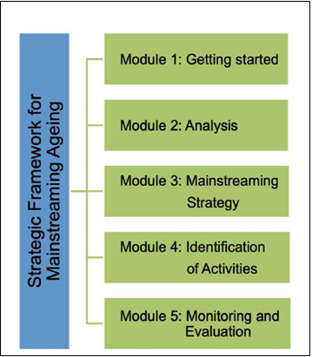

Purpose of the guidelines

The purpose of the guidelines is to support policy makers in developing a holistic, cross-cutting, coordinated and coherent approach to ageing-related policies in order to respond effectively to the challenges, and seize the opportunities, related to individual and population ageing.

A strategic approach to mainstreaming ageing across all policy fields at all levels of government, as recommended in these guidelines, can help ensure that enabling factors such as political commitment and stakeholder buy-in, coordination and collaboration between concerned line ministries and other actors, enhanced knowledge, resources and capacity for mainstreaming are fostered.

The development of a strategic framework for mainstreaming ageing forms the backbone of a comprehensive forward-looking and effective response to both population ageing and the needs of older persons (Box 1.4).

Box 1.4: Twin-track approach to mainstreaming ageing

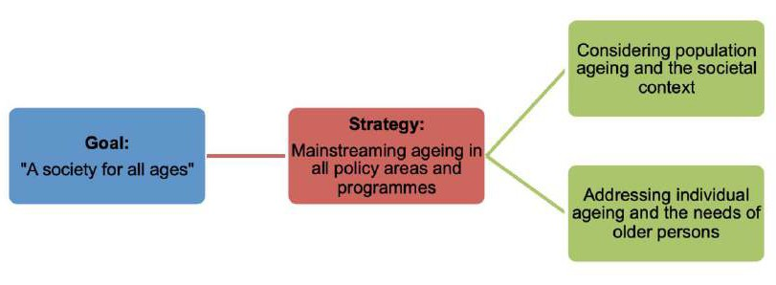

Target users

The guidelines are developed for policymakers that envisage to mainstream ageing across and at all levels of government and society in a participatory manner. Depending on the country context and institutional structures, main users can include staff responsible for ageing issues such as; national focal points on ageing, experts and officials from line-ministries and government agencies at the national and sub-national level, officers from National Statistical Offices/Bureaus of Statistics.

As the guidelines support a participatory and inclusive process, the guidelines can be useful for stakeholders and other groups such as: social partners, civil society organizations, academia, think tanks, and representatives from the private sector.

Mainstreaming Ageing

Mainstreaming ageing is a policy strategy directed towards integrating ageing issues into all relevant policy fields at all levels. This helps to ensure better integration of the needs of all age groups into the policy making process. Over the past decades, the importance of mainstreaming ageing has been recognized in respective international frameworks and dialogues. This chapter elaborates on the key commitments and initiatives of relevance to population ageing and older persons and highlights how the need to mainstream ageing has been defined.

Key international frameworks and initiatives

Thus far, a number of international policy frameworks and initiatives have responded to population ageing and the needs of older persons (Box 2.1). Since the Vienna International Plan of Action on Ageing was endorsed in 1982 as the first international instrument on ageing, the Madrid International Plan of Action on Ageing (MIPAA) and the Regional Implementation Strategy (RIS) for the UNECE of 2002 represent important steps forward in supporting older persons and moving towards building societies for all ages. With the adoption of MIPAA, governments committed for the first time to linking ageing related questions to a broader spectrum of social and economic aspects and human rights.

To date, MIPAA is the principal policy framework guiding ageing-related policy. MIPAA’s 20th anniversary is a milestone for the successful adjustment of societies to population ageing that represents improvements in the quality of life and well-being of older persons, as well as in the adaptation and sustainability of socio-economic systems. Examples of sector specific commitments were endorsed in the context of WHO’s ‘Global strategy and action plan on ageing and health’. Furthermore ageing related aspects such as social security, lifelong learning and accessible and safe local environments were included into a broader global framework with the adoption of the 2030 Agenda for Sustainable Development, which united countries around the pledge to ‘leave no one behind’ and determination to ensure that every person can fulfill their potential in dignity, equality and in a healthy environment.

Box 2.1: International frameworks and developments of relevance to population ageing

Vienna International Plan of Action on Ageing
As the first international instrument on ageing, the ‘Vienna International Plan of Action on Ageing’ was endorsed in 1982 and aimed at strengthening the capacities of Governments and civil society to deal effectively with population ageing and to address the developmental potential and dependency needs of older persons. The declaration includes 62 recommendations for action, addressing research, data collection and analysis, training and education as well as a number of sectoral areas, such as; health and nutrition, protection and elderly consumers, housing and environment, family, social welfare, income security and employment, and education.

Madrid International Plan of Action on Ageing
The Madrid International Plan of Action on Ageing (MIPAA) and the Political Declaration was adopted at the Second World Assembly on Ageing in April 2002. MIPAA focuses on three priority areas;

- Older persons and development;
- Advancing health and well-being into old age;
- Ensuring enabling and supportive environments.

A review and appraisal of MIPAA takes place every five years. The first three review and appraisal processes were completed in 2008, 2013 and 2018.

UNECE Regional Implementation Strategy for MIPAA
The Regional Implementation Strategy was adopted by UNECE Member States to focus on specificities of the demographic and economic situation in the region. The overarching emphasis of the strategy is to “mainstream ageing concerns in all policy fields with the aim of securing gender-sensitive and evidence-based coordinated and integrated policies to bring societies and economies in harmony with demographic change”. The first three MIPAA/RIS reviews concluded with adoption of respective Ministerial Declarations in 2007 (León), 2012 (Vienna), and 2017 (Lisbon).

WHO Global Strategy and Action Plan on Ageing and Health
The Global strategy and action plan on ageing and health was adopted by the Sixty-ninth World Health Assembly in May 2016 and provides a political mandate for the action that is required to ensure that everyone has the opportunity to experience both a long and healthy life. The strategy builds on MIPAA and WHO’s policy framework on active ageing. The strategy called for a Decade of Healthy Ageing (2020-2030) to implement the political commitments and evidence- based actions. The Decade places older persons at the center in bringing together governments, civil society, international agencies, professionals, academia, the media and the private sector. With the aim of improving the lives of older persons, their families and their communities. The ‘Decade’ aims to address four areas of action: i) Change how we think, feel and act towards age and ageing; ii) Ensure that communities foster the abilities of older persons; iii) Deliver person-centred integrated care and primary health services responsive to older persons; and iv) Provide access to long-term care for older persons who need it. The ‘Decade’ supports the achievement of the Sustainable Development Goals (SDGs) and is guided by a number of principles; interconnectedness and indivisible; inclusivity; multi stakeholder partnerships; universality; ‘Leaving No One Behind’ (LNOB); equity; intergenerational solidarity; commitment; and ‘doing no harm’.

International Conference on Population and Development (ICPD)
The 1994 ICPD articulated a vision about the relationships between population, development and individual well-being. Its 20-year Programme of Action (PoA) includes a bold vision of the integral interlinkages between population and development and focused on meeting the needs of individual women and men, rather than demographic structures. The Programme of Action was extended in 2010 and serves as a guide to people-centered development progress. In 2014 the UNECE region reviewed the twenty-year progress of the Implementation of the PoA in close cooperation with UNFPA. The review concluded with the UNECE Regional Conference ‘Enabling choices: Population priorities for the 21st Century’ (1-2 July, in Geneva) and the launch of the report “ICPD Beyond 2014: The UNECE Region’s Perspective’.

The 2030 Agenda for Sustainable Development
The 2030 Agenda for Sustainable Development was adopted in 2015 and consists of 17 Goals and 169 targets. The Agenda sets out a universal plan of action to achieve sustainable development in a balanced manner and seeks to realize the human rights of all people. It calls for ‘leaving no one behind’ and for ensuring that the SDGs are met for all segments of society, at all ages. Ageing cuts across the Agenda, including the specific Goals on poverty eradication (Goal 1), good health (Goal 3), gender equality (Goal 5), economic growth and decent work (Goal 8), reduced inequalities (Goal 10) and sustainable cities (Goal 11). The Agenda aims to embrace transformative change and to achieve the SDGs through participatory and inclusive approaches. It thereby provides a context for recognizing older persons as active agents, responding to the needs of older persons and help mainstream ageing into policies, programmes and actions.

In addition to the various frameworks, global and regional intergovernmental Working Groups on Ageing have emerged over the past decade. They serve as valuable platforms for discussing and helping advance ageing-related priorities (Box 2.2).

Box 2.2: Global and Regional Working Groups on Ageing

Working Group on Ageing
The UNECE Working Group on Ageing (WGA) is an intergovernmental body, which is a subsidiary to the Executive Committee of UNECE. First convened in 2008 its membership consists of national focal points on ageing that represent the member States of the UNECE Region. Representatives from NGOs, academia and international organizations participate as observers. The WGA aims to support all members to mainstream ageing in their policy and regulatory framework, adjust to demographic change and create an environment that is conducive to the full realization of the individual and societal potential of ageing. The WGA supports the realization of the policy principles of MIPAA/RIS and the subsequent Ministerial Declarations on Ageing among UNECE Member States. It strives for synergies in the activities related to the implementation and monitoring of MIPAA/RIS and those related to the regional and national follow-up on the implementation of the 2030 Agenda for Sustainable Development and other population related international frameworks such as the ICPD Beyond 2014 and the WHO global Strategy on Ageing and Health.

Open-Ended Working Group on Ageing
At the global level, the Open-Ended Working Group on Ageing (OEWGA) was established by the UN General Assembly in 2010. The OEWGA is held annually and provides a platform for the consideration of the existing international framework of the human rights of older persons, to identify possible gaps and to discuss how best to address them including by considering the feasibility of further instruments and measures. A key aspect discussed in the context of the OEWGA is the potential establishment of a mechanism that protects and promotes the rights of older persons in the form of an international convention on the rights of older persons.

These developments illustrate how ageing has moved from the margins of policy dialogues to becoming a more prominent policy priority. The growing awareness of population ageing calls for a need to adapt to ageing societies and consider the situation of older persons.

What is mainstreaming ageing?

Many of the above-mentioned frameworks and platforms recognize the need for comprehensive solutions that can address the challenges faced by older persons and anticipate the future ageing population. In this context, the need to mainstream ageing was highlighted and endorsed in various ways, however detailed guidance as to how to approach mainstreaming ageing was not specified. A definition of- and mandate to - mainstreaming ageing takes inspiration from among others gender mainstreaming as well as the specific commitments endorsed by MIPAA/RIS, related declarations and other frameworks.

As an overall concept, a historical prototype of mainstreaming can be traced back to the 1997/2 ECOSOC conclusions that defined mainstreaming in the context of gender. The conclusion stated: “Mainstreaming of gender is the process of assessing the implications for women and men of any planned action, including legislation, policies or programmes, in all areas and all levels. It is a strategy for making women’s as well as men’s concerns and experiences an integral dimension of the design, implementation, monitoring and evaluation of policies and programmes in all political, economic and societal spheres so that men and women benefit equally and inequality is not perpetuated. The ultimate goal is to achieve gender equality….”.

Experiences that have been employed to successfully mainstream gender are among others; data collection; analysis; refocusing strategies, goals, actions and processes according to gender; reflection of gender in budget allocation, policy decisions and overall planning. In contrast to the clear existing definitions and approaches available to mainstream gender, mainstreaming ageing mostly features as an aspiration in international strategies and plans.

For instance, MIPAA highlights the important role of mainstreaming of ageing in paragraph 15: “Mainstreaming ageing into global agendas is essential. A concerted effort is required to move towards a wide and equitable approach to policy integration. The task is to link ageing to other frameworks for social and economic development and human rights. Whereas specific policies will vary according to country and region, population ageing is a universal force that has the power to shape the future as much as globalization. It is essential to recognize the ability of older persons to contribute to society by taking the lead not only in their own betterment but also in that of society as a whole. Forward thinking calls us to embrace the potential of the ageing population as a basis for future development.”

Commitments to mainstream ageing are also included in the UNECE Regional Implementation Strategy (RIS) that was adopted in 2002. Its first commitment is to mainstream ageing in all policy fields with the aim of securing gender-sensitive and evidence-based coordinated and integrated policies to bring societies and economies into harmony with demographic change. This applies equally to the health, economic, labour market, social protection and education sectors. (Box 2.3).

Box 2.3: MIPAA/RIS commitments covering different facets of population and individual ageing:

- To mainstreaming ageing in all policy fields.
- To ensure full integration and participation of older persons in society.
- To promote equitable and sustainable economic growth in response to population ageing.
- To adjust social protection systems.
- To enable labour markets to respond to the economic and social consequences of population ageing.
- To promote lifelong learning and adapt educational systems.
- To strive to ensure quality of life at all ages and maintain independent living including health and well-being.
- To mainstream a gender approach in an ageing society.
- To support families providing care for older persons and promote intergenerational and intragenerational solidarity among their members.
- To promote the implementation and follow-up of the regional implementation strategy through regional cooperation.

The further promotion of mainstreaming of ageing was reiterated in the follow-up declarations to MIPAA. The León Ministerial Declaration of 2007 highlights the need to mainstream ageing at multiple levels of government and identifies principles of intergenerational reciprocity, equity and interdependence, which are to be comprehensive, properly coordinated, and gender sensitive. Furthermore, commitment to protecting the rights of persons of all ages and to preventing age discrimination and social exclusion is expressed.

The promotion of active ageing and incorporating the life-course approach was highlighted in the Vienna Ministerial Declaration of 2012, which states the need to implement integrated policies for active and healthy ageing, where older persons are continuously recognized as an asset for a sustainable and inclusive society for all ages.

Member States commitments to achieve a ‘Sustainable Society for All Ages” are reconfirmed by the Lisbon Ministerial Declaration of 2017, which aims at realizing the potential of living longer. The Lisbon Declaration stresses the importance of further mainstreaming ageing into relevant policy areas and combating ageism in its many forms. It reaffirms the commitment to designing and implementing integrated policies for active and healthy ageing, where older persons are continuously recognized as an asset for a sustainable and inclusive society for all ages (Box 2.4).

Box 2.4: Lisbon Ministerial Declaration - Policy Goals by 2022

- Recognizing the potential of older persons by:
  - Empowering individuals to realize their potential for physical, mental and social wellbeing throughout their lives and to participate in and contribute to society.
  - Fostering effective consultations with, and involvement of, older persons and their representatives at the national, regional and local levels in designing policies, strategies and measures that directly or indirectly influence their lives, taking into account the diversity of older persons and their needs.
  - Promoting a positive image of older persons, acknowledging their contributions to society and strengthening multigenerational discourse and intergenerational learning by all stakeholders, cultivating a life-course perspective.
  - Fostering work and volunteering of younger and older persons in intergenerational settings.
  - Encouraging businesses, non-profit organizations and public enterprises to involve older persons as consumers in the planning, design and monitoring of goods and services.
  - Ensuring that older persons can attain and maintain their highest possible level of health and functional capacity.

- Encouraging longer working life and ability to work by;
  - Recognizing the potential embedded in the employment of older workers and developing labour market strategies to promote maximum participation opportunities for workers of all ages.
  - Fostering access to and promoting lifelong learning opportunities and development of skills as a prerequisite of an active and fulfilling life at all ages.
  - Developing strategies to fight unemployment at all ages, reducing financial inequalities and poverty, taking up measures to reduce the gender pay gap as well as other gender inequalities, and preventing age-related discrimination in employment.
  - Encouraging employers to value the experience of, and to retain and hire, older workers, promoting age management in both the public and private sectors, and supporting age-adapted, safe, health-promoting, and flexible working conditions throughout the entire working life.
  - Providing incentives for longer working life opportunities and more flexible retirement choices and fostering alternatives to early retirement including, but not limited to, rehabilitation, reintegration into work and flexible employment options to retain older workers.
  - Planning and implementing pension reforms, that take into account the increasing longevity and the extension of working lives.
  - Facilitating the reconciliation of employment and care work, providing access to flexible working arrangements and appropriate care services, and promoting an equal division of care work between women and men.

- Ensuring ageing with dignity by;
  - Protecting older persons’ enjoyment of all human rights and dignity, promoting their autonomy, self- determination and participation in society, and making sure that no law, policy or programme leaves room for discrimination of any kind.
  - Supporting the necessary infrastructure and assistance to prevent all types of abuse and violence against older persons, ensuring their economic, physical, and psychological safety.
  - Fostering the development of innovative methods and services as well as user- and age-friendly technology and products for reliable, accessible and affordable support and care.
  - Raising quality standards for integrated social and long-term care and health services, as appropriate, and continuously adapting the status, training and working conditions of professional care workers, including migrant care workers, to the growing need for culturally-sensitive care and health services.
  - Supporting research on individual and population ageing processes to better address emerging needs in ageing societies, with special attention to the situation of persons with dementia and/or mental and behavioral disorders, and their families.
  - Promoting the participation of both persons with dementia and/or mental and behavioral disorders and their informal carers in social and community life, and ensuring integrated care on a local basis with treatment, care, and support after diagnosis as needed, especially through community-based services
  - Respecting the self-determination, independence and dignity of older persons, especially, but not limited to, towards the end of life, through patient-centred medical and social care, including access to appropriate palliative care and aspiring to facilitate where possible the preferences of older couples to be cared for together.

In addition, the WHO’s ‘Global Strategy and Action Plan on Ageing and Health’ of 2016 calls for a multisectoral approach to mainstreaming from a health perspective. The plan ‘urges Member States to implement the proposed actions in the Global Strategies and action plan on ageing and health through a multisectoral approach, including establishing national plans or mainstreaming those actions across government sectors, adapted to national priorities and specific contexts’. To achieve the strategy, 10 priority areas were identified in the context of the ‘Decade of Healthy Ageing’ 2020-203011. A mainstreaming approach can help advance similar initiatives in other sectors where ageing and issues related to older persons remain marginal.

Lastly, the mainstreaming of ageing is relevant in the context of the ongoing implementation of the 2030 Agenda for Sustainable Development that was adopted in 2015. The 2030 Agenda is universal, transformative and rights-based, and aspires to among others realize the human rights of all people, including older persons. It calls for ‘leaving no one behind’ and for ensuring that the SDGs are met for all segments of society, at all ages. Preparing for an ageing population and addressing the needs of older persons is vital to the achievement of sustainable development, with ageing cutting across the SDGs on among others poverty eradication, good health, lifelong learning, gender equality, economic growth and decent work, reduced inequality and safe and accessible cities (Box 2.5). Annex 2 includes a detailed overview of the overlaps of the 2030 Agenda, the 2017 Lisbon Ministerial Declaration and MIPAA/RIS.

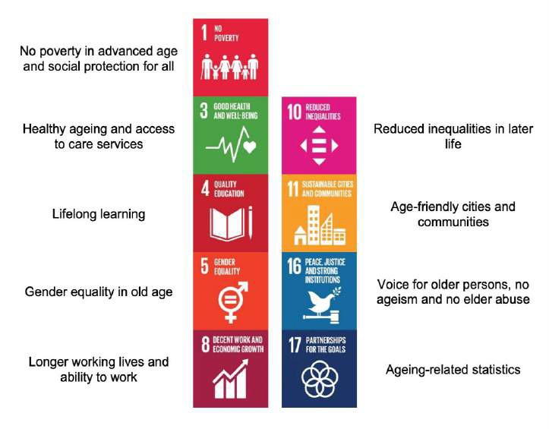
Box 2.5 Ageing and the 2030 Agenda for Sustainable Development

The 2030 Agenda for Sustainable Development is of relevance to ageing policies and programs in various ways. The Agenda aspires to achieve sustainable development through inclusive, cross-cutting and transformative efforts. The implementation of the SDGs has triggered the creation of new platforms and structures at national and local level that can help mainstream ageing into policies and programs. Its significance for ageing is directive and indirectly embedded in the SDGs as well as through its commitment to ‘Leave No One Behind’ (LNOB). Connecting MIPAA/RIS and the 2030 Agenda results in the following areas of policy integration:

Source: UNECE Background paper on Ageing and the SDGs

The need for a holistic approach to mainstreaming ageing

In response to the demographic developments and the adoption of MIPAA/RIS and other commitments, various efforts to address population ageing and the needs of older persons have emerged across the UNECE region. However, a holistic approach to mainstreaming ageing remains an outstanding task. While early definitions of mainstreaming ageing focused on older persons explicitly, these guidelines aim to support a broader approach that not only focuses on catering to the needs of older persons but aims at creating a ‘society for all ages’, reflecting the transformative changes needed to adapt to population ageing. It is based on a ‘twin-track” process that addresses population ageing on the one hand, and considers the specific needs of all generations, including older persons, on the other hand (Box 2.6).

Box 2.6: Twin-track approach

The twin-track approach to mainstreaming ageing considers ageing from a societal perspective –
population ageing in overall terms – as well as from an individual life-course perspective:

Societal perspective - Population ageing
The first track reflects how population ageing impacts society. The ageing population has implications for nearly all sectors of society, including labour and financial markets, healthcare and social protection, the demand for goods and services, such as housing, transportation and social and education services, as well as family and intergenerational ties. As ageing cuts across various sectors, mainstreaming ageing should consider the impacts of population ageing on society in general.

Individual perspective – needs of older persons
The second track aims to ensure that the needs of older persons are taken into account in planning and decision-making. Understanding the needs of older persons is critical in e.g. care situations, housing and the living environment, the provision of services, and transportation. It is therefore critical to ensure that mainstreaming ageing strategies and activities are responsive to the needs of older persons.

By definition, mainstreaming is a strategy and a process as well as a multi-dimensional effort. Successful mainstreaming should lead to: a) greater social integration of a particular group and
b) to the inclusion of a particular issue into all aspects of social, political, economic and cultural life. The overall objective of mainstreaming should be the achievement of more equitable development within a society for the benefit of all social and age groups. To view for instance health, education, employment, or housing through the prism of a particular social group (i.e. children, youth, working parents, older persons, persons with disabilities, etc.) promotes greater attention to the specific concerns of that group, as well as to more inclusive policymaking.

The concept of mainstreaming has already been successfully applied in a number of fields. It is among others established as a globally accepted approach to promote human rights and gender equality. For instance, gender mainstreaming involves ensuring that gender perspectives and attention to the goal of gender equality are central to all activities including policy development, research, advocacy, dialogue, legislation, resource allocation, planning, implementation as well as monitoring of programmes and projects. Experiences from these mainstreaming efforts can serve as an example for identifying the essential elements for mainstreaming ageing.

Building on the overall definition and existing mainstreaming experiences, mainstreaming ageing can be approached as a strategy, process and multi-dimensional effort that addresses both the societal and individual dimensions of population ageing. Given the wide scope of contexts, stakeholders and activities required for mainstreaming ageing, a system-wide and holistic effort is needed to successfully mainstream ageing into all policy fields and all policy levels. The approach should be evidence-based and systematically consider the concerns and rights of different age groups that can among others help foster intergenerational solidarity and equity. To ensure that all relevant aspects are considered, mainstreaming ageing should be built on a participatory approach that includes all relevant stakeholders and target groups in the policy-making process.

3.0 Developing a ‘Strategic Framework for Mainstreaming Ageing’

To mainstream ageing by systematically reflecting the needs of older persons while at the same time considering population ageing from a societal perspective, the guidelines support the development of a ‘Strategic Framework for Mainstreaming Ageing’. With respect to the different country contexts, and in line with agreed international commitments, the Strategic Framework should be human rights-based, gender-responsive and sustainable. It should moreover promote equality and non-discrimination; explicitly avoid ageism in policy development and implementation, and support eliminating inequalities of opportunities that may exist in different fields on the basis of age.

Taking these principles into consideration, the development of a ‘Strategic Framework for Mainstreaming Ageing’ consists of analyzing and assessing existing efforts to set the baseline for the mainstreaming strategy and the short-, medium- and long-term activities. These form the basis for the national priorities concerning older persons relative to other generations, suggested procedures as well as concrete targets for developing mainstreaming efforts at national, regional and local level. The ‘Strategic Framework’ should be anchored in the internationally agreed policy standards as defined by MIPAA/RIS, the 2030 Agenda for Sustainable Development, the WHO Decade of Healthy Ageing, etc. The development of the Strategic Framework recommended by the guidelines consists of five main components referred to in Box 1.3 earlier and briefly described in the form of Modules in Box 3.1.

Box 3.1: Modules: Developing a ‘Strategic Framework for Mainstreaming Ageing’

Module 1: Getting started
Module 1 consists of suggestions that are relevant for preparing the process of developing a ‘Strategic Framework for Mainstreaming Ageing’. To start the process, the scope and timelines need to be determined and a number of preparatory aspects can be considered such as; setting up a task force/coordination body, determining timelines, stakeholder analysis/engagement approaches, determining awareness raising measures/consultative bodies as well as reaching consensus and political commitment to the process.

Module 2: Analysis
In many countries, efforts that support mainstreaming aging are already in place and should be considered in the mainstreaming framework. Module 2 focuses on analyzing and assessing the policy landscape to map existing practices and identify gaps that need to be addressed to mainstream ageing. The Module consists of suggested activities including, to gather, map and review relevant information e.g. legislation, progress reports, policies as well as (age disaggregated) data. By suggesting tools that can help provide a full picture of the current situation, e.g. age-sensitive analysis or impact assessments as well as stakeholder consultations, this Module helps to ensure that a baseline is established for developing a Mainstreaming Strategy (Module 3).

Module 3: Mainstreaming Strategy
Module 3 focuses on the policy formulation. Based on the analysis, mapping and assessment conducted in Module 2, the ‘Mainstreaming Strategy’ should be developed with the engagement of- and in consultation with older persons and key stakeholders. The Module includes a number of suggested activities that help ensure the Mainstreaming Strategy outlines the aspirations and policy directions through the development of a vision statement, strategic goals and strategic objectives. The ‘Mainstreaming Strategy’ should be outcome based and include short-, medium-, and long-term goals aimed at achieving a ‘society for all ages’ that focuses not on the needs of older persons but also address population ageing at the societal level.

Module 4: Identification of Activities
Based on the Mainstreaming Strategy and the short-, medium- and long-term goals and objectives identified in Module 3, Module 4 focuses on the priority setting of policies and programmes and the identification of specific activities on population ageing and addressing the needs of older persons. These can be e.g. short- term: raising awareness, medium-term: developing policies/measures that are reflective of the needs of older persons, and long-term: improving the wellbeing of older persons. The setting of commonly agreed activities should be based on a participatory process, engaging with stakeholders of all generations. The Module also suggests establishing institutional structures, competence development and capacity building efforts, as well as the selection of implementing partners.

Module 5: Monitoring and Evaluation
As a final component, Module 5 focuses on the monitoring and evaluation of the Strategic Framework. The activities defined in Module 4 should be regularly monitored in order to track progress and evaluate the implementation of the framework. The purpose of this Module is to finalize the development of the Strategic Framework by establishing a monitoring and evaluation approach, identifying indicators and determine a monitoring mechanism and format. The Module supports establishing M&E efforts that help measure progress of the activities and mainstreaming efforts of the Strategic Framework.

Box 3.2: Five Modules to Develop the Strategic Framework for Mainstreaming Ageing
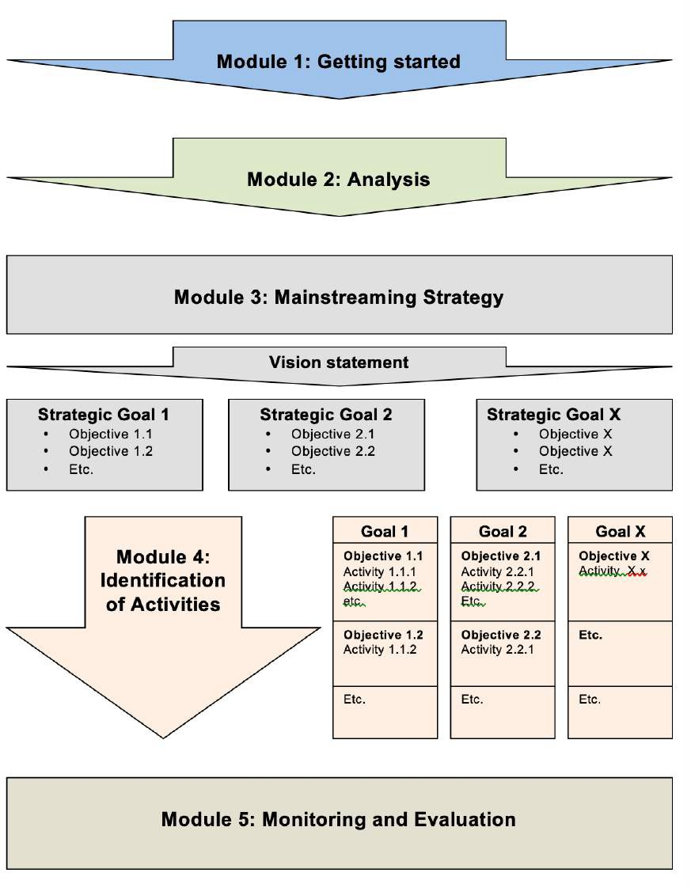

Methodology and principles

The guidelines to develop the ‘Strategic Framework for Mainstreaming Ageing’ is a result of a collaborative process among the UNECE member States. This section explains the methodology and general principles that were applied to support the development guidelines, including the work process, provision of case examples, tools, research, literature and longstanding experience in the UNECE member States.

Work Process

In response to the MIPAA Regional Implementation Strategy commitment to “mainstream ageing in all policy fields with the aim of bringing societies and economies into harmony with demographic change to achieve a society for all ages”, the UNECE Working Group on Ageing included the development of guidelines on mainstreaming ageing in its ‘Programme of Work for 2019-2020’. A Task Force on Mainstreaming Ageing was established in June 2019. The Task Force consists of 10 UNECE Member States that have since June 2019 lead the work on the development of the guidelines on mainstreaming ageing.

As a first step, the Task Force, in collaboration with the UNECE secretariat, initiated a stocktaking exercise to: i) learn to what extend UNECE countries have developed mainstreaming ageing strategies to integrate ageing issues into all relevant policy fields, and ii) to identify and collect available mainstreaming ageing methods and tools that are applied in the UNECE region.

To understand how mainstreaming ageing is practiced in the respective countries, a stocktaking questionnaire was initially piloted by members of the Task Force and thereafter shared with all the members of the Working Group on Ageing. As a result of the exercise, and based on an agreed template, countries were invited to complete a ‘country note’ on mainstreaming ageing. All in all, 22 country notes were completed, which in most cases included a general overview of the national implementation of mainstreaming ageing, concrete information on methods and tools developed as well as good practices illustrating their use. The country note results constitute a part of the knowledge base for the development of the mainstreaming guidelines.

Following the stocktaking exercise, a consultant was engaged to develop the guidelines on mainstreaming ageing in cooperation with the UNECE Secretariat and the Task Force on Mainstreaming Ageing.

Literature and document review

While developing the guidelines, the consultant analyzed documents of relevance to mainstreaming ageing and population ageing in general, including the international frameworks, research, policy briefs and other reports. Literature related to planning and key aspects of relevance to mainstreaming in general were also reviewed. Furthermore, the 22 country notes that were prepared by UNECE member States to take stock of progress on mainstreaming ageing in the region were reviewed and analyzed.

Selection of cases

Cases presented in the guidelines are a result of the responses to the questionnaire and content included by member States in their respective country notes. These were selected based on their ability to exemplify specific matters discussed in the guidelines. Hence, references to countries and examples featured are for illustrative purposes only and do not express any judgement, evaluation or political views.

Consultation

The guidelines were developed in close cooperation with the UNECE Population Unit and the Task Force on Mainstreaming Ageing. Regular updates and revised versions were shared with both the UNECE team and the Task Force enabling feedback at various stages of the development of the zero draft of the guidelines. A present consultation process to review the first draft among Member States seeks feedback from focal points on ageing and other stakeholder that will be considered and incorporated into the final version of the guidelines.

Core principles

Based on existing experiences in ageing and in alignment with the main relevant international frameworks, the guidelines are developed to address both the societal and individual dimensions of population ageing. By applying a twin-track approach, the guidelines aim to address: i) population ageing from a societal perspective, while at the same time ii) addressing the needs of older persons.

In order to best respond to the individual situations and needs of older persons the guidelines recognize the heterogeneity and diversity of older persons. By applying a Human Rights-based Approach (HRBA) (Box 4.1) the guidelines aim to ensure equality, non-discrimination and to avoid ageism. This approach is applied in order to promote participation and to reduce the inequalities of opportunities that may exist due to e.g. age, gender or other factors.

Box 4.1: Human Rights-based Approach

The equal and inalienable rights of all human beings provide the foundation for freedom, justice and peace in the world, according to the Universal Declaration of Human Rights, adopted by the UN General Assembly in 1948. A UN Common Understanding of a Human Rights Based Approach (HRBA) clarifies how human rights standards and principles should be put in practice. Under the HRBA, plans, policies and processes are anchored in a system of rights and corresponding to obligations established by international law, including all civil, cultural, economic, political and social rights and the right to development. HRBA requires human rights principles: universality, indivisibility, equality and non- discrimination, participation and accountability to guide policy and program formulation. Good practices under the HRBA include:

- Policies and programs identify the realization of human rights as ultimate goal.
- People are recognized as key actors in their own development, rather than passive recipients of commodities and services.
- Participation is both a means and a goal.
- Strategies are empowering.
- Both outcomes and processes are monitored and evaluated.
- Programmes focus on marginalized and excluded groups.
- The process is locally owned.
- Policies and programs aim to reduce disparities and empower those left behind.
- Analysis is used to identify immediate, underlying and root causes of problems.
- Analysis includes all stakeholders, including the capacities of governments- and non- government actors.
- Human rights standards guide the formulation of measurable goals, targets and indicators.
- National accountability systems need to be strengthened.
- Strategic partnerships are developed and sustained.
Source: The Human Rights-based approach to Development Cooperation

In addition, a number of core principles were agreed by the Task Force for Mainstreaming Ageing for the development of the guide. These include: applying a holistic and systematic approach, encouraging adaptability and accessibility of the guidelines; ensuring an outcome and evidence-based approach; as well as promoting efficiencies and offering practical solutions.

A holistic and systematic approach
The guide is based on promoting a holistic approach that ensures the systematic consideration of the concerns of different age groups, including older persons, in all areas and levels of policy making. This approach enhances collaboration across and at all levels of government to leverage the promotion and implementation of mainstreaming ageing. The holistic and systematic approach is among others supported by the introduction of a ‘whole-of-government’ approach as well as participatory processes that can help ensure and include the voices and interests of all relevant stakeholders and age groups. By promoting dialogue the approach aims to help foster intergenerational solidarity and equity and applying a ‘life course approach’ to the development of the Strategic Framework on Mainstreaming Ageing.

Adaptable and Accessible
The UNECE region consists of 56 member States, each with its own respective country context, government structure, levels of decentralization, as well as traditions and cultures. The guidelines recognize that each member State is unique stressing the importance of country ownership of the mainstreaming process. The Modules are designed to provide guidance and suggestions that allow countries to base the mainstreaming process on their respective principles and priorities. Furthermore, the guidelines are developed for specialists as well as non- specialists.

Outcome-oriented and Evidence-based
To support the development of a ‘Strategic Framework for Mainstreaming Ageing’, the guide seeks to provide practical “hands-on” suggestions that are supported by case studies consisting of good practices from UNECE member States. Furthermore, evidence accumulated at global, regional, national and local level is considered. Also, experiences obtained in mainstreaming processes on gender, human rights, disability, and of the SDGs are considered. Each Module includes a checklist that helps to ensure key outcomes of relevance to mainstreaming ageing are considered in the development of the Strategic Framework. Furthermore, the guidelines suggest an evidence-based approach to mainstreaming, which is critical for informing the mainstreaming process itself, but also helps define targeted policies and activities.

Promoting efficiencies and offering practical approaches
Respecting the different country contexts and recognizing the importance of ownership, the guidelines encourage countries to leverage the development of the Strategic Framework on existing processes whenever possible. Building on existing measures should avoid duplication and increase the complexity of existing national legislative and policy frameworks. Through the inclusion of case examples and tools, the guidelines aim to offer practical approaches that can be considered at various stages in the development of a Strategic Framework. Guidance is grounded in the practices of UNECE member States and informed by gaps and challenges identified in the stocktaking of country notes and ageing-related efforts in the region.

Glossary and concepts

In order to develop the Strategic Framework for Mainstreaming Ageing, various terms and concepts are introduced:

Active Ageing Active ageing is a multidimensional concept referring to a
situation where people continue to participate in the formal labor market, engage in unpaid and productive activities, and live healthy, independent and secure lives as they age. Active ageing policies thus need to address these dimensions; i) Enable possibilities for longer working life, ii) Ensure social involvement,
iii) Encourage healthy lifestyles, and iv) Provide opportunities for independent living and ageing in dignity for both men and women.

Ageism Ageism is the stereotyping, prejudice and discrimination against people based on their age. It often has significant impacts and/or can have harmful effects on older persons. Ageism occurs in various contexts such as, at the labour market, healthcare, by the financial service sector or through the media. Ageism negatively affects health and well-being and can reduce life expectancy. Its complexity and intersectionality call for a comprehensive and multisectoral policy responses at all levels of society.

Intergenerational solidarity MIPAA emphasizes that solidarity between generations at all
levels- in families, communities and nations – is fundamental for the achievement of a society for all ages. In addition, solidarity is an important prerequisite for social cohesion and a foundation of formal public welfare and informal care systems.

Human Rights-Based Approach The Human Rights-based Approach is a conceptual framework
for the process of human development that is normatively based on international human rights standards and operationally directed to promoting and protecting human rights. It seeks to analyze inequalities and redress discriminatory practices and unjust distributions of power.

Life-course approach The Iife-course approach acknowledges that the ‘standard
course of life, in which periods of study, work and retirement follow one another in sequence is becoming less common. A life- course approach emphasizes the importance of individual lifestyle choices; including healthy living, diminishing inequalities over the life course and saving funds for old age.

Lifelong learning A policy strategy directed towards integrating older persons into
the contemporary labour market, to give them the necessary education to adapt to the educational system in order to meet the changing economic, social and demographic conditions and to include older persons in retirement.

Mainstreaming ageing Mainstreaming ageing is a strategy, process and multi-
dimensional efforts of integrating ageing issues into all policy fields and all policy levels. The ultimate objective is to achieve a more equitable development within society that will benefit all social groups. Successful mainstreaming means including all relevant stakeholders in decision-making, to ensure that the needs of all age-groups are met in all policy fields.

Multi-Stakeholder Partnerships The concept of Multi-Stakeholder Partnerships (MSPs) as an
instrument for achieving goals serves to complement strengths or core values and pool resources and assets in addressing and solving problems. MSPs are meant to promote a holistic approach to development and efficient government.23

Part II

Module 1 – Getting Started

What is this Module about?

Module 1 consists of suggestions and recommendations that are relevant for preparing the process to develop a ‘Strategic Framework for Mainstreaming Ageing’. In order to start the process, the scope and timelines need to be determined and a number of preparatory aspects should be considered such as; setting up the institutional architecture, determining stakeholder analysis/engagement approaches, as well as awareness raising measures that help reach consensus and ensuring political commitment to the process. A well-prepared process will help the development of a comprehensive Strategic Framework that takes into consideration existing measures, views of all relevant stakeholders and ensures adequate strategies and activities can be formulated that mainstreams ageing across and at all levels of society.

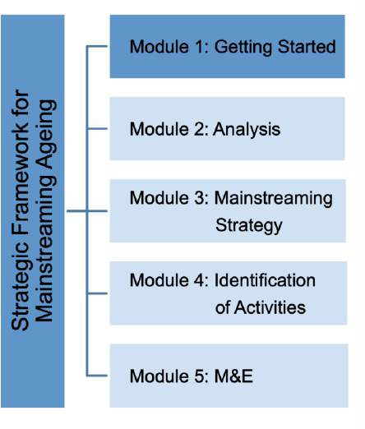

Introduction

With respect to the country context and government structure, the suggested development of a Strategic Framework for Mainstreaming Ageing consists of a number of phases including: the analysis and assessment of the context that helps set the baseline for the Mainstreaming Strategy (Module 2), identifying strategic goals and objectives (Module 3). These form the basis for the identification of activities (Module 4) and the M&E of the framework (Module 5). As a first step in this process, various preparatory aspects should be considered to help kick start the development of the Strategic Framework.

The overall aim of the Strategic Framework for Mainstreaming Ageing is to build a strong backbone for ageing-related policy making for the formulation, implementation, monitoring and evaluation of ageing-related policies that prepares and helps adapt society to population ageing and ensures that the needs of all age groups, including older persons are met. In order to develop a framework that integrates these aspects into all policy fields and at all levels, a well-prepared process can be ensured by determining the scope and timeline and establishing a ‘mainstreaming architecture’, that clarifies responsibilities. When determining these aspects, it is essential to consider the main principles that guide the mainstreaming ageing and ensuring an evidence- and human-rights based, gender responsive and sustainable framework. The framework should promote equality and non-discrimination; explicitly avoid ageism in policy development and implementation, and support eliminating inequalities of opportunities that may exist in different fields according to age.

To systematically mainstream ageing across sectors and at all levels, the preparation should consider the ‘whole-of-government’ and a ‘whole-of society’ approach (Box 1.1). This approach entails including experts and representatives from across and multiple levels of government to ensure alignment of efforts at national and sub-national level. This approach is relevant for fostering collaboration among different government departments and stakeholders, so that the Strategic Framework is developed by relevant government entities - such as those responsible for health, social development, youth and gender, finance, planning, population and statistics - as well as and stakeholders, including older persons.

The institutional setting is moreover important to ensure the systematic mainstreaming of ageing at multiple levels of government. Effective coordination at the national and sub-national level is critical to ensure alignment of mainstreaming efforts. Interdepartmental or interagency working groups, councils or commissions, or assigned focal points on ageing can help achieve the streamlining of measures.

Box 1.1: ‘Whole-of-Government’ and ‘Whole-of-Society’ Approach

Mainstreaming ageing across and at all levels requires a ‘Whole-of-Government approach’ that engages relevant government stakeholders of concern to ageing e.g. representatives from line-ministries e.g. ministries of health, social affairs, education etc. and or representatives from specialized agencies such as the national statistical bodies. Consideration to engaging Parliament should be given as well as participation of representatives from subnational level to ensure alignment with local efforts.

The ‘Whole- of-Government’ and ‘Whole-of-Society’ approach can help inform the formulation of the Strategic Framework while ensuring a system-wide incorporation of the main principles. It can at the same time foster awareness and eventually support the integration of ageing related priorities into the relevant institutional mandates, policies and programmes.

Currently national focal points on ageing serve as the main catalyst for mainstreaming ageing. The establishment of a coordination group is recommended to coordinate the process and future implementation and monitoring of the Strategic Framework. Such a group can include members such as older persons, representative from government ministries and departments, civil society, academic and research institutions, private sector as well as the media.

    - Horizontal coordination
Priorities of relevance to population ageing and the needs of older persons cut across various sectors and services, calling for the collaboration between representatives from a wide range of government departments and agencies. The development of the Strategic Framework for Mainstreaming Ageing requires horizontal coordination with several national government officers from ministries and departments such as those responsible for finance, statistics, health, social welfare, the interior, gender, housing, agriculture, education and legal affairs.

    - Vertical coordination
In countries where ageing related responsibilities are decentralized to subnational levels, government authorities and local stakeholders should be included in the development of the Strategic Framework for Mainstreaming Ageing. The process should be a top-down and bottom-up process that enhances alignment between national and local mainstreaming efforts. Including and ensuring the participation of subnational government representatives local government officers or local non-government stakeholders e.g. associations is therefore critical to ensure vertical coordination.

An important element of the ‘Whole-of-society’ approach is the aspect of stakeholder engagement and ensuring a participatory approach to developing the Strategic Framework for Mainstreaming Ageing (Box 1.2). Bottom-up participatory approaches have been encouraged in the review and appraisal of MIPAA. Firstly, this approach has a methodological function as it is used for ‘in-depth evaluation of national efforts to implement MIPAA. Secondly, it helps directly engage older persons in actions on their behalf and thereby promote their participation in implementation efforts. While this approach can help make the reality of older persons visible, it also supports learning from community and local realities. In addition to MIPAA, the 2030 Agenda SDG 16 target 7 calls for ensuring ‘responsive, inclusive, participatory and representative decision making at all levels’. Indicators to measure progress are:

- Indicator 16.7.1: ‘Proportion of positions (by sex, age, persons with disabilities and population groups) in public institutions (national and local legislators, public services, and judiciary) compared to national distributions’.
- Indicator 16.7.2: ‘Proportion of population who believe decision-making is inclusive and responsive, by sex, age, disability and population groups’.

Box 1.2: Participatory approach and stakeholder engagement

The immediate purpose of the participatory approach is to ensure that older persons have an opportunity to express their views on the impact of policies and action affecting their lives. The overall goal is to ensure that older persons and relevant stakeholders are engaged in all the phases, including strategic development, policy design, identification of activities and monitoring and evaluation.

The aim of this approach goes beyond generating knowledge and consists of supporting action and promoting public awareness. Furthermore, it helps the identification of older person’s needs, learning about opportunities and informing on actions required to address those.

The adoption of a participatory approach supports:

- The identification of problems, needs and expectations of older persons
- A better understanding of how ageing-related content relates to policy measures and activities
- Increase participant’s empowerment and trust in the mainstreaming process
- Prevention and management of risks, unexpected results and misunderstandings
- Effectiveness and identification of efficient measures
Source: Guidelines for review and appraisal of the Madrid International Plan of Action on Ageing – Bottom-up participatory approach, United Nations, 2006.

Hence, successful mainstreaming means including all relevant stakeholders to ensure that the needs of all age groups are met in all policy fields. Establishing national consultative platforms/networks on ageing issues, councils, boards or commissions is recommended. These should not only include older persons but also consider the voices of younger persons as a stakeholder group. Younger persons are current contributors to pension systems and will be affected by demographic changes across the life course and when they reach the retirement age. Their involvement is moreover relevant in view of adding an intergenerational context to the Strategic Framework and to build consensus and commitment among groups of all ages. Furthermore, relevant stakeholders such as NGOs, the private sector and trade unions should be institutionally prescribed. An office on age-discrimination or an ombudsperson can assist in overseeing adherence to ensuring non-discriminatory standards.

Box 1.3 illustrates a mainstreaming architecture that applies the ‘whole-of government’ and ‘whole-of-society’ approach.

Box 1.3: Example of a mainstreaming ageing approach

‘The national multilevel co-managed coordination of active ageing policies in Italy (2019-2021)’ aims to
mainstream active ageing with the involvement of various stakeholders at multiple levels of government.

As a first step, a project team and a national stakeholder network was established. The project team manages the implementation of the planned tasks. The national stakeholder network consists of representatives from all the Ministries and relevant government agencies; all subnational governments; as well as representatives from civil society. The network discusses and agrees on activities, workplan in close collaboration with the project team.

Four project tasks:

- Analysis: To determine the state of play of policies on active ageing at the national- and subnational level, including agreeing on a definition of active ageing, define research tools to identify, study and assess existing documents, and to carry out field work. Focal points at subnational level were appointed to assist the work. A survey considering the 10 MIPAA commitments and the SDGs was conducted. Based on the analysis, a report was drafted.
- Guidelines: Based on the results of the analysis, guidelines are drafted based on the 10 MIPAA/RIS commitments and the SDGs.
- Identification of possible areas of intervention at the national and sub-national level.
- Developing policies and monitoring activities.

As in Italy, many ageing-related efforts fall under the responsibility of subnational governments, a mainstreaming effort that aligns the efforts at multiple levels of government is important. Efforts therefore include aligning the national measures to the development of a regional plan of action on active ageing at the sub-national level. In the context of the ‘National multi-level co-managed coordination of active ageing policies’, a regional law on the promotion of Active Ageing was adopted in January 2019. The law enables adopting the national mainstreaming approach to subnational level and conduct regional analysis and develop actions on the basis of an aligned methodology and framework.

Potential challenges

Issues concerning ageing societies and older persons relative to other age groups still suffer from a lack of attention and resources in many countries. In order to get started, endorsement and political commitment to embark on the process to mainstream ageing is recommended. This is needed to ensure adequate capacities, resources and allocation of funds required to develop the Strategic Framework for Mainstreaming Ageing. In order to ensure a holistic approach to mainstreaming ageing, awareness raising may be needed to help government and non- government stakeholders understand the advantages of mainstreaming ageing and make the case for why systematically mainstreaming ageing should be initiated.

In addition, securing political commitment to mainstream ageing should help support the participation and collaboration required to effectively mainstream ageing across and at all levels of government. Existing responsibilities on ageing related questions might be scattered across government/society or operate in silos leading to fragmented approaches that pose a barrier to systematically address ageing related aspects. The application of the above mentioned ‘whole-of government’ and ‘whole-of-society’ approach to mainstreaming requires a well-prepared process that includes; initial stocktaking; establishing a strong mainstreaming architecture to coordinate the process, considerations to apply participatory approaches and stakeholder engagement,

identifying clear roles and responsibilities, as well as a defining a concept note and work plan that can help ensure consensus, generate funding for- and establish political commitment to the development of the Strategic Framework for Mainstreaming Ageing.

Getting started – Suggested Activities

In order to build a strong backbone for ageing-related policy making, the preparation phase of developing the Strategic Framework is of critical importance. In getting started the following activities can be considered:

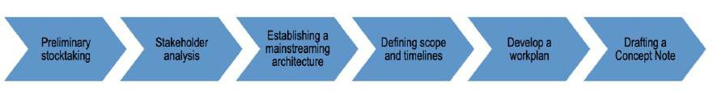

Preliminary stocktaking
To start developing the Strategic Framework for Mainstreaming Ageing preliminary stocktaking is needed. This involves among others a mapping of stakeholders within the government that currently take on ageing-related responsibilities. The mapping of existing structures should clarify whether e.g. there are ageing units or focal points in line ministries and which/if entities at subnational level exist. The mapping can moreover inform to what extend ageing is coordinated and how stakeholders are connected across and at multiple levels of government. Are there any processes in place that support collaboration on ageing. If so, do these processes take into consideration the needs of older persons?

The identification of who is in charge of ageing-related policies across and at different levels of the government should help identify which gaps exist. The preliminary stocktaking should help inform the mainstreaming architecture and consider what existing structures can be built upon when composing the mainstreaming architecture and e.g. establishing a coordinating group for mainstreaming ageing as described below.

Stakeholder analysis
Effective, meaningful and informed stakeholder participation is essential for ensuring an inclusive process to developing the Strategic Framework. This is also needed to foster a comprehensive coverage of ageing related issues across and at all levels of government. The engagement of different non-state actors is of importance not only in view of applying a Human Rights Based Approach (HRBA)25, but also to ensure that all relevant aspects are systematically considered in the framework e.g. gender sensitive approaches, as well as the concerns and rights of different age groups that help foster intergenerational solidarity and equity. To ensure the full consideration of all relevant principles and aspects, the process to develop the Strategic Framework should be built on a participatory approach that includes all relevant stakeholders and target groups (Box 1.2). Stakeholder engagement is not only essential for the development of the mainstreaming ageing approach but can also help with informational and awareness-raising activities. Stakeholder analysis and developing a stakeholder engagement plan are effective tools to determine how effective and meaningful participation can be established. This can inform the composition of a ‘Stakeholder Network’ as described below.

An overview of which entities and stakeholders are of relevance as well as which roles they may play in the development of the Strategic Framework, table 1.1 provides an overview of government- and non-governmental stakeholders that can be considered in the determination of the mainstreaming architecture.

Table 1.1: Examples of stakeholders and their roles in the development of the Strategic Framework

Stakeholder groups | Roles in the Development of the Strategic Framework on Mainstreaming Ageing
Older persons | - Participating in the planning of the Strategic Framework for Mainstreaming Ageing  - Generating information and analysis  - Participating in planning meetings and provide feedback on analysis and assessment of ageing policy and priorities  - Engaging in consultation processes and voicing the needs of older persons  - Engaging in the identification and verification of strategic goals, objectives and activities  - Acting as active stakeholders in the monitoring and evaluation of the Strategic Framework
Representatives from line ministries and departments, including national statistical offices and local governments | - Identifying older persons-focused information, data and measures in the respective fields of responsibility  - Providing background information from respective sectors, relevant data or sub-national activities  - Providing feedback on analysis and (impact) assessments  - Identifying gaps and opportunities in service provision  - Leading the planning process and formulation of strategic goals and objectives as well as the identification of activities  - Acting as implementing partners  - Leading the monitoring and evaluation of the Strategic Framework
NGOs/CSOs | - Engaging in planning of the Strategic Framework for Mainstreaming Ageing  - Generating information, data and analysis  - Facilitating or supporting participatory processes at national and local level  - Participate the planning process and formulation of strategic goals and objectives as well as the identification of activities  - Generating awareness raising and advocacy efforts  - Acting as implementing partners  - Supporting monitoring and evaluation efforts
Research groups and academia | - Supporting with research and information to assist in analysis and (impact) assessment  - Facilitating or supporting participatory processes at national and local level, and providing background and justification for involvement of older persons  - Generating quantitative and qualitative information  - Verification and analysis of findings of analysis and (impact) assessments
Private sector | - Participating in the planning process and formulation of strategic goals and objectives as well as the identification of activities  - Providing feedback on analysis and (impact) assessments  - Supporting awareness raising and advocacy efforts  - Acting as implementing partners  - Supporting monitoring and evaluation efforts
Media | - Generating awareness raising and advocacy efforts  - Change perceptions of older persons  - Supporting the dissemination of information on e.g. the vision statement, mainstreaming strategy and the Strategic Framework on Mainstreaming Ageing in general  - Acting as implementing partner  - Build support for the rights of older persons

Establishing the mainstreaming architecture
Base on the preliminary stocktaking and stakeholder analysis it is recommended to establish a mainstreaming architecture that consists of a two-tiered structure:

- A coordinating group for mainstreaming ageing
- Stakeholder Network

Task Force for Mainstreaming Ageing
Establishing an institutional support structure that engages relevant government stakeholders of concern to ageing should be considered e.g. in the form of a government task force for mainstreaming ageing that is responsible for the process to develop the Strategic Framework.
Key elements of importance when establishing a task force are; the roles and responsibilities, reporting structures as well as which capacities should be taken into consideration to support a holistic effort, e.g. gender, human rights or health experts as well as representatives from relevant Agencies, Parliament and subnational government. The Taskforce can be installed as a temporary body that is responsible for developing the framework (Box 1.4). It is however strongly recommended to establish a permanent entity that will coordinate the implementation and M&E of the
Box 1.4: Example of Cross-Departmental Group to Mainstreaming Strategy

Ireland’s National Strategy was developed by a Cross- Departmental Group (CDG). This Group was comprised of representatives of the Departments of Health; Social Protection; Jobs, Enterprise and Innovation; Education and Skills; Environment, Community and Local Government; Communications, Energy and Natural Resources; Taoiseach; Transport, Tourism and Sport; Justice and Equality as well as the Central Statistics Office and An Garda Síochána. The development of the Strategy was overseen by the Cabinet Committee on Social Policy. It overseen by the Cabinet Committee on Social Policy.

Source: National Positive Ageing Strategy, Ministry of Health, Ireland, 2013
Strategic Framework for Mainstreaming Ageing as suggested in Module 4.

Stakeholder Network
Box 1.5: Examples of stakeholder engagement platforms/networks

In the Republic of Moldova, the ‘Platform for active ageing’ includes more than 20 NGOs of older persons, Congress of Local Authorities, UNFPA, Confederation of Trade Unions and Employers and other partners. The platform has played an instrumental role in carrying out public consultations as well as awareness raising campaigns.

Also in Italy, a ‘National Stakeholder Network’ was established to support mainstreaming ageing efforts. The network consists of representatives from all the ministries and other national agencies, subnational governments, civil society organizations, NGOs, experts and academia. The network meets periodically to discuss the work plan and agree on activities to be carried out. It works in close collaboration with a project team that is responsible for the implementation of the planned tasks.

Source: Country Notes
If not yet existent, establishing a platform for engagement consisting of a wider network of stakeholders is recommended. Such platforms are useful for multiple purposes including coordination, consultation, data collection as well as awareness raising (Box 1.5). Stakeholder analysis, as suggested above should inform which stakeholders need to be included.

Recommended roles and stakeholders for both the ‘Task Force’ and the ‘Stakeholder Network’ are summarized in Table 1.2.
39

Table 1.2 Recommended Mainstreaming Architecture
 | Roles | Composition
Task force for Mainstreaming Ageing | - Leading the development of the Strategic Framework for Mainstreaming Ageing  - Coordination of implementation and monitoring  of the Strategic Framework | - Focal Points on Ageing  - Representatives from line-Ministries/Departments and government agencies, including gender focal points, human rights, statistical offices  - Representative from Civil Society/older persons  - Representative from subnational government level  - Private Sector Representative  - Representative from academia
Stakeholder Network | - Providing feedback,  - Wider coordination with members/ community,  - Consultation  - Provision of information and data collection  - Awareness raising | - Older persons and their families  - Wider network of national government officers from ministries and departments, such as those responsible for finance, statistics, health, social welfare, the interior, gender, housing, agriculture, education and legal affairs  - Existing committees on ageing or national networks of older persons  - Community members  - Local health workers and other service providers  - Research institutes and universities  - Geriatric and gerontological societies  - Organizations (governmental, non-governmental and private working in the area of prevention of elder abuse)  - Local NGOs working with older persons  - Local NGOs working in the areas of human rights  - Women’s and men’s organizations  - International NGOs  - United Nations organization and donors  - Private sector organizations e.g. businesses, banks and financial service providers, pension- and insurance companies and private utility providers (e.g. power, water etc.)  - Labour organizations and trade unions.  - Media e.g. press, television and radio

Defining the scope/timeline of the process
Defining the scope, objectives and timeline of establishing the Strategic Framework is needed to determine its focus and goals. Carrying out a planning analysis can help assess whether there is a need to e.g. strengthen procedures or regulate the process of mainstreaming ageing, initiate awareness raising efforts and/or consultation processes. Furthermore, the analysis can help identify systems and structures of relevance for the different phases to develop the framework, including Module 2: analysis, mapping and assessment, Module 3: mainstreaming strategy, Module 4: identification of activities and Module 5: Monitoring and Evaluation. The planning analysis can inform the development of a concept note and work plan that formulate the objectives and goals of developing the Strategic Framework. It is suggested to consider to anchor the process in relevant internationally-agreed frameworks and commitments and priorities e.g. the MIPAA/RIS commitments, 2017 Lisbon Ministerial declaration and others such as the 2030 Agenda for Sustainable Development.

Work plan
Once the mainstreaming architecture, the timelines, scope and planning have been determined, a preliminary work plan should be drafted. The work plan should address what concrete deliverables and timelines of activities are envisaged and outline who should be engaged when and where. The work plan can follow the key stages as suggested by the Modules; analysis, the identification of activities, developing a mainstreaming strategy; and defining monitoring and evaluation. Depending on the preferred approach the work plan can take into consideration when stakeholder engagement, consultations and awareness raising efforts should be envisaged. Once finalized, the work plan can be included as an annex a concept note.

Concept note
As a final preparatory step, the drafting of a concept note is recommended. The note should outline the rationale, scope, objectives and work plan to develop a Strategic Framework. In addition to conceptualizing the approach, the note should include key arguments for why mainstreaming ageing is needed and what benefits there are to mainstream ageing. The note can include the various roles and responsibilities and the institutional support structure, findings of the planning analysis, potential costs, and a stakeholder engagement plan. The concept note can be utilized to address potential challenges related to capacity, resources, and allocation of funds that may exist.

If challenges occur in terms of ensuring commitment to mainstream ageing, the concept note can be utilized to raise awareness and strengthen the understanding of- and endorsing the go-ahead develop the Strategic Framework. In such a way, the concept note can make a clear case for why the development of the framework is needed to generating consensus, allocating funding for- and establish political commitment to the development of the Strategic Framework for Mainstreaming Ageing.

Checklist

- Preliminary stock taking carried out
- Stakeholder analysis completed
- Mainstreaming architecture established, including
  - Task force for Mainstreaming Ageing
  - Stakeholder Network
- ‘Whole-of–government’ and ‘whole-of-society’ approach applied
- Planning analysis conducted
- Timelines and scope determined
- Aligning the process with the international commitments (MIPAA/RIS, 2017 Lisbon Ministerial Declaration, SDGs etc.)
- Work plan developed
- Concept note completed
- Political commitment to - and endorsement of the concept note and work plan

Module 2 – Analysis

What is this Module about?

To develop a holistic ‘Strategic Framework for Mainstreaming Ageing’, a comprehensive screening and analysis of the context is needed. The objective of Module 2 is to develop an overview and analysis of the current situation that sets a baseline for the further development of the Strategic Framework. The Module consists of suggestions and recommendations that enable a comprehensive analysis of existing legal acts, policies and data of relevance to population ageing and the needs of older persons. The collection and review of information and data, analysis and impact assessment support evaluation, design and planning of the mainstreaming strategy and its objectives (Module 3).

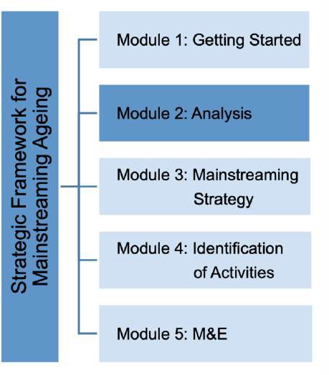

Introduction

During the initial development of the Strategic Framework, analysis of the current situation is needed in order to determine the ‘landscape’ or context, which the mainstreaming ageing is subject to. As a part of defining the context, the analysis can help determine the state of play of population ageing and the situation of older persons. It also helps in identifying ageing related measures and data, assesses to which extent ageing and key principles have been integrated into policy areas, legislation and programmes, and determines which gaps exist. As ageing cuts across multiple sectors, many policies, activities and legislation impact population ageing and the situation of older persons. In order to systematically evaluate ageing, the analysis should
consider various sector perspectives including health, social protection, employment, the economy, education, inter-generational relations and gender.

Since ageing has been on the radar of countries for many years, various mainstreaming efforts have already been initiated. These take diverse forms ranging from national action plans, strategies, programmes to specific legislation aimed at sector specific actions. In order to build on the existing efforts and to evaluate potential gaps, a thorough exercise to collect, review map, analyze and assess the current state of play should avoid duplication and ensure existing measures are considered in the mainstreaming framework.

Collecting and reviewing information and in particular the analysis of available (disaggregated) data can help inform the development of an evidence-based framework and support the process in identifying trends, risks, challenges and opportunities. Compliance with the principles of MIPAA/RIS and/or other relevant frameworks can be applied as guidance to the review and analysis of information and data. This should help ensure the key principles and ageing related commitments are mainstreamed.

This ‘screening’ excise can draw on guidance provided by the Active Ageing Index (AAI) (Box 2.1). This is an initiative that was established in 2012 by UNECE and the European Commission that allows assessment and measuring national progress in ageing related policies and programmes. The index measures the extent to which older persons can realize their full potential in terms of total and healthy life expectancy, participation in the economy, in social life and in terms of independent living

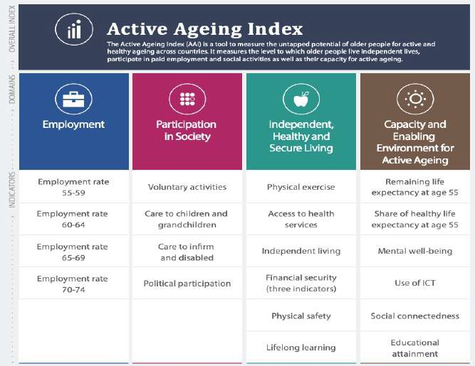
Box 2.1: Active Ageing Index

The Active Ageing Index (AAI) is a tool that can help assess and measure the untapped potential of older persons for active and healthy ageing across countries. It measures to which older persons live independent lives, participate in paid employment and social activities, and their capacity to age actively. The AAI was developed in 2012 by UNECE and the European Commission in cooperation with the Expert Group on AAI. The index can help look at population ageing in a comprehensive and multifaceted way that can help to make older persons’ contribution to society more visible. The AAI can be adapted to different contexts at the national as well as the subnational level. The AAI consists of twenty-two indicators grouped into four domains:

- Employment
- Participation in society
- Independent healthy and secure living
- Capacity and enabling environment for active ageing

Source: www.unece.org

The participation of relevant line-ministries and stakeholders is critical to guarantee expertise and perspectives from concerned sectors and interests are taken into consideration in the analysis. The final purpose of the analysis is to assist in determining the strategic direction and identifying priorities of the mainstreaming framework.

Potential challenges

Population ageing affects virtually all domains of society and brings challenges and opportunities that require evidence-based policy responses. In-depth and wide-ranging analysis and data are critical to enable evidence-based decision-making and planning of the Strategic Framework. The compilation of age- (and gender-) specific information for planning, monitoring and evaluation has long been identified as a critical element of the implementation of MIPAA. Statistical agencies have faced many challenges in meeting this need: statistics on the lives of older people are often dispersed, and limited in their scope, comparability and completeness.

Determining the current situation and the needs of older persons is heavily reliant on (disaggregated) data. Data and statistics demonstrate the transformative changes needed and address questions in key areas of concern to develop age-inclusive strategies and activities. However, many gaps in ageing related statistics exist and challenge a quantifiable assessment and understanding of the effects, needs and possibilities related to ageing. In particular the need for disaggregated data by age and indicators addressing issues relevant to older persons are of critical importance.

The lack of data may limit the assessments and analysis and challenge the ability to establish an evidence-based Strategic Framework. The Module therefore suggests to among others carry out a thorough review and mapping of information, data and measures that can help identify which gaps need to be addressed. The strengthening of ageing related statistics, increased data availability and disaggregated data can also be included as a strategic goal, objective (Module 3) and activities (Module 4) to enable a stronger evidence-base for future ageing related measures.

Analysis – Suggested Activities

In order to enable an analysis of the current landscape, determine ‘problem’ areas and gaps that should be addressed through mainstreaming ageing, it is suggested to conduct the following activities:

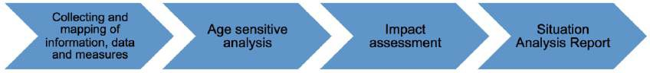

Collection and mapping of information, data and measures
The collection and mapping of relevant information, data and measures is a first step of the analysis. It is suggested to combine qualitative information with quantitative sources, which can create comprehensive base for the analysis. This can also help address any data availability gaps there may be. The collection should take into consideration information, data and measures from across sectors including:

- Social protection
- Labour markets
- Health and well-being
- Lifelong learning
- Gender equality
- Intergenerational solidarity
- Adherence to human rights of older persons
- Integration and participation of older persons in society; e.g. age-friendly environments, volunteering, housing, transport, decision-making, access to services etc. including interdisciplinary efforts at the national- and sub-national level.

The process should take into consideration contributions from- and the views of the line-ministries and stakeholders (stakeholder network). As a result, the collection and mapping of information, data and measures should: provide an overview of all the relevant information, data and measures exist; help the identification knowledge gaps and inform the mapping process; support in identifying data and indicators, and help determine which data/indicators of success to use moving forward.27

What information is relevant?
Information can include findings from research, studies and outcomes of consultations. Furthermore sources e.g. policy reports, reports from civil society, as well as analysis prepared by specific agencies and statistical offices. Reporting on the progress related to international frameworks should also be considered, such as the reviews and appraisal reports of MIPAA/RIS.
Box 2.2: Human Rights Based Approach to Data

Data disaggregation and collection by population group is central to a Human Rights Based Approach to Data (HRBAD). A HRBAD enables assessing possible inequalities and discrimination and can help determine whether human rights obligations are met.

The approach focuses on the collection and publishing of disaggregated data by sex, age, ethnicity, migration or displacement status, disability, religion, civil status, income, sexual orientation and gender identity.

The HRBAD aims among others at strengthening systematic data disaggregation by bringing together relevant data stakeholders to supplement traditional data collection efforts and can be helpful in addressing data gaps and the identification of indicators to monitor progress on the mainstreaming ageing efforts.

- For more guidance on the HRBAD: A Human Rights-Based Approach to Data – Leaving no one behind in the 2030 Agenda for Sustainable Development – Guidance note to data collection and data disaggregation.
What data should be collected? At the core of the Strategic Framework is understanding that population ageing affects all domains of society bringing opportunities and challenges that require evidence-based policies. The need for relevant statistics is therefore wide ranging and research, data and questions related to ageing are numerous. They relate to socio- demographic, economic, medical, intergenerational, gender and other aspects. The collection and review of data can consider data from multiple sources, such as censuses,

household- and other surveys, and civil registration system. When dealing with data, they should be age disaggregated as well as by gender, disability ethnicity etc. As gaps in (disaggregated) data or the quality of data can potentially form a barrier to the analysis, the collection and review of available data can help identify where data gaps exist and where further data is needed. To address the data availability, data from non-traditional data sources can be considered. This is among others promoted by a Human Rights Based Approach to Data (HRBAD) (Box 2.2). Furthermore, it is suggested to follow the recommendations on ageing-related statistics that were identified by the Task Force on Ageing-related Statistics (Box 2.3).

In addition to these four areas, the recommendations cover demographic measures of ageing, issues such as data gaps and the need for further data collections; institutional population aspects; dissemination and communication of ageing-related statistics as well as recommendations for national statistical offices.
Encourage longer working life and maintain ability to work.
Promote participation, non-discrimination and social inclusion of older persons. Promote and safeguard dignity, health and independence in older age.
Maintain and enhance intergenerational solidarity.
i)
ii) iii) iv)
Box 2.3: Recommendations on ageing-related statistics

In light of the increasing policy relevance of ageing and the need for evidence-based policy formulation a UNECE Task Force on Ageing-related Statistics was established in 2013. The Task Force developed recommendations for statistical offices to improve the availability, accessibility and comparability of statistical data in support of ageing-related policymaking. The recommendations were prepared through the lens of the four principles of the Vienna Declaration for the period of 2012-2017:

Which additional measures are relevant?
In addition to information and data, measures that have been initiated in the field of ageing should be gathered, such as (national/local) strategies, plans, policies, legislation, programmes, commitments to international frameworks and awareness raising efforts. Furthermore, a ‘screening’ of the national budget can help evaluate where key commitments to specific policy areas reflect ageing related policies and priorities.

Finally, a mapping of information, data and measures can be carried out. The mapping exercise can among others help cross-reference relevant information, data and measures and help identify the underlying causes of e.g. ageism, discrimination and other. Furthermore, structuring the mapping in compliance with the principles of MIPAA/RIS and/or other commitments of relevance to ageing can help shed light on areas that need specific attention in the development of the mainstreaming framework.

Age (sensitive) analysis
In addition to and based on the results of the mapping of information, data and measures, carrying out an age sensitive analysis is suggested. Age sensitive analysis can help provide information on ageing and older persons in society of specific aspects. It can help inform the mainstreaming of ageing into policies, programmes and other efforts. The aim is to help identify gaps, problems and barriers that should be addressed in the Strategic Framework.

By analyzing different levels of policies, progammes and legislation, underlying causes and effects of population ageing and the situation of older persons can be determined. The analysis is therefore an important step to ensure that sound and critical advice is provided when developing the Strategic Framework. The outcome of the analysis can help develop targeted responses to issues that relate to e.g. older persons’ access to services and resources, and benefits of- and

contributions to society, and the needs and rights of older persons. The analysis should take into consideration measures at the national as well as local level.

An area where age sensitive analysis is particularly relevant is in the context of e.g. COVID and other emergencies. COVID and the measures taken in response to the pandemic have impacted older persons not only as a risk group, but also lead to increased social isolation, loneliness, neglect and other aspects. An analysis of these impacts and bringing to light the experiences can help analyze the response, identify bottlenecks and determine needs to ensure efficient future responses. Soliciting feedback from older persons, their associations and key stakeholders e.g. care homes can help identify areas that need innovative solutions and new forms of response, support and care.

While limited experience to carry out age sensitive analysis is available, frameworks have been developed in the field of gender mainstreaming. These tools often represent step-by-step guidance for carrying out analyses, assisting in raising questions, analyzing information and developing strategies. Some of these can be applied to age sensitive analysis as illustrated in Box 2.4.

Box 2.4: Questions of relevance for carrying out age-sensitive analysis

- Who is the target of the policies, programs or legislation? Specifying age groups, gender, older women or other groups among the ageing population.
- Why is the policy, program or legislation of relevance to older persons and how?
- What are the main problems of the policies, programs or legislation vis-à-vis population ageing/ needs of older persons?
- Were older persons consulted?
- What specific mechanisms can be proposed to encourage and enable older persons to participate?
- How are activity, access and other patterns shaped by the social economic context, structural factors (demographic, legal and institutional) and by cultural and religious aspects?
- Where do opportunities or entry points for change exist? And how can they best be used?

Source: Inspired by gender-analysis, EIGE.

In some cases ageing-related analysis was incorporated in gender analysis, for instance in Canada where the ‘Gender-Based Analysis Plus’ tool helps ensure age-sensitive analysis (Box 2.5).

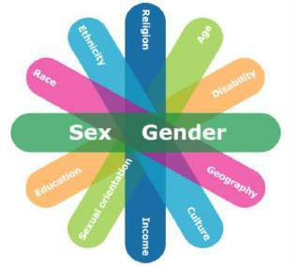
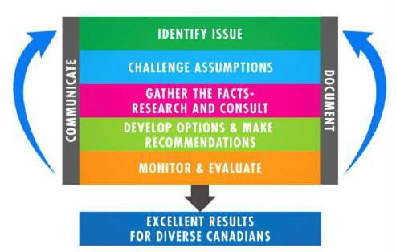
The GBA+ is an analytical process used to
Box 2.5: Gender-Based Analysis Plus (GBA+) in Canada

Gender-Based Analysis Plus (GBA+) is an important tool
for ensuring age-sensitive analysis and policy development is embedded in the policy process across federal organizations. assess how diverse groups of women and men and non-
binary people may experience policies, programs and initiatives. The GBA+ goes beyond gender and considers factors like age, race, ethnicity religion and mental or physical disability.

The approach has been applied since 1995 as a result of the Beijing Platform for Action. The Government has recently re- newed its commitment and is working to strengthen its implementation across all federal departments.

Key elements of the GBA+ Framework are as follows:

- A Responsibility Centre to oversee the implementation of GBA+ and provide internal advice
- An Organizational needs-assessment, to determine what capacity and resources already exist in the organization and to inform the creation of a work plan.
- A policy statement, or statement of intent to articulate commitment to the GBA+ and provide a mandate for implementation.
- GBA+ training and tools, to facilitate buy-in, build capacity and inform different parts of the organization about GBA+.
- A GBA+ ‘pilot’ initiative, to provide a concrete example of the GBA+ application.
- Ongoing monitoring of progress, to highlight success, best practices and to identify gaps and new priorities..

The GBA+ process helps analyze and systematically incorporate diversity considerations in the work across
the government. The GBA+ focuses on diversity and inclusion. By routinely using GBA+ checklists and tools, asking GBA+ questions mainstreaming of gender and related issues can be fostered.

Source: https://cfc-swc.gc.ca/gba-acs/index-en.html
The GBA+ includes a number of elements:
GBA+ factors

Impact assessment
Impact assessment can be carried to help identify potential effect of measures on older persons. They can for instance check if existing laws, policies and measure etc. have ageist provisions, which may lead to the need for strengthening measures on age-based discrimination. If guidelines on age impact-assessments are available, these can be applied. If no guidelines exist, the development of guidelines is recommended to avoid negative impacts of measures on ageing-related priorities. To enable mainstreaming across sectors, inter-disciplinary assessments can help evaluate existing laws/policies. In some countries (inter-disciplinary) assessments of relevance to ageing have been carried out as a part of national planning efforts, or as a part of regulatory assessments (Case 2.6). Assessments in areas of relevance to ageing may have been conducted e.g. when older persons are included as a target group in poverty impact or other assessments and should be taken into consideration.

As many impacts affecting ageing and older persons depend on future events, assessments should reflect uncertainties posed by e.g. climate change, demographic developments, economic shocks, natural disasters and other emergencies (incl. COVID) and urbanization. In order to enable addressing these uncertainties scenario planning is a helpful technique. Scenario planning can help take into account risks of various future scenarios and strengthen an understanding of the potential impact of these developments. It is therefore a helpful technique that can support generating strategic options around the effects of ageing.
Box 2.6: Example of Ageing Inclusive Impact Assessment

Since 1998, Government Departments and Offices in Ireland have been required to proof impacts on poverty and vulnerable groups. Based on a commitment set out in the national partnership agreement, the Government is committed to a coherent strategy for social inclusion based on a “life cycle approach’. The approach places the individual at the center of policy development and delivery by assessing the risks facing him or her and the supports available at key stages of the life cycle. The life cycle stages are: children, people of working age, older persons and persons with disabilities.

The ‘Regulatory Impact Assessment’ (RIA) is applied as a tool that is used for the structured exploration of different options to address particular policy issues. While it is used for the consideration of regulatory measures, it involves detailed analysis that can potentially benefit all policy areas and groups. Guidelines on RIA recommend examining potential impacts for a number of areas, including the rights of citizens as well as the socially excluded and vulnerable groups. The guidelines are based on a participatory approach and suggests the identification of various options/scenarios enabling alternative solutions and allowing for addressing transformative change.

The guidelines highlight the national development planning efforts and the need to address the cross- cutting nature of poverty and exclusion. These are stressed in the context of tackling exclusion in a number of areas, such as employment, income maintenance, education, health and housing policy and identify several groups vulnerable to poverty, including older persons. Taking account of the highlighted policy areas, RIA encourages the consideration of the impacts on people of different genders, ages, sexual orientation to identify likely impacts on inequality. The guidelines detail how poverty impact assessments should be conducted and references guidance on social inclusion and equality.

Source: RIA Guidelines, how to conduct a Regulatory Impact Assessment, Department of the Taoiseach Government Buildings, 2009

Situation Analysis Report
Findings of the collection, mapping, assessment and analysis should be summarized in a ‘situation analysis’ report. The report should be subject to consultation with line-ministries and stakeholders (Stakeholder Network). By presenting the current situation on ageing from a sector specific/cross-cutting perspective, the purpose of the report is to provide a baseline for further development of the Strategic Framework, highlight which gaps exist and what areas need specific attention. The report can be included in a final Strategic Framework for Mainstreaming Ageing document. Elements, which the report can include:

- Details on the demographic structure.
- Analysis concerning the status and development of older persons, e.g. per sector at national and sub-national level.
- Services offered to older persons.
- Frameworks, policies and activities implemented.
- Institutional/organizational structures.
- Adherence to international commitments.

Box 2.7 provides details on the content of the situation analysis report specific to population ageing and the situation of older persons. As a result, the report can provide a comprehensive overview of the situation and serve as a base line for mainstreaming strategy, its goals and objectives (Module 3) and the further identification of activities (Module 4) of the Strategic Framework.

Box 2.7: What does the situation analysis include?

The situation analysis report should contain information on the demographic situation, on how older persons are faring and what ageing-related policies and services are is place. The information should inform the development of the strategic approach and activities of the Strategic Framework for Mainstreaming Ageing. This includes general facts about the country, e.g. lands area, geographical facts, area etc., its demographic structure, relevant socio-economic facts, policies and measures as well as the institutional framework. Results of the age sensitive analysis and the impact assessment should help identify which gaps exist and what ‘problem’ areas should be addressed through mainstreaming ageing.

Questions to be addressed in a situation analysis report:
- What does the demographic context look like?
  - What is the population size?
  - What is the percent of older persons (incl. by gender)/proportion of older persons per age groups in total population?
  - Percentage of persons living in urban setting?
  - What are the medium- and long terms population projections?
  - What is the life expectancy by birth/sex and at specific age, e.g. at 65?

- What is the socio-economic context?
  - What is the GDP per capita/growth rate?
  - What are the unemployment rates/projections?
  - Details on labour market/pension systems.
  - Insurance situation?
  - Information on trade/ exports.
  - Business sector and environment.
  - What are medium- and long-term projections?

- Which institutional structures are in place that address ageing and the needs of older persons?
  - Focal points on ageing?
  - Are line ministries involved? If yes, which?
  - Which subnational institutions are responsible for ageing and the needs of older persons?
  - Is there a coordination group and mechanism?

- Which policy, legal and other measures of relevance to ageing and older persons exist at the national and subnational level?
  - Integration and participation of older persons in society, e.g. age-friendly environments, volunteering, housing, transport, decision-making, access to services etc.
  - Social protection
  - Labour markets
  - Health and well-being
  - Lifelong learning
  - Gender equality
  - Intergenerational solidarity
  - Research and data collection
  - Adherence to human rights of older persons
  - Etc.
- What gaps and problems have been identified as a result of age sensitive analysis/impact assessment?

Checklist

- Relevant information, data and measures collected
- Mapping of information, data and measures
- Gaps, problems and challenges identified
- Analysis conducted
- Impact assessment carried out
- Risks considered
- Compliance with MIPAA/RIS and other frameworks ensured
- Report on the context and situation completed
- Report consulted among relevant stakeholders (Stakeholder Network)

Module 3 – Mainstreaming Strategy

What is this Module about?

Drawing from the situation analysis report, Module 3 focuses on developing a Mainstreaming Strategy the responds to the findings and identified gaps in Module 2. The Mainstreaming Strategy can be considered the over-arching blueprint for the Strategic Framework on Mainstreaming Ageing. In accordance with the ‘twin-track approach’ the development of the strategy will outline the broader directions of the mainstreaming framework including a vision statement, strategic goals and objectives that i) consider population ageing and the societal context and ii) address individual ageing and the needs of older persons. As a part of the mainstreaming strategy, the aim of the Module is to identify strategic goals and objectives which will translate into concrete activities that will be identified in Module 4.

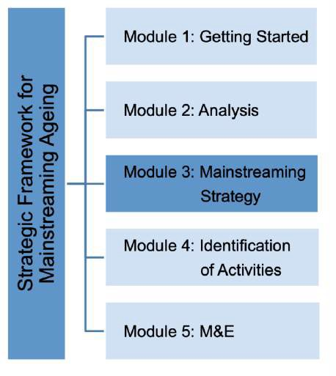

Introduction

The purpose of identifying a mainstreaming strategy is to define the overarching direction of the Strategic Framework. As a part of the mainstreaming strategy, this phase consists of setting out an overall vision statement, strategic goals and strategic objectives to help define short-, medium- and long-term change needed to systematically mainstream ageing.

In order to define the long-term aims for mainstreaming ageing, a vision can help provide a shared understanding across government and society of how to meet the needs of individual and population ageing in the years ahead.

Developing strategic goals and objectives that are inclusive, integrated and cross-cutting can help achieve the aspirations defined. The mainstreaming strategy should consider MIPAA/RIS and other commitments and translate those into the national/sub-national context. Anchoring strategic efforts in these commitments supports ensuring a mainstreaming strategy that aspires to achieving a society for all. As an example of cross-checking goals against commitments, Box 3.1 illustrates how ageing related goals were mapped against the SDGs.

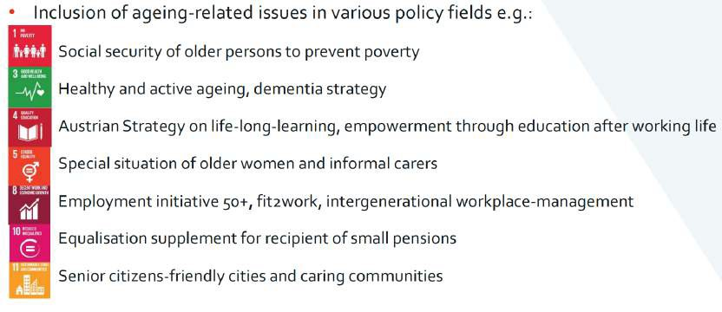
Box 3.1: Cross-checking ageing goals and the SDGs

Source: UNECE, Policy Seminar on Ageing and the SDGs, Presentation by Mr. A. Schaller, Austria, 21 November 2018.

In addition, key concept should be considered e.g. applying human rights- based approach, the life- course approach etc. (Box 3.2).

Box 3.2: Recommendations - Key concepts to consider
Advancing Intergenerational Solidarity
Commitment 9 of the UNECE Regional Implementation Strategy aims to support families that provide
care for older persons and promote intergenerational and intra-generational solidarity among their members. Various dimensions of intergenerational solidarity exist, ranging from family networks, to care and volunteering. Solidarity between generations at all levels – in families, communities and nations – is identified in MIPAA as fundamental for the achievement of a society for all ages. In addition, solidarity is an important prerequisite for social cohesion and a foundation of formal public welfare and informal public care systems. For more information: Advancing Intergenerational Solidarity, UNECE Policy Brief, No. 9.

Human Rights-Based approach
The Human Rights-based Approach is a conceptual framework for the process of human development that is normatively based on international human rights standards and operationally directed to promoting and protecting human rights. It seeks to analyze inequalities and redress discriminatory practices and unjust distributions of power. For more information see Part I, section 4.4.

Life-course approach
An age-integrated approach that facilitates the transition between phases of education, working, caring and leisure and the possibility to combine them flexibly across the life course is advised. The Iife course approach acknowledges that the ‘standard course of life’, in which periods of study, work and retirement follow one another in sequence is becoming less common. A life course approach emphasizes the importance of individual lifestyle choices; including healthy living and saving funds for old age. For more information: ‘ Realizing the potential of living longer’, UNECE Policy Brief No 19, 2017

Gender-responsive approach
Unless gender- and age-responsive approaches are addressing the multiple dimensions of gender inequality in ageing societies, women risk to be disproportionately disadvantaged by the consequences of population ageing, facing double and triple shifts of paid, domestic and care work at the detriment of their own health, earnings and savings which can accumulate to a greater risk of poverty, social isolation and unmet care needs in their own advanced age. Advancing gender equality in ageing societies requires an age- and gender responsive societal adaptation to population ageing through strategic efforts that focuses on:

- Preventing the accumulation of gendered disadvantages over the life course by tackling inequalities at all levels to close gender gaps in education, employment, care, earnings and pensions;
- Mitigating the risks resulting from gender inequality among older persons through redistribution and support;
- Anticipating the impacts of current reforms on future generations of women and men by mainstreaming age and gender in societal adaptations to demographic change.

For more information: ‘Gender Equality in Ageing Societies’, UNECE Policy Brief No. 23, 2020

Ageing in place
Ageing in place entails orienting policies to enable older persons to remain in their own homes for as long as possible and in as good health as possible. The emphasis is put on independent living and deinstitutionalization by building and strengthening a comprehensive and integrated case and support infrastructure at local level supporting older persons and their family caregivers in the community. By promoting services and support to the individual or family to enable older persons to continue living for as long as possible in their own environment and community. Key concepts of ageing in place:
- Long-term care: Including a wide range of services to persons whose limited ability to live independently carries on for an extended period of time.
- Community care: Integrative approach of care for older persons, which takes place in their familiar environment with the help of formal and informal care giving
- Residential care: Care that takes place in a residential home
- Formal care: care provided by professionals
- Informal care: Care provided by non-professional care givers. This may include home cate. Home care refers to long-term care services provided to care recipients who live in their homes.

For more information: ‘Towards community long-term care’, UNECE Policy Brief No 7, 2010

Apart from providing an overall blueprint for the Strategic Framework, the mainstreaming strategy can; help place ageing on the national agenda, support making older persons an integral part of society and facilitate the definition of age positive activities that builds in the contributions of older persons. Some examples of national approaches that include substantive ageing policies to mainstream ageing are described in Box 3.3. In addition to substantive ageing policies core strategic goals of the mainstreaming strategy could include goals to; build awareness and commitment; strengthen coordination, cooperation and collaboration on ageing, as well as building mainstreaming capacities.

Box 3.3: Examples of National Strategies and Plans

Various ageing related strategies and plans already exist across the UNECE region. Depending on country contexts the approaches to mainstream ageing take different forms. Some examples of strategies and plans that were developed are:

Federal Plan for Senior Citizens: “Ageing and the Future”
Austria’s Federal Plan for Senior Citizens: “Ageing and the Future” follows the four main goals of the Vienna Ministerial Declaration on ‘Ensuring a society for all ages: promoting quality of life and active ageing. Canada’s approach is based on four policy objectives; i) improving access to housing, ii) Improving income security; iii) Promoting healthy ageing and access to healthcare and iv) fostering social inclusion and engagement.

National Action Plan Promoting Positive Ageing for 2013 – 2017
The Czech Republic’s National Action Plan Promoting Positive Ageing for 2013 – 2017 is a strategic document that aims to change attitudes towards active ageing, increase interest of society as well as the prolonging of age and the quality of the life spent in old age. The plan consists of eight strategic areas: i) Implementation of the Ageing Policy in the Czech Republic; ii) Securing and Protecting the Human Rights of Older People; iii) Life-long learning, iv) Employment of older workers, v) Quality life environment for seniors; vi); Volunteering and intergenerational cooperation; vii) Healthy ageing; and viii) Care for the elderly.

National Demographic Strategy: “Every Age Counts”
In Germany the 2012 national demographic strategy ‘Every Age Counts’ applies to both federal and local level and aims at benefiting from the opportunities offered by population trends and describes fields of action in response to demographic change. A dialogue was launched with representatives from multiple levels of government, the private sectors, social partners, academia and civil society. Concrete approaches were formulated by joint working groups in 2013. Follow-up and further development of the strategy was initiated in 2015 aimed at “greater prosperity and better quality of life for all generations”, including additional activities and strengthened partnerships.

National Positive Ageing Strategy
Ireland’s National Positive Ageing Strategy is a high level document outlining the country’s vision for ageing and older persons and the national goals and objectives required to promote positive ageing. It is an over-arching cross-departmental policy that serves as the blueprint for age related policy and service delivery across Government in the years ahead. The Strategy marks a milestone in the development of policies for older people as it; i) was developed on the basis of the expressed views of older people and their representatives about what they, as citizens of Ireland, need to enable them to age positively. Therefore, the Strategy is citizen-centered as opposed to service-centered. II) is a holistic and integrated Strategy that addresses the very wide spectrum of issues necessary to ensure that the experience of ageing in Ireland is a positive one.

The National Strategic Policy for Active Ageing: 2014-2020
‘The National Strategic Policy for Active Ageing: Malta 2014-2020’ is premised upon three major themes: active participation in the labour market, participation in society and independent living. Based on a context analysis the strategic policy is embedded in the concept of ‘ active ageing’ and follows seven key principles: i) contribution to the well-being of older persons; ii) involving all older persons; iii) focusing on the avoidance of ill-health and social exclusion in later life; iv) Intergenerational focus and stakeholder inclusion; v) embodiment of both rights and obligations; vi; participation and empowerment; and vii) sensitivity to national and cultural diversity.

Source: Country notes on Mainstreaming Ageing

Potential challenges

As the complexities of population ageing are wide-ranging, the development of a comprehensive Mainstreaming Strategy needs to take into consideration a number of aspects; including the twin- track approach, key concepts, principles and international commitments that together support the aspiration of developing a ‘society for all ages’. In many cases, ageing related priorities are however addressed by ad hoc measures and approached in silos.

The analysis in Module 2 intended to identify a number of needs and gaps in need of a response. However, capturing the complex interrelations between population ageing and its impact on different sectors, while at the same time considering the needs of older persons, may require further exploration.

In order to enable targeted and a holistic Mainstreaming Strategy, Module 4 suggests among other things a consultation process that can inform the definition of a vision statement and the overall strategic goals and objectives based on consultation that is built on the suggested twin- track approach: i) the need to consider the benefits and implications of population ageing from a societal perspective and ii) the situation and needs of older persons in terms of individual ageing. This approach can help integrate cross-cutting connections and inform a holistic mainstreaming strategy and the broader policy directions. Aligning and anchoring the strategic goals and objectives in international commitments of relevance to mainstreaming ageing is recommended to help ensure these are translated to national- and local level.

Mainstreaming Strategy – Suggested Activities

Suggested activities to develop a mainstreaming strategy consist of the of the following activities:

Key suggested activities to develop the mainstreaming strategy are; determining its scope; carrying out consultations to help identify the broader policy directions, developing a visions statement, strategic goals and objectives and once these are identified, create awareness around the strategy. It is recommended to complete the ‘Mainstreaming Strategy Matrix’ (Table 3.1) that supports ensuring alignment of the strategic goals and objectives with the findings of Module 2 as well as priorities framed by international commitments.

Table 3.1: Strategic Mainstreaming Matrix
Vision Statement (Module 3)
Strategic Goal 1: (Module 3)
Findings/ Analysis (Module 2) | Strategic objectives | MIPAA/RIS | Lisbon Declataion | SDGs
Include key findings of Module 2 and the situation analysis report of relevance to  the Strategic Goal and objectives | Objective 1.1.  Objective 1.2:  Objective 1.3: Etc. | Which MIPAA/RIS  commitments do the objectives correspond to? | Which Lisbon commitments do the objectives correspond to? | Which SDG(s) do objectives correspond to?
Strategic Goal 2: Etc.
Findings/recommen dations Analysis (Module 2) | Strategic objectives | MIPAA/RIS | Lisbon Declaration | SDGs
Objective 2.1
Objective 2.2 Etc.
Findings/recommen dations Analysis (Module 2) | Strategic objectives | MIPAA/RIS | Lisbon Declaration | SDGs
Objective 3.1
Objective 3.2 Etc.

Once the mainstreaming strategy is in place, awareness raising of the strategy is recommended. An example of national strategic approached that that follow the suggested elements are described in Box by Box 3.4.

Box 3.4: Examples of national strategies

‘National Positive Ageing Strategy’

Ireland’s ‘National Positive Ageing Strategy’ was developed on the basis of a citizens-centered approach and considered the expressed views of older people and their representatives about what they say, as citizens, and need to enable them to age positively. It furthermore is developed based on a ‘whole-of government’ and ‘whole-of–society’ approach to ensure a holistic and integrated Strategy that addresses a wide spectrum of issues necessary to ensure that the experience of ageing is a positive one. The strategy was developed based on cross-departmental collaboration and the inclusion of stakeholders.

The strategy was moreover grounded in and consistent with commitments of relevance to ageing. Of these developments, the WHO’s ‘Active Ageing – A Policy Framework (2000)’ was considered the most appropriate as it among others i) provides a road map for designing multi-sectoral active ageing policies;
- aims to encourage policy makers to recognize and address factors that affect how people and populations age, iii) encourages a life-course perspective and to promote inter-generational solidarity; and iv) emphasizes the need for a balance between the roles of both individuals and government in facilitating active ageing. The WHO Active Ageing Framework calls for action on three pillars of actions: participation, health and security.

Ireland’s ‘National Positive Ageing Strategy’ consists of:

  - A Vision Statement
  - Operating principles
  - Four National
  - Goals
  - Goal-specific Objectives
  - Cross-cutting Objectives
  - Priority Action Areas
  - Implementation and Monitoring Arrangement

Source: ‘Positive Ageing – Starts Now!’, The National Positive Ageing Strategy, Ireland

Active Ageing Strategy
Slovenia’s Active Ageing Strategy lays out a vision and principal objectives to respond to challenges brought about by population ageing. The document includes starting points for development, key highlights of a new paradigm, the vision and objectives, and proposals for guidelines. The strategy is in line with international frameworks including MIPAA and builds on the concept of active ageing. It aims to create an environment in which individuals across their life course, old age included, can live active, healthy, independent and safe lives, in intergenerational harmony and in full enjoyment of their rights.

The document focuses on four segments (pillars):

- Employment (adjustments on the labour market, including education and training, and provision of sufficient labour through net immigration).
- Independent, healthy and safe living for all generations (systems of social protection, accessibility of healthcare and long-term care services, concern for health, reducing inequalities in healthcare).
- Participation in society (intergenerational cooperation, volunteering, use of ICT in communication, prevention of discrimination and violence in society, political activity.
- Environment enabling an active life throughout the life course (adjustments to the economy, dwelling conditions and transport systems with the support of ICT and technological solutions).

Source: Republic of Slovenia, 2018, ‘Active Ageing Strategy’

Scope of the Strategy
The mainstreaming strategy should be determined based on the planning efforts (Module 1) as well as the analysis (Module 2). Its scope; e.g. whether or which international frameworks it wishes to follow, what principles the mainstreaming strategy should be guided by as well as the timeline of the strategy e.g. 10 years, 15 or 20 years. The timeframe may depend on various factors, such as the need to ensure alignment with government planning or implementation of other efforts. A national strategy or sector strategies of relevance to ageing may exist. These can be existing plans on aging and/ or sector strategies such as health, life-long learning or others. If such strategies exist, these should be taken into consideration. Identifying the scope of the mainstreaming strategy should include timelines of the review and reporting of the strategy and actions (Module 4).

Consultation process
To ensure a unified mainstreaming strategy the process should be informed by feedback from key stakeholders (Stakeholder Network). It is recommended to carry out a stakeholder consultation that can inform the formulation of the vision statement, the strategic goals and objectives.

Consultation is important in order to solicit targeted feedback that can help foster a clear understanding of the complexities of ageing related questions and interests and needs of different stakeholders. Stakeholders may be affected by or contribute differently to public interventions, have different perspectives on which strategic priorities are most important. The involvement of older persons makes it possible to identify specific concerns and implications facilitating the identification of evidence-based strategic planning.

Consultation can take many forms, e.g. surveys, strategic workshops or roundtables at national and subnational level. Information and outcomes of the process can be summarized in a report that informs the development of the vision, strategic goals and objectives. In addition to informing the mainstreaming strategy, consultation of key stakeholders can strengthen buy-in, commitment, cooperation and collaboration of relevance to the further development and eventual implementation of the Strategic Framework. It is important to carry out the consultation in such a way that feedback on both population ageing as well as individual ageing is provided as suggested in Box 3.5.
Box 3.5: Recommendations - Consultation process

Stakeholder consultation is closely linked to participatory governance, which puts citizens at the heart of policy planning, implementation, monitoring and evaluation. Consultation aims to engage the diverse perspectives of different groups to better identify issues of concern and ensure an informed Strategic Framework. It is recommended to:

- Engage the Stakeholder Network to ensure relevant stakeholders including older persons are consulted (Module 1).
- Select a main partner with experience in participatory processes, e.g. a non-governmental organization, academia or a consultant group could be invited to facilitate the consultation
- Carry out the consultation based on the twin-track approach and foster clarity on aspects that help:
-
  - Mainstreaming ageing into all relevant policy fields at all levels (Societal context).
  - Addressing the needs of older persons (Individual context).

- Anchor the consultation in international commitments, incl. MIPAA/RIS, the Lisbon Declaration and others.
- Ensure gender and human rights perspectives are considered.

Defining a vision statement
As an overarching aspiration of the mainstreaming strategy, it is suggested to develop a vision statement. The definition of a vision statement for the framework helps identify where the country wants to be to best meet the needs of individual and population ageing in the years ahead. A vision statement can help foster a common understanding about the meaning of ageing, the direct strategic goals and objectives, as well as activities towards its purpose. Box 3.6 provides an example of a vision statement that aspires to achieve a ‘society for all ages’ while addressing ageing related aspects at both the individual as well at the societal level.
Box 3.6: Example of a Vision Statement aspiring to develop a ‘society for all ages’

The Irish National Positive Ageing Strategy was build on the following visions statement:

“Ireland will be a society for all ages that celebrates and prepares properly for individual and population ageing. It will enable and support all ages and older people to enjoy physical and mental health and wellbeing to their full potential. It will promote and respect older people’s engagement in economic, social, cultural, community and family life, and foster better solidarity between generations. It will be a society in which the equality, independence, participation, care, self-fulfillment and dignity of older people are pursued at all times”.

The vision and strategy are underpinned by the UN Principles for Older Persons (Annex 3), which are: independence, participation, care, self-fulfillment and dignity. These principles are set to guide the actions developed to progress Ireland towards an age-friendly society i.e. they should be used to assess the age- friendliness of policies, programmes and services for older persons and serve as an age-proofing tool for policy development and service delivery purposes.

Source: ‘Positive Ageing – Starts Now!’, The National Positive Ageing Strategy, Ireland

Strategic goals and objectives
Guided by the vision statement, and based on the outcomes of the consultation process, national strategic goals and objectives should be determined. These can reflect priority areas such as; health care, social services, lifelong learning and education, transport, employment, the built environment, housing and in the area of violence, abuse and
neglect of older persons.

Strategic goals can be broad and cross-cutting ambitions that support the vision statement. Under each strategy a number of strategic objectives should be formulated that are needed to achieve the overall objective. If possible, it is suggested to identify objectives in alignment with the twin- track approach (Track 1: Population ageing and the societal context and Track 2: Individual ageing and the specific needs of older persons) as suggested in Table 3.2:

Table 3.2: Applying the twin-track approach to the identification of strategic goals and objectives
Strategic Goal 1: Remove barriers to participation and provide opportunities for the continued involvement of older persons in all aspects of cultural, economic and social life in their communities according to their needs, preferences and capacities
Track 1: Population ageing and the societal context | Track 2: Individual ageing and the specific needs of older persons.
Objective 1.1: Develop employment options for  older persons, including options for gradual retirement | Objective 1.2: Identify barriers to continued  employment and lifelong learning for people as they age
Objective 1.3: Promote access to opportunities for continued learning and education for older persons  e.g. transport availability, accessibility of venues, affordability. | Objective 1.4: Promote the value of volunteering and encourage older persons to engage in- and to contribute to their own communities
Etc.
In addition to individual policy areas, cross-cutting aspects should be identified and considered. It is recommended to anchor and align the goals and objectives with the MIPAA/RIS commitments, the Lisbon declaration, the SDGs and other international frameworks (See Annex 2) /and or selected principles. Table 3.3 provides an example of a strategic goal and its objectives and its correspondence to a number of international commitments.

Table 3.3: Example of a Strategic Goal and Objectives and their correspondence to international commitments
Vision Statement (Module 3)
Strategic Goal 1: E.g Support people as they age, improve or manage their physical health and mental health and well- being
Findings/ Analysis (Module 2) | Strategic objectives | MIPAA/RIS | Lisbon Declaration | SDGs
E.g. findings on health challenges and their impacts on the physical health, mental health and well-being. | Objective 1.1. Prevent and reduce disability, chronic disease and premature mortality as people age by supporting the development and implementation of policies to reduce associated lifestyle factors  Objective 1.2: Promote the development and delivery of a continuum of high-quality care services and supports that are responsive to the changing needs and preferences of people as they age and at end of life  Objective 1.3: Recognize and support the role of | MIPAA/RIS Commitment 7: to strive to ensure quality of life at all ages and maintain independent living including health and well-being  - Promote health and well-being over the  entire life course, by mainstreaming health through inter-sectoral policies  - Ensure equal access to health and social services including long-term care for persons of all ages  - Ensure appropriate financing of health and social services for persons of all ages  - Enable people to make healthy choices | Empower individuals to realize their potential for physical, mental and social wellbeing throughout their lives (Goal I, Para 12).  Adapt health and social care systems to provide integrated, prevention- and person-oriented services (Goal I, Para 18).  Integrated social and long-term care and health services… adapting the status, training and working conditions of professional care workers (Goal III, Para 29).  Ensure integrated care on a local basis with treatment, care, and support after diagnosis… especially  through community- | SDG 3 – Ensure healthy lives and promote well-being for all at all ages

 | Carers |  | based services (Goal III, Para 31).
 | Etc.
 |  |  | Support and care suited to the varied and changing needs of older persons, allowing them to maintain social connections and stay in their preferred living environment for as long as possible (Goal III, Para 28)
 |  |  | Respect the self- determination, independence and dignity of older persons, especially, but not limited to, towards the end of life, through patient-centred medical and social care, including access to appropriate palliative care and aspiring to facilitate where possible the preferences of older couples to be cared for together. (Goal III, Para 32)

Strategic Goal 2
Findings/recommend ations Analysis (Module 2) | Strategic objectives | MIPAA/RIS | Lisbon Declaration | SDGs

Strategic Goal 3
Findings/recommend ations Analysis  (Module 2) | Strategic objectives | MIPAA/RIS | Lisbon Declaration | SDGs

In addition to policies and cross-cutting sector-specific strategic goals and objectives, consideration to priorities that support awareness raising as well as strengthening institutional capacities to support the systematic mainstreaming ageing efforts should be considered. Examples are summarized in Table 3.4.
Table 3.4: Examples of Strategic Goals and objectives to strengthen institutional capacities and strengthen awareness

Strategic Goal X: Building awareness and commitment to develop a society for all ages at national and subnational level and among stakeholders and partners
Findings/recommen dations Analysis  (Module 2) | Strategic objectives | MIPAA/RIS | Lisbon Declaration | SDGs
Lack of knowledge in area XX  Need for data  Need for partnerships | Objective X Identify areas  which need specific attention and call for better understanding of the complexities and impacts of population ageing and the needs of older persons  Objective X: Identify areas which need specific attention and call for better understanding of the complexities and impacts of population ageing and the needs of older persons  Objective X: Improve the collection of data and research to strengthen the understanding of and monitor progress on ageing specific priorities (including collection of sex- disaggregate data and research) | Commitment 7 to strive to ensure quality of life at all ages and maintain independent living including health and wellbeing  - it is necessary to collect data and have statistics  that are differentiated by both sex and age (Para  69). | “We underline the importance of monitoring and evaluating ageing- related policies based on research and improved data collection, as specified in the UNECE Recommendations on Ageing-related Statistics, involving older persons and their organizations throughout this process”. (Final remarks, Para 34) | SDG 17:  Strengthening the means of implementation and revitalize the global partnership for sustainable development.  Encourage and promote effective public-private and civil society partnerships, building on resourcing strategies of partnerships (Target 17)  By 2020, enhance capacity-building to support developing  countries […] to increase significantly the availability of high quality, timely and reliable data disaggregated by income, gender, age, race, ethnicity, migratory status, disability, geographic location and other characteristics relevant to national contexts (Target 17.18)

Awareness raising of the mainstreaming strategy
Finally, in order to enhance political commitment and ensure a shared understanding of the mainstreaming strategy, campaigns and other activities can help raise awareness of the vision, strategic goals and objectives.

Checklist

- If existent, existing strategies reviewed and considered
- Situation Analysis and key findings, identified gaps and needs considered
- Stakeholder consultation carried out
- Vision statement defined
- Strategic goals identified
- Strategic objectives/cross-cutting objectives determined
- Strategic objectives take into consideration the twin-track approach
- Need for awareness raising considered
- Need for institutional capacities considered
- The mainstreaming strategy is cross-checked with international commitments e.g. MIPAA/RIS, Lisbon Declaration, SDGs or others
- A human rights-based approach is applied
- The mainstreaming strategy clearly features solutions that reflects key concepts and approaches of relevance to ageing including a HRBA, intergenerational solidarity, gender-sensitive approach, life-course approach etc.
- The mainstreaming strategy is endorsed and approved by all stakeholders (Stakeholder Network)
- Awareness raising of the mainstreaming strategy completed

Module 4 – Identification of Activities

What is this Module about?

To achieve the mainstreaming strategy identified in Module 3, Module 4 consists of suggestions and recommendations that are relevant for defining activities that can help realize the strategic goals and objectives. These can be activities that are implemented on the short-, medium- or long-term. When identifying the activities different should be clearly assigned in consultation with line-ministries and stakeholders taking into account relevant linkages between thematic areas. The Module moreover suggests the consideration of institutional structures and selection of implementing partners. It is suggested to summarize the identified activities and implementing stakeholders in a Plan of Action (Table 4.1).

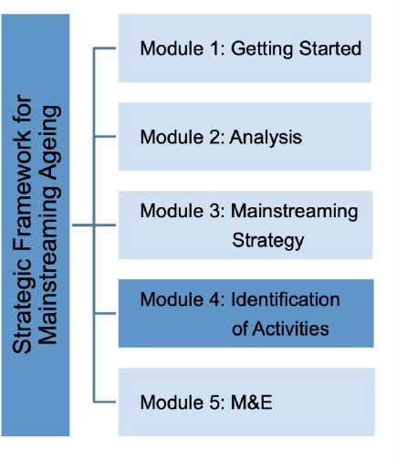

Introduction

Module 4 focuses on identifying activities that help achieve the strategic goals and objectives as defined in Module 3. It includes the framing and definition of interventions based on the findings and recommendations of the (impact) analysis (Module 2). This can help the systematic consideration of the impacts of envisaged activities and consequences for population ageing and the situation of older persons in all assigned strategic areas. During this phase a detailed definition of the activities, its timelines and responsible implementing partners is formulated.

The actions should both identify societal as well as individual ageing relevant to the national context, and at the same time help achieve key priorities as framed by international commitments such as MIPAA/RIS, the SDGs etc. The actions can consist of new measures, but can also help revise existing policies, programmes and laws, making amendments where needed. Examples of mainstreaming efforts that already have been put in place are summarized in Box 4.1.

Box 4.1: Examples of activities supporting strategic efforts to mainstream ageing

While many activities that support mainstreaming ageing exist across the UNECE region, the following examples activities that enable or support mainstreaming ageing, including framework legislation, specific policies as well as an example of subnational effort to mainstreaming ageing:

Act on adapting society to an ageing population (ASV Act)
The Act on adapting society to an ageing population entered into force in France in 2016. The reform is based on three pillars:

- Anticipating loss of autonomy by better meeting the demands of older persons in terms of housing, transport, social and civic life, and in doing so preventing and combating isolation.
- Adapting society to ageing by housing measures, including renovating residence accommodation for independent living and encouraging older persons to engage in volunteering activities
- Supporting older persons facing loss of autonomy to enable them to stay at home as long as possible. In addition, a “personal independence allowance” and measures to support informal carers are covered by the law.

National Action Plan on Dementia
In 2018, Denmark launched the “National Action Plan 2025”, which sets overarching goals toward 2025 for the care of patients with dementia. The aim is i) to create a dementia friendly country underlining the importance of having dignified and safe lives and ii) to ensure treatment and care for people with dementia that is based on individual needs with a focus on prevention, best evidence and more research; iii) to ensure the active involvement of caregivers and increased access to support. The plan aims to create 98 dementia friendly municipalities with the support of 23 initiatives that focus on; early diagnosis and better quality of diagnostic evaluation and medical care; better quality of care and rehabilitation; support and counseling to caregivers of people with dementia; dementia friendly society; and better education and research.

Age-friendly cities
In response to population ageing, the City of Brussels has since 2016 invested in developing a policy aimed addressing population ageing and older persons. As a member of WHO’s Global Network of Age Friendly Cities and Communities, the city initiated consultations and identified a number of priorities including; opening a ‘house for seniors’, improving public spaces; strengthening access to social services; paying extra attentions to fragile older persons; policy on senor housing as well as strengthening the participation of older persons in policy making.

Source: Country Notes

Furthermore, the engagement of stakeholders in the identification of activities is recommended to ensure broad ownership and help identify realistic activities with the commitment of implementing partners across and at all levels of society.

As in many countries ageing-related efforts fall under the responsibility of sub-national governments, considering local activities is key. Consideration to how activities can translate to the local level is of critical importance when identifying activities. Efforts to create so-called age- friendly communities already exist in a number of countries. Many of these efforts are based on the WHO Age-friendly Cities Framework and guidelines. (Box 4.1)

Box 4.2: Age-friendly Cities Framework

The WHO Age-friendly Cities Framework and Guidelines provide a useful tool for cross-sectoral collaboration and joined-up thinking across sectors at community level. Informed by the WHO’s approach to active ageing, the purpose of the guide is to engage cities to become more age-friendly as well as to tap into the potential of older persons.

The framework proposes eight interconnected domains that can help to identify and address barriers to the well-being and participation of older people: i) community and health care; ii) transportation; iii) housing; iv) social participation; v) outdoor spaces and buildings; vi) respect and social inclusion; vii) civic participation and employment; and viii) communication and information.

The approach builds on the establishment of a steering group that coordinates and brings different actors around the table. It furthermore builds on a participatory process in which older persons and their representatives are consulted.

A Global Network of Age-friendly Cities and Communities (GNAFCC) was established by the WHO in 2010 to bring together like-minded cities and communities committed to becoming more age-friendly, to facilitate the exchange of information, resources and best practices.

Potential challenges

The identification and implementation of activities may constitute challenges entailing investment in financial and human resources as well as the commitment of government and stakeholders to engage in implementing efforts. Traditionally ageing related issues have been associated with the health care sector with limited consideration of ageing aspects in other policy spheres. Module 4 helps assigning responsibility for ageing related matters across government as well as in the form of (multi-stakeholder) partnerships, which my help increase awareness of ageing as being a cross-cutting responsibility. This can require reforms or new forms of collaboration in the shape of
e.g. new institutional structures and/or multi-stakeholder partnerships as elaborated on in the suggested activities. The Module therefore recommends the promotion of competence development and capacity building that can help enhance awareness and strengthen commitment and the allocation of resources to implement the Strategic Framework.

Furthermore, activities in one area can impact progress in another area. Cross-cutting activities should take into consideration the potential trade-offs. Introducing age impact analysis to policies, can help uncover and negative impacts measures may have on e.g. the situation of older persons.

Identification of Activities – Suggested Activities

The identification of activities is a critical step in the development of the Strategic Framework on Mainstreaming Ageing. Suggested activities include:

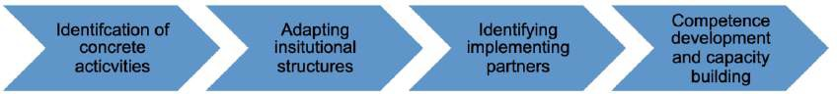

In order to help translate the goals and strategic objectives of Module 3 into concrete activities it is suggested to apply Table 4.1: Plan of Action. The plan includes considering timelines and implementing partners for each activity.

Table 4.1: Plan of Action
Vision Statement (Module 3)
Strategic Goal 1 (Module 3)
Strategic objectives (Module 3) | Activities (Module 4) | Timeframe By (Module 4) | Implementing partners (Module 4)
Objective 1.1 | Activity 1.1.1 | E.g. by 2030 | E.g. Ministry of Social Affairs
Objective 1.1 | Activity 1.1.2 | Etc. | Etc.
Objective 1.1 | Activity 1.1.3
Objective 1.1 | Etc.
Objective 1.2 | Activity 1.2.1
Objective 1.2 | Activity 1.2.2
Objective 1.3 | Etc.
Strategic Goal 2
Strategic objectives | Activities | Timeframe | Implementing partners
Objective 2.1
Objective 2.2
Etc.
Strategic Etc
Strategic objectives | Activities | Time frame | Implementing partners
Objective 3.1
Etc.

Identification of concrete activities
In order to achieve the determined strategic goals and objectives of Module 3, short-, medium- and long-term activities should be identified. These can take many forms such as policies, legislation, programmes or activities that address specific themes or activities that help mainstream ageing into thematic areas such as poverty, health, gender, decent work, inequalities, disability environment, conflict and in emergency situations (Box 4.3). In addition to ensuring coherence across thematic areas, activities for both national and sub-national mainstreaming should be considered.
Box 4.3: Older persons in emergency situations

One area of specific interest is older persons in emergency situations. As older persons remain among the most seriously affected groups in emergency situations, specific focus in the formulation of activities is required. This has among others been demonstrated during the COVID 19 pandemic, which impacted populations disproportionally calling on countries to respond. Emergency situations impact older persons to different degrees depending on e.g. specific health and social factors. These may relate to; physical health, mental health, functional status and disability, nutrition, lifestyle habits, family and social relations, gender considerations and their economic situation. Awareness of the needs and contributions of older persons while developing activities can contribute to more effective interventions, including equitable access to essential health and social services to older people during all phases of an emergency.

It is suggested to base identification of activities with the inclusion of key stakeholders (Stakeholder Network) to include all views. While stakeholder engagement can be carried out in various ways, consideration can be given to focus on clustering groups supporting the strategic goals or strategic objectives. Multi-stakeholder dialogues can help build consensus and help shape joint activities and also support the identification of cross-cutting aspects. Table 4.2. offers examples of activities, timelines and implementing partners as defined in response to the strategic goals and objectives.

Table 4.2: Examples of concrete activities, timelines and implementing partners
Vision Statement (Module 3)
Strategic Goal X Mainstream ageing into all sectors and strengthen collaboration across and at all levels of government
Strategic objectives | Activities | Timeframe By | Implementing partners
Objective X:  Improved capacity and greater priority on ageing related priorities across and at all levels of government | Activity X:  Identify incentive barriers that could exist within the workings of government. | E.g. by 2022 | E.g. Ministry of Social Affairs
 | Activity X:  Increase the allocation of resources, but also training provided to ageing coordinators/focal points at ministerial or subnational level | By XX | Etc.

 | Activity X:  Create multi-stakeholder partnerships that help address capacity needs | Etc.
 | Etc.
Objective X: Strengthened coordination and collaboration on ageing across and at all levels of government | Activity X: Establish a multi-  stakeholder coordination mechanism and coordination strategy aimed at strengthening information exchange and coordination channels | E.g. By 2022 | E.g. Task Force on Mainstreaming Ageing
 | Activity X:  Establish focal points for ageing in all relevant line ministries and definite of clear TOR and mandates | By XX | XX
Objective X: Systematic inclusion of ageing concerns and older persons in the formulation of new laws and policies | Activity X:  Develop guidelines for impact assessments | Etc. | Etc.
Objective X: Combating ageism and eliminating discrimination of older persons at all levels of government | Activities X: Training provided to ageing  coordinators/focal points and staff at ministerial or sub-national level
 | Activity X: Strengthening the mandate on age-based discrimination of the ombudsperson or the establishment of one could be another concrete activity
 | Etc.

Strategic Goal X: Building awareness and commitment to develop a society for all ages at national and subnational level and among the public, government institutions, stakeholders and partners
Strategic objectives | Activities | Time frame | Implementing partners
Objective X  Identifying areas which need specific attention and call for better understanding of the complexities and impacts of population ageing and the needs of older persons | Activity X  Carry out public consultation | By 2022 | e.g. University or specialized research agency
 | Activity X  Roundtables on specific topic of concern to population ageing and the needs of older persons | By XX | Task Force on Mainstreaming Ageing
 | Activity X Etc.
Objective X:  Raising the awareness on the benefit of population ageing and the contributions of older persons | Activity X  Carry out a national campaign aimed at addressing existing stigmas of older persons
 | Activity X: Development of sector specific ageing resources with key messages of why it is important to take ageing into concerns each sector e.g. the transport or energy sector
 | Activity XX: Organization of thematic seminars or webinars could be considered
Objective X:  Improve the collection of data and research to strengthen the understanding of and monitor progress on ageing specific priorities (including collection of sex-disaggregate data and research) | Activity X:  Promote the collection of non-traditional data | By XX | E.g. National Statistical Offices, Civil Society Organizations, Universities  and research institutes
Activity X
Establish public-private partnerships to develop innovative approaches to strengthen data on ageing related trends, demographic developments and the situation of older
Persons
 | Etc.

As a part of the action plan – and as exemplified in table 4.2, it is suggested to include awareness-raising efforts. These can be aimed at generating awareness about the impact of population ageing on society as well as to create sensitivity to issues related to ageing and the needs of older persons at the individual level (twin-track approach). Successful awareness raising efforts require the collaboration among stakeholders. Some efforts that can help raise awareness as well as criteria for effective ageing related awareness raising activities are listed in Box 4.4. Box 4.5 lists various examples of awareness raising that is practiced in UNECE countries.
Box 4.4. Recommendations - Awareness raising efforts and criteria for effective awareness raising activities

Examples of awareness raising efforts:

- Leaflets, brochures, handbooks, manuals and guidance
- Websites and information materials
- Inclusion in school curricula, including education on human rights
- Conferences, roundtables and workshops
- Social media
- Media campaigns
- Exhibitions
- Inclusion as part of related campaigns on e.g. equality, gender, discrimination etc.

Some criteria for effective awareness raising campaigns are;

- A strong basis in human rights and gender;
- Guided by clear and comprehensive definitions,
- Application of multi-sectoral and multi-level approaches, and with the inclusion and engage of relevant stakeholders/communities.
- Awareness raising activities should be grounded in evidence.

Box 4.5: Examples of Awareness Raising Practices

Multiple types of awareness raising efforts are practiced in the UNECE region. The following includes examples of initiatives that aim to increase general public awareness, or on a specific topic, while others aim at enhancing awareness to help mainstream ageing at the local level.

Age-friendly communities
Specific guidance by the Canadian Federal Government is provided to enhance Age-friendly communities in Canada’s provinces. A web-portal provides specific information explaining what an age- friendly community is, what it looks like and how communities can become more age friendly. To help communities, ‘Pan-Canadian Age-Friendly Communities Milestones’ were developed describing the steps a community needs to follow to successfully apply the ‘Age-friendly Communities’ model. Communities that have demonstrated that they have met at least three age-friendly communities milestones can be recognized by their province or territory as officially on the road to becoming age-friendly. They may also seek recognition from the Public Health Agency of Canada and the World Health Organization.

Exhibition ‘What’s old anyway?’
In Germany a photographic and video competition was organized by the Federal Ministry for Family Affairs, Senior Citizens, Women and Youth focusing on how ageing is understood and perceived. The exhibition called ‘What’s old anyway?” aimed to address questions such as; how old is old age? Until what age are we young? What is life in old age really like? The results were included in a publication shedding light on themes such as active ageing and generational aspects.

Awareness campaign on violence against older people
In the Czech Republic, Zivot 90 – an NGO dedicated to the issue of abuse of older persons – implemented a campaign on violence and abuse of older persons. With support from the Ministry of Labour and Social Affairs, the campaign aimed at increasing the awareness, enhancing the ability to recognize different forms of abuse among the general public, and make existing support services known. The campaign included media interviews, press releases, media advertisements, billboards and banners, as well as information disseminated through social media. It was launched at the International Day of Older Persons in 2012.

Source: Country Notes

Adapting institutional structures
The implementation of the activities may require institutional reforms or trigger new forms of collaboration. It is recommended to establish a specialized unit at the highest level of government. The body should be mandated to coordinate the implementation and monitoring of Strategic Framework. A national mechanism on ageing, whether a council, commission or similar body will have important responsibilities for coordination across and at all levels of government/society. If so decided, this may be the same group as established in Module 1 (Task Force for Mainstreaming Ageing).

Some examples of institutional structures established to systematically coordinate ageing exist in the form of councils, commissions or specific units dealing which can coordinate the implementation of the Strategic Framework (Box 4.6).

Box 4.6: Examples of institutional structures to mainstream ageing

Various institutional structures to mainstream ageing have been initiated across the UNECE region. Some countries appoint a national coordinator or have a unit established in a main Ministry that can help drive ageing related strategic efforts and activities. Depending on the government structure, levels of decentralization, division of responsibilities, and/or whether strategic efforts and action plans are in place, these structures take various forms:

Active Ageing Unit
An example of a permanent institutional structure that aims to holistically address ageing is Malta’s ‘Active Ageing Unit’ that was set up to coordinate its ‘National Strategic Policy for Active Ageing 2014- 2020’ strategy. Established in 2015, the Unit is responsible for coordinating the strategy that aims to achieve a society of all ages and ensuring Malta’s adoption of specific measures aimed at transforming the country into an age-friendly nation. Collaboration and programmes is carried out with line ministries with active collaboration of the Ministry for Education, the Ministry of local government, the Ministry of Health and the Ministry of Culture.

Central- and subnational level coordination
In Austria the ‘Unit on Ageing, Population and Volunteering Policies’ coordinates with various line- ministries including those responsible for health, science, technology, mobility, education. At the subnational level, similarly units on ageing are responsible for ageing related priorities. A Senior Citizens’ Advisory Council was established in 1998 under the Chair of Minister for Labour, Social Affairs, Health and Consumer Protection. The Council consists of representatives of all federal ministries, social partners, provinces and senior citizens’ organisations at province and community level.

Also in Denmark, ageing is mainstreamed at both national and subnational level. At the national level the Ministry of Health coordinates the follow-up of MIPAA. However, due to the bulk of local social service delivery, a strong role is assigned to sub-national governments.

In Germany mainstreaming ageing is practiced through a national, regional and local level institutional structure. At the national level 3 Directorate General of the Federal Ministry for Family Affairs, Senior Citizens, Women, Youth’ work on ageing related matters; i) Demographic changes, ii) Senior Citizens, and iii) Social Welfare. The Ministry is also responsible for the coordination and implementation of MIPAA). At the subnational level,16 Laender have coordinating ministries that monitor and assess implementation of the action in laender. Input from laender and stakeholders for the review of MIPAA is also ensured.

Shared responsibilities across federal/provincial/ municipal and indigenous governments
In Canada a Federal Focal Point at the ‘Employment and Social Development Canada’s Seniors and Pensions Policy Secretariat’ is responsible for mainstreaming ageing. Within the Secretariat, the ‘Forum of Federal, Provincial and Territorial Ministers Responsible for Seniors’ is an intergovernmental body established for the purpose of sharing information, discussing new and emerging issues related to seniors, and working collaboratively on key projects. Since 2007, a ‘National Seniors Council’ advises the government. Canada’s mainstreaming efforts are based on a collaborative approach with the participation of stakeholders.

Source: Country Notes

If no such body exist, a new body will need to be established. A number of key recommendations with regards to establishing adequate institutional structures for the purpose of implementing and monitoring of the Strategic Framework are listed in Box 4.7.

Box 4.7 Recommendations – institutional mainstreaming structure

In view of the need for new forms of collaboration and responsibilities for mainstreaming ageing, institutional structures may be reformed/strengthened to coordinate and enable collaboration across and at all levels of government. Some key recommendations are:

- Establishing a national mechanism e.g. a Council, Commission or similar body, for coordinated inter-ministerial collaboration to implement and monitoring of the Strategic Framework for Mainstreaming Ageing.
- The mechanism should be established at the highest level of government.
- Ensuring a clear mandate ensuring legitimacy, acceptance and cooperation across government through ToRs and MoUs. Key ministries/agencies include those responsible for health, social development, youth and gender, finance, planning, population and statistics.
- The institutional mechanism should enable the participation of older persons in decision- making and ensures their voice is heard at all levels of government.
- Installing focal points on ageing in line ministries.
- It is particular important to establish relations with gender focal points across sectors. Also ensuring a gender balance in the body is critical.
- Government authorities at the local level should be included as essential partners.
- National offices of statistics are key sources of background information for example on the demographic, economic and social situation of older persons and should be represented in the mechanism.
- Strengthening the mandate on ageing of Parliamentary commissions.
- Installing measures that ensure implementation of non-discrimination on the basis of age and provide support to victims of age-discrimination and/or a mechanism that addresses anti- discrimination issues e.g. an ombudsman or commission.

Identifying Implementing Partners
As highlighted above, in order to ensure commitment, the lead responsibility for the implementation of the Strategic Framework should be assigned to a centrally located entity in the government, preferably at highest level e.g. in the Prime Minister’s or Head of State’s office. In order to ensure implementation of the activities, implementing partners responsible for each activity should be identified. In accordance with the ‘whole-of-government’ or ‘whole-of-society’ approach these can be e.g. government departments, government agencies, CSOs, subnational governments, academia, businesses or other stakeholders. Their roles, responsibilities and tasks should be determined for each activity.

A collaborative approach to jointly implement the identified actions is suggested with the inclusion of multiple-stakeholders. The development of Multiple-Stakeholder Partnerships (MSPs) can play an important role in ensuring a coherent implementation of activities (Box 4.8). Partnerships that cross disciplines, sectors and levels of government can ensure the necessary capacities that are needed to implement activities. This can not only foster innovative solutions but also lead to new knowledge.
Furthermore, it should be determined, what new skills may be required for the implementation of activities and whether training or capacity building is required.
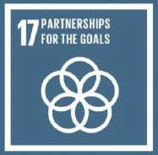
Box 4.8: Multi-stakeholder partnerships to mainstream ageing

The development of (multiple-stakeholder) partnerships can be instrumental for ensuring coherent implementation of the action plan and the development of activities that help the systematic mainstreaming of ageing across and at all levels of government. The importance of multi-stakeholder partnerships has been widely promoted as a result of the adoption of the 2030 Agenda for Sustainable Development. To achieve the Sustainable Development Goals (SDGs), governments are strongly encouraged to work closely on implementation with subnational governments, academia, philanthropic organizations, volunteer groups and others. This partnership approach is among others, embodied in SDG 17 (“Strengthen the means of implementation and revitalize the global partnership for sustainable development”),
target 7.14, which calls on countries to “enhance policy coherence for sustainable development” as a means of implementation. The target speaks to the interconnectedness between the 17 SDGs and the benefits of synergetic actions among stakeholders and levels of government. The need for integrated, inclusive, and coherent approaches— that enhance horizontal coordination between sectors, and vertical integration between levels of government—also addresses one of the underlying principles of the 2030 Agenda of “leaving no one behind.”

Source: Author

Competence development and capacity building
In view of newly established forms of institutional structures, collaboration, partnership collaboration the development of competences may be needed. Competence development is aimed at strengthening the knowledge and skills among government entities and stakeholders to engage with ageing related efforts. For this purpose, the Plan of Action (Table 4.1) can include strengthening capacities and knowledge of ageing specific priorities among government officials and other stakeholders at all levels of government, e.g. training, development of guidelines, sector specific notes etc. (Box 4.9).
Box 4.9 Recommendations - Competence and capacity building efforts

Competence development and capacity building is critical to ensure that government departments and other stakeholders are well equipped to implement the Strategic Framework for Mainstreaming Ageing. Competence development and capacity building should aim at enhancing knowledge about the mainstreaming ageing approach, demographic change and its social and economic consequences as well as the needs of older persons. Competence and capacity building can consist of :

- Training seminars and workshops on the overall mainstreaming strategic goals, objectives and activities of the Framework, the benefits of mainstreaming ageing, as well as key concepts and priorities such as active ageing, human rights of older persons.
- Development of guidelines e.g. to carry out age-sensitive analysis.
- Developing and disseminating sector specific notes.
- Investing in a webportal including information and analysis that provides a resource hub on ageing for e.g. media and other users. It could include infographics, case studies, best practices, lessons learnt and best practices, and research.

In addition, capacity-building measures should take into consideration the competence of specialists in the field of ageing as well as specialists with expertise in e.g. human rights or gender. Experts should be sensitized to the intersection between age and human rights or age and gender and the specific needs and vulnerabilities of older women and men to ensure that the needs and concerns of older persons are mainstreamed.

Checklist

  - Mainstreaming strategy and strategic objectives considered (Module 2)
  - Findings of the analysis and impact assessment considered (Module 3)
  - Mapping of existing activities against the objectives carried out
  - Adherence to MIPAA/RIS, Lisbon Declaration/other international frameworks ensured
  - Multi-stakeholder dialogues carried out
  - Short-, medium and long-term activities identified
  - Institutional structures determined
  - Competence development and capacity building considered
  - Implementing partners/multi-stakeholder partnerships identified

Module 5 – Monitoring and Evaluation

What is this Module about?

The activities defined in Module 4 should be regularly monitored in order to track progress and evaluate the implementation of the Strategic Framework for Mainstreaming Aging. The purpose of this Module is to finalize the development of the Strategic Framework for Mainstreaming Ageing by establishing a monitoring and evaluation approach, identifying indicators and determine a monitoring mechanism and format. The Module supports establishing M&E efforts that help measure progress of the activities and mainstreaming efforts of the Strategic Framework.

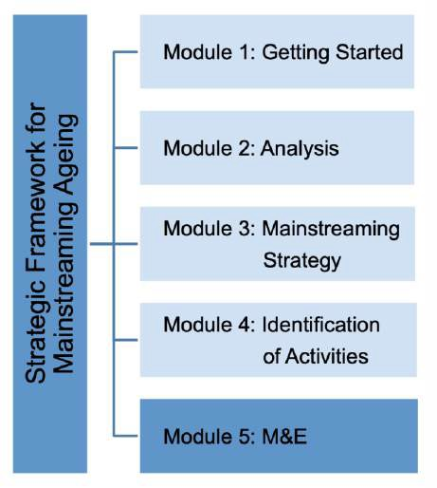

Introduction

Monitoring and evaluation (M&E) is critical to review and measure progress on the implementation of the Strategic Framework on Mainstreaming Ageing. M&E supports the determination of where and how activities are being implemented and whether transformative change is occurring by mainstreaming ageing. Investments in M&E also serve to gain a better understanding of the situation of older persons, their needs and preferences. Based on the determined strategic goals and objectives (Module 3) and activities (Module 4), a final step is the investing in M&E efforts that can help track whether the implementation of the Strategic Framework is progressing as planned.

In many countries M&E of ageing related policies and programmes already feature. These efforts can be considered when establishing M&E measures for the Strategic Framework. This can be in the context of regular government reporting, the review and appraisal of MIPAA, by applying Active Ageing Index (AAI) or in the context of the follow up and review of the 2030 Agenda for Sustainable Development. In countries that have national plans or strategies on ageing, specific mechanisms may have been developed to help to track progress of activities.

MIPAA has been central to the measurement of action on ageing in many countries. Every five years, countries of the UNECE region undertake an analysis of the current state of play in the context of the review and appraisal of MIPAA (Box 5.1). A framework for monitoring, review and appraisal of MIPAA was developed consisting of guidance on qualitative and quantitative methods that can be helpful in review and appraisal as well as a set of indicators to assess progress made (Annex 4). In addition to considering these methods, the periodic reviews of MIPAA implementation can integrate the monitoring and evaluation of the Strategic Framework on Mainstreaming Ageing.
Box 5.1: Review and appraisal of MIPAA

Every five years, countries undertake an analysis of the current state of play of MIPAA/RIS and the actions required to make further progress. The first cycle (MIPAA +5) was carried out in 2007, the second (MIPAA +10) in 2012 and the most recent cycle (MIPAA +15) was held in 2017. In the UNECE region, the Working Group on Ageing facilitated the process by among others preparing guidelines. Preparations of the fourth review and appraisal of MIPAA have started and will mark the 20th anniversary of MIPAA in 2022.

Measuring progress on mainstreaming ageing and enabling conditions at the local level might require the definition of local indicators. The WHO has developed a set of indicators to monitor the age-friendliness of cities. Guidance on indicators is formulated in; ‘Measuring the Age- friendliness of Cities: A Guide to using core indicators. An example of measuring progress on establishing age-friendly communities is the Canadian initiative; ‘Age-friendly communities evaluation guide’ (Box 5.2)

Box 5.2: M&E at sub-national level – ‘Age-friendly Communities Evaluation Guide’

As an example of measuring process related progress and evaluation, the ‘Age-friendly Communities Evaluation Guide’ developed by the Public Health Agency of Canada provides communities with practical information on how to use indicators to measure progress and evaluate their age-friendly initiatives. Age Friendly Communities are those communities that are taking steps to help older persons remain healthy, active and independent, and to continue to make important contributions as they age.

The Guide focuses on the use of indicators in planning, implementing and evaluating age-friendly community initiatives. In addition to providing information on how and why the use of indicators can strengthen community age-friendly initiatives, it offers a menu of specific, measurable indicators that are applicable to eight domains of community life that are being addressed in age-friendly programming. The Guide also includes four other indicators that reflect longer-term health and social outcomes for seniors.

The Guide provides practical and flexible indicators that are supplemented by ready-to-use or adapted tools as well as links to information to support community evaluations. It outlines the benefit of evaluation and how communities can make the most of evaluation results to strengthen and improve programs, increase community interest, attract funders and meet their needs.

Further monitoring efforts of relevance for ageing related issues are also ongoing in the context of the follow-up and review of the 2030 Agenda for Sustainable Development. The Agenda requires systematic follow-up and review processes to be country-led and take into consideration the key principles of the Agenda including the commitment to the principle of ‘Leaving No on Behind’. The follow- up and review of the 2030 Agenda is to ensure a participatory approach to tracking progress and ensure accountability through the engagement of citizens, Parliament and non- government stakeholders. To strengthen inclusive implementation of the SDGs and among others reduce inequality, disaggregation of data by sex, age and other socio-economic e.g. income/wealth, location, class, ethnicity, disability status is needed. A global indicator framework was developed to ensure monitoring of the SDGs, including 231 indicators. Complementing the global indicator framework, countries are to identify nationally-relevant and human rights sensitive indicators and targets as well as establish baseline data. The 2030 Agenda encourages the development of disaggregated indicators by sex and age, covering older age groups. Furthermore, as countries are to develop monitoring and reporting systems many monitoring efforts are ongoing, by e.g. developing review processes and mechanisms that measure progress on nationally and sub-national SDG implementation efforts. It is recommended to align or integrate monitoring efforts with these efforts.

Potential challenges

Fundamental for the successful implementation of the Strategic Framework is M&E. In many cases, specific capacities for the measuring of strengths and weaknesses of ageing related policies and programmes are non-existent. In order to ensure M&E of the Strategic Framework, the Module recommends the consideration of timely M&E efforts and the establishment of an M&E mechanism. Furthermore, to strengthen accountability and ensure that lessons learnt are adapted throughout the lifetimes of the Strategic Framework, it is recommended to establish a format that encourages routine reporting format and a structure that is built on stakeholder engagement.

A prerequisite for effective M&E is the availability of data and research. However, data availability and a lack of disaggregated data are likely to form a constraint to monitoring ageing related efforts. This may require the application of new approaches to data collection. The Module suggests the application of non-traditional data sources, development of new guidelines to be developed or the establishment of a platform to broaden the availability of (disaggregated) data. It moreover recommends the application of qualitative information as a means to supplement quantitative sources.

Monitoring and Evaluation – Suggested Activities

Progress on the Plan of Action (Module 4) should be reviewed periodically, identifying causes of potential shortfalls. This can help evaluate a number of aspects such as: to what extent does/doesn’t the Strategic Framework meet its goals?; which adjustments are needed?; And what are the lessons learnt? The following suggested activities help development of M&E measure for the Strategic Framework:

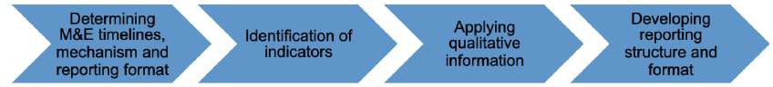

A comprehensive approach to monitoring and regular monitoring should include the possibility to adapt to changing environments and conditions. To ensure M&E of the Strategic Framework, the suggested activities support the integration of M&E and the development of indicators into the Plan of Action for each activity (Last column in Table 5.1).

Table 5.1: Plan of Action including indicators
Vision Statement (Module 3)
Strategic Goal 1 (Module 3)
Strategic objectives  (Module 3) | Activities (Module 4) | Timeframe By (Module 4) | Implementing partners (Module 4) | Indicators (Module 5)
Objective 1.1 | Activity 1.1.1 | E.g. by 2030 | E.g. Ministry of Social Affairs
Objective 1.1 | Activity 1.1.2 | Etc. | Etc.
Objective 1.1 | Activity 1.1.3
Objective 1.1 | Etc.
Objective 1.2 | Activity 1.2.1
Objective 1.2 | Activity 1.2.2
Objective 1.3 | Etc.
Strategic Goal 2
Strategic objectives | Activities | Timeframe | Implementing partners | Indicators
Objective 2.1
Objective 2.2
Etc.
Strategic Goal 3
Strategic objectives | Activities | Time frame | Implementing partners | Indicators
Objective 3.1
Etc.

Determining M&E timelines, mechanism and reporting format
Determining M&E timelines, mechanism and reporting format help create an M&E framework for the activities defined in the Strategic Framework and support consistent monitoring of progress. Routine monitoring can help gain clarity on the progress made and ensure the implementation of the Strategic Framework is on track. As a first step, it is recommended to determine how frequent the monitoring of the Strategic Framework will be carried out. This can include the establishment of an M&E cycle and/or a monitoring mechanism. Successful M&E of the activities to mainstream ageing requires collaboration across and at all levels of government. A participatory approach to assessing the implementation of the activities of the Strategic Framework allows the broad

examination of progress towards the strategic objections and activities. The monitoring mechanism should therefore enable the engagement of stakeholders, including older persons, in order to measure progress during the life of the Strategic Framework. A central body – as discussed in Module 4 - should oversee the M&E of the Strategic Framework. Box 5.3 includes an example of how the monitoring of ageing-related activities of a national strategy is approached in practice.

Box 5.3: Examples of M&E efforts

Many countries carry out monitoring of ageing related policies and programs in the context of the review and appraisal of MIPAA/RIS, or as a part of regular government reporting activities. Some countries where plans or strategies on ageing exist in some cases have established specific reporting and monitoring structures as is the case in Ireland:

Monitoring the National Positive Ageing Strategy - Ireland
The implementation of the National Positive Ageing Strategy will be monitored on an ongoing basis to ensure that it remains reflective of older people’s needs and preferences. A mechanism to review the implementation of Healthy Ireland is used to monitor the National Positive Ageing Strategy. A robust framework and levels of indicators were defined. Collaboration across government was initiated to identify indicators that were includes in an ‘outcome framework’. A National Health and Well-Being Council as well as an Annual Positive Ageing Forum were established to reflect and to assess progress from the perspective of older persons and their representative organizations. An annual report is produced and presented to the so-called Cabinet Committee on Social Policy, which oversees the implementation of the National Positive Ageing Strategy.

Source: ‘Positive Ageing – Starts Now!’, The National Positive Ageing Strategy, Ireland

Identification of indicators
Indicators are the cornerstone of effective M&E. They provide critical information on performance, achievement and accountability of the activities of the Strategic Framework.

The selection of indicators should aim at measuring progress over time and evaluate the impact of the Strategic Framework. In some cases, indicators have already been developed. These can be existing national statistical and quantitative data used to assess progress on ageing related efforts, AAI, or indicators that were developed in the context of the review of MIPAA/RIS or the SDGs. In these cases, indicators may apply to the strategic framework. New indicators may have to be developed. Some key components for developing indicators are summarized in Box 5.4.

As mentioned above, the identification of indicators is subject to availability of data. The review of data in Module 2 should help inform about existing data gaps and what data is available. In order to address data gaps, the application of non-traditional data or the use of non-official data sources can be considered. Establishing an online platform or database that enables stakeholder collaboration on the collection of data can help broaden the data collection sources and engage non-governmental stakeholders as data providers.

Box 5.4: Indicators’ components

When new indicators are being developed the following criteria can be considered:

Title: A brief heading that captures the focus of the indicator.

Definition: A clear and concise description of the indicator.

Purpose: The reason why the indicator exists?

Method of measurement: The logical and specific sequence of operations used to measure
the indicator, e.g. data collection tools, sampling frames and quality assurance.

Numerator: The top number of a common fraction, which indicates the number of parts from the whole that are included in the calculation.

Denominator: The bottom number of a common fraction, which indicates the number of parts in the whole.

Calculator: The specific steps in the process to determine the indicator value.

Data collection method: The general approach used to collect data
(e.g. administrative registers, surveys, models, estimates, etc.)

Data collection tools: The specific tools used to collect the data (e.g. household surveys,
demographic and health surveys etc.)

Data collection frequency: The intervals at which data are collected (e.g. quarterly, annually
etc.)

Strengths and weaknesses: Subgroups - collected data is disaggregated by e.g. sex, age, etc.

Challenges Potential obstacles or problems that may have an impact on the use of the indicator or its accuracy

Relevant Sources of additional References to information/materials that relate to the indicator.
Information:

Source: ‘An Introduction to Indicators, UNAIDS, Monitoring and Evaluation Essentials, 20XX

Applying qualitative information
In addition to using quantitative data and information, it is suggested to apply a qualitative approach for M&E. Qualitative information can be obtained from available research or through a bottom-up participatory approach. As the qualitative approach calls on the participation of older persons, this approach is helpful in evaluating specific needs of older persons and their quality of life. Aspects such as: what relevance population ageing and the needs of older persons is given in the administration or by stakeholders, e.g. in dedicated programmes or departments. This can help give feedback on the mainstreaming of knowledge and awareness of ageing related matters in certain contexts. Qualitative information can moreover come from seminars or research projects that explore ageing related questions.

Developing reporting structures and format
Reporting structures can help strengthen accountability among implementing partners and ensure that the Strategic Framework remains a priority for the government and stakeholders. Reporting can also help raise awareness and strengthen commitment to the Strategic Framework throughout its duration.

In order to support the M&E efforts, developing a reporting format and/or guidelines is suggested. Progress reports on the Strategic Framework on Mainstreaming Ageing can be part of an overall communication strategy or applied as an awareness raising activity. Linked to the reporting, establishing a structure that ensures accountability to all engaged stakeholders is recommended. This is particularly important for the purpose of self-evaluation and assessment of progress as well as to strengthen accountability and apply lesson-learnt from one reporting period to the next. Reporting structures should therefore for the opportunity of stakeholders to provide feedback. This can take form in terms of a forum or platform where reporting can be made publicly available, presented and discussed. In addition to enabling the communication of challenges and lessons learnt, a forum can be instrumental for making public and communicate progress on Strategic Framework for Mainstreaming Ageing. It can in addition help raise awareness for the ageing related priorities that need attention and help ensure commitment among stakeholders to continue mainstreaming ageing.

Checklist

- Monitoring and reporting timelines determined
- M&E mechanism identified
- Indicators identified
- Qualitative information considered
- Reporting structure and format determined
- Participatory approach to M&E ensured
- Reporting structures and format determined

Part III

Part 3 – Conclusion

Summary

Mainstreaming ageing is a policy strategy directed towards integrating ageing issues into all relevant policy fields on all levels, which helps to prepare for population ageing and ensure the integration of the needs of all age groups, including older persons into the policy making process. Over the past decades, the importance of mainstreaming ageing has been recognized in international frameworks of relevance to ageing, such as the Vienna International Plan of Action on Ageing, MIPAA/RIS, various ministerial declarations as well as the WHO Global Action Plan of Ageing and Health. While these commitments have helped frame population ageing and fostered national efforts to mainstream ageing, a holistic approach to mainstreaming ageing has been outstanding. As a response, the guidelines on mainstreaming ageing were developed to support UNECE Member States in establishing a comprehensive approach to build ‘a society for all ages’.

To systematically mainstream ageing, the guidelines suggest the development of a Strategic Framework for Mainstreaming Ageing. The framework aims to mainstream ageing by applying a ‘twin-track approach’ that:

    - Considers population ageing from a societal perspective
    - Addresses individual ageing and the needs of older persons

‘Whole-of-government’ and the ‘whole-of-society’ approaches have been guiding recommendations for establishing the institutional mainstreaming architecture that places a strong emphasis on stakeholder engagement. Establishing a Task Force for Mainstreaming Ageing and a Stakeholder Network are important suggestions that help leverage the promotion and implementation of mainstreaming ageing across and at all levels of government and society. It suggests to ensure participation and enhance collaboration to systematically mainstream ageing and place older persons at the center of the process. The engagement of a number of specific stakeholder groups is suggested to help foster an informed mainstreaming process that considers e.g. intergeneration solidarity as well as gender and human rights sensitive approaches.

Core principles and concepts of relevance to ageing issues have informed the development of the guidelines. In addition to promoting a holistic approach, the guidelines take into consideration the different country contexts, government structures, levels of decentralization, as well as respective traditions and cultures. They recognize that each member State is unique and are designed to foster country ownership of the Strategic Framework. To avoid duplication, the guidelines encourage countries to build the Strategic Framework on existing efforts and processes when possible.

Furthermore, the guidelines suggest an evidence-based approach to mainstreaming that is based on thorough analysis that helps define targeted strategic goals, objectives and activities. The guidelines moreover highlight - and aim to address - key challenges that users may encounter, such as: lack of political commitment and/or funding; the need for knowledge and awareness of the challenges and benefits to population ageing and the needs of older persons; limited experience in systematically mainstreaming ageing; existing silo-ed and fragmented approaches; need for capacity and institutional structures; as well as lack of (disaggregated) data and information.

Modules – Suggestions and outcomes

In response to the challenges and opportunities that come with population ageing the mainstreaming guidelines were developed in the form of five Modules that support countries in establishing a ‘Strategic Framework on Mainstreaming Ageing’:

Module 1: Getting Started
Module 2: Analysis
Module 3: Mainstreaming Strategy Module 4: Identification of Activities Module 5: Monitoring and Evaluation

Each Modules includes a number of suggested activities that are summarized as follows:

Module 1: Getting Started

- Preliminary stocktaking
- Stakeholder analysis
- Establishing a mainstreaming architecture including:
  - Task Force for Mainstreaming ageing
  - Stakeholder Network
- Determining the scope and timelines of the process
- Drafting a concept note
- Establishing a work plan Outcome: Concept note and work plan

Module 2: Analysis:

- Collection and mapping of information, data and measures
- Carrying out age-sensitive analysis
- Conducting an impact assessment to identify potential effects of measures on population ageing and older persons as well as to identify impacts and risks
- Summarizing findings, gaps and analysis in a report that provides a comprehensive overview of the situation and establishes a baseline for the mainstreaming strategy as well as the further identification of activities.

Outcome: Situation Analysis Report

Module 3: Mainstreaming Strategy:

- Identification of the scope of the strategy
- Public consultation process
- Defining a vision statement
- Identifying national goals and strategic objectives
- Awareness raising of the mainstreaming strategy Outcome: Vision Statement and Strategic Goals and Objective

Module 4: Identification of Activities

- Identifying short-, medium- and long-term activities.
- Establishing institutional structures
- Competence development and capacity building.
- Identifying implementing partners

Outcome: Plan of Activities, including implementing partners

Module 5: Monitoring and Evaluation:

- Determining M&E timelines, mechanism and reporting format
- The identification of indicators.
- Applying qualitative information
- Developing reporting structure and format

Outcome: M&E mechanism, indicators and reporting format/structures

Completing the Strategic Framework for Mainstreaming Ageing

While the suggested activities aim to be non-prescriptive, the guidelines aimed to provide users with a comprehensive approach to systematically mainstream ageing by following the suggested activities. As a final step, the outcomes of each Module can be summarized in a ‘Strategic Framework for Mainstreaming Ageing’ report that includes:

- Situation analysis report.
- Mainstreaming Strategy, including a vision statement.
- Overview of short-, medium- and long-term activities.
- Clear overview of who is implementing which activities.
- Monitoring and evaluation mechanism, timelines, indicators and format.
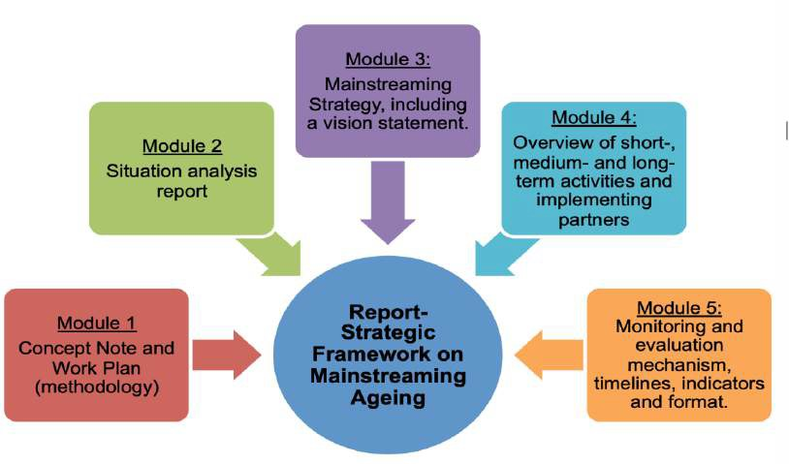

Annexes

Annex 1 - Terms of Reference for the Task Force on Mainstreaming Ageing

Background
At its eleventh meeting on 20 November 2018, the Working Group on Ageing decided to include the development of guidelines on mainstreaming ageing in its programme of work for 2019-2020 and to establish a Task Force to guide this work.

Mandate
The Task Force on Mainstreaming Ageing reports to the Standing Working Group on Ageing. The Task Force will be created for a period of 18 months, at the end of which the guidelines will be submitted to the WGA and its Bureau for launch at the 13th annual meeting of the Working Group on Ageing on 19-20 November 2020.

Objective
The objective of the Task Force is to develop guidelines on mainstreaming ageing grounded in the experience, lessons learnt, and good practices developed by members of the Working Group on Ageing over the past two decades of implementing the Madrid International Plan of Action on Ageing and its Regional Implementation Strategy.

Planned activities and outputs
The following activities and outputs are planned:
- Identification and agreement on core elements of mainstreaming ageing that need to be covered by the guidelines
- Stocktaking of experience, lessons learnt, good national practices and guiding materials on the thematic areas identified
- Drafting of core modules for the guidelines
- Feedback on draft guidelines at different stages of the drafting process

Timetable

June 2019 Development of a stocktaking questionnaire
July – September 2019 Stocktaking of national practices and experience gained by
members of the Task Force on their own countries
September 2019 Feedback on how the stocktaking questionnaire can be further
improved before it is sent out to the WGA in September September–November 2019 Stocktaking of national practices and experience of WGA
members
November 2019 Task force members report back to WGA on key learnings from
information gathered and collect further experience from members of the WGA during group discussions at the WGA meeting in Geneva on 18-19 November. Task force members moderate and report back on group discussions
November - January 2020 Each thematic lead team drafts their modules based on the
information collected by the end of January
February – April 2020 Preparation of an outline for the guidelines based on modules

May 2020 Review of draft outline by the WGA Bureau
May - July 2020 Preparation of zero draft by a consultant
July - September 2020 Consultation with WGA for feedback on zero draft July October 2020 Finalization of draft guidelines
November 2020 Presentation of draft guidelines to the WGA at annual meeting for
endorsement
December 2020 Finalization of guidelines on mainstreaming ageing for publication

Methods of work
The Task Force will primarily work via email and telephone conferences. One face-to-face meeting will be organized on the margins of the 12th meeting of the Working Group on Ageing on 18-19 November 2019. Participation in the meetings will be self-funded. Conference calls are planned for June and September 2019 and January and April 2020

Membership
The Task Force on Mainstreaming Ageing includes representatives of the following UNECE member States: Austria, Belarus, Canada, Czech Republic, Germany, Ireland, Italy, Portugal, Republic of Moldova, Spain. In addition, three NGOs participate: Ardager Kazakhstan, ILC Canada, and Turbota pr litnih v Ukraini from Ukraine.

UNECE Population Unit acts as secretariat to the Task Force.

Annex 2: Country notes

Country notes on mainstreaming ageing were prepared by the following member States:

Austria

Belarus

Belgium

Bulgaria

Canada

Czech Republic

Denmark

France

Germany

Hungary

Ireland

Israel

Italy

Malta

Monaco

Portugal

Republic of Moldova

Slovakia

Spain

Sweden

Turkey

United Kingdom

Annex 3: Connecting MIPAA/RIS and the Agenda 2030 for Sustainable Development
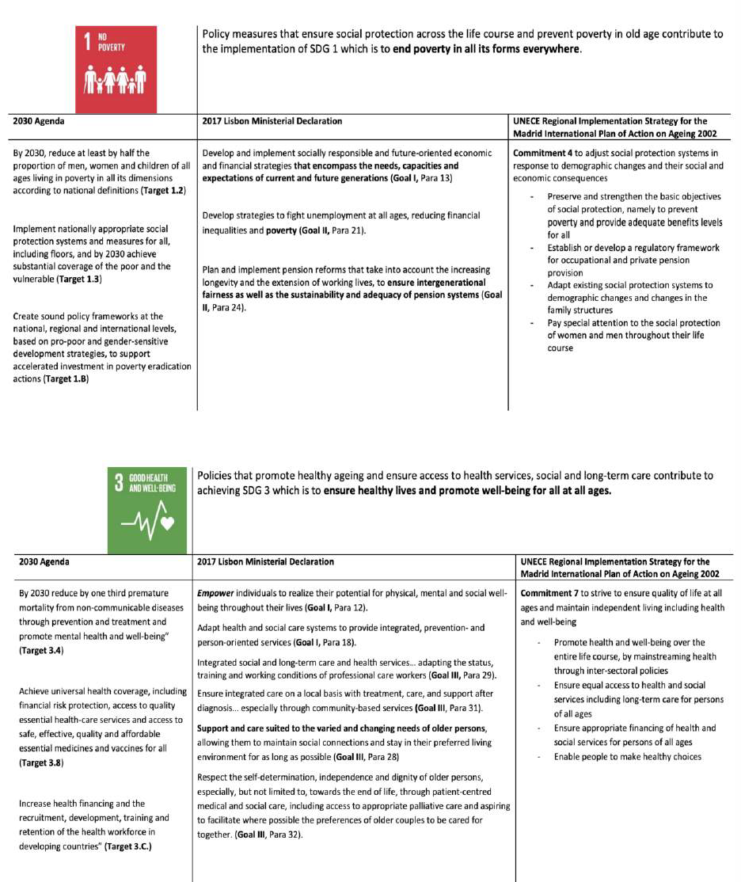

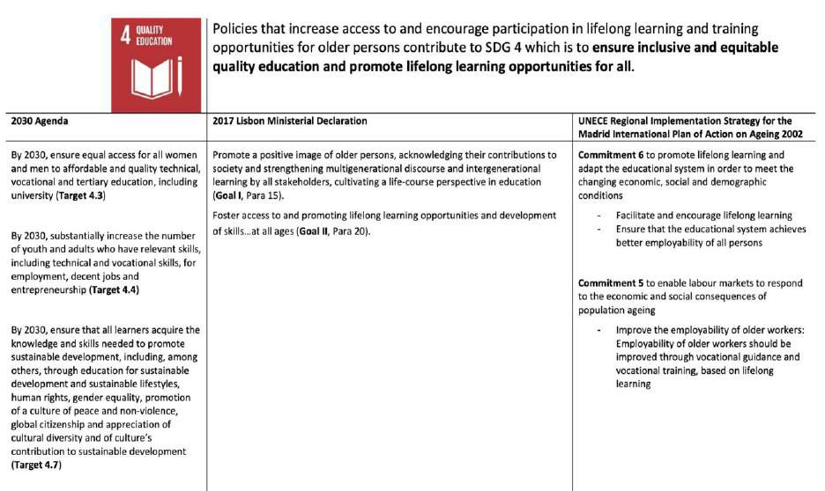

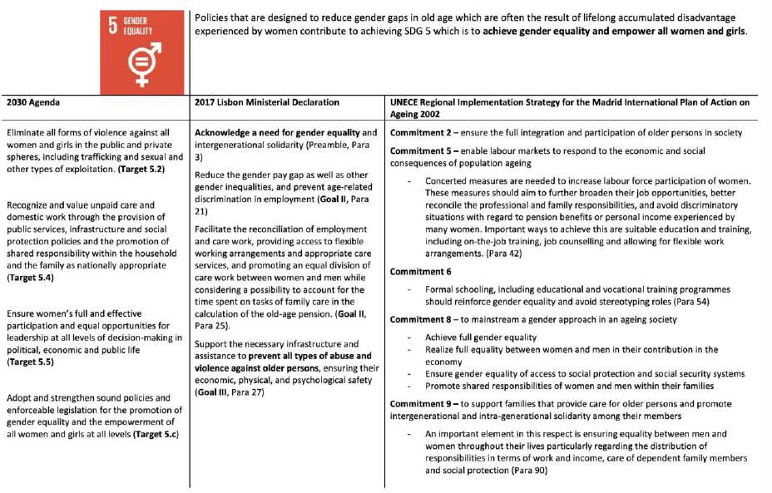

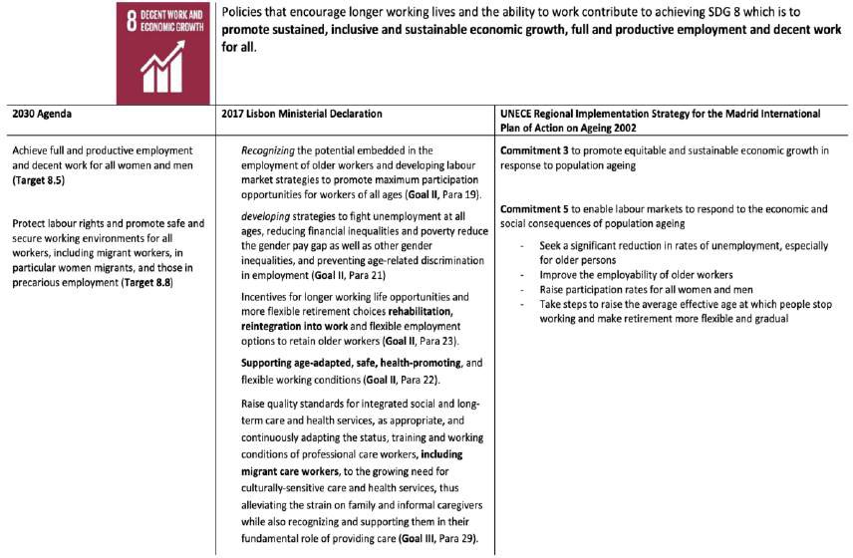
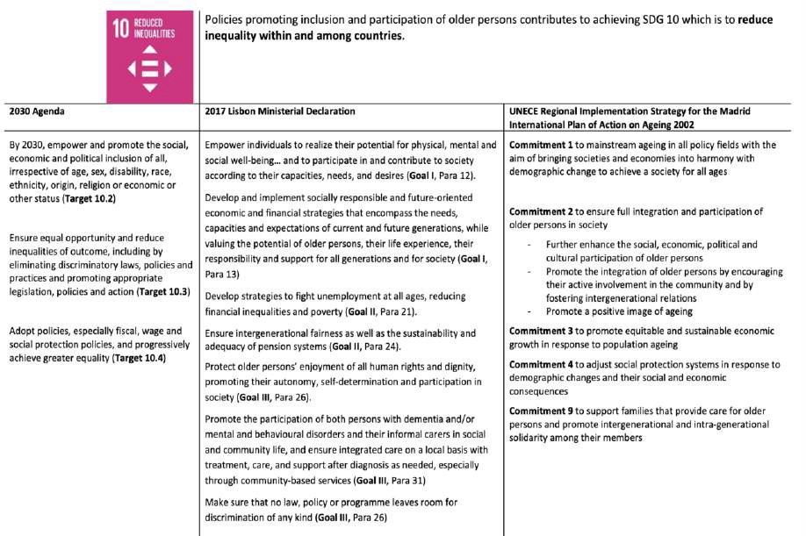

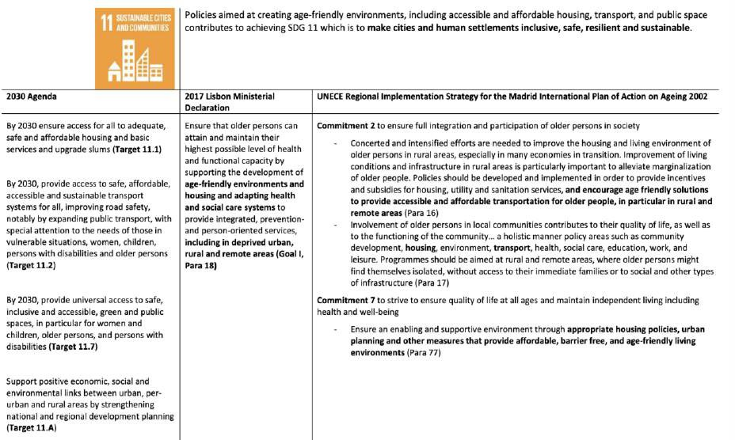

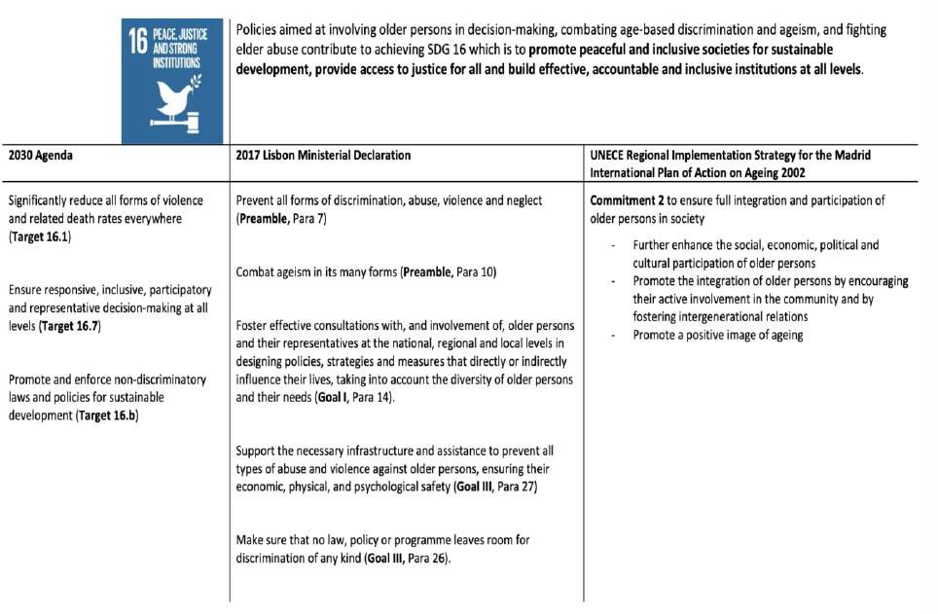

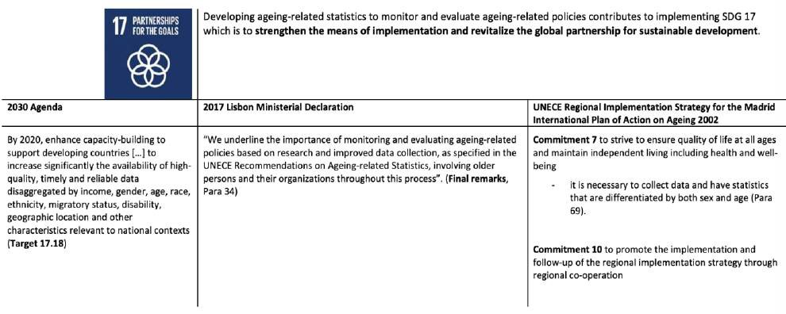

Annex 4 – The UN Principles for Older Persons

Adopted by General Assembly resolution 46/91 of 16 December 1991, countries are encouraged to incorporate the following principles into their national programmes whenever possible:

Independence
- Older persons should have access to adequate food, water, shelter, clothing and health care through the provision of income, family and community support and self-help.
- Older persons should have the opportunity to work or to have access to other income- generating opportunities.
- Older persons should be able to participate in determining when and at what pace withdrawal from the labour force takes place.
- Older persons should have access to appropriate educational and training programmes.
- Older persons should be able to live in environments that are safe and adaptable to personal preferences and changing capacities.
- Older persons should be able to reside at home for as long as possible.

Participation
- Older persons should remain integrated in society, participate actively in the formulation and implementation of policies that directly affect their well-being and share their knowledge and skills with younger generations.
- Older persons should be able to seek and develop opportunities for service to the community and to serve as volunteers in positions appropriate to their interests and capabilities.
- Older persons should be able to form movements or associations of older persons.

Care
- Older persons should benefit from family and community care and protection in accordance with each society's system of cultural values.
- Older persons should have access to health care to help them to maintain or regain the optimum level of physical, mental and emotional well-being and to prevent or delay the onset of illness.
- Older persons should have access to social and legal services to enhance their autonomy, protection and care.
- Older persons should be able to utilize appropriate levels of institutional care providing protection, rehabilitation and social and mental stimulation in a humane and secure environment.
- Older persons should be able to enjoy human rights and fundamental freedoms when residing in any shelter, care or treatment facility, including full respect for their dignity, beliefs, needs and privacy and for the right to make decisions about their care and the quality of their lives.

Self-fulfillment
- Older persons should be able to pursue opportunities for the full development of their potential.
- Older persons should have access to the educational, cultural, spiritual and recreational resources of society.

Dignity
- Older persons should be able to live in dignity and security and be free of exploitation and physical or mental abuse.
- Older persons should be treated fairly regardless of age, gender, racial or ethnic background, disability or other status, and be valued independently of their economic contribution.

Annex 5: Vienna Declaration Goals, 2012
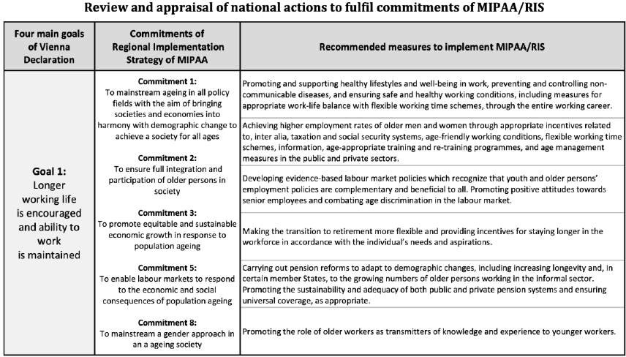

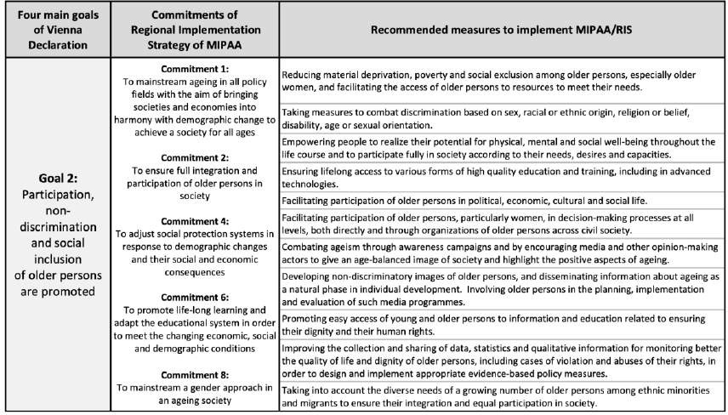

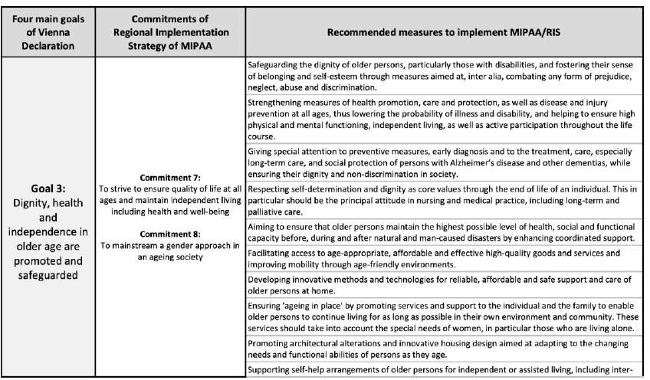

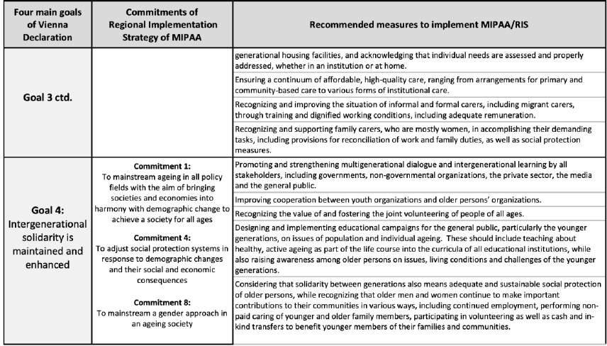

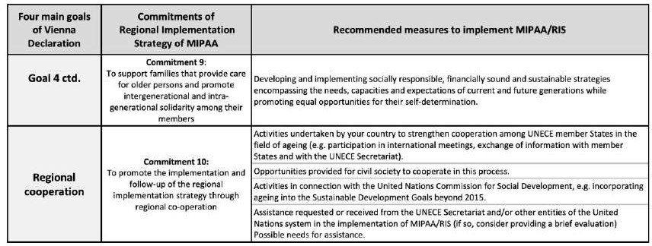

Literature

  - Global Knowledge Partnership, 2003, ‘Multi-stakeholder Partnerships – Issue Paper’

  - Government of Austria, Ministry of Labour, Social Affairs and Consumer Protection, 2012, Federal
Plan ‘Ageing and the Future’

  - Government of Czech Republic, 2013, National Action Plan Promoting Positive Ageing for 2013- 2017

  - Government of Denmark, 2018, ‘The National Action Plan 2025’

  - Government of Germany, 2012, National Demographic Strategy: “Every Age Counts”

  - Government of the Republic of Ireland, Positive Ageing – Starts Now!’, The National Positive
Ageing Strategy

  - Government of the Republic of Ireland, Department of the Taoiseach Government Buildings, 2009,
‘RIA Guidelines, how to conduct a Regulatory Impact Assessment’

  - Government of Malta, 2014, The National Strategic Policy for Active Ageing: Malta 2014-2020

  - Public Health Agency of Canada, 2015, ‘Age-friendly Communities Evaluation Guide – Using
Indicators to Measure Progress’

  - Republic of Slovenia, 2018, ‘Active Ageing Strategy’

  - United Nations, 2020, ‘Policy brief: The impact of COVID-19 on older persons’

  - United Nations, 2018, ‘A Human Rights Based Approach to Data – Leaving No One Behind for
Sustainable Development’

  - United Nations, 2017, The global indicator framework, Resolution A/RES/71/313.

  - United Nations, 2015, Transforming our World: the 2030 Agenda for Sustainable Development’
(A/RES/70/1).

  - United Nations, 2006, ‘Guidelines for review and appraisal of the Madrid International Plan of Action on Ageing – Bottom-up participatory approach’

  - United Nations, 2003, ‘Political Declaration and Madrid International Plan of Action on Ageing’

  - United Nations, 1995, ‘World Summit for Social Development, The Copenhagen Declaration and
Programme of Action’, World Summit for Social Development’

  - United Nations, 1991, General Assembly resolution 46/91

  - UNAIDS, 20XX, An Introduction to Indicators, Monitoring and Evaluation Essentials,

  - UN Department of Economic and Social Affairs, 2020, Policy Brief No. 68, ‘COVID-19 and Older
Persons: A Defining Moment for an Informed, Inclusive and Targeted Response’

  - UN Department for Social and Economic Affairs, 2016, Income Poverty in Old Age, an Emerging Development PriorityUN Department for Social and Economic Affairs, Venne, R., 2009, ‘Mainstreaming the concerns of older persons into the social development agenda’

  - United Nations Department for Social and Economic Affairs, 2019, World Population Prospects
2019’

  - UNECE, 2020, Policy Brief No. 23: Gender Equality in Ageing Societies

  - UNECE, 2019, Policy Brief No. 21: Combating Ageism in the World of Work

  - UNECE, 2019, ‘2018 Active Ageing Index – Analytical Report’

  - UNECE, 2018, Background paper: ‘Connecting MIPAA/RIS and the 2030 Agenda for Sustainable
Development: Areas for Policy Integration

  - UNECE, 2017, Lisbon Ministerial Declaration – ‘A Sustainable Society for All Ages: Realizing the
Potential for Living Longer’

  - ‘UNECE, 2017 Policy Brief No 19: ‘Realizing the potential of living longer’

  - UNECE, 2016, ‘Recommendations on Ageing-related Statistics’

  - UNECE, 2015, ‘Preparation of national reports for the third review and appraisal cycle of the implementation of the Madrid International Plan of Action on Ageing and its Regional Implementation Strategy (MIPAA/RIS) 2012 – 2017, Guidelines for National Focal Points on Ageing’

  - UNECE, 2014, ‘ICPD Beyond 2014: The UNECE Region’s Perspective’.

  - UNECE, 2013, Policy Brief No. 14: Abuse of older persons

  - UNECE, 2012, Vienna Ministerial Declaration (MIPAA+10): Ensuring a society for all ages:
promoting quality of life and active ageing’

  - UNECE, 2010, Policy Brief No. 9: ‘Advancing Intergenerational Solidarity’

  - UNECE, 2010, Policy Brief No. 7, ‘Toward Community Long-term Care’

  - UNECE, 2010, Policy Brief No. 5, ‘Lifelong learning’

  - UNECE, 2009, Policy Brief No. 1: ‘Mainstreaming Ageing’

  - UNECE, 2007, ‘Leon Ministerial Declaration (MIPAA+5): A society for all ages: challenges and
opportunities’

  - UNECE, 2002, ‘Regional Implementation Strategy for the Madrid International Plan of Action on Ageing’

  - UNSDG, 2003, ‘The Human Rights-based approach to Development Cooperation’

  - World Health Organization, 2017, ‘Global Plan and Action Plan on Ageing and Health’

  - World Health Organization, 2016, ‘Decade of Healthy Ageing – Development of a proposal for a Decade of Healthy Ageing 2020-2030’

  - World Health Organization, 2015, ‘Measuring the Age-friendliness of Cities: A Guide to using core indicators.

Websites:

  - Gender based Analysis Plus: https://cfc-swc.gc.ca/gba-acs/index-en.html

  - Age-Friendly communities:https://www.canada.ca/en/public-health/services/health- promotion/aging-seniors/friendly-communities.html

  - European Institute for Gender Equality (EIGE), Gender mainstreaming toolkit: https://eige.europa.eu/publications/gender-equality-training-gender-mainstreaming-toolkit

Mainstreaming the concerns of older persons into the social development agenda, Robert Venne, Division for Social Policy and Development, Department of Economic and Social Affairs, United Nations Secretariat, 2009.
World Population Prospects 2019’, United Nations Department for Social and Economic Affairs, 2019
Policy brief ‘Mainstreaming Ageing, UNECE, 2009.‘
Policy brief: The impact of COVID-19 on older persons’, United Nations, 2020
The Beijing Platform for Action’s Section H refers to “national machineries for the advancement of women” as central policy-coordinating units inside government that support government-wide mainstreaming of a gender equality perspective in all policy areas. It states “the necessary conditions for an effective functioning of such national machineries include: A: location at the highest possible level of Government, falling under the responsibility of a cabinet minister; B: institutional mechanisms of processes that facilitate, as appropriate, decentralized planning, implementation and monitoring with a view to involving NGOs and community organisations from the grass-roots upwards; C: sufficient resources in terms of budget and professional capacity; D: opportunity to influence development of all government policies.
Political Declaration and Madrid International Plan of Action on Ageing, 2003, DPI/2271, p.12-13.
Regional Implementation Strategy, paragraph 2
Leon Ministerial Declaration, 2007 (MIPAA+5): A society for all ages: challenges and opportunities, paragraph 6.
Vienna Ministerial Declaration, 2012 (MIPAA+10): Ensuring a society for all ages: promoting quality of life and active ageing, Paragraph 11.
‘Global Plan and Action Plan on Ageing and Health’, WHO, 2017.
‘Decade of Healthy Ageing – Development of a proposal for a Decade of Healthy Ageing 2020-2030’, World Health Organization, 2016
Social integration aims to create ‘a society for all’ which every individual, each with rights and responsibilities, has an active role to play, Source: ‘The Copenhagen Declaration and Programme of Action’, World Summit for Social Development, 1995, p.95.
‘Mainstreaming the concerns of older persons into the social development agenda’, Venne, Robert; UN DESA, 2009.
‘UNECE Policy Brief No. 1 on Mainstreaming Ageing’, UNECE, 2009
Regional Implementation Strategy for the Madrid International Plan of Action on Ageing’, Commitment 1, UNECE, 2002
Austria, Belarus, Canada, Czech Republic, Germany, Ireland, Italy, Portugal, Republic of Moldova and Spain
See Terms of Reference in Annex 1
These are selected based on the feedback provided by UNECE Member States in the country notes as described in section 4.1
Policy Brief, ‘Combating ageism in the world of work’, UNECE, 2019
Policy Brief No. 8, ‘Advancing Intergenerational Solidarity’, UNECE, 2010
Policy Brief No. 5, ‘Lifelong learning’, UNECE, 2010
Policy Brief No. 1, ‘Mainstreaming Ageing’, UNECE, 2009
‘Multi-stakeholder Partnerships – Issue Paper’, Global Knowledge Partnership, 2003.
Policy Brief on Ageing No. 1, ‘Mainstreaming ageing’, UNECE, 2009
Terminology will be addressed in a glossary
See Part I, Chapter 2.2
The final identification of indicators to monitor the Strategic Framework is suggested in Module 5: Monitoring and Evaluation.
Questions inspired by Gender Mainstreaming tool – Gender Analysis. European Institute for Gender Equality.
Developing guidelines for ageing impact-assessments can be considered as one of the strategic objectives (Module 3) or activities (Module 4) of the Strategic Framework for Mainstreaming Ageing.
As suggested in Part III - Conclusion
Strategic goals and objectives exemplified in the Irish National Strategy for Positive Ageing.
The global indicator framework was adopted in 2017 and will be refined annually. Details are contained in resolution A/RES/71/313.

