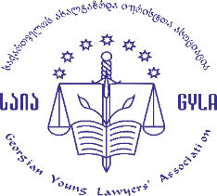

Presentation of the Report
“PREVENTION OF AND RESPONSE TO
INCIDENTS OF ILL-TREATMENT”

Date: February 26, 2019
Venue: Rooms Hotel Tbilisi

11:30 – 12:00 – Registration/Coffee
12:00 -12:30 – Welcome and Opening Speeches
Sulkhan Saladze - Chairmen of Georgian Young Lawyers’ Association
Lela Tsiskarishvili - Executive Director of The Georgian Centre for Psychosocial and Medical Rehabilitation of Torture Victims (GCRT)
12:30 – 13:00 – Presentation of the Report
Nona Kurdovanidze - GYLA
Meri Daushvili - GYLA
13:00 - 13:40 – Discussion, Q&A
13:40 – 13:50 – Concluding Remarks

