Agenda: question and answer session on coding and certification of deaths due to COVID-19

20 July 2020, 10:00-11:30
Time | Item | Speakers
10 min. | Welcome | Dr Natasha Azzopardi Muscat, Director, Division of Country Health Policies and Systems, WHO/EURO
30 min. | WHO guidelines and approaches on certification and classification (coding) of deaths related to COVID-19 | Dr Robert Jakob, Team Leader Classifications and Terminologies, WHO/HQ  Dr Carine Alsokhn  Technical Officer, Classifications and Terminologies, WHO/HQ
45 min. | Question and Answer session | Moderated by Dr David Novillo Ortiz, Programme Manager, Division of Country Health Policies and Systems, WHO/EURO
5 min. | Conclusions | Dr Natasha Azzopardi Muscat, Director, Division of Country Health Policies and Systems, WHO/EURO

How to connect to the virtual meeting:

Here is the link to use for the Q&A session on 20 July from 10:00 – 11:30:

https://who-euro.webex.com/who-euro/j.php?MTID=m875d40efab6951d6b17eac2fcc14131a

Meeting number: 137 717 6017
Password: 3H2hC3MQBPj

How to access Russian language simultaneous interpretation:

For this meeting, we are able to offer simultaneous online interpretation to and from the Russian language in a separate app called Congress Rental Network. Please read the below instructions for accessing the app.

1. Download: “Congress Rental Network” app on Apple Store for Apple products (mobile phone, iPad) or on Google Play for Android Products.
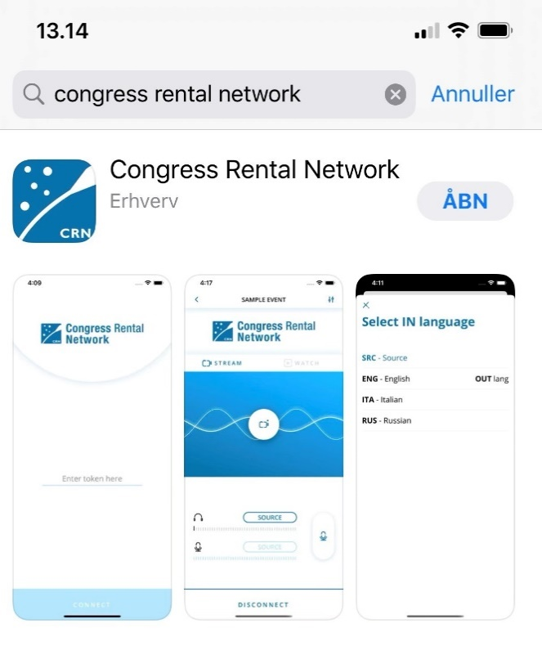

2. Make sure a headset is connected to your phone/iPad

3. Once the app is downloaded, access the app by adding the following code (only use small letters): whoqanda

