#1 ATC code translations
- NCC added ATC codes (format $##$$ ($=letter #=digit) to diagnosis codes in the new tables
- Anatomical Therapeutic Chemical (ATC) Classification System is a drug classification).
- Example: A12CC = Magnesium compounds.
- Those are included in the other Nordic DRG versions w. ICD-10-diagnoses.
- Those may in principle affect some DRG groups but do not affect in [this] Georgian version, although accepted (=no error for unknown dg) by it.
- ATC codes cannot be registered alone but only as a part as additional information in diagnosis pairs.
  - Using ATC codes alone resules in “ATC as sympron” warning message in VisualDRG.
- Missing names do not anyhow affect DRG results.
- VisualDRG-Example:
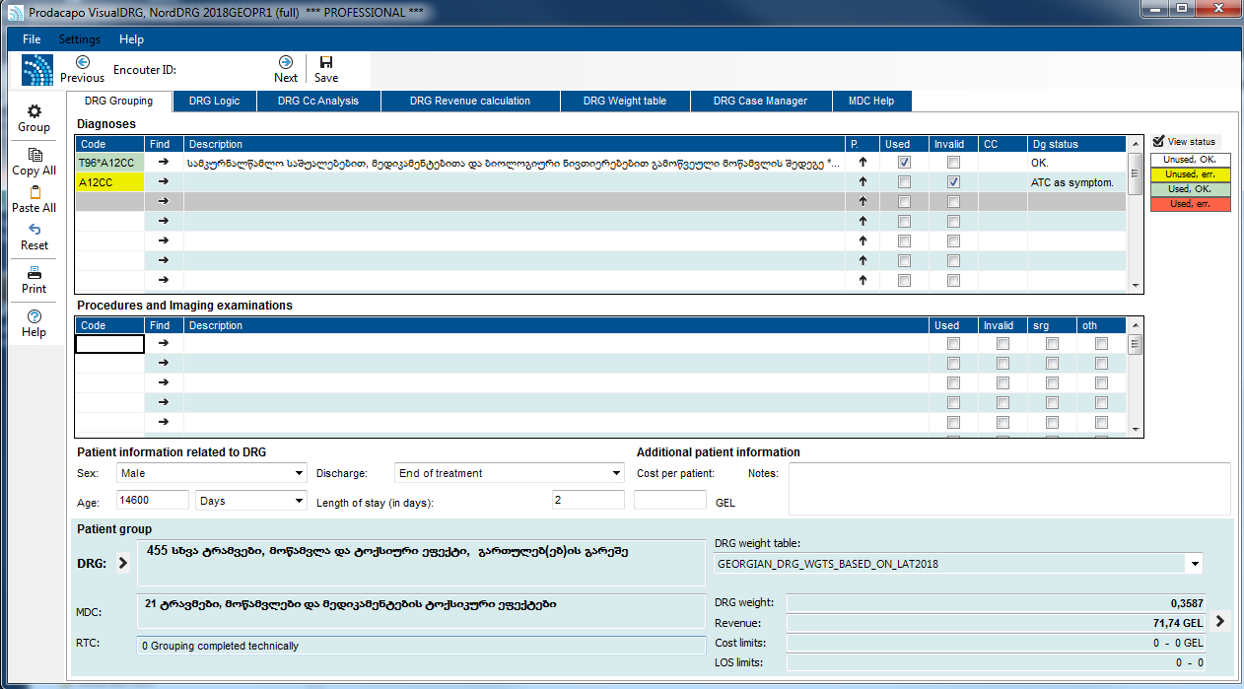
- Suggestion: No changes at this time. May be changed in later versions (v2020) if necessary.
- Agreed on:

#2 other (than ATC) diagnoses w/o translation
- Diagnoses are translated outside of NCC’s original tables, thus there may be missing names.
  - This is because of process (NCC working based on Latvian version, original translation was based on initial tables, added dg codes after that) and technology (dBase table management do not accept Georgian UTC-8 characters).
- These codes are used in grouping and can be used in VisualDRG but no text appears, for example.

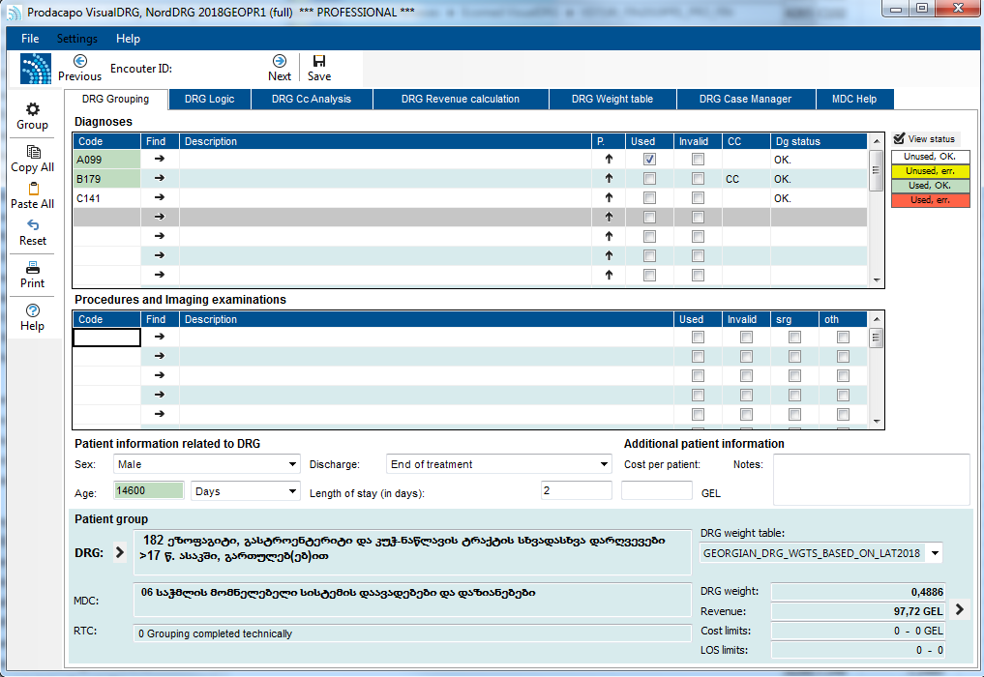

  - Full listing in "U:\Work\NordDRG\Groupers\GEO\Missing_ICD-10-translations_in_NCC-tables_v20190121.xlsx"
  - Total: 100 missing translations
  - Suggestion: Georgian ministry to fill in this table and send to Prodacapo.
  - Agreed on:

3 Still some errors because of unknown diagnoses (based on test file).

ICD-10 codes (other than codes w. syntax errors such as + . or * included in the code) caused DRG 470: K436 and K437. These are unrecognized by this def table set version resulting in error no or unknown principal diagnosis.

Martti’s comments (mail 5.11.2018) were:
“
rtc1 code K436 NOT in icdcodes
Not included (in the table sent form Georgia). Not original ICD-10 code. I add to the Georgian version now
rtc1 code K437 NOT in icdcodes
Not included (in the table sent form Georgia). Not original ICD-10 code. I add to the Georgian version now
“

K436 = Other and unspecified ventral hernia with obstruction, without gangrene
K437 = Other and unspecified ventral hernia with gangrene

These are added also to “missing ICD translation table” (#2)

Of course (as normal) some cases may group to error grouper because of wrong age (in relation to principal diagnosis) or rare or unrecognized (by DRG logic) combination or ICD and NCSP. These are not issues in DRG system but in ICD code registration. You should collect potential such issues and instruct to change code entry or suggest NCC to change logic in future versions (2020?)

Also larger and later may reveal yet more missing dgs.

Options:
Keep it as-is
or
Ask NCC to add there in tables and provide yet another version (already 4th table set version then) of tables.

Agreed on:

