

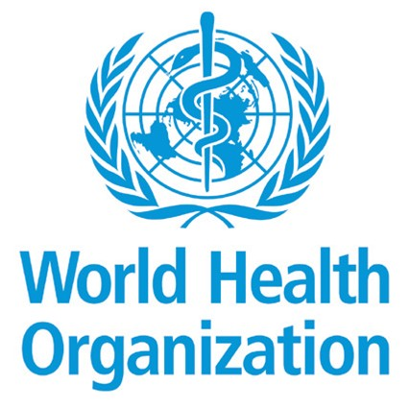Georgia: building an efficient and transparent financing
system for UHC

In 2013 Georgia introduced a new ‘Universal Health Care Programme’, so that the population could access health services and not have to pay out-of-pocket. The new UHC Programme was supported by a substantial increase in public spending on health to meet people’s needs. Georgia urgently
needed better tools to ensure that public funds were efficiently used. What was the solution?

Here is the story of how the Ministry of Internally Displaced Persons from the Occupied Territories, Labour, Health and Social Affairs of Georgia (MoIDPLHSA) and the Legal Entity of Public Law (LEPL) Social Services Agency (SSA) worked closely with the WHO Regional Office for Europe to improve the purchasing and payment system of health service providers.
Minister of Health, David Sergeenko attending the opening ceremony of a renewed health clinic. Increased financial access of patients to medical services has had a positive impact on the development of medical institutions.

Diagnosis Related Group system
The MoIDPLHSA is focusing on strategic purchasing by the LEPL SSA to obtain better value for money and is planning to establish the ‘Diagnosis Related Group’ (DRG) system as a way to pay providers for services. This helps to create a more efficient and transparent financing system, essential for quality of care and moving towards universal health coverage.

The DRG system categorizes patients treated at hospital into similar diagnosis groups and then relate each group to the costs or resources it takes to treat them.

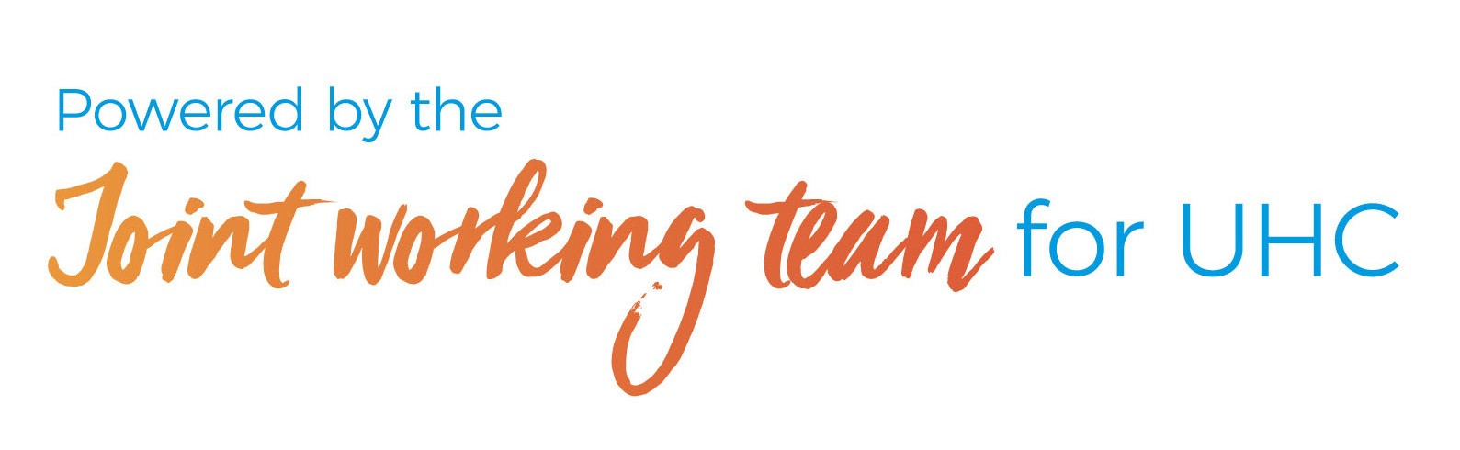The logic of the groupings takes into account the patients’ principal

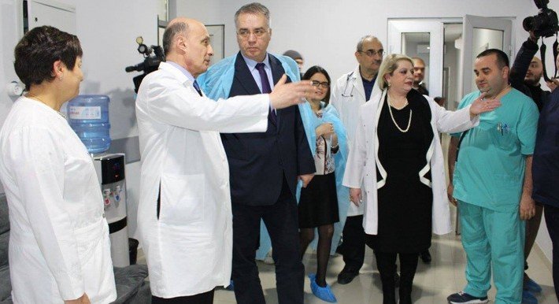diagnosis, age, sex, complications, comorbidities, procedures and other factors such as weight on admission in newborns and discharge status. Patients under one DRG will require approximately similar hospital resources, and therefore similar funding.

Implementing the DRG system will improve the efficient use of resources within a hospital, increase
the transparency of hospital services, and enable the SSA to monitor the performance of hospitals, thereby contributing to improving the level
of quality of care.

With significant support of the UHC Partnership and the WHO Regional Office for Europe, we are committed to take tangible steps towards UHC by introducing DRG- based payment and a strategic purchasing system. This will ensure delivery of cost-effective, transparent and patient-oriented quality health services without people
experiencing financial hardship.”
David Sergeenko, Minister of Internally Displaced Persons from the Occupied Territories, Labour, Health and Social Affairs of Georgia.

April 2019

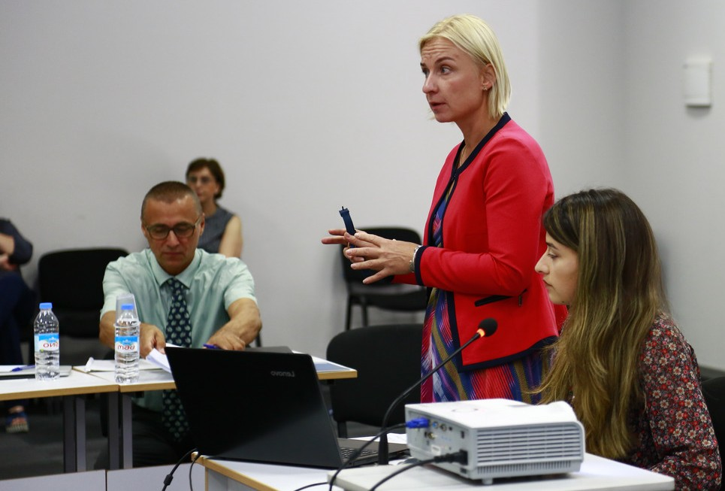Stages for establishing the DRG

In mid-2017 the MoIDPLHSA made a decision to move to the DRG system and as Georgia is using the same surgical procedures classification system as Nordic countries, it chose NordDRG (Nordic); this makes the transition to the new system much easier.
1

WHO conducted a feasibility study in 2017 to be sure that the NordDRG system was suitable for Georgia. The results of the feasibility study were encouraging; no major obstacles were found. Georgia already had a digital patient-level claims system, which included all the necessary information for the DRG system. However, efforts were needed to further improve data quality in parallel to implementing the new system.
2

In early 2018, the MoIDPLHSA and SSA developed a comprehensive DRG transition strategy and implementation plan.
3

By the end of 2018, the Nordic Casemix Center had developed the Georgian version of the NordDRG system. WHO provided training for the MoIDPLHSA, SSA and hospitals to enable them to understand the basics of the DRG system.
4

In 2019 the transition to the new system will begin. Initially, selected big hospitals will start testing the DRG system to validate changes in the claims management process. Then there will be
5
preparations for a ‘shadow funding’ period in 2020 to develop the DRG pricing and reimbursement policy.

We are pleased that Georgia has already gained an official license for the use of the NordDRG system, which will be launched in the pilot mode in 2019."
David Sergeenko, Minister of Health

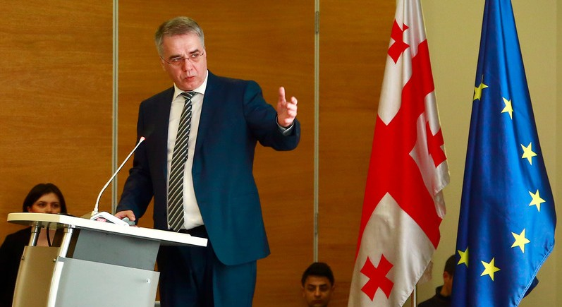

The Minister of Health presenting the positive results of the
Georgia health utilization and expenditure survey 2017.

September 2018: training on DRG system implementation was conducted for selected pilot clinics.

Background

Georgia’s health system has been evolving since the country’s independence from the Soviet Union in 1991. The system was highly decentralized and extensively privatized under reforms implemented between 2007 and 2012.

The health sector was deregulated and most Government spending on health was channeled through private insurance companies which covered services only for target groups such as people living under the poverty line, internally displaced populations, the military, children under five and older people; only about one third of the total population.

The other two thirds of the population had access to very limited services through vertical programmes, had to buy private health insurance or had to pay for any service out- of-pocket when they used it. This had an impact on patients, whose out-of-pocket payments for health services were very high, leading to financial hardship for many people. It provided the rationale for the political decision to move towards universal health coverage.

In 2013, the newly-elected Georgian Government introduced the Universal Health Care Programme, which led to unprecedented expansion in health service coverage.

Nearly the entire population was entitled to publicly- financed health care. It was all made possible by a substantial and essential increase in public funding for the health system that was channeled through a single purchasing agency (the SSA).

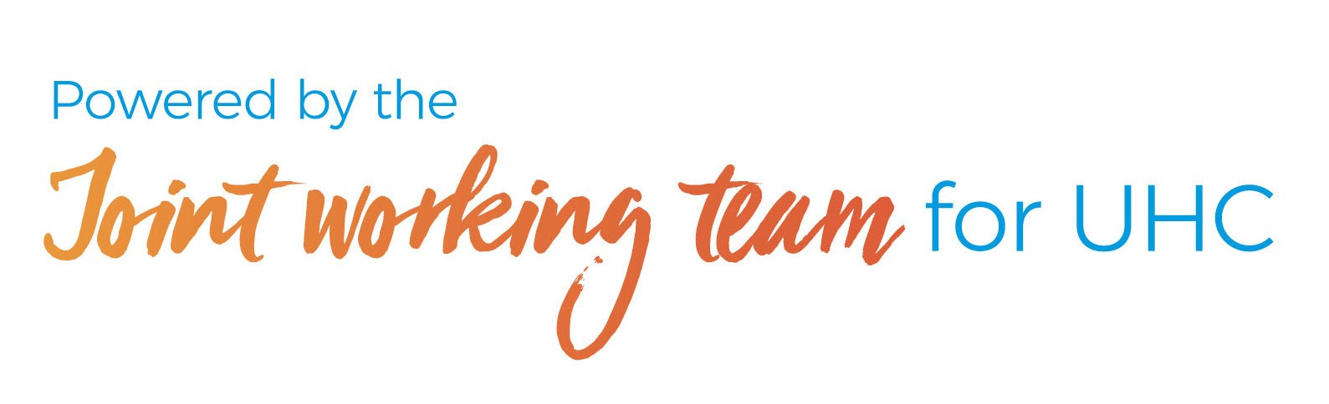

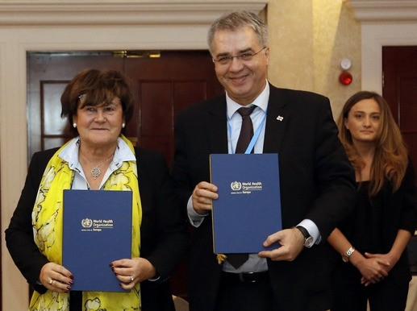To make the health system financially sustainable in the longer term, the Government realized that it needed to use its limited resources more effectively.

The 2016 WHO report on “Active purchasing for universal health coverage in Georgia: situation analysis and options for improvement”, provided key recommendations on how to integrate vertical programmes with UHC programmes and how to implement strategic purchasing.

The report also suggested moving from a very detailed and complicated payment system with different tariff setting principles to a system which allowed for better case grouping for payment, which could be applied to all UHC-program-funded inpatient care.

As a result, Georgia started searching for efficient and transparent systems to strengthen the SSA’s role as a strategic purchaser of health services.

Strong collaboration

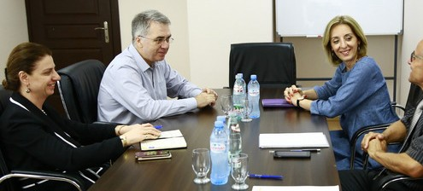

The MoH and WHO meet to discuss women's reproductive health and maternal and child health issues, current and future programmes and challenges.

A strong partnership between the MoIDPLHSA and the UHC Partnership at WHO has led to greater capacity to improve the health financing system by strengthening the strategic purchasing and supporting implementation of the DRG.

WHO worked with the MoIDPLHSA to develop the capacity of the SSA (the purchasing agency) to enhance efficiency in the organization and delivery of publicly-financed health services.

Technical assistance in the area of health system strengthening that includes work on introducing the DRG payment system is labour intensive. The WHO Country Office coordinated the work so that it was delivered in a smooth, efficient and consolidated way.”
Marijan Ivanuša, WHO Representative, Georgia.

Zsuzsanna Jakab, Regional Director WHO EURO and David Sergeenko, Minister of Health holding the signed 2018-2019 Cooperation Agreement between the Ministry of Health of Georgia and WHO EURO.

So far, Georgia’s Universal Health Coverage Programme is making good progress towards its goals of universal access to health services without financial hardship.

Evidence shows that the use of health services has increased, financial barriers which prevent people from accessing services have been reduced, and financial protection for households has improved for services targeted by the Programme.

On average, there were 3.6 outpatient visits per capita per year in 2017 compared to just 2.3 in 2012, and hospitalization rates have seen a steady increase from 11.3 per capita in 2012 to 14.2 per capita in 2017. Out-of-pocket spending of total health expenditures has declined from
73% in 2012 to 54% in 2017.

A survey conducted by the US Agency for International Development in 2014 showed that 80.3% of surveyed beneficiaries were satisfied with their outpatient service and 96.4% expressed satisfaction with hospital level emergency care within the Universal Health Care Programme. The most recent household survey conducted
in 2017 also revealed positive trends in use of health services and reduction of out-of-pocket expenditures.

Now, the DRG needs to play its role to ensure that public funds continue to be efficiently and transparently used to delivery health services to the population.

The UHC Partnership is a collaboration between WHO, the European Union and Luxemburg to support policy dialogue on national health policies, strategies and plans for UHC. The Partnership enabled the WHO Regional Office for Europe to scale up support to the Government of Georgia as it seeks to achieve UHC, focusing on the DRG and strategic purchasing.

