6. Factors that strengthen and undermine financial protection

This section considers the factors that may be responsible for financial hardship caused by out-of-pocket payments in Georgia and that may explain the trend over time. It begins by looking at factors outside the health system affecting people’s capacity to pay for health care – for example, changes in the living standards and the cost of living – and then looks at factors within the health system.

6.1 Factors affecting people’s capacity to pay for health care

The following paragraphs draw on data from the SSA Unified Database for Socially Vulnerable Families and other sources to review changes in people’s capacity to pay for health care. Poverty among people more likely to need health care is a particular challenge for financial protection.

The Georgian economy bounced back following the global financial crisis in 2008 and experienced robust growth, averaging 5.6% of GDP a year from 2010 to 2014, which allowed for increased government spending. However, the Georgian economy is vulnerable to external shocks and weakening external demand since the end of 2014 has rapidly slowed Georgia’s economic growth (World Bank PER 2017). Although general inflation has been contained, the value of the Lari fell in 2017 which has pushed up the price of imports, including pharmaceuticals. This also happened during the global financial crisis – pushing up total health expenditure without any increase in public health spending (Mladovsky et al 2012Pharmaceutical spending in Georgia accounts for around 2.7% of GDP in 2017 (Smith 2013).

However, the cost to households in meeting their basic needs has remained relatively stable and has not been so affected by inflation as the cost of medicines. This means that the average capacity to pay has improved since 2010. The share of households living below the basic needs line fell steadily until 2015 but has been increasing again since then (Fig 27). This means that the poor have become more poor during recent years.

Fig. 27. Changes in the cost of meeting basic needs, capacity to pay and the share of households living below the basic needs line

Note: Capacity to pay is measured as a household’s consumption minus a normative (standard) amount to cover basic needs such as food, housing and utilities.
Source: authors based on household budget survey data.

Average monthly nominal wages of the employees have increased year-on-year. However, the subsistance minimum has not been increasing in line with the average monthly nominal salary (Fig. 28).

Fig. 28. Average monthly wage of employees

Note: amounts are shown in nominal terms.
Source: National Statistics Office of Georgia (GEOSTAT).

Nominal household income in Georgia has increased since 2010. However, the average masks a gap between average monthly household income in urban and rural areas (Fig. 29). The gap between rich and poor is also wide, with the richest quintile holding 40.4% of total income in 2015 and the poorest holding 8.4%. However, income inequality, as measured by the Gini Coefficient narrowed from 41% in 2010 to 37% in 2018
Fig. 29. Average monthly income per household

Note: amounts are shown in nominal terms.
Source: National Statistics Office of Georgia

As a result of economic growth and the development of social protection mechanisms in recent years, there has been a reduction in poverty indicators in the country in both urban and rural areas, from 36% of the total population living in absolute poverty in 2010 to 20% in 2018 (Fig. 30). Poverty indicators are based on the consumption patterns of households and are central to the proxy means testing approach to awarding social and health benefits. Since 2005, households have been scored and categorized in the unified database of vulnerable families for the targeting of social assistance, including health care benefits, to those living in extreme poverty.

Fig. 30. Share of the population below the absolute poverty line

Source: National Statistics Office of Georgia

By 2019, just over 1.5 million people (41.4% of the country’s population) were registered in the unified database of vulnerable families, up from 36% in 2014. Almost one third of the people registered in the unified database receive targeted social assistance.

The social package introduced in 2012 is received by certain groups: people with the disabilities (100-150 GEL per month), families where the main breadwinner is ill, and victims of political oppression (100 GEL per month). By 2015, there were 167 226 recipients of the social package (4.5% of the total population).

6.2 Health system factors

This section looks at health spending and health coverage, then focuses in on more detailed exploration of medicines coverage, prices and use. Finally, health-seeking behaviour and the relationship between unmet need and financial protection are considered.

6.2.1 Health spending

In absolute terms, public spending and out-of-pocket spending have both followed an upward trend since 2000 (Fig. 17b), but as a proportion of total health spending, the increase in public spending has reduced out-of-pocket spending from 75.6% in 2011 to 54.8% in 2017 (Fig. 17a). However, public spending on health remains low and out of pocket spending is still high relative to other countries of Europe (Fig. 16).

Public spending on health rose rapidly since introduction of the Universal Health Care Programme in 2013 and resulted in increasing share of total government spending allocated to health. Total government spending allocated to health has been doubled from 5.0% in 2011 to 10.3% in 2016, followed by slight decline in 2017 (Fig. a).

Fig. a. Trends in the size of government and public spending on health

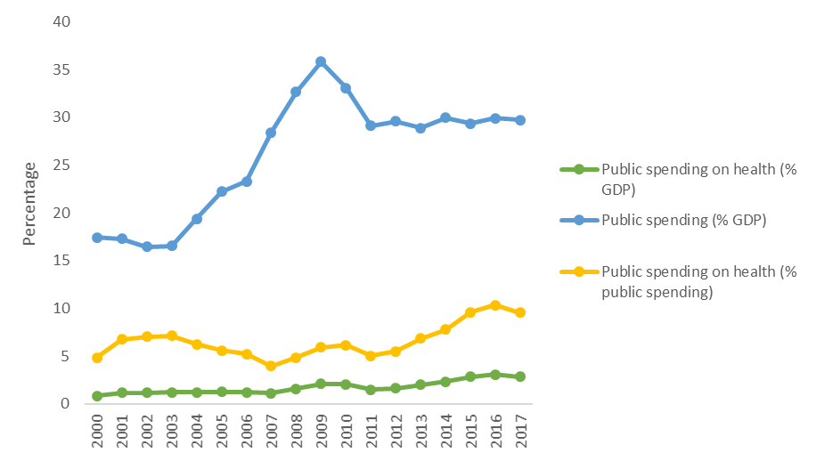
Source: WHO (2020).

Despite of the remarkable increase in public spending on health since 2013, Georgia’s level of public spending on health as a share of GDP remains low in the European Region (Fig. b), largely because of the relatively small share of total government spending allocated to health compared to the European Region – 9.5% in 2017, where the average is 12.2%.

Fig. b. Relationship between public spending on health as a share of GDP and GDP per person in the European Region, 2017
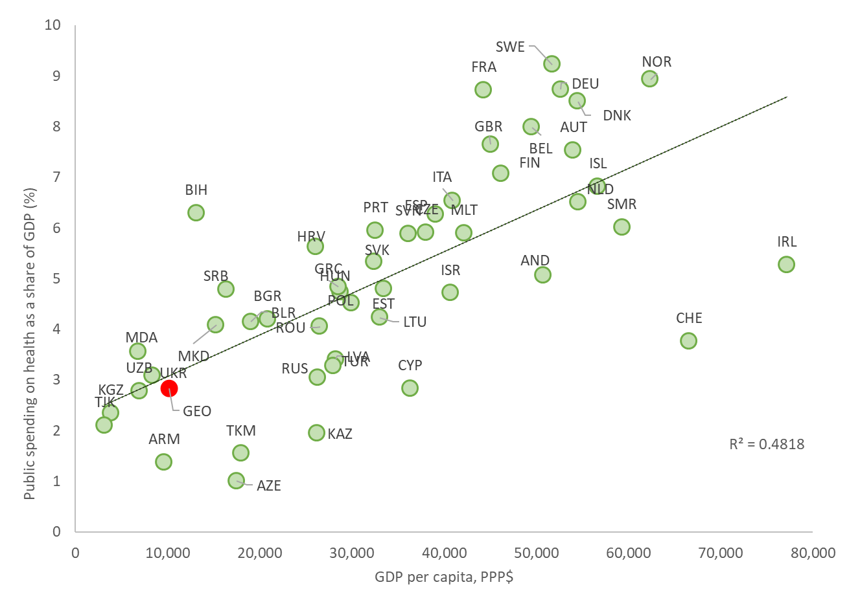
Notes: PPP: purchasing power parity. Public refers to all compulsory financing arrangements. R2: coefficient of determination. The figure excludes Albania, Montenegro, Monaco and Luxembourg. Georgia is shown in red.
Source: WHO (2020).

Fig. c shows that increasing public spending on health has not been resulting in reduction of out-of-pocket spending as expected and out-of-pocket spending share remains higher than in many countries with similar level of public spending on health as a share of GDP. This suggest that increase in public spending has not achieved its full potential to reduce household spending on health and other health system factors are likely to have an important role in explaining why the number of households facing financial hardship is increasing (see Fig. 19).

Fig. c. Relationship between public spending on health as a share of GDP and out-of-pocket payments, WHO European Region, 2017
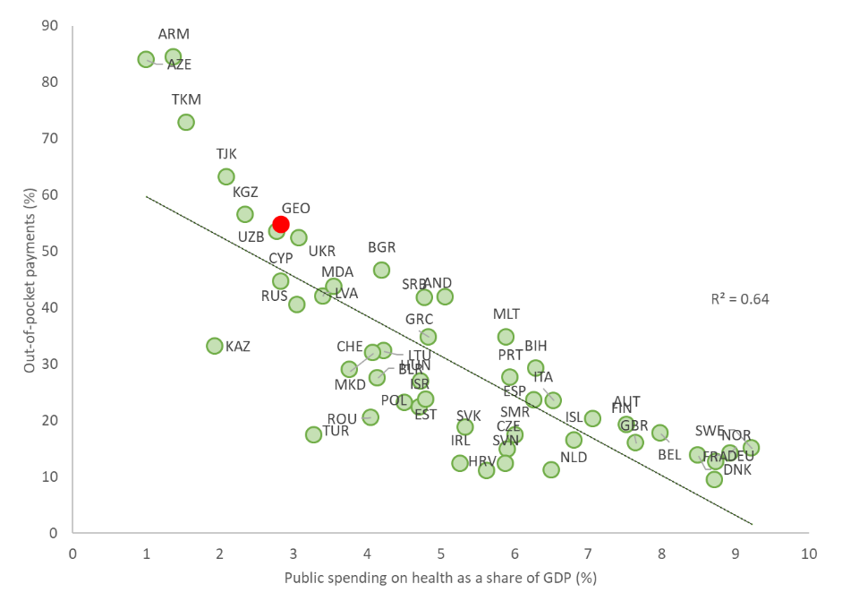
Notes: R2: coefficient of determination. The figure excludes Albania, Montenegro, Monaco and Luxembourg. Georgia is shown in red.
Source: WHO (2020).

6.2.2 Health coverage

In Georgia, population entitlement to the statutory package of benefits is determined by income level and existing coverage under private insurance schemes. The Universal Health Care Programme introduced in 2013 aimed to expand the coverage and as a result the population coverage is around 95% (85% under the Universal Health Care Programme and 10% under private insurance arrangements). However, the depth of coverage under the Universal Health Care Programme varies depending on income level, age and other characteristics. The whole population is eligible to several programmes for priority diseases and conditions.

The relatively rich population (mainly those employed in the formal sector) has private insurance, which covers a wider spectrum of services than the Universal Health Care Programme, such as the treatment of chronic conditions and outpatient medicines. However, the role of private insurance remains limited constituting only 6% of total current health spending and 10% of private spending in 2017 and out-of-pocket payments continue to play the major role, especially to finance outpatient care, diagnostic services and outpatient medicines (Fig. d). All this indicates that current coverage policy has gaps and does not provide enough protection.

Fig. d. Selected service categories by sources of financing, 2017

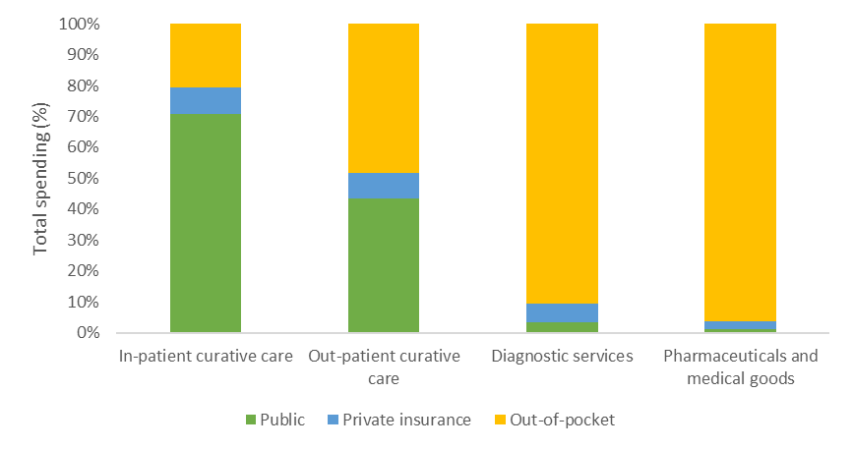
Notes: External sources excluded.
Source: NHA 2017

One explicit gap in service coverage for all groups is dental care which is not included to the publicly funded benefit package. However, dental care is not the main cause of financial hardship for any income group which suggest that households prioritise other more urging health needs, potentially resulting in high unmet need for dental care. Since 2018, the high out-of-pocket spending on inpatient care is the main source of catastrophic expenditure for the richest households. This could be the result of the changes in the coverage policy terminating the richest households’ entitlement to the Universal Health Care Programme benefits in mid-2017.

High out-of-pocket spending on medicines is the main cause of catastrophic spending for all other income groups (see below). Second largest source of catastrophic spending for these income groups is outpatient services. The Universal Health Care Programme benefit design has been prioritizing inpatient care since beginning. Essential outpatient services are expected to be part of the primary care package but in practice patients seek care from specialists and pay out-of-pocket, partly due to the low level of trust towards primary health care providers but also because of the gaps in services included to the primary health care package. For example, diagnostic tests in case of cancer suspicion, except organized screening programmes, are not included to the Universal Health Care Programme. Moreover, the capitation payment for the PHC is not risk-stratified and is not revised regularly which results in discrepancies between the population health needs and actual resources available to meet these needs. Furthermore, providers have strong incentive to increase their revenues by prescribing additional diagnostic services which are covered by out-of-pocket payments. This results in overutilization of laboratory tests and clinical imagines by those patients who have capacity to pay.

Waiting times are not a concern in Georgia as providers do not have volume caps and providers have been upscaling their capacity since introduction of the Universal Health Care Programme. Lack of volume control mechanism together with weak price regulation are the key reasons why other mechanisms, mainly service coverage and co-payment levels, are used to manage expenditure growth. In the past, complicated administrative procedures to access benefits were also used but over the years these have gradually replaced with more patient-friendly digital solutions.

The Universal Health Care Programme has different co-payment levels for health care services for different population groups as a percentage of service price. The Universal Health Care Programme also stipulates case limits for emergency inpatient services (15000 GEL) and annual reimbursable caps on planned medical services (12000 GEL for oncological diseases and 15000 GEL for other planned services). Similar approach, setting annual caps for expenditures, is used under the Programs for Medical Services in Priority Areas. Applying annual spending caps in unusual in Europe and is one important cause of financial hardship if treatment related expenditures exceed the limit. Patients are also required to cover the difference between the maximum price set by the state for planned services and the price determined by the provider. Providers ability to charge extra formally partly explains the minimal role of informal payments in Georgia compared to similar countries.

Overall, the design of co-payment system is complex and is difficult for the patient to understand. For example, as the patient co-payment may constitute a certain percentage of the cost of service which price varies by different providers, it is difficult for person to determine the actual amount covered by state. Moreover, the co-payment levels and annual expenditure caps of different population groups and types of services vary and might be ambiguous. All this together makes patient cost sharing difficult to predict resulting in financial uncertainty and increased risk of catastrophic payments.

6.2.3 Medicines

Affordability of medicines remains the key policy concern. Almost all outpatient pharmaceuticals are purchased at full price out of pocket. Catastrophic spending affects the poorest households the most and outpatient medicines are the largest single cause of catastrophic spending. Between 2010 and 2018, 47-61% of catastrophic and impoverishing expenditure (87-91% in the poorest quintile) is related to out-of-pocket expenditure on medicines. According to the National Health Accounts for 2017, 36% of total health care expenditure and 62% of out-of-pocket expenditure incurred by households is for purchasing medicines, which is high by European standards. At the same time, only 1% of spending on medicines came from public sources.

Inequality in the ability to pay is still significant for outpatient medicines; out-of-pocket expenditure has a regressive distribution. The HBS data indicated that in 2010-2015, the share of out-of-pocket expenditure on medicines increased for the poorest quintile group, in 2016-2017 this was reversed, but in 2018 increased again (Fig. 5.3). Medicines are imposing a financial burden on all households. However, financial protection remains problematic for the relatively poor households where household members have chronic conditions, especially in rural areas. The list of the medicines covered by the Universal Health Care Programme includes up to 100 medicines in total and reimburses only 50% of the price of those within a 50GEL-200GEL annual limit. Any additional expenditure above the annual cap is paid in full by the patient out of pocket However, the actual use of this benefit has been always extremely low due to multiple reasons as bureaucratic procedure, low awareness among target group, limited and outdated selection of medicines and high co-payment. For example, in 2017 drug expenditure under the Universal Health Care Programme was 23 492 GEL.

Since May 2017, 23 drugs for 4-6 major chronic conditions have been provided free of charge for the most vulnerable population as registered in the unified social database. From 2019, these free prescription entitlements were extended to pensioners. However, the program take-up remained very low (total expenditures around 6 million GEL in 2019) due to failures in the procurement process, stock-outs of most needed medicines and low awareness among target population. In February 2020, these two programs were merged into one under the Universal Health Care Programme keeping the main focus on six chronic conditions and socially vulnerable population groups. As a result, the administrative procedure for patients to access covered medicines is simplified and strict programmatic budget cap for medicines has been eliminated. The planned budget for 2020 is still small – 10 million GEL – but in case of higher need it can be exceeded and will be taken into account to plan the next year budget.

High out-of-pocket spending on medicines is further exacerbated by the lack of price regulation and abundant recommendation of brand-name medicines by doctors and the more limited availability of low-cost generic medicines in retail pharmacies (World Bank PER 2017). The prices of medicines are high compared to neighbouring countries and the cost plus margin (frequently more than 100%) significantly exceeds that established in EU countries (Gotsadze 2011, Richardson and Berdzuli 2017). In 2017, spending on medicines constituted more than one third (35%) of the total health expenditures.

6.2.4 Inpatient care

Before the introduction of the Universal Health Care Programme in 2013, the poorest households were already covered under the MIP state health insurance programme from 2007. Consequently, households just above the poverty line have benefitted most from the Universal Health Care Programme and utilization of inpatient services has increased more for this group than the poorest group who were already eligible for a comprehensive package of benefits.

The Universal Health Care Programme reduced the gap between the poorest and the richest quintile groups in terms of access to hospital services, by decreasing financial barriers. As the access to inpatient care improved, the number of hospitalizations per 100 population has more than doubled between 2010-2018. In 2018, there were 16.7 hospitalizations per 100 population, which is high according to European averages. High utilization of hospital care is a result of the benefit package and financial incentive design. First, service coverage and co-payments provide better financial protection for inpatient, especially emergency, care. Moreover, outpatient consultations and diagnostic services coverage is limited and trust towards primary health care is low. Second, activity-based payment for hospitals without any volume control mechanism encourages hospitals to treat as many people as possible.

6.3 Summary

The marked increase in public spending on health since 2013 and the introduction of the Universal Health Care Programme. Despite of this remarkable increase, Georgia’s level of public spending on health as a share of GDP remains low in the European Region. Low level of public spending on health and gaps in coverage policy are the key reasons why Georgia has not been achieving its full potential to reduce out-of-pocket spending on health and to improve households’ financial protection.

The increased public funding over the last years particularly improved access to inpatient and outpatient care and reduced the gap between the poorest and the richest households since 2010. For example, the difference between the poorest and the richest quintiles of respondents who reported being sick in the last six months and consulted a health care provider, reduced from 12 percentage points in 2010 to 6 in 2017. However, access to outpatient medicines has been improving for all income groups but the difference between poorest and richest households widened as the cost of medicines has not been comprehensively covered. One potential explanation for improved access to medicines could be that the better coverage of inpatient and outpatient services has allowed households to spend more on medicines. However, the outpatient medicines remain to be the single most important driver of financial hardship. As a result of very limited coverage for outpatient medicines, although some promising developments in recent years, households bear most of the financial burden of high pharmaceutical prices, particularly for the poorest households and people with chronic conditions.

The cost to households in meeting their basic needs has remained relatively stable since 2010. The average capacity to pay has somewhat improved since 2010, although since 2014 the trend has been downwards. The share of households living below the basic needs line fell steadily until 2015 but has been increasing since then (Fig 27). This means that the poor have become more poor during recent years. This worsening economic situation of households could partly explaind the increasing share of households facing catastrophic health expenditures. Improving access to care due to the additional public funding and increased providers’ capacity have been incresing people’s ability to use health care services. As a result, people are more exposed to out-of-pocket payments. However, the system of co-payments remains complex, potentially confusing for patients and provides limited coverage. Latter is one of the key factors conributing to the detoriation of financial protection over time as. The gaps in current coverage policy prevent providing sufficient protection for poor households and people with greater need for health care.

7. Implications for policy

The recent health financing reforms have been improving access to care, but out-of-pocket share of total spending has not fallen as fast as expected. These reforms have successfully reduced financial barriers to access, and consequently increased the use of, particularly for those groups who were previously uninsured. However, out-of-pocket payments for health as a share of household expenditure remain high at 8-9%. In absolute terms, higher income groups spend much more on health services compared to lower income groups, but the share of out-of-pocket payments on health is about the same within these groups between 2010 and 2018.

Financial protection in Georgia is weak and deteriorated over time. In 2018, 1 in 6 households faced catastrophic out-of-pocket payments going up from 1 to 9 households in 2013.

Catastrophic spending on health is heavily concentrated among the poorest households. In 2018, almost half of all households in the poorest quintile experienced financial hardship, compared to only 5% in the richest quintile. Thus, the lower income households are 7-8 times more likely to face catastrophic health expenditure than the higher income households.

Despite increase in public spending on health since 2013, the level of public spending on health as a share of GDP remains low – 9.5% in 2017, where the average in European region is 12.2%. Low level of public spending is one of the reasons why the out-of-pocket spending as a share remains higher than in many countries with similar level of public spending on health as a share of GDP.

Outpatient medicines are the single key driver of financial hardship because of very limited coverage and high prices of medicines. Among the poorest quintile about 90% of catastrophic health spending can be related to the out-of-pocket payments on medicines. For the richest quintile, the main driver of catastrophic expenditure is inpatient care as the richest population was excluded from the Universal Health Care Programme in 2017 and the voluntary health insurance does not provide enough protection. Interestingly, dental care does not have important role in driving catastrophic health spending, although excluded from public benefit package for all population groups.

The affordability of outpatient medicines should be increased. In mid-2017, the stated introduced outpatient medicines program targeting the poorest population but uptake of the program has been very modest. Furthermore, low cost generic medicines are generally less available in retail pharmacies, as compared to more expensive originator products. This may influence purchasing decisions, skewing consumption towards higher-priced medicines. In 2017, only 1% of spending on outpatient medicines came from public sources. To increase affordability of medicines, the outpatient medicines program should be extended significantly. Moreover, stronger price regulation and rational use of medicines require immediate attention.

Weak price regulation of health care services and providers ability to charge extra form patients, are one of the important reasons of high out-of-pocket payments on inpatient and outpatient services. Unexpected positive side effect is that informal payments are not a problem in Georgia because in most of cases providers can set their own prices and to charge extra from patients.

Co-payment system remain complex, potentially confusing for patients and provides limited coverage. Annual caps for publicly covered expenditures, percentage co-payments combined with providers’ ability to charge extra from patiens, result in vaguely regulated user charges causing high out of pocket expenditures. Moreover, the lack of volume control mechanism makes public expenditure growth very difficult to manage. As a result, in mid-2017 the richer population was excluded from the Universal Health Care Programme co-payments for some population groups were increased.

Additional public investment on health alone is not enough to strengthen financial protection. Better coverage policies, stronger price regulation and volume control mechanisms are also needed to get more value for money. Low public spending on health (2.8% of GDP in 2017), high reliance on out-of-pocket payments (55% of current spending on health in 2017), significant gaps in coverage and lack of price regulation are the main factors undermining financial protection. Any additional investment in the health system should be used to prioritize stronger protection for poorer households and regular users of health care. Moreover, stronger price regulation for medicines and health services with adequate volume control mechanisms would enable better use of existing

