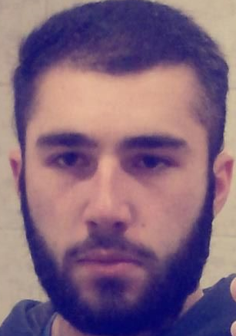

foto

Saba noniashvili

Personal Data

Name Username | Saba Noniashvili
Gender | Male
Date of birth  Day/month/year | 15/03/1994
Place of birth | Rustavi
Marital status | Married
Citizenship | Georgian  Latvia (Temporary)
Legal address | Georgia Tbilisi Nutsubidze street III plateau II mk. D. Building 1 flat 21  Latvia DU Teatra street 2 Flat 7
Identify card number | 01008055661
Contact information

Mobile Phone | +995 579700703  +371 25 392119
Home Phone
Service phone/fax
E-mail | noniashvilisaba@yahoo.com
Education:

Name of University |  | Tbilisi State University
Faculty/Specialty |  | Medicine
Gained quality |  | Diploma in Medicine
Date of entry /  Date of Graduation |  | 2011 - 2018

Name of University | Tbilisi state University
Faculty/Specialty | Epidemiology and environmental medicine (Master Dagree)
Gained quality | student
Date of entry /  Date of Graduation | 2018/2019

Name of University | Daugaupils University
Faculty/Specialty | Management Science
Gained quality | Doctoral student
Date of entry /  Date of Graduation | 2019/

Work Experiance

Organization Name | Clinic Neo Med
Occupied position | Junior M.D of Critical Medicine Department
Entry and departure date | 10.2018 -
Reason for leaving

Main responsibilities and function | 24-hour monitoring of patients  Patient document description

Organization name | Clinic Neo Med
Occupied position | Junior M.D of EVACUATION SERVICES
Date of entry and departure | 07.2018-10.2019
Reason for leaving work
Main responsibilities and functions | Safe and fast evacuation of passengers

Organization name | LTD Family Doctor
Occupied position | Junior M.D ER department
Date of entry and departure | 2014-2017
Reason for leaving work | Changed Living place
Main responsibilities and functions | Monitoring of Patients  Patient document description

Organization name | National Center of K.eristavi National Surgery Center
Occupied position | Nurse Of Critical Medicine Department
Date of entry and departure | 2015-2018
Reason for leaving work | Changed Living place
Main responsibilities and functions | Monitoring of Patients
Knowledge of languages:
(evaluate the 5-point system)
 | Talk | Write | Read
Georgian | +5 | +5 | +5
Russian | +4 | +4 | +4
English | +4 | +4 | +4

Organization name | British Language Centre Of Tbilisi
Occupied position | Student
Date of entry and departure | 10.2010- 12.2010
Level Of Course | Certificate Upper Intermediate Course
Organization name | BLS (British Language School)
Occupied position | Certificate
Date of entry and departure | 12.2017- 01.2018
Level Of Course | Certificate In Basic Life Support

Organization name | Lewis School Of English (United Kingdom)
Occupied position | Student
Date of entry and departure | 13.09.2010- 24.09.2010
Level Of Course | Certificate upper Intermediate Plus

Name of University | Daugaupils 62 th conference
Faculty/Specialty | Management Science
Gained quality | Repportour
Certificate | Certificate in  HealthCare/ Policy,Health Economic  Publicc healthcare in Georgia (Republic)

