cv
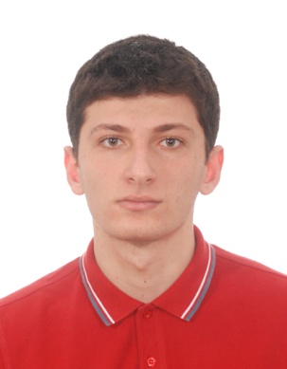

Vakhtang Magrakvelidze

Georgia, Tbilisi | 555979882 | Vakhtangimagrakvelidze@gmail.com

PERSONAL INFORMATION

Date of birth: 29/10/1992

EDUCATION

Ilia State University
Bachelor of Business Administration in Management 2010–2015

Tbilisi State University
Master of Business Administration (finance) 2017

RELEVANT SKILLS

Language skills
• Georgian–native
• English–advance
• Russian- pre intermadiate

Computer skills
• MS Excel
• MS Word
• MS Power Point.

Working experience

2018 - TBC bank- call center operator- intern
2018 - 100 Marketing solutions - call center sales agent
2019 - swiss capital - microcredit manager
2019 - Pasha Bank - sales manager
2020 - TBC bank – credit administrator intern

