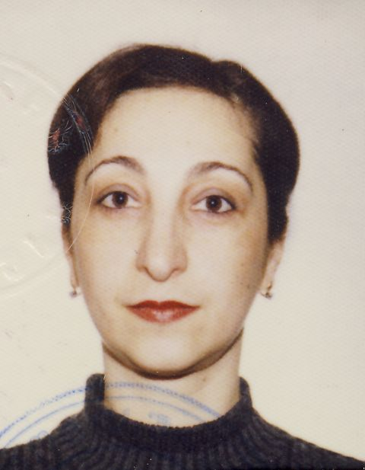
First Name: Maka

Last Name : Chachanidze

Phone Number: +995577141440

Adress: 16a Ir. Abashidze Str.

E-mail Address: chachanidzemaka68@gmail.com
Date of Birth: 30.01.1968

Work Experience:
01.2020 – Head of Outpatient and Diagnostic Department.
03.2019-12.2019 Medical Director at Universal Medical Center
08.2017-03.2019 Medical Director at Open Heart General Hospital. 5th Clinical Hospital
11.2016-08.2017 - Medical Director at Medical Holding Medison
08.2015 - 10.2016 - Medical Director at Hemoline Blood Bank & Plasma Center
06.2012 - 08.2015 - State Procurement and International Supplier Relationships Project Manager at the at the JSC GPC’s
04.2011 - 06.2012 - Deputy Head of Administrative Department at the Ministry of Labor, Health and Social Affairs
12.2010 - 06.2011 - Program Coordinator of the State Program for Provision of Special Medicines to Population at the Health Projects Implementation Center
01.2008 - 05.2008 - Deputy Head of Department for Registration and Distribution of Medical and Supplementary Facilities at the Health Programs Agency of the Ministry of Labor, Health and Social Affairs.
04.2007 - 11.2010 - Head of Division of Registration and Distribution of Medical Means at the Health and Social Programs Agency of the Ministry of Labor, Health and Social Affairs.

05.2004 - 04.2007 - Head of Division at the United State Fund of Georgia
12.2001 - 09.2004 - Scientific Editor for the "Georgian book" Association
10.1993 - 11.1998 - Family Doctor at the "Curatio," company of family doctors
Education:
09.1987 - 07.1993 - Tbilisi State Medical University;
03.1996-04.1996 - Certified Course in Clinical Neurology (certificate) - Quality Development Department Of Medical Concern "CIF"
10.1997-11.1997 - Certified Course in Gynecology (certificate) - Quality Development Department Of Medical Concern "CIF"
11.1997-12.1997 - Certified Course in Roentgenology (certificate) - Quality Development Department Of Medical Concern "CIF";
05.2007-07.2007 - Health Organization and Management (Certificate) - Health Development Program
Languages:
Georgian - Native;
English - Good;
Russian - Excellent;
Computer Programs:
Microsoft Office Word - Excellent;
Microsoft Office Excel - Excellent;
Microsoft Office PowerPoint - Excellent;

References:
Zaza Sopromadze - zsopromadze@ssa.gov.ge T: 577407673
Vato Surguladze - vsurguladze@unison.ge T: 577503009
David Kiladze - d.kiladze@gpc.ge T:599572824
David Ebralidze - debralidze@tbilinvets.ge T: 577555000
Uva Katchiuri - kvan003@gmail.com T: 577100300
Giorgi Tokhadze - g.tokhadze@ic.ge T: 577005656

