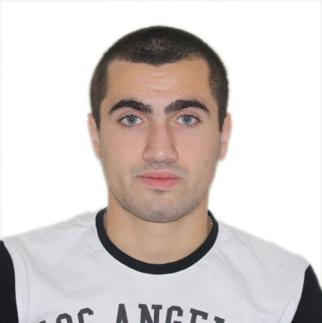
CV
Name: Beqa
Surname: Iluridze
Birthdate: 21.10.1995
Address: Tbilisi, Gldani, 6th micro, 9th block, flat -56
Mobile: +995 595325597
Email: beka.iluridze.1@iliauni.edu.ge
IDnumber :01001065223
Drivinglicense : B, B1
განათლება:
University | Faculty | The study period | Degree
Ilia state university | Business | 2013-2017 | Bachelor
Windows | Very good
MS Office | Very good
Internet | Very good
E-mail | Very good
ტექნიკური უნარ-ჩვევები:ენები:
Georgian | Native
English | Very good
russian | Average

Workexperience:
- H&M (Croatia ,Zagreb )- Consultant & Cashier
- Bank of Georgia –Universal Cashier & Operator

