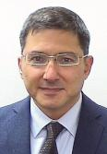

Levent Yener Short BIO

Levent Yener has been with the Bank since February 2010. Before joining the South Caucasus region as the Human Development Practice Leader, he worked as the Senior Human Development Specialist in Bank’s Turkey Office working on tasks in all Human Development sectors. Prior to the World Bank he was employed as a civil servant by the Turkish Ministry of Treasury and Finance, and had dealt with policy development issues, and management and financing of projects in a multitude of sectors, including those dealing with poverty reduction, social assistance, education, health, labor, and public administration. He holds a Ph.D. in finance.

