Annex D

Business process details in Electronic Portal of SESA

Registration of recipients of compensation as the victims of the Coronavirus pandemic initiated by the Government of Georgia:
Fields Required for the Registration:
- Personal N
- Name
- Surname
- Mobile phone number
- Password
The compensation seeker enters personal number, name, surname and the mobile phone number in the interface and presses the SMS button.
The compensation seeker will be identified by his/her personal number, name and surname on the server of the Public Service Development Agency, a password will be sent to the mobile number and after entering the password the seeker will be able to enter the request form. The user will be able to log in every time with a new one-time password that will be valid for 10 minutes.
Site Registration Form (Fig. 1)

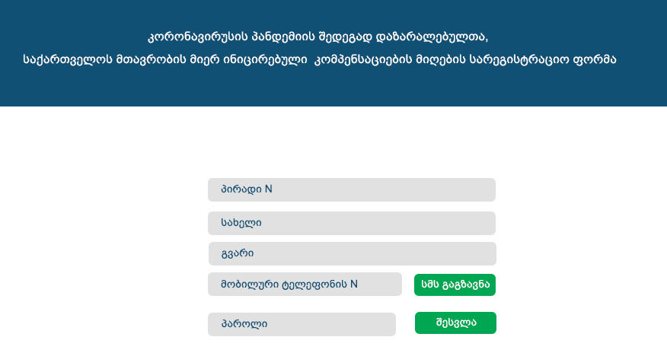

Registration form for receiving the compensation as the victims of coronavirus pandemic initiated by the Government of Georgia

Personal Number
Name
Surname
Mobile Phone Number | Sending SMS
Password | Log in

2. If the person could not be identified by his/her personal number and surname, the message "Personal data is incorrect, please correct it" will be sent and the password will not be sent via SMS

Filling the Request Form

For the natural person whose income is confirmed by the Revenue Service – fields required to complete the application:
- Personal N – Auto fill , no field editing read-only
- Name - Auto fill , no field editing read-only
- Surname - Auto fill , no field editing read-only
- Phone Number - Auto fill , no field editing read-only
- Bank Account N – Manually filled
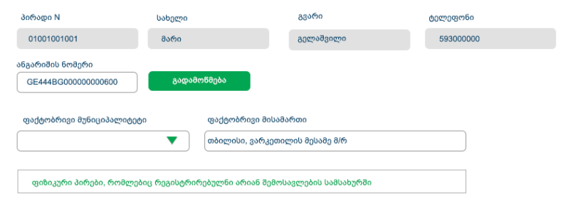

Personal N | Name | Surname | Phone Number
01001001001 | Mari | Gelashvili | 593000000

Account Number
G44BG0000000000600 | verification

Actual Municipality | Residence address
 | Varketili third micro district, Tbilisi

Natural persons registered at the Revenue Service

6. Actual municipality (Select field)
7. Residence address – Manually filled

After filling in the fields, click on the verify button, it will check whether the applicant’s personal number is on the list of the Revenue Service for one-time transfer; it will also check the compliance of personal number and bank account.
After the verification the following messages appear:
  - If the person is employed - "You are employed and you are not eligible to the one-time compensation” (The applicant cannot continue registration)
  - The applicant was employed but lost the job - "You are not eligible to the one-time compensation and you will receive your monthly compensation without registering in the system” (The applicant cannot continue registration)
  - The applicant is in the list of one-time compensation and is registered at the Revenue Service -
    - If the bank account is incorrect, the following message will appear “Please, correct the number of bank account and try to verify it again”
    - If the bank account is correct the following message will appear "Your data has been successfully verified. Please press the request submit button your compensation will be credited in a few days”
Persons registration field will be auto filled at the Revenue Service (For natural persons registered at the Revenue Service)
  - If the applicant is not in the list of one-time compensation
    - - If the bank account is incorrect, the following message will appear “Please, correct the number of bank account and try to verify it again”
    - –If the bank account is correct the following message will appear “ To register, please select the type of economic activity and upload the documents confirming the self-employment, then press the end button”
Persons registration field will be auto filled at the Revenue Service (For natural persons who are not registered at the Revenue Service)
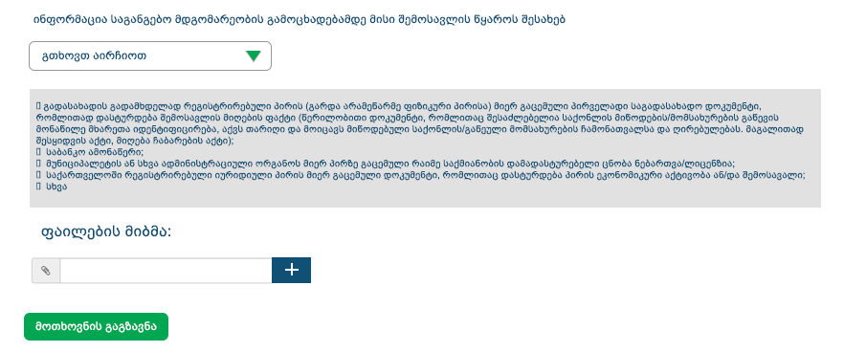

Information about the applicant’s source of income before the declaration of the state of emergency
Please select
Initial tax document issued by a person registered as a taxpayer (except for a non-entrepreneurial natural person) confirming the fact of receiving income (A written document that identifies the parties involved in the delivery of the goods / services, has a date and includes a list and value of the goods / services supplied, such as the procurement certificate, the acceptance and delivery certificate)
Bank Statement
Certificate / license for any confirmed activity issued to a person by a municipality or other administrative body.
Document issued by the legal entity registered in Georgia confirming the person’s economic activity and/or income.
Other

Attaching File

Natural person sends his/her request only once

Agency Interface
The submitted request will be displayed on the page of full list of the Agency interface. Upon submission, a unique request number and type will be assigned to it ("no-commission" – for the natural persons found in the one-time transfer list of income taxpayers, or "commission" – for the natural persons who are not in the one-time transfers list of taxpayers and who uploaded documents confirming that they are self-employed)
There will be the following sections on the interface
- Filters panel - it will be possible to search data based on the various parameters as well as download retrieved data (For example, Request N, Personal N, Account N, Municipality, Commission Type, Processing Status, Acceptance Status, Request Submission Period, Transfer Status, Transfer Period, Request Type , Request recipient, etc.)
- Complete list of Requests – will be filled with the auto sent requests.
The List of Request Fields:
- Acceptance status- only for commission requests
  - Reviewed (Reviewed at the initial level)
  - Accepted (the Status shall be granted after it is reviewed by the working group member)
  - Only the requests with the accepted status goes to commission
- Processing Status
  - Compensated
  - Not compensated
  - To be reviewed
- Request N – Unique number generated when the request is sent. Request number shall be given to commission requests as well as to the no commission requests
- Applicant name
- Applicant surname
- Personal N
- Municipality
- Address
- Phone N
- Bank account N
- Type – Commission or empty field commission - for natural persons not registered at the Revenue Service)
- Transfer Status - (shall be filled in if the data of beneficiaries with transferred compensation will be uploaded on the interface)
- Date of Transfer - (Will this date be provided?)
- Date of sending request
- Request receiver
- Date of the request received

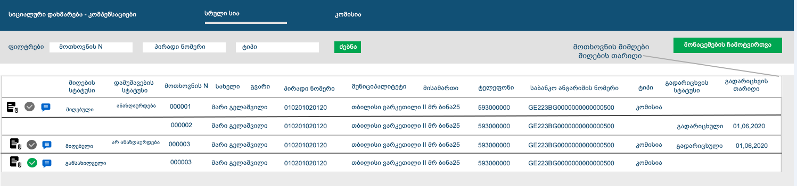

Social assistance - Compensations |  |  |  |  |  |  | Complete List |  | Commission
Filters |  | Request N |  |  |  |  | Personal N |  |  |  | Type |  |  | Search
Persons Status | Processing  Status |  | Request N | Name | Surname | Personal N |  | Municipality |  | Address |  | Phone | Banking Details |  | Type | Transfer Status | Transfer Date

Commission List
There will be an additional button to the list of the commission, pressing the button will open a window where the requests with the accepted status will be displayed. Requests will be grouped by the working group user who clicked to accept the request. According to the members of the working group, the requirements will be summarized and a new commission will be created by pressing the commission button based on the requirements chosen by us.
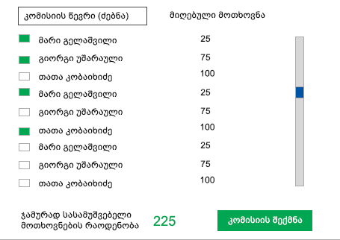

Commission Member (search) | Received requests
Mari Gelashvili | 25
Giorgi Usharauli | 75
Tata Kobakhidze | 100
Mari Gelashvili | 25
Giorgi Usharauli | 75
Tata Kobakhidze | 100
Mari Gelashvili | 25
Giorgi Usharauli | 75
Tata Kobakhidze | 100
Nnumber of Requests Processed in Total |  | 225 | Establishing Commission

„“Instead of Commission member write “a member of working Group” and instead of received requests write “Completed requests”

After the establishing of the commission, the protocol of the commission with active status will be added to the full list and a unique number will be generated for each new commission.
Commision N | Date of Commision creation | Status | Number of Requests | Commission Decisions
1526 | 15,24,2020 | Active | 12

By editing the protocol of the commission, it will be possible to go to the list of detailed requirements and grant positive or negative status of remuneration.
There will be a filters panel on the interface of the commission protocol (detailed) - it will be possible to retrieve data with different parameters, each request will have the ability to be marked.
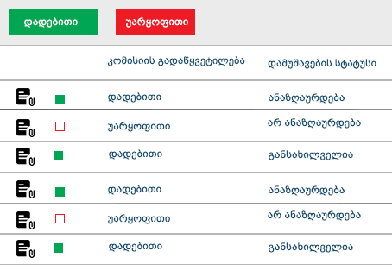
Positive | Negative
Commission Decision | Status of the Processed Cases

Positive | compensated
Negative | not compensated
Positive | to be reviewed
Positive | compensated
Negative | Not compensated
Positive | To be reviewed

Initially all "commission decisions" will be automatically negative, by pressing the "positive decision" button it will be possible to grant "positive decision" to the data to filtered by different statuses, or change the "positive decision" status to negative. Change of decision statuses will also be possible upon specific request, based on marking or unmarking of the request
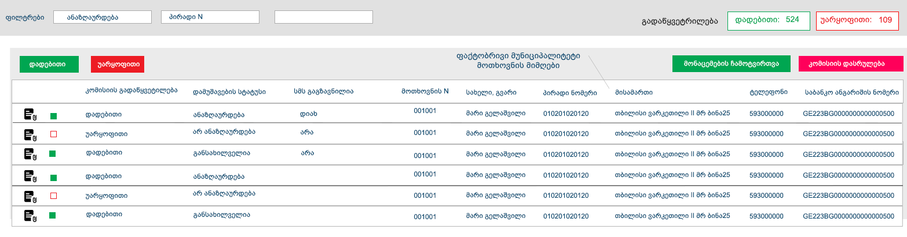
Actual Municipality
Accepting the requests

Commission Decision | Processing Status | SMS sending | Request Number | Name. surname | Personal Number | Address | Telephone Number | Bank account Number

Once the Working Group grants the compensation to requests by pressing the Commission End button, the commission will end and no positive / negative status changes will be made to the requests.
There will be an opportunity to download Excel to the completed commission, which will reflect the positive / negative (or only positive) answers of the commission.
Questions to be Discussed
- When registering a user, does the service return to us the civil statuses provided by the decree, including the death of a person? - We do not check
- How to send an SMS (send positive or negative answers) when the commission ends its activities? - We will discuss and tell you
- Registration of Agency staff users and their access to the interface. – Working group members will have the access to the interface
- Reflection of transferred requests in the system – Yes, they will be reflected

